MARKING SCHEME MATHEMATICS PAPER 1
- 22 + 14 = 36 = -3
-12 12

16X -6 – 12
-96 -12 = -108 -108 = 4
-27

72 ÷ -8 X 3
-9X 3 = -27
-3 – 4 = -7
2. II (17.5)² – 52(10.5)² = 616mm²
V= 6.16 X 250 = 1540CM³
Mass =V X D
= 1540 X 1.25
= 1925g
3.36=2² x 3²
=54 = 2 x 3³
=G.C.D =2 x 3² = 18
= L.C.D = 2² x 3³ = 108
=108 – 18
=90
216 = 2³ x 3³
= 2³ x 3 = 24

4 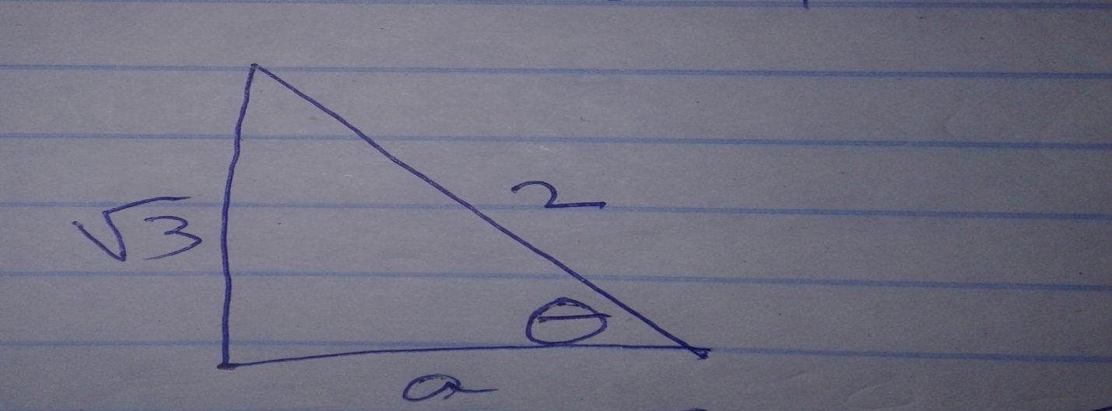
a² =$√\left(4-3\right)$
a=1
Cos θ= ½
Tan θ = $√$ 3/1
5. School fees = ¼ x
Electricity & water = ¼ + ¾
=3/16 x
Transport = 1/9(x-1/4x +3/16x)
=1/16x
Remainder = x –(1/4x + 3/16x + 1/16x)
=1 /2 x
=1/2 x =3400 x 2
X=6800
6. SA=454R² = 506
R= $√\left(506/π\right)$
= 9
Internal radius r=9-1.5
=7.5
V =4/3llr³ x ½
=2/3 x 3.142 x 7.5³
=883.69
7. 3x² – 2xy –y²
3x2 -3xy +xy – y2
3x9x-y) +y(x-y)
(3x+y)(x-y)

8.a

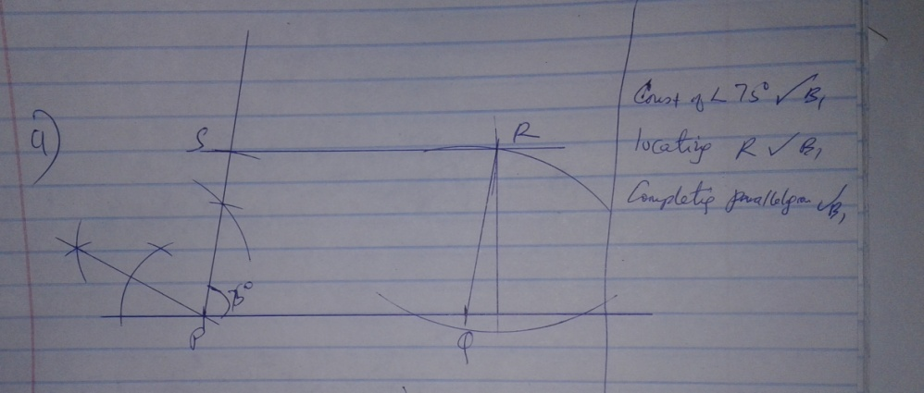

b. 3.9+/- 0.1

9.a)

22

b) 20 + 21
2
20.5
10. 120% -------36000
100% ____ 100 x 36000
120
=30,000
% profit = 3600 x 100
30000
=12%
11. L₁ =y= -x
L ₂ =3x -4y =24
L3= x - 4
L₂ y ≥ -2
L ₂ ,3x -4y < 24
L ₃ x ≥ -4

12. 3x² -1-2x² + x + 1
(x + 1 (x + 1)
X² + x
(x + 1 (x -1)
x
X -1

13. (a) 2³ x 3² x 5
b) 2’x 5’=10

14. 2 log 4 + log 6 –log 1000
2(0.6021) + 0.7782 – 3
  - -3
1.0176

15. Cost of commission = 115 x 4800
100
= 5520 US
In Ksh 5520 X 103.34 = 570436.80
=72200 x 103.34
117.20
=63679.30
Total inKsh =570436.80 + 63679.30
= 639116.10
16. (a+2b)² –(2b-a)²
(a+2b)² = a² + 4ab + 4b²
(2b-a)² = 4b² – 4ab + a²
A² + 4ab +4b² – 4b² – 4ab + a²
=8ab

17 a) 250x 14x2x2 = 14000
Net profit = 14000 – 6000 = 8000
b) 8000 x 25 = 200,000 = 190,000
c)Saving = 40/100 x 190,000 = 76,000
Remaining profit = 36/100 x 190,000 = 68400
Muthoka share
=2/9 x 68 400
=304800
d)475 000 x 34100 = 1500000
95

19. speed of B = (x +12) km/h
Time = 350
X + 12
Time = 350
X
350 - 350 = 6
X x + 12 5

350 (x+12 ) – 350x = 6
X (x + 12) 5
X + 12x – 350 = 0
a=1, b=12, c= -3500
x = -12 ±$√($12² + 1400)
2
=-131 0r 107
2 2
X =53.5km/h
b) 350 = 5.34 hrs
53.5 + 12
= 5 hrs 20 min
Time taken by A = 5 hrs 20 min
20 min
5 hrs
Distance by A 5 x 53.5
= 267.5km from Nairobi
- a)48 = 21 + x
16 x
3x = 21 + x
2x =21
X = 10.5cm

b) Volume of bigger cone = 1/3 x 22/7 x 48² x 31.5 = 76032cm³
Volume of small cone = 1/3 x 22/7 x 164 x 10.5 = 2816cm³

Total volume = 73216cm³

c)
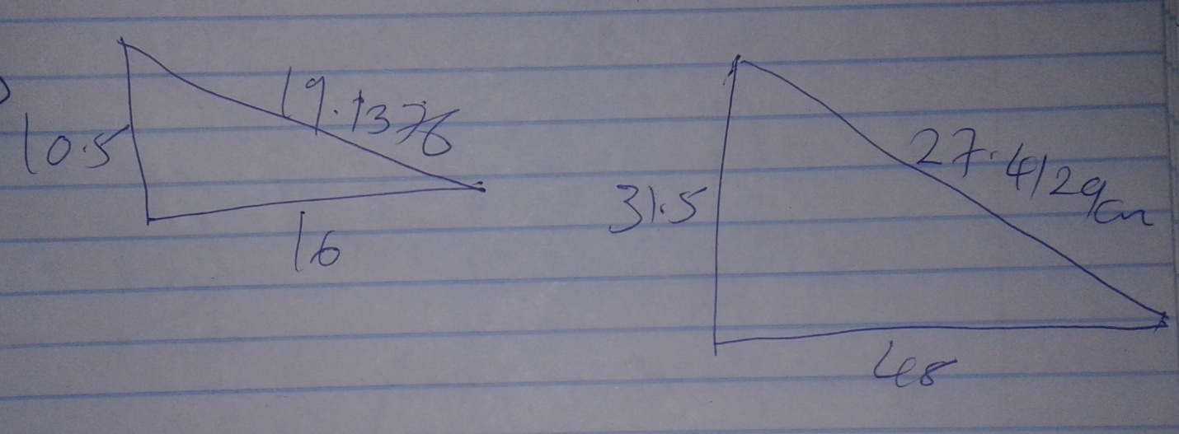
C.S.A of small = ll rl
=22/7 x 16x19.1376
=962.347 cm²
C.S.A of bigger cone = llRl
=22/7 x 48x 57.4129
=866.146cm
Total = 7698.799
Small circle = 22/7 x 16²=804 4/7cm²
Bigger circles = 22/7 x 48² = 7241 1/7
Total =15744.513cm²
-1
20 a)$\left(\begin{matrix}4 & 3 \\ 3 & 2\end{matrix}\right)=-1\left(\begin{matrix}2 & -3 \\ -3 & 4\end{matrix}\right)$=$\left(\begin{matrix}-2 & 3 \\ 3 & -4\end{matrix}\right)$

$\left(\begin{matrix}a & b \\ c & d\end{matrix}\right)=\left(\begin{matrix}-2 & 3 \\ 3 & -4\end{matrix}\right)\left(\begin{matrix}1 & 2 \\ 3 & 4\end{matrix}\right)$

$\left(\begin{matrix}a & b \\ c & d\end{matrix}\right)$=$\left(\begin{matrix}7 & 8 \\ -9 & -10\end{matrix}\right)$

b)$\left(\begin{matrix}2 & 1 \\ 2 & 2\end{matrix}\right)$ $\left({x \atop y}\right)$ = $\left({10 \atop 14}\right)$

1/2$\left(\begin{matrix}2 & -1 \\ -2 & 2\end{matrix}\right) \left(\begin{matrix}2 & 1 \\ 2 & 2\end{matrix}\right)\left({x \atop y}\right) = 1/2 \left(\begin{matrix}2 & -1 \\ -2 & 2\end{matrix}\right)\left({10 \atop 14}\right)$

$\left({x \atop y}\right)$ =$1/2\left({6 \atop 8}\right)$

X = 3 and y = 4

c) det = 1 -3 = -2
-1/2$\left(\begin{matrix}1 & -1 \\ -3 & 1\end{matrix}\right)$ =$\left(\begin{matrix}-0.5 & 0.5 \\ 1.5 & -0.5\end{matrix}\right)$
X = 4
Y =3

- a) Sin Q = x/8
sin 35 = x/8
x = 8 sin 35
=4.59
Sin 20 4.59
Pb
PB=13.42
b) θ/360 llr² -1/2 absin θ
70/360 x 22/7 x 18² sin 70
=39.11 – 30.07
= 9.04cm²
40/360 x 22/7 x 13.42² – ½ x 13.42² sin 40
= 62.89 – 57.88
= 5.01cm²
5.01 + 9.04
14.05cm²
c) ½ x 8² sin 70 x ½ 3.42² sin 40 – 14.05
=30.07 + 57.88 -14.05
=73.9cm²
- (i) 90 – 50 = 40º
ii) 360 – 2(50)
=360 – 100
= 260⁰
iii) 40º
iv) 180 – 80º – 50⁰
=50º
v) PQR = 40 + 90º
= 130º
- a (i) OB = p + Qq
ii)AD =3q –p
iii) CB = p -4q

b ) Ax =k(3q-p)
OX=r(p=q)
Ox =p +k (3q-p)
=p +3qk –kp
Ox=rp=rq =P +–kp
r=1 –k3kq
r=3k
3k=1 –k
4k=1
K=1/4
R=3/4

24.
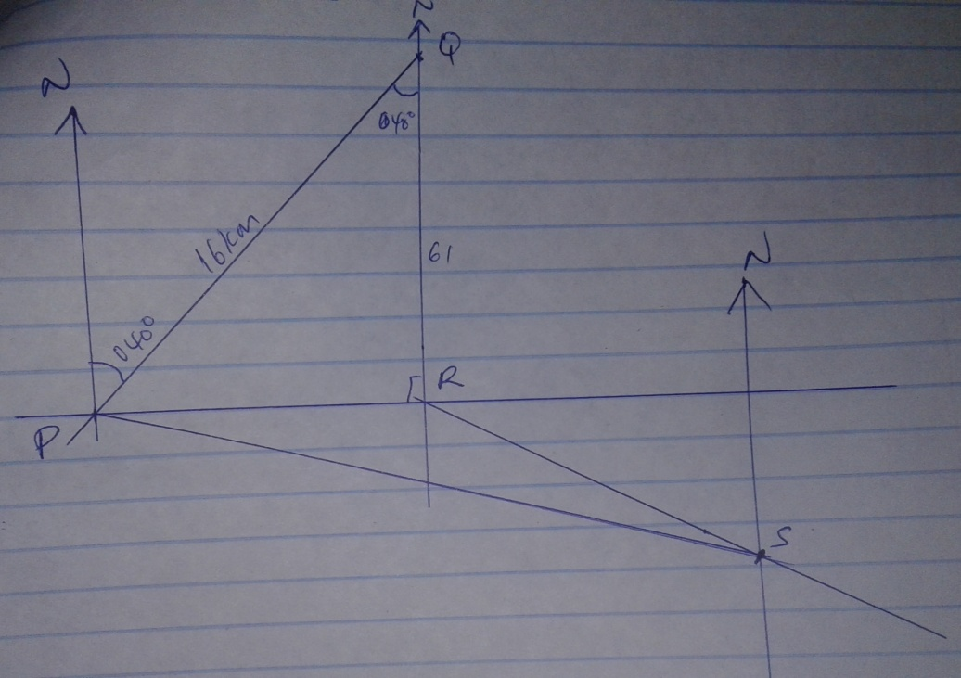

B9i) 10.8 ± x 2 = 21.6
ii)S74^{O} E ±1

iii) NR =6.1X2 = 12.2
Area =1/2x12.2x16 sin 40
=62.74

