MARKING SCHEME PP2 BUSINESS STUDIES
1a. Differences between private limited companies from public corporations
Private limited companies | Public corporations
- Formed under company’s act | Formed by an act of parliament
- Financed by shareholders | Initiating financed by government
- Directors appointed by shareholders | Board of directors appointed by government
- Profits go to the shareholders | Profits surrendered to the government
- Losses may lead to the collapse of the business | Losses may be subsidized by the government
- Owned by the shareholders | Owned by the government
- No political interference except through the enacted laws | Political influences especially nominating directors by the government
- Profits motivated | Formed mainly to provide essential services to the citizens

1b.Advantages of pooling of risks to an insurance company
- Its able to invest through giving out loans /buying shares
- Helps to determine /calculate the premises to be paid by various potential clients
- Its able to compensate /identify to insured who suffer from the insured risks
- Enables the insurance to get profit from pool funds in excess of claims which is paid to the owners /ploughed back to the business
- Enables the insurance to meet its operating /running cost by paying rent/salaries /bills.
- Enables company to spread risk over a large number of the insured people
- Enables the insurance company to create a common pool of funds from the regular premiums from client
- Enable the insurance company to re-insure itself enabling it to insure expensive items /enable it to be compensated out of re-insurance cover
Mention 1
Fully explained 2 mk
5x2=10mks
2a. Reasons for popularity of motor cycle transport
- Cheap to buy /maintain
- Saves time
- Flexible-offers door to door service
- Readily available
- Form of employment
- Can be used where there are no good roads
- Low hire charges
- Fast /speed as there is no picking /dropping of passengers
2b. Measures that may encourage establishment of industries in rural areas
- Giving free /cheap land
- Lowering tax on firms establishments in rural areas
- Offering direct financial assistance to the firms
- Offering subsidies
- Improvement of infrastructure

3a.Effects on equilibrium price due to increase in demand

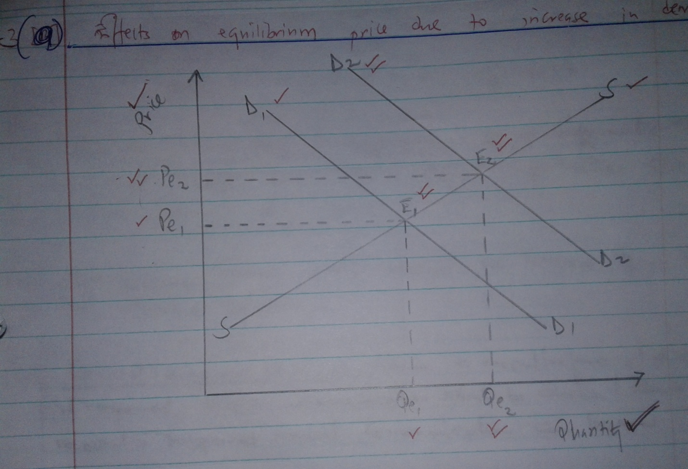

- The increase in demand will create excess demand
- Equilibrium price will increase from Pe1 to pe2
- Equilibrium quantity will increase from Qe1 to Qe2
- Equilibrium point will increase from E1 to E2
20x1/2=10mk
3b. Factors to consider when choosing a media of communication within the firm
- Cost: choose a mean s that is affordable
- Confidentiality/secrecy of information: secret information cannot be passed through some means /general information can be passed through any means
- Reliability: means should ensure the message gets to the intended person
- Record /reference /evidence: where a record /referenced /evidence is required written communication should be chosen /where no record is required verbal communication can be used.
- Accuracy: consider a method which will deliver the message correctly /without distortation.
- Length /detailed message –where long/detailed written communication /short /simple message verbal method can be chosen
- Recipient : is level of literacy /culture/disability of recipient to achieve desired goal
- Availability : as business council; use a method that is not there
- Urgency/speed/time: urgent message require fast means /less urgent message a slow method may be used
Mention 1
Fully explained 2 mk
5x2=10mk

4a. Reasons for filing documents in an office
- Keeps office tidy as documents are neatly arranged
- Quick access to information as documents are coded/serialized
- Safety of information from damage by bad weather/fire
- Saves on space as documents are kept compactly
- Security of information against loss due to theft /misplacement
- Safe guards confidential information as documents are kept away from unauthorized access/under lock and key
- Safe keeping of information for future reference
Mention 1
Full explained 2
4x2=8mks

\

4bi.
Kathiri traders
Trading profit and loss account
For the year ending 30/6/201
Opening stock 110,000 | Sales 900,000
Add purchases 470,000 | Loss sales returns 60,000
Add carriage inwards 20,000 | Net sales 84,000
49,000
Loss purchase returns 78,000 412,000
Cost of goods available for sale 522,000
Floss closing stock 100,000
Cost of sales 422,000
Gross profit c/d 418,000
840,000 | 840,000
Bad debts 56000 | Gross profit b/d 418,000
Commission 70,000 | Rent 74,000
Electricity 30,000
Net profit 336,000
492,000 | 492,000

21x1/3=7mks
ii.
Kathiri traders
Balance sheet
As at 30/6/2014
Fixed assets |  |  | Capital | 1,050,000
Buildings |  | 990,000 | Profit | 336,000
Furniture |  | 120,000 |  | 1,386,000
 |  | 1,110,000 | Loss drawings | 33,000
Current assets |  |  |  | 1,320,000
Debtors | 250,000 |  | Short term liabilities
stock | 100,000 | 350,000 | creditors | 140,000
 |  | 1,460,000 |  | 1,460,000
10x1/2=5mks

5a.Reasons that account for steady rise in level of national income
- Human resource /labour /man power : the county has well trained skilled man power /human resource that produces high quality /quantity goods /generating income
- Availability of natural resources enabling it to produce more goods /services services hence generating more income
- High level technology that leads to production of high quality /quantity goods
- Availability of capita/man made resources making production of goods easy increasing production
- Increased foreign investments increasing production of goods/due to favourable investment conditions
- Good governance /political stability leading to more production /increase in business industries.
- Appropriate good culture /entrepreneurship that encourages hard works.

5b.Characteristics of money
- Acceptability
- Divisibility
- Portability
- Durability
- Stability
- Homogeinity
- Cognisibility
- \scarcity
- Malleability
- Not easy to forge
6a. Challenges of over population
- Low industrialization
Most resources used on satisfying basic needs
- Environmental degradation
Due to over exploitation of natural resources
- Increase in social evile
As citizens without jobs strive to survival /earn a living
- Inflation
As demand for goods and services exceeds supply
- Low savings
Due to high dependency
- High level of unemployment
As growth in population exceeds job creation in the country
- Poor education /housing /health services
As demands for them exceeds their supply
- Landlessness
Due to land fragmentation caused by pressure on land
5x2=10mk)\
6b.
Sales journal
Date | Details | Invoice no | Ledger no | amount
May 3 2010 | Anyimba |  |  | 60,000
 | Mary |  |  | 150,000
 | Posted to the sales a/c |  | Gl | 210,000

Purchase journal
Date | Details | Invoice no | Ledger no | amount
May 8 2010 | John slove |  |  | 120,000
 | XYZ traders |  |  | 160,000
 | Posted to the purchase a/c |  | Gl | 280,000

Purchase returns ac
Date | Details | Credit no | Ledger no | amount
May 12 2010 | John slove |  |  | 6,000
 | Posted to P. returns a/c |  | Gl | 210,000

General journal
Date | Details | Dr | Cr
23/5/2010 | Motor ran  Embu motors  Being a purchase of motor  Ran on credit from Embu motor on credit | 3,200,000 | 3,200,000
30/5/2010 | Chap ltd co.  Office equipment a/c  Being sale of office equipment  On credit to chap ltd. Co. | 840,000 | 840,000

20x1/2=10mks

