PAPER 1 MARKING SCHEME CHENISTRY
1a. To magnesium oxide (MgO) add excess hydrochloric acid (HCl) or sulphuric acid (H₂SO₄). Add sodium hydroxide (NaOH) solution or potassium hydroxide (KOH) solution to the mixture. Filter and dry the residue
b.Anti-acid (treatment of acid indigestion )
2a.Energy change that results in the formation of an ion when an atom gain an electron
b.B, B releases the highest amount of energy so it has the strongest attraction of electron to its nuclear
3a.Polythene
b.n-4956÷28=177
4a.Cooling curve
b.BC
c.The kinetic energy of the molecules decreases as heat energy is lost to the surrounding leading to drop in temperature
5.Mass of NH₃=1000x0.88x0.35=308
Molarity =308/₁₇=18.118M
6a. 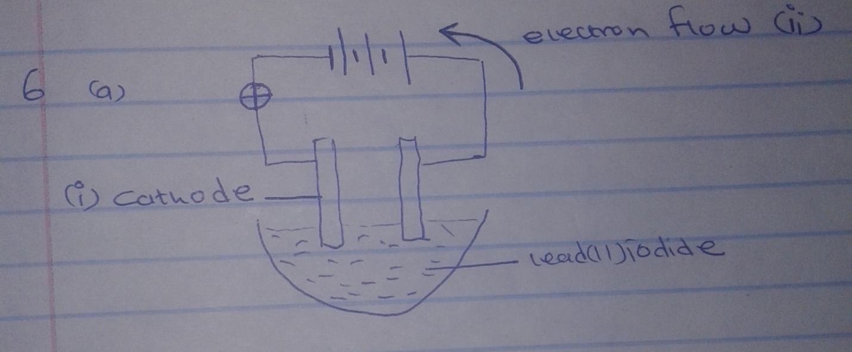
7a. Boyle’s law states that the volume of a fixed mass of a gas is inversely proportionally to its pressure when temperature is kept constant
b.
P1V1  T1 | P2V2  T2
780x400  303 | =600xV2  323
V2 = | 323 x 780 x 400  303 x 600
 | = 554.3234cm3

8a.Enthalpy change when are mole of a compound is formed from its gaseous ions
b.DHF =2x-394-286-(-1300)
+ 226KJ/mole.

9a.

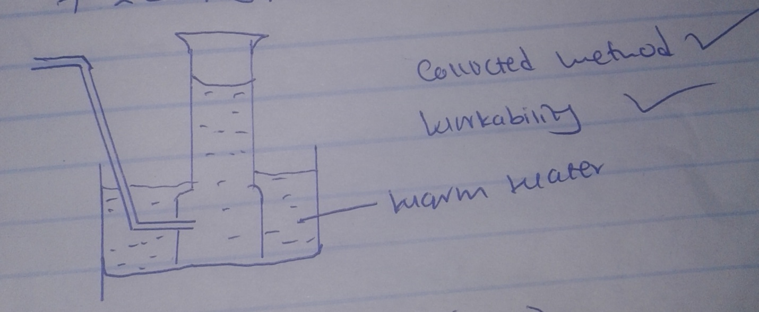
b. dilute hydrochloric acid (1mk)
10.
0.1 moles _______  ?___________ | 1000cm³  250cm³
=0.1 x 250 =  1000 | 0.025 moles
0.025 moles _____ | 6.95  FM
FM = 6.95 =  0.025 | 278
FeSO₄.nH₂O  152 +18n =  n= | = 278  278  7

11. X (2.8.2)
Y(2.8.7 (1mk)
b.Atomic radius of y is smaller than that of x (1mk)
c.Alkaline earth metals (1mk)
12a.Carbon (II) oxide burns with a blue flame
2CO(g) + O2(g) ___________2CO2)(g)
b.It will produce carbon (II) oxide since there is no air to burn it
13.Ratio M:O
Moles ^{0.254}/_{63.5} ^{0.64}/₁₆
0.04 0.04
EF=MO
14a.Nitric (V) acid has low boiling point than sulphuric (VI) acid
b.Sodium nitrate
c.Manufacture of fertilizers
15a.2 NaOH (aq) + Cl(g) ___________NaCL(aq) + NaCL(aq) + H2O (aq)
b.Sodium hypochlorate
NaOCL + dye _________NaCl + dye -0
16a.Calcium Hydrogen carbonate and magnesium hydrogen carbonate
b.Distillation removes the substance dissolved in water
c.Contain Ca²⁺ necessary for formation of strong bones and teeth
17a.Iodine melting point is above the room temperature
b.Increase of molecular mass increase the forces of attraction between the molecules
18a.Water /moisture
And oxygen /air
b.Tin cans are not reactive and non toxic
19.Dessicator –drying substances
Crucible –heating solid
Deflagrating spon-holding substances being burnt.
20a.Mg (s) + H2O(g) _______MgO(s) + H2(g)
b.Potassium –reacts with steam explosively
21a.Grahams law : rate of diffusion of a gas is inversely proportional to the square root of its density

bi.
RA = 2.9  RB = 1.98 | = 121  Gas B diffuse 1.21 fasts than A
Bii. RA = 64  RB MMA | - = 64  mmA  1.212=64  MMA  MMA= 64  1.212  =43.69

22i.C₂H₅OH = 12
ii.C₂H₅Cl – 5
b.Dehydration
23a.Salt ?Y at 500 only 82g of the 120g of y dissolves
b.120-82g
=38g
24a.X – iron will rust
Y iron will not rust
b.In y iron will not rust because zinc is more reaction that will react with oxygen protecting iron.
25.
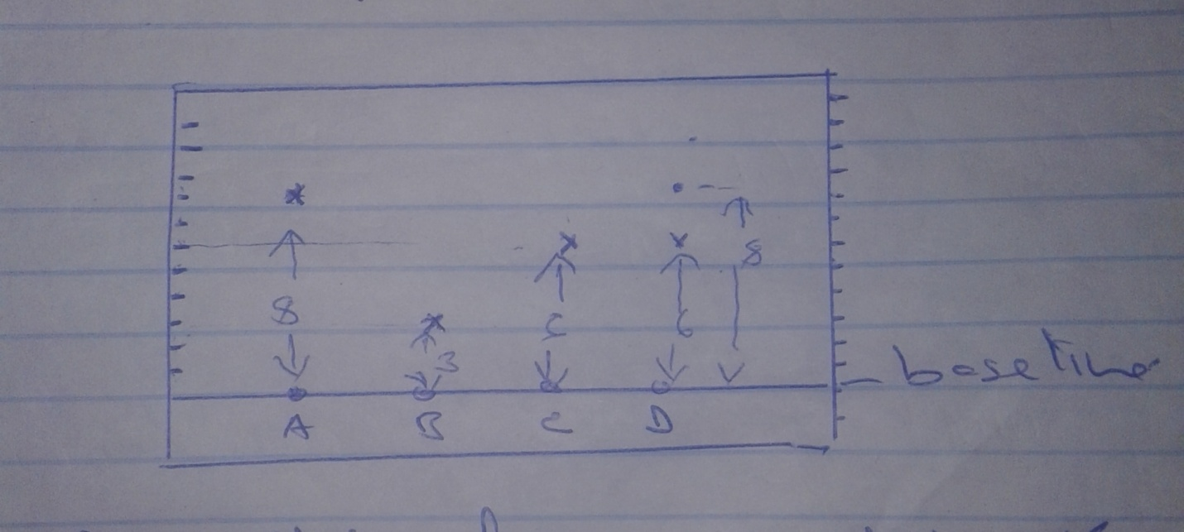
ii.Contained c and A
26.M1V1 =M2V2
50 x 5.0 =1 x v2
V2=250cm³
Volume of distilled water 250-50
= 200cm³

PAPER 2 CHEMISTRY MARKING SCHEME
1i. Noble gases
ii.D₂SO₄
iii at Y b. E
- Ionic bond-bond formed by transfer of e-s from metal to non metal
- D/M
- Element E react by gaining one electron which reduce the electrostatic pull by the positive nuclear making ionic radiuses increase
- Group (VI) period 3
- Because of increase in the strength the molecular bond in the oxide of L compared to G
- Atomic radii of C is smaller that that of L. due to increase of the positive nuclear charge across the period
- Ionization energy increase from J to L due to increase of the strength of the nuclear charge.

H
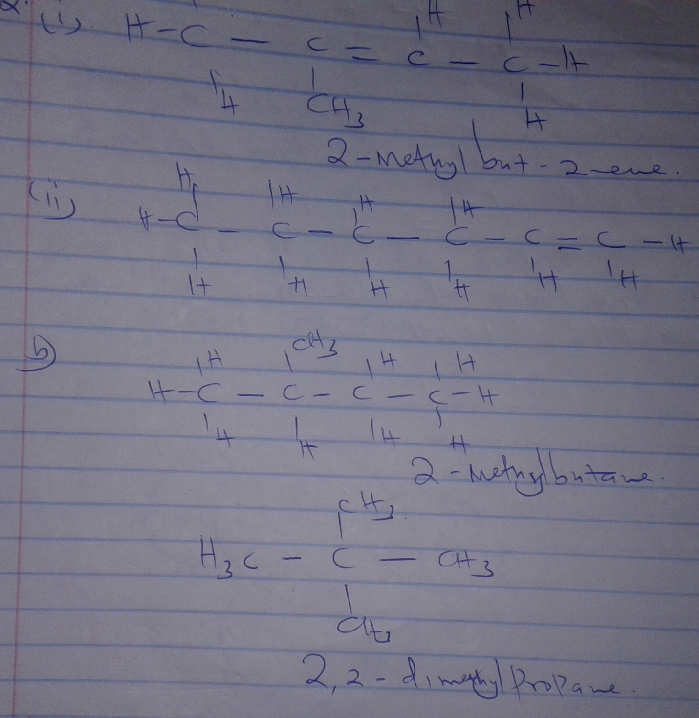
ci. A-C4H10
ii.butyne decolourised purple H+ potassium manganese (VII) while compound A doesn’t
iii.C₄H₈+HCL C₄H₉CL
Or
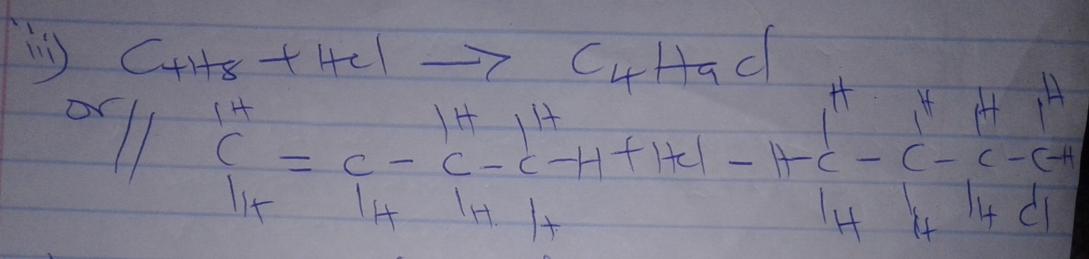
iv.
v.Addition reaction (hydrogenation)
vi.Reagent –hydrogen
Condition –Nickel catalyst
Heat 1500C
d.Were found to deplete the ozones layer that prevents ultra violet rays of the sun reaching earth
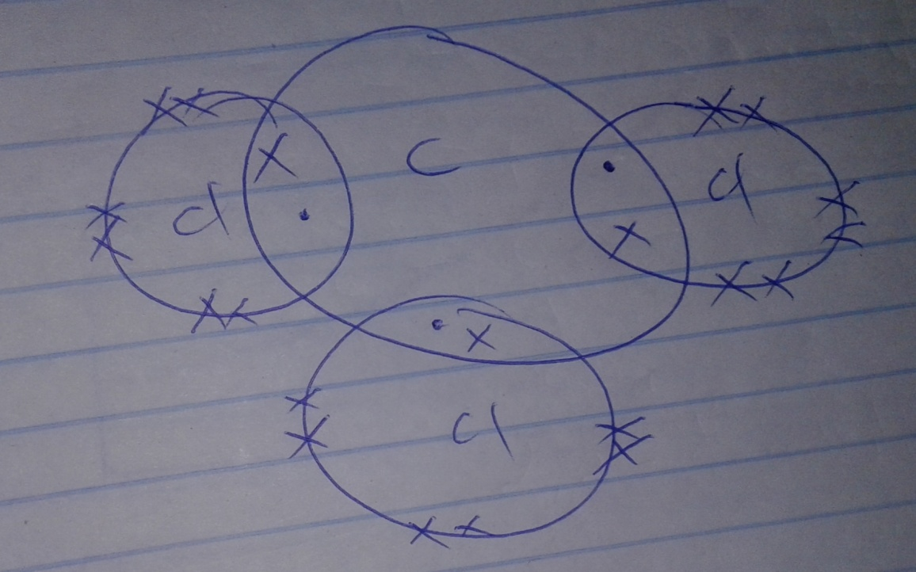

3a. A solution which cannot dissolve any more of a solute at a particular temperature
bi.25g per 100g of water
iiMass dissolved =62g
Mass undissolved =80-62=18g
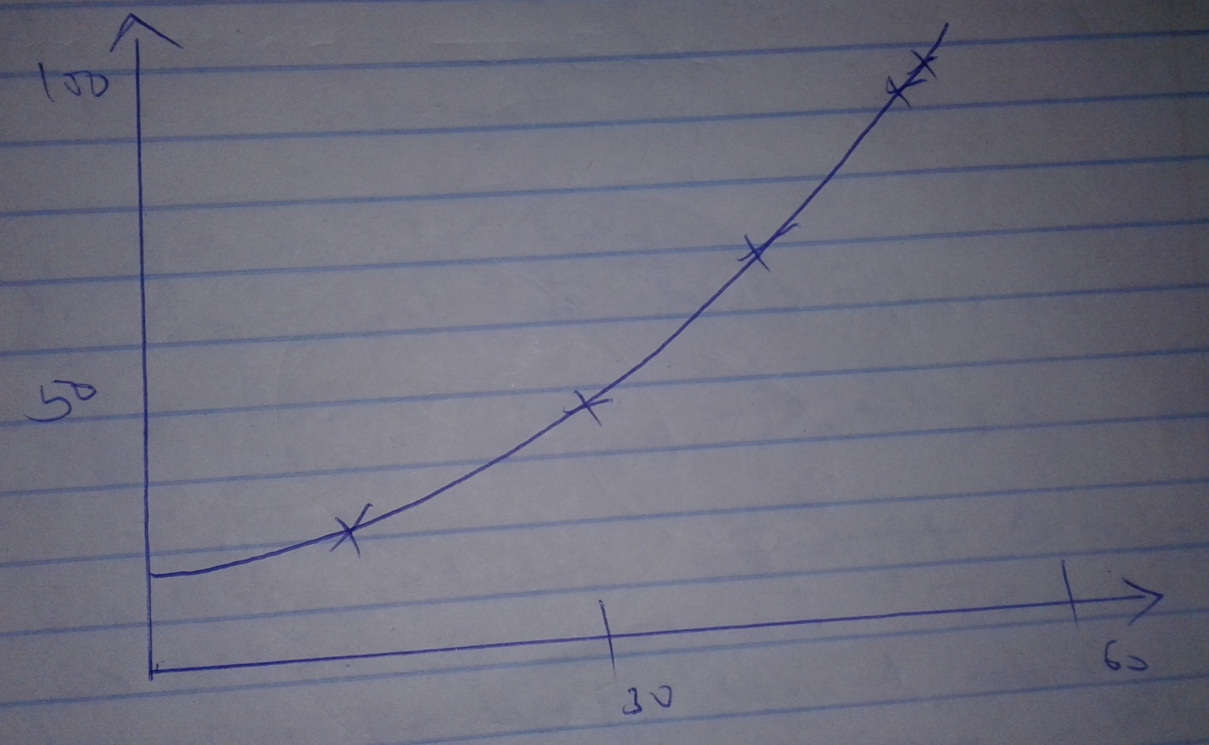

Scale -1mk
Axis -1mk
Plotting -1mk
Shape -1mk
c.RFM of KNO₃ =101
Moles in 100g = ²⁵/₁₀₁ =0.2475
Moles in 1000g of water =0.2475x1000=2.475m
d.Add NH₄OHSOL to precipitate AL(OH)₃
-Filter
-Dry with low temperature
4a.Nitrogen –R
bi.Cracking of long chain alkaline
-Natural gas
-Electrolysis of acidified water
ii.To remove the impurities that would poison the catalyst
iii.Iron catalyst
ci.Heat exchange
ii.To cool the mixture
ii.N_{2(g)} + 3H₂g___________2NH_{3g}
d.Reaction between catalytic oxidation of ammonia is an exothermic reaction the heat produced, during the reaction enable the platinum wire to glow.
c.Manufacture of nitrogenous fertilizer
-Softening hard water
-Man. Of hydrazine used in rocket fuels.
5a.Different forms of an elements at the same physical state
b.Graphite has a delocalized electron that is not used in bonding
ci.

ii.Reduction property of carbon
d.Salt made of two bonded salts
ei.Boiling water under high pressure
ii.Sulphur froth
fi.

ii.Through oxidation
Dye+Nacl_______(dye-0) + NaCl (colourless)
6ai.Effervescence is observed due to production of a gas
ii.A white precipitate solid is observed due to formation of insoluble lead (II) chloride
bi.

- Penalize fully if not balanced
- Penalize fully if letters are joined
- Penalize fully if small letters are mixed with capital letters
ii.

-Penalize as above
c.

d.Precipitation of double decomposition
ei.Zinc (II) nitrate
ii.Zinc (II) oxide
iii.

7i.Black soil
ii.NaOH or KOH to absorb CO₂
iii.Its poisonous
iv.2CO_{(g)} +O_{2(g)} _________2CO_{2(g)}
v.Prevent heat from burning the cork/bring or prevent copper (III) oxide from being blown into the delivery tube.
vi.Fuel –reducing agent in extraction of metals

PAPER 3 MARKING SCHEME
1A.Titration label –(4mks)
Award as follows
- Complete table –1mk
- Decimal …..1/2mk tied only to the first and beyond rows only. Ie one decimal place through out or if two decimal places, the last digit must be zero or 5 through out otherwise 0 mark
- Accuracy
If any +- 0.1 of the s.v award 1mk
If none of check if any value is within +- 0.2 award ½ mk, otherwise 0 mk
- Principle of arranging …..1mk
- Final answer …..1mk let the candidate answer (use condition for accuracy to award marks)\
bii.RFM of C =126 1/2mk
Concentration of c =6.3/126 correct Ans 1/2mk
(do not penalize if the RFM is wrongly calculated )
iii.Moles of C used = (ans (ii) x litre value ) ÷1000
iv.Dibasic acid ;NaOH=1:2 ½
Moles of A in 25cm3 =ans (iii) x2 =correct answ
v.Concentration of A =(ans (iv) x 1000) /25=correct ans ½
TITRATION TABLE 2 (41/2mk)
Award as follows –as per table 1 above
c.Moles NaOH used =(molarity in procedure 1b(v) x 25) /1000) ½ = correct ans ½
d.Moles of D =(time value from table 2x25/1000)1/2
Correct an ½
e.Moles of D in 250ml has mole in d. above x(250/25) = ans Q
NaOH : HCL=1:1
25ml of B has answ Q
f.Molarity of B =(ans Q x 1000) /25 1/2 = correct ans 1/2
QUESTION 1B
Table 3……………………(3mks)
Award as follows
Complete table ………….(1mk) penalize half mark
Once incomplete table
Decimal ……………………1/2mk whole numbers /one decimal place 0.0,0.5 used throughout.
Accuracy ……………..1/2mk (+-20C at second minute of the s.v
Trend ……………..1mk (constant temperature from 1st minute 1/2mk, then constant temp. from 2¹/2mk minute to 4¹/2 minute 1/2mk (all temp must be lower /than from the 1st trend)

GRAPH (3MKS)
Award as follows
- Labeling both axes correctly…..1/2mk
- Scale …..1/2mk (actual graph to occupy atleast half of the space on each axis )
- Plotting ……………………………….1mk (all 8 to 9 plots correctly plotted award 1mk. 5 to 7 plotted around half marks, less than 5 zero ).
- Shape ………………1mk
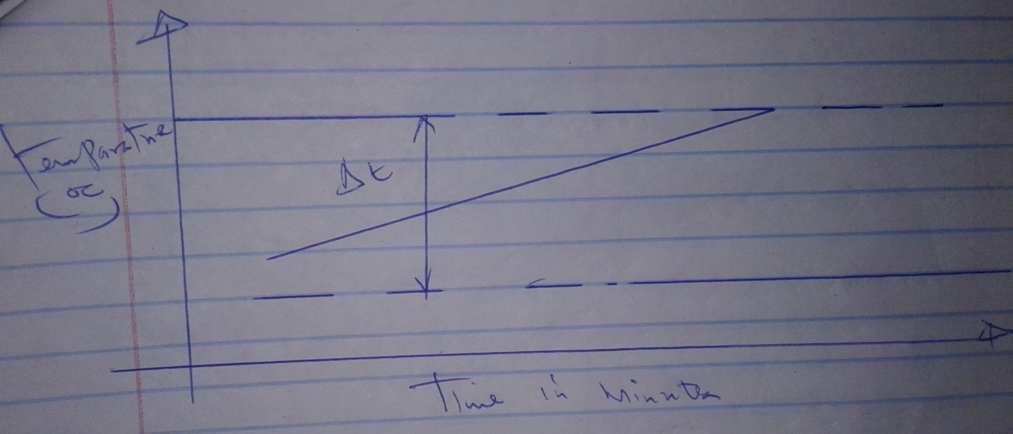

- Showing the Dt correctly 1/2mk
- Then reading it correctly 1/2mk
- Moles =3/101=0.0297 1/2mk (3d.p)
30 x Dt x 4.2 ½ =correct ans ½
- Heat of solution =ans in iii /ans in ii above =-ve value ½ (ignore the answer of no negative sign.)
a.
Observation | inferences
Droplets of a colourless  Liquid from on cooler parts of the boiling tube | C is hydrated  C contains water of crystallization

b.
Observation | inferences
Dissolves to forms a pale green solution | Coloured ion soluble

i.
Observation | inferences
Green ppt insoluble in excess | Fe2+ present
ii.
Observation | inferences
Green PPt which turns brown on adding H2O2 | Fe2+ present or Fe2+ oxidized to Fe3+

iii.
Observation | inferences
White ppt that persist warming | cl- absent

iv.
Observation | inferences
White ppt | So2-, SO3-, CO32- present

v.
Observation | inferences
The green colour of solution faded turns colourless  A grey deposit | Zn displaces cation of C from solution

3a.
Observation | inferences
Burns with yellow flame | C=C or C=C

b.
Observation | inferences
Forms a colourless solution | Polar substance

c.
Observation | inferences
Purple colour turns colourless | C=C or C=C  R=OH

d.
Observation | inferences
pH =5 | Weakly acidic

