MARKING SCHEMES MATHEMATICS PAPER 2
- No log
4.283 0.6317 All logs m1
-
0.9748 1.9889 +/- m1
0.6206
-
Log4.189=0.6221 1.7939 ÷/× m1
0.8267x1/3
1.8863 0.2756 CAO A1 (4mks)

- Actual area = 8.8 x 2.6 = 22.88 M1
Value – Actual x 100 = 27 – 22.88 x 100 M1
Actual 22.88
18% A1
- Make r the subject in the formular (3mks)
S= rt
R² -t
S = r² t^{2 M1}
R² - t
S² r² – s² t = r² t² M1
R² (S2 – t) = S² t
R =± $√$ (S²t/s²-t) A1 (3mks)
- A in 1 hr = 1/6
3 ½ x 1/6 = 7/12 B1
Work remaining 1 – 7/12
5/12
Time taken by B in 1 hr =5/12 ÷1/9 B1
= 5/12 x 9
= 45/12
3 ¾ hrs A1 (3mks)
- A (i) 6.xR = 4.8 x 5
XR = 4.8 x 5 M1
6
= 4cm A1

ii)(QT)²= 18 x 8 M1
QT = 144
QT = 12 A1 (2mks)

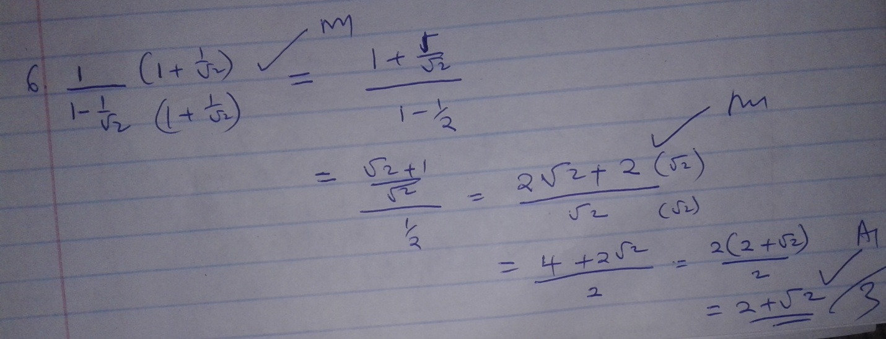

a) Q=$5\left({3 \atop 2}\right)-2\left({4 \atop 1}\right)=\left({7 \atop 8}\right)$ B1 B1
- Q¹=$\left({-4 \atop -6}\right)+\left({7 \atop 8}\right)=\left({3 \atop 2}\right)$ B1

- Q’(3,2) A1

8.

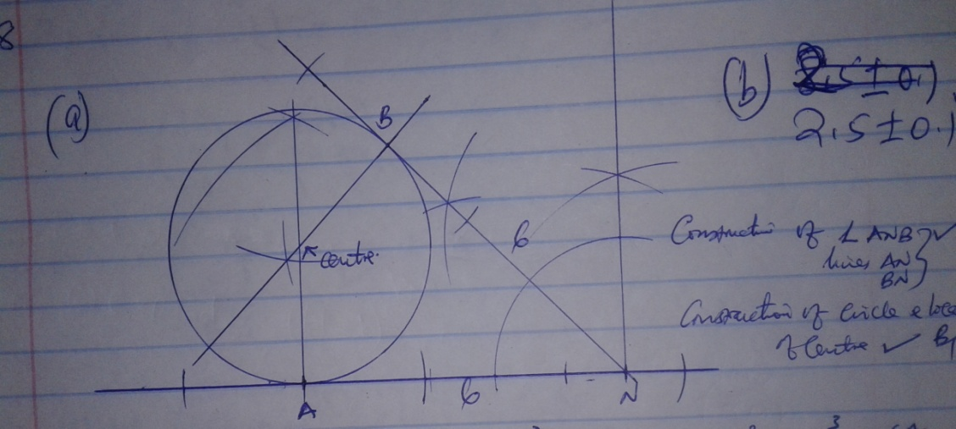

- a) 1(1⁵ (2x)º + 5(1)⁴(2x)¹ + 10(1)³(2x)² + 10(1)²(2x)3 M1
1 + 10x + 40x² + 80x³ A1

b) 1.02 = 1+2x
0.02 = 2x
X=0.01
1 + 10(0.01) + 40(0.01)² + 80 (0.01)3 M1
1.10408
1.104(3d.p) A1
10. A = 24,000 91 + 16/100x ¼ 3/2 x 4 M1
= 24,000 (1.04)6 M1
=30,367.66 A1(3mks)

11. 4(3i = 2j –k) = 12i = 8j – 3k
3(6i – 8j +3k) = 18i – 24j +9k
C=$\left(\begin{matrix}12 \\ 8 \\ -3\end{matrix}\right)$+$\left(\begin{matrix}18 \\ -24 \\ 9\end{matrix}\right)$=$\left(\begin{matrix}30 \\ -16 \\ 6\end{matrix}\right)$ B1

C = $√($ (30)² + (-16)² + (6)² ) B1
= 34.525
=35 A1 (3mks)

12. a = 2R
Sin A

a = 2R M1
Sin 60
R= a M1
2 sin 60
=5.2cm A1 (3mks)

13. (x -0)² + (y-2)² = 21 + 0+4 M1
(x – 0)² + (y -2)² =25 = 5^{2 M1}
centre = (0, 2)
radius = 5 units A1

14. See the graph attached

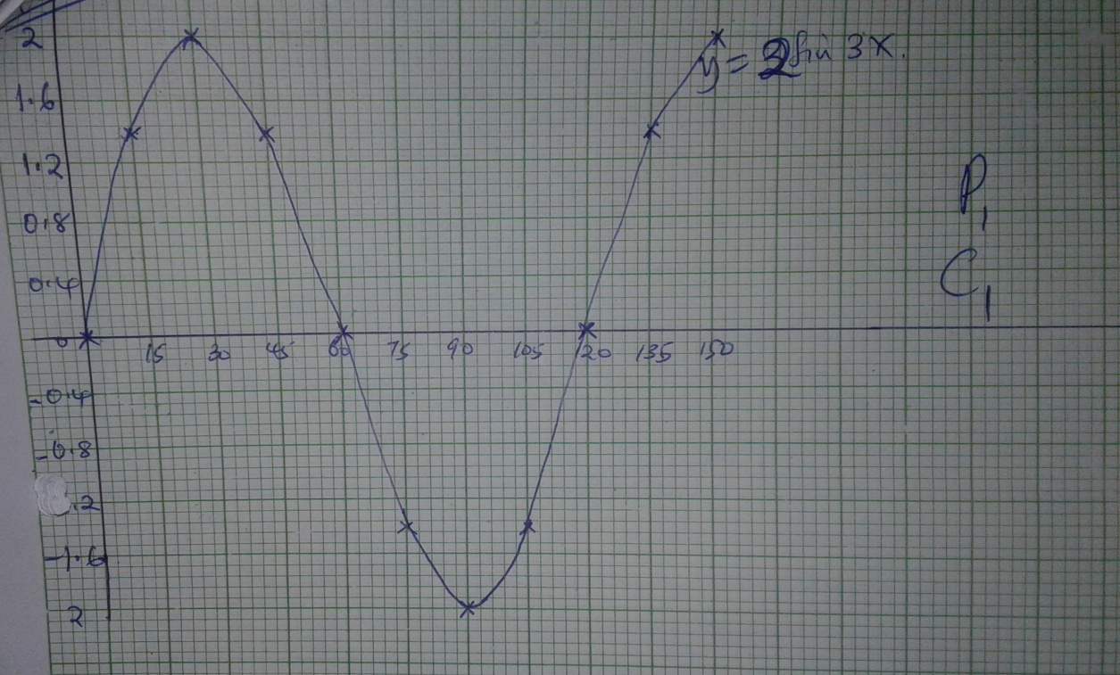

15. b ² = a x c
2

8 ² = 4 x c M1
2
16 = 4c
C = 4
K-3 = 4
K=7 A1

16.log (x + 5)= Log $\left\{4 | X+2\right\}$
X+ 5 = 4
X + 2 M1
(x+5)(x+2) = 4
X + 7x + 6 = 0 M1
X=-6 or -1 A1
17. a) i) Taxable income p.a in K£
12500 + 6550 = 19050 M1
19050 X 12
20 = 11,430 K£ A1

ii) Income tax per month

1980 x 2 = 3960
1980 x 3 5940 M1
2480 x 5 = 12400
1480 x 7 = 10360 M1
1960 x 9 = 17820
1530 x 10 = 15300
65720 M1
Tax per month = 5481 – 300 M1
= 5181 A1
b) total deductions
= 5181 +320 X 0.02 x 1950
=5881 M1
Net salary = 19050 – 5881
= Ksh 13169 A1

18. Sin = 10/2 ( 2 x 2 + (10 – 1) d ) M1
155 = 20 + 45d
= d = 3 A1
ii) Sin = n/2 ( 2 x 2 + 9n-1) d = 392 M1
n/2 (4 + 3n -3) 392 M1
3n² + n -783 = 0
N=16 A1
B(i) a + 2d, a=4d, a = 7d M1

R = a + 4d = a = 7d
A +2d a + 4d
(a +12) (a+12) = (a =21) M1
18 =3a
A=6 A1
ii) S= a(r^{n} – 1)
r – 1
= 6(2 ¹¹– 1) M1
2
=6141 A1

19
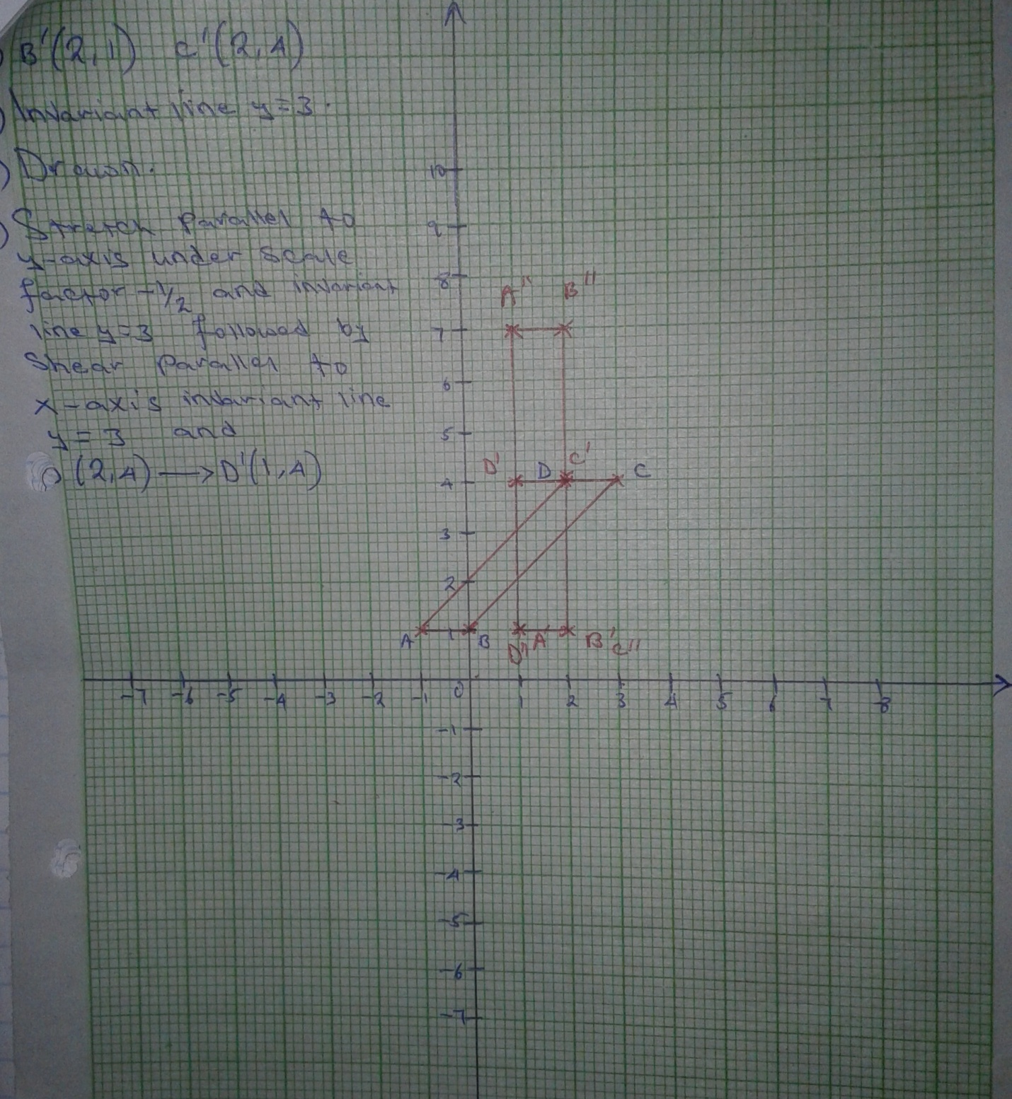

20. a) i) x -5 M1
ii) 4x -10 A1
b(i) young = X + 15
Elder = X + 20
Parent 4X + 10 M1
(x+15) (x +20) = 15(4x +10) M1
X ²+ 35x – 60x + 150 = 0 M1
X² -25 + 150 = 0
Elder child 15 years or 10 years A1
ii) parent
(4x15)-10 = 50 years M1
(4x10) – 10 = 30 years A1
iii) ages of younger child
15 + 15 = 30 years M1
15+ 10 = 25 years A1
22.
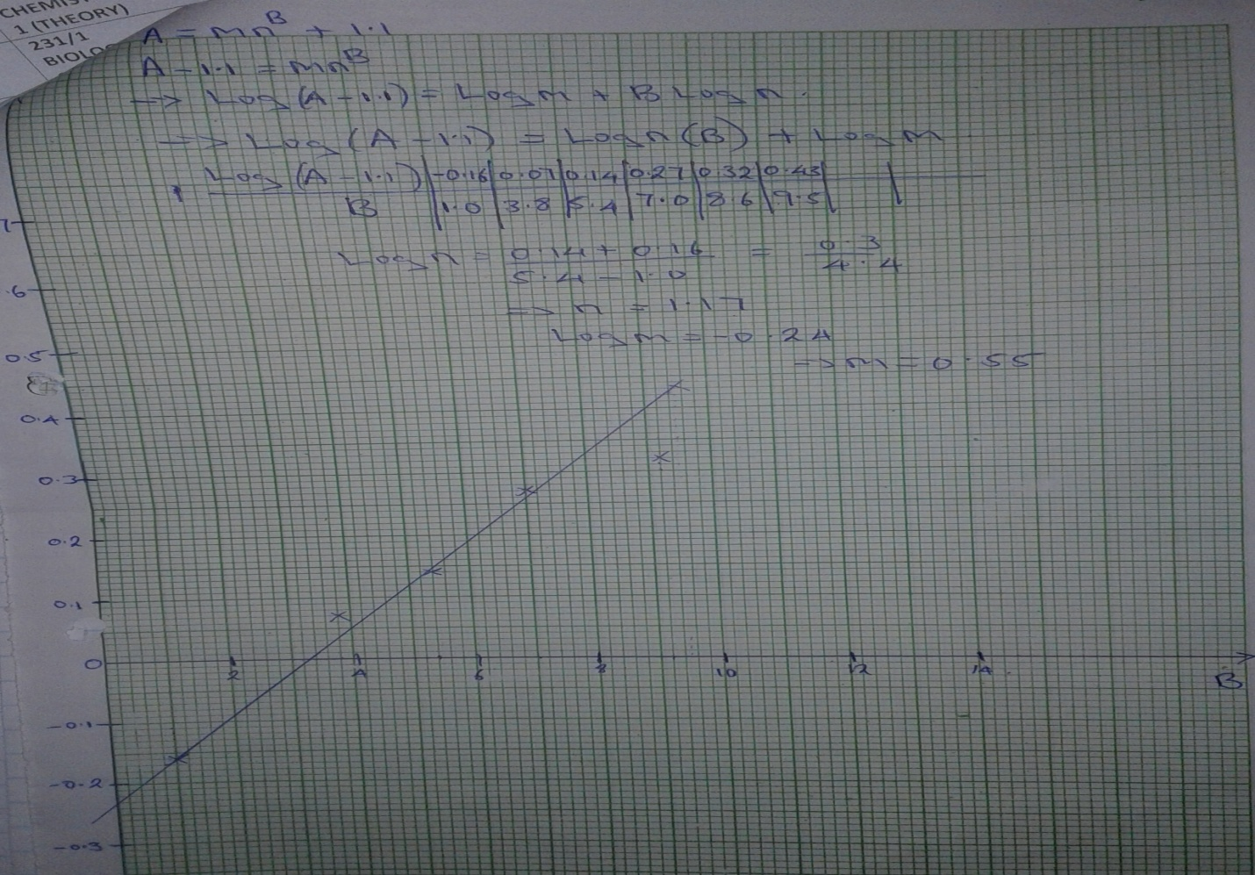

21

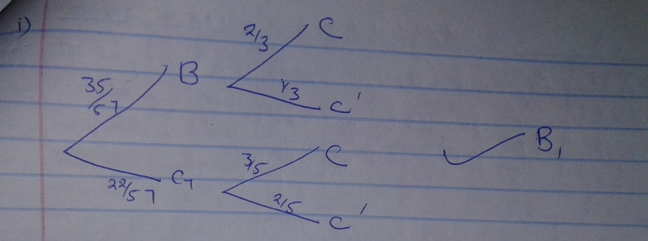

P(BC) = 35 /57 x 2/3 = 70/171 B1
ii) P(BC) or P(C C)
35/75 x 2/3 + 22/57 x 3/5 B1
70/171+ 66/285 B1
=1096/1710 A1
b) P(BC’) on P (C, C’)
35/57x 1/3 and 22/57 x 2/5 B1
35/171x 44/285 B1
1540/48735 B1
=308/9747 A1
23.
Marks | Frequency | C.f | x | d | fd | Fd²
1 – 10 | 5 | 5 | 5.5 | -50 | -250 | 12500
11 – 20 | 12 | 17 | 15.5 | -40 | -480 | 19200
21-30 | 20 | 37 | 25.5 | -30 | -600- | 18000
31 -40 | 44 | 81 | 35.5 | -20 | -880 | 17600
41 – 50 | 68 | 149 | 45.5 | -10 | -680 | 6800
51 – 60 | 42 | 191 | 55.5 | 0 | 0 | 0
61 – 70 | 24 | 215 | 65.5 | 10 | 240 | 2400
71 -80 | 15 | 230 | 75.5 | 20 | 300 | 6000
81 – 90 | 12 | 242 | 85.5 | 30 | 360 | 10800
91 - 100 | 8 | 250 | 95.5 | 40 | 320 | 12800
- median = ½ x 250 = 125
L + (n –c) = 40.5 +(125 – 81 10
F
= 46.97

B9i) X = A £fd M1
F
= 55.5 + - 1670 = 48.82 M1 A1
250
ii) s=$√(\frac{\sum{fd^{2}}}{\sum{f}}-(\frac{\sum{fd}}{\sum{f}})$²
=106100 – (-1670/250)²
250
S= 19.48
24.

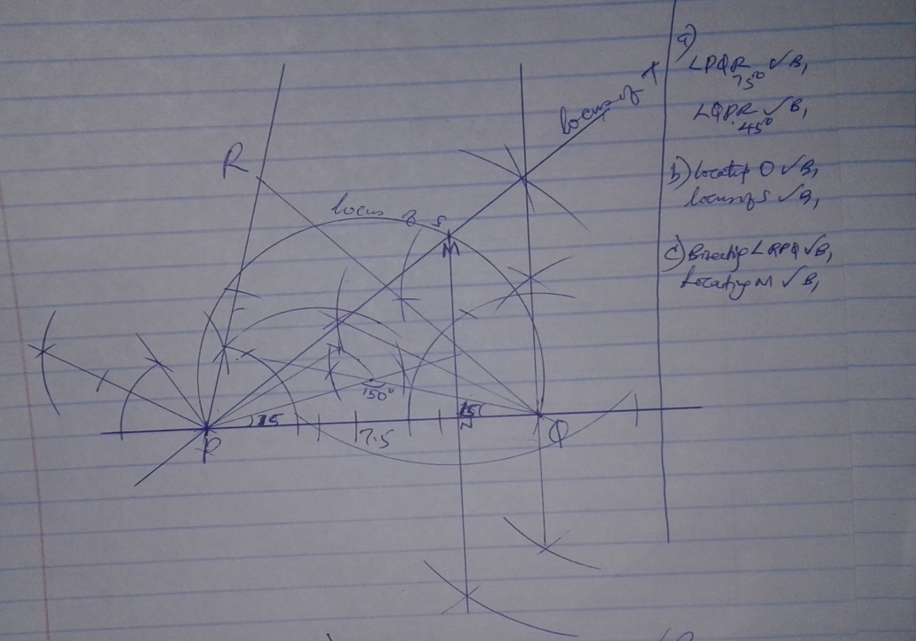

d)MN=4.3 ± 0.1 B1
Area of PMQ= ½ X 7.5 x 4.3 M1
=16.125 A1

