MUKINDURI MIXED DAY SECONDARY SCHOOL
FORM 3 MID-TERM 2 2017
MATHEMATICS
NAME:______________________________________________________ ADM NO:__________
- Use logarithms to evaluate
$\sqrt{\frac{2.354×456}{0.5674}}$ (4 marks)

- Solve for x in the equation
32^{(x-3)}÷8 ^{(x-4)}= 64 ÷ 2^{x} (3 marks)

- The length and width of a rectangle measured to the nearest millimeter are 7.5cm and 5.2cm respectively. Find, to four significant figures, the percentage error in the area of the rectangle. (3 marks)

- A financial institution charges compound interest on money borrowed. A business woman borrowed Kshs 16, 000 from the financial institution. She paid back Kshs 25,000 after 2 years. Find the interest rate per annum. (3marks)

\
- Solve for x in the equation
2 log₁₀ x + log₁₀ 5 = 1+ 2log₁₀ 4 (4 marks)

- Solve the simultaneous equations
x² + y² = 26
x – y = 4 (4 marks)

- Simplify (3 marks)

- Given that sin a =$\frac{1}{\sqrt{5}}$ where a is an acute angle find,without using mathematical tables:
- cos α (2 marks)

- Tan (90-α) (1 mark)

- In the figure below, BT is a tangent to the circle at B. AXCT and BXD are straight lines AX = 6cm, CT = 8cm, BX = 4.8 cm and XD = 5cm.
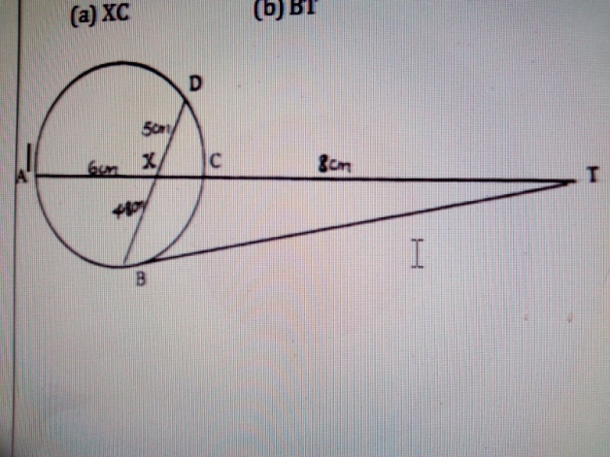

Find the length of
- XC (2 marks)

- BT (2 marks)

- In the figure above, triangle ABC is similar to triangle AED and BC // ED. Given that the ratio AB: AE = 2:5, find the ratio of the area of triangle ABC to that of the trapezium BCDE. (3 marks)

A

B C

E D

- Solve the following inequalities and represent the solutions on a single number line:
3 – 2x < 5
4 – 3x ≥ -8 (3 marks)

- Simplify the expression (3 marks)

- A perpendicular is drawn from a point (3, 5) to the line 2y + x = 3. Find the equation of the perpendicular. (3marks)

- If a=0.342, b=2.43 and c=3.4,find the absolute error and percentage error made in calculating
- a-b (2 marks)

- ac-b ( 3 marks)

- simplify
3log 4 + log 125 -3 log 2 (2 marks)

SECTION B:
Instructions: answer any five questions in this section.

- Complete the table below for the function $y=2x^{2}+4x-3$ (2marks)
x | -4 | -3 | -2 | -1 | 0 | 1 | 2
$$2x^{2}$$ | 32 |  | 8 | 2 | 0 | 2
+$4x$
-3 | -3 | -3 | -3 | -3 | -3 | -3 | -3
Y

- On the graph paper provided, draw the function $y=2x^{2}+4x-3$ and use the graph to estimate the roots of the equation $2x^{2}+4x-3=0$ (3 marks)

- Use the graph to solve $2x^{2}+x-5=0$ (3marks)

- In the figure below, AC=12cm, AD=15 cm and B is point on AC. Angle BAD = angle ADB= 30°.

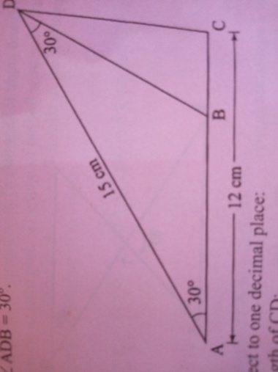

Calculate correct to 1 decimal place:
  - The length of CD: (3 marks)

  - The length of AB. (3 marks)

  - The area of triangle BCD. (2 marks)

  - The size of angle BDC ( 2 marks)

- The table below shows the taxation rates in a certain year.
Income in K£ p.a. | Rate of taxation in sh. per K£
1-3 900 | 2
3 901-7 800 | 3
7 801-11 700 | 4
11 701-15 600 | 5
15 601-19 500 | 7
Above 19 500 | 9
In that year, Juma was earning a basic salary of sh. 21,000 per month. In addition, he was entitled to a house allowance of sh. 9,000 p.m. and a personal relief of sh. 1,056 p.m.
- Calculate Juma’s annual pay in K£. (2 marks)

- Calculate the tax payable by Juma. (5 marks)

- Juma’s deductions per month were:
Co-operative society contributions sh. 2,000
Loan repayment sh. 2,500
Calculate his net salary per month. (3 marks)

- Complete the table below for y=2cos x and y=tan x for $0°≤x≤360°$ (2 marks)

x | 0 | 30 | 60 | 90 | 120 | 150 | 180 | 210 | 240 | 270 | 300 | 330 | 360
2cos x
tan x
- On the graph paper provided and on the same Cartesian plane plot the waves of y=2cos x and y= tan x for $0°≤x≤360°$ (4 marks)

- Use the graph to solve the equations:

- 2Cos x= tan x (1 mark)

- 2cos x = -0.5 (1 mark)

- Tan x = 0.3 ( 1 mark)

- Three towns R,S and T are such that R is 300m from S on a bearing of 300˚ and T is 450m directly south of R
  - Using a scale of 1cm to represent 60m, draw a diagram to show the position of the towns. (3 marks)

  - Use the scale drawing to determine:
    - The distance between T and S in meters (2 marks)

    - The bearing of T from S. (2 marks)

  - Calculate the area of RST. (3 marks)

- Halima deposited Ksh. 109 375 in a financial institution which paid a simple interest at a rate of 8% per annum. At the end of 2 years, she withdrew all the money. She then invested the money in shares. The value of the shares depreciated at 4% per annum in the first year of investment. In the next 3 years, the value of the shares appreciated at 18% per annum.
  - Calculate the amount Halima invested in shares. (3 marks)

  - Calculate the value of Halima’s shares:
    - At the end of the first year. (2 marks)

    - At the end of the next 3 years. (2 marks)

    - After the fourth year. (1 mark)

  - Calculate Halima’s gain from shares as a percentage. (2 marks)

