GATITU MIXED SECONDARY SCHOOL
MATHEMATICS FORM 3 opener exam TERM 1 2015
ANSWER ALL THE QUESTIONS
- Use mathematical tables to evaluate. Give your answer to 3 sign figures. 3mks

2.935 × 0.0765)
32.74

- Solve for x in the equation 3mks

81^{2X} × 27^{X} = 729

9^{X}

- A straight line passes through points A (-3, 8) and B (3,-4) and parallel to AB. Give the answer in the form y = mx + c where m and c are constants. 3mks

- In the triangle ABC shown below DE is parallel to BC. If AE =3 cm and EC =2cm, determine the ratio of the area of the triangle ADE to that of triangle ABC. 2mks
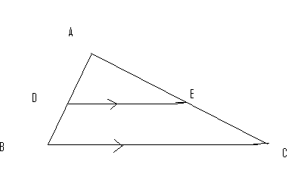

- Solve the simultaneous equations. 3mks
3X -2Y =7
5X + Y =3

- In the fig. ABCD is a rhombus whose diagonals AC and BD meet X. Given that AC = 27.6 cm and BD = 16.2cm. Calculate the area of the rhombus. 2mks

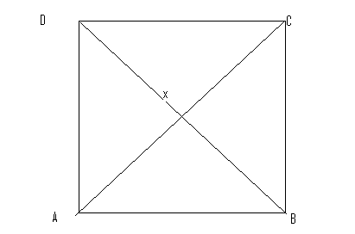

- A farmer has twice as many goats as cows and two thirds as many pigs as goats.
- If he has x cows, write down a simplified expression in x for the total number of animals .1mk

- Find the total number of animals given that the farmer has 20 pigs. 3mks

- Calculate the area of the trapezium. 3mks

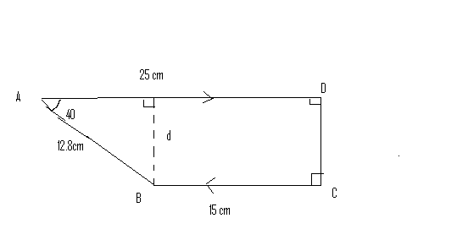

- Simplify the following expression by reducing it to a single fraction 2mks
2x -3 - x -2 - 1 –x
3 2 4

- It would take 15 men 8 days to dig a trench 240m long find how many days it would take 18 men to dig a trench 360 m long working at the same rate. 3mks

- A trader sold an article at 15% discount to a customer who paid sh. 510 for it. What was the marked price of the article? 2mks

- Solve for x in the equation 3mks

2^{(3x -2)} × 8^{x} = 4 ^{(x +1)}

- Without using mathematical tables evaluate 4mks

Sin 60 tan 30 tan 45 – cos 45 sin 45 cos 60

Cos 30 tan 60 sin 30 – cos 60 sin 60 cos 30

- Syengo spends 1/3 of his salary on food, ¼ on rent , 3/5 of the remainder on transport and saves the rest. If he spends sh. 1800 on transport, find how much money he saves. 3mks

- The fig shows 2 circles centre A and B and radii 6 cm respectively. The circles intersect at P and Q. angle PAB = 42⁰ and angle ABQ = 30⁰.

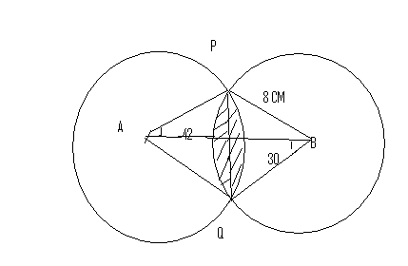

- Find the size of angle PAQ and PBQ 2mks

- Calculate to one decimal place the area of
- Sector APQ and PBQ 2mks

- Triangle APQ and PBQ 2mks

- The shaded area (take II =22/7) 4mks

