GATITU MIXED SECONDARY SCHOOL
MATHEMATICS FORM 3
PAPER 2 MIDTERM EXAM 2015
SECTION 1 (40MKS)
ANSWER ALL THE QUESTIONS IN THIS SECTION
- Given that p=4 +√2 and Q = 2 +√2 and that p/Q = a +b√c where a, b and c are constants, find the values of a, b, and c. 3mks

- Solve for Y given that
Log₂ (2y+ 3) – 2 = log₂ (y-2) 3mks

- Solve the equation 3mks
2 - 1 = 1
x -1 x+2 x

- Solve the following simultaneous equations 3mks
Y= 4x + 7
5y + 6x =17

- By using the substitution y =2^{x}, solve the equation 3mks

5×2^{2x -1} - 3×2^{x} – 34 =0

- Find the equation of a line perpendicular to 2x +4y =8 which crosses the line at its y-intercept. 3mks

- Given that a=3, b=-1 and c=2, evaluate; 3mks

a - b²

4 -2b +c

- A number n,is such that when its divided by 3,7,11 or 13, the remainder is always one. Find the number n. 3mks

- Under an enlargement, centre (2,1)the image of p (1,-1) is p1(4,5). Determine the scale factor of the enlargement. 3mks

- A small cone of height 9 cm is cut off from a bigger cone of height 18cm. if the volume of the small cone is 160cm³, find the volume of the frustum. 4mks

- Given the column vectors a= 1 b= 6 c= -3

-2 -3 2

and that p= 2a -1/3b +c , express p as a column vector and hence calculate its magnitude to 3 significant figures. 3mks

- The scale of a map is given as 1: 20000. Find the actual area of a region represented by a triangle of 5cm, 6cmand 7cm. 3mks

- If tan o=8/15. Find the value of
SIN O - COS O

Cos o + sin o
Without using a calculator or tables. 3mks

SECTION II (40MKS)
ANSWER ANY FOUR QUESTIONS IN THIS SECTION
- Joy is a sales executive earning a salary of ksh. 20,000 and a commission of 8% for sales in excess of sh. 100,000.
- Determine the amount of sales she made in that month. 4mks

- If the total sales in the month of may and June increased by 18% and then dropped by 30% respectively. Calculate
- Joy’s commission in May 3mks

- Her total earnings in June 3mks

- Musembi bought three cows and twenty five goats spending a total of sh. 75,000. If he had bought two cows and thirty three goats, he would have saved sh, 5400. Musembi later sold all his animals at a profit of 40% per cow and 50% per goat .determine
- The cost at which he bought each animal. 5mks

- The total amount of money Musembi received after selling all the animals. 5mks

- In the figure below, o is the centre of the circle of radius 3cm and AB is a chord such that its shortest distance from o is 1 cm.
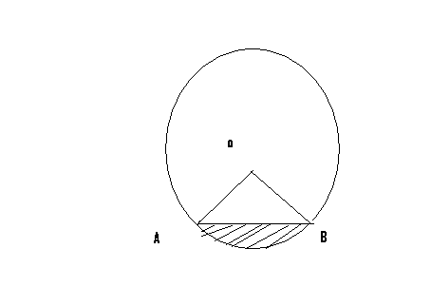

Calculate,
- The length of the chord AB 3mks

- Angle AOB 2mks

- Area of the minor sector OAB 2mks

- Area of the shaded segment 3mks

- The cost of manufacturing a radio can be divided into the cost of materials, labour, other expences and advertising in the ratio 4:3:2:1. This year, the cost of materials increased by 25%, the cost of labour increased by 20% other expences decreased by 10% while advertising remained the same. Determine the percentage increase in the cost of manufacturing the radio. 10mks

- Measurements of a maize field using a baseline xy were recorded as shown below in metres.

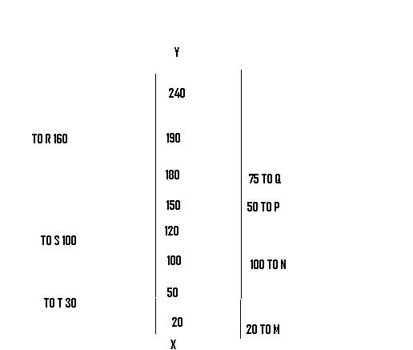

- Draw the map of the maize field. 3mks

- Find the area of the field in hectares. 5mks

- If the cost of one hectare is ksh. 65,000. Find the cost of the maize field. 2mks

