ADM.NO. …………………………………………. class:…………………………

NAME:……………………………………………………………….

FORM 1

TERM 2 EXAMINATION 2016

MATHEMATICS

TIME: 2 ½ HRS

INSTRUCTIONS
The paper consists two sections; Section 1 and 2.
Answer ALL questions in both sections.
Show ALL the working in the spaces provided below each questions.
Mathematical tables may be used.

Section l (50Marks)
Answer ALL the questions in the section
- Evaluate (3mks)

$$\frac{-8+2+12×9-4×6}{56+7×2}$$

- A number of books is such that when divided among 27, 28 or 36 students, the remainder is always 3. Find the least number of books. (3mks)

- Convert the decimal 0.405 into a fraction in it’s simplest form. (3mks)

- Given that a=3, b=-\ and C=2.Evaluate in simplest form. (3mks)
$$\frac{a-b^{2}}{4-2b+c}$$

5. Express as a simple fraction (2mks)
$$\frac{3}{4}- \frac{5× -2}{12}$$

6. Express 784 as a product of prime factors. Hence find √784 (3mks)

7. 10 men working 2 hours do a piece of work in 5 days. What percentage of the same work is done by 5 men working 1 hour per day by the end of the fourth day (3mks)

8. A father is 20 years oider than his son. 12 years ago, he was six times as old as his son. Find their present age. (3mks)

9. A bicycle wheel has a diameter of 65cm. During a journey the wheel makes 1000 complete revolutions. How many metres does the bicycle travel. (Take n = 3.142)
(3mks)

10. A motorist took2 ¾ hours to travel from town A to town B. n he started the journey at 10.30am, determine the time the journey ended in 24 hour clock system. (3mks)

11. Solve the pair of simultaneous equation (3mks)
4y-3x = 2.
2y+l=2x

12. Three containers have capacities of 420, 720, and 1080 litres. Ajar is used to fill each one of them a number of times. Find the capacity of the largest possible jar. (3mks)

13. a) Write the following in figures;
Four hundred and sixty seven million thirty nine thousand eight hundred and sixty one
(1 mk)

b) Round off your answer to
i) The nearest ten thousand (1 mk)

ii) 4 significant figures (1mk)

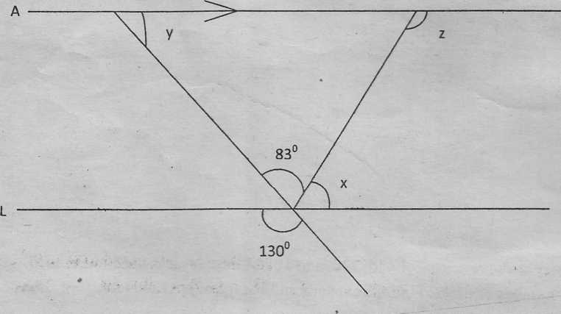
- Find the values of the angles marked x, y and z. (3mks)

- A rectangle which is three times as long as it’s width has the same perimeter as a square of area 64cm². Calculate the area of the rectangle. (4mks)

- The figure below shows a swimming pool. Find the capacity of the swimming pool in litres (4mks)

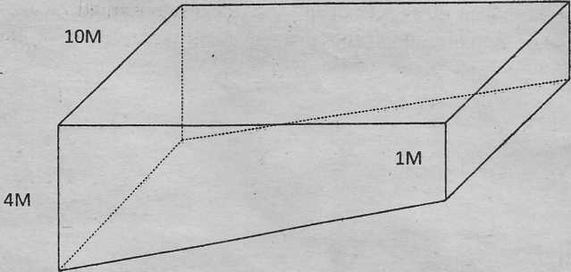

SECTION 2(50 Marks)
ANSWER ALL QUESTIONS IN THIS SECTION
- Cheserem, Otieno and Kariuki divided 500eggs among themselves in the ratio 14:5:6 respectively. Later Cheresem gave 20 eggs to Otieno and 20 eggs to Kariuki.
- Find in the simplest form the ratio of eggs that they finally got (4mks)

- The ages of Sarah and Rose are in the ratio 4:5. The ages of Rose and Anne are in the ratio 3:2. If Anne is 20 years old, how old is Sarah. (3mks)

- Three business men, Kiget, Kamau and Lumbi are to share Sh 12,000 in the ratio 5:6: x respectively. If Kiget receives Sh 4,000, determine the value of x.
(3 mks)

18. Koki spends - of her salary on food and - of the remainder on clothes. She uses $\frac{2}{5}$
of what is left on entertainment. The difference between what is spent on clothes and entertainments is Sh 700. Determine the total income. (4mks)

b) i) The numerator and denominator of the fraction ~ are each increased by 4.
What is the new fraction in the simplest form. (1mk)

- What fraction should be multiplied by |to give an equivalent fraction to the new fraction obtained in b(i) above. (2mks)

- Evaluate (3mks)
$$\frac{3}{4}+\frac{1}{2} of \frac{6}{8}- \frac{5}{18}÷\frac{1}{3}$$

- The relation between two quantities F and L is given by the formula
F = $\frac{4}{5}L$ + 20

The table below shows some values of F and L
L | 0. | 10 | 20 | 30 | 40 | 50 | 60 | 70 | 80 | 90 | 100 | 110
F | 20 |  |  |  |  |  | 68

a. Complete the table (2mks)

- Using a suitable scale, draw a straight line graph of F[y-axis] against L[x-axis]
(3mks)

- Use your graph to find the value of 5mks
- F when L=48

- L when F=82

- F when L=108

- L when F=66

- F when L= 120

- During a storm, the depth of the rainfall was 15.4mm. The rain which fell on a horizontal roof measuring 7.5m by 3.6m was collected in cylindrical tank of radius 35cm which was empty before the storm began. Calculate
- The area, in cm² of the roof (2mks)

- The volume in cm³ of the rain which fell on the roof 2mks

(Taking $= \frac{22}{7}$ ) find:
c. The area in cm² of the cross section of the tank (2mks)

- The height in cm of the rain water in the tank (2mks)

e. Number of 5 litre buckets required to empty the full cylindrical tank. (2mks)

- In 1998, the number of students in-a secondary school was 600. This was an increase of 25% of the number of students in 1997. The student population dropped by 10% in 1999 but increased by 20% in the year 2000
- Determine the student population
- In the year 1997 (2mks)

- In the year 1999 (2mks)

- In the year 2000 (2mks)

- Express as a percentage the increase in students’ population in the year 2000 over the population in the year 1998 (2mks)

- What was the percentage increase in students’ between 1997 and 1999 (2mks)

21. In 1998,the number of students in a secondary school was 600. This was an increase of 25% of the number of students in 1997. The student population dropped by 10% in 1999 but increased by 20% in the year 2000.
a) Determine the student population.
i) in the year 1997 (2mks)

ii) In the year 1999. (2mks)

- In the year 2000 (2mks)

b) Express as a percentage the increase in student’s population in the year 2000 over the population in the year 1998. (2mks)

