GATITU MIXED SECONDARY SCHOOL
MATHEMATICS FORM 1 END OF TERM 2 2013 EXAM
- Show how the following additions and subtraction done using a number line. 2mks
- ( -5) + ( -3)

- (-6) – (-3)

- Write the number in words
96,708,476 2mks

- Write the value of
2⁴ × 3² ×5² 2mks

- Express As a single fraction
X – 1 + x +2 + x 2mks
2 4 5

- Simplify by use of common factors 2mks

18ar - 18am
- Jane is 10 years older than her brother John. Find an expression for
- The sum of their ages 1mk

- The sum of their ages in 5 years time 2mks

- The product of their ages 3 years ago 2mks

- 4 men can till a piece of land in 6 days. How long would it take 2 men to till the same piece of land? 2mks

- The enrolment in wengi primary school was 1283 pupils last year. The enrolment this year is 109% of last year’s. What is this year’s enrolment? 3mks

- Find the perimeter of 2mks

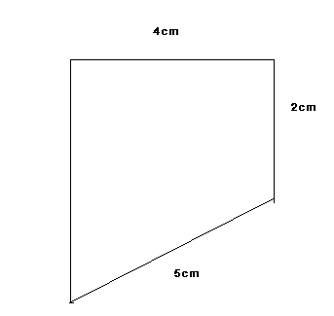

- Add and express your answer in metres 1.3 km, 3.8 Hm, 2 Dm, 4m, 20 dm, 16mm 3mks

- Express 125689 to 4, 3, 2, and 1 significant figures 4mks

- Express 0.09854 to 1,2 and 3 decimal places. 3mks

- The profit of a divided between now plant, reserves and dividends are in the ratio 3: 7: 9. If the profit is sh. 380,000. What is the amount put to dividends? 2mks
- A trader plans to increase prices in the ratio 7:6. What will be the new price of an iron box which is marked at sh. 1800? 2mks

- An alloy is to be made by combining copper and aluminium in the ratio 3:8. If there is 39kg of copper, how much of aluminium is required to make the alloy? 2mks

- If a:b =3:4 and b:c = 5:7 find a:c 2mks

- A factory produced 4200 rolls of barbed wire in a 5 – day working week . What was the rate of production of rolls of wire per day? 2mks

- Factorise the expression
X² + x y + 2x +2y 2mks

- Find 1764 by factorization 3mks

- Express 0.1⁰5⁰ as a fraction 3mks

ALL THE BEST

