GATITU MIXED SECONDARY SCHOOL
MATHEMATICS FORM 1 END OF TERM THREE EXAM CAT 1 2014
- Solve the equation 2mks
9x - (4x -3) = 11+2 (2x -1)

- The sum of two numbers is 120 and their difference is 18. Find the two numbers. 3mks

- An exam took 2 ¼ hrs and ended at 10.45 a.m. at what time did the exam start? 3mks

- Use elimination method to solve the simultaneous equations. 4mks
X +2y =11
2x –y =2

- Simplify 2mks
96 xy
60x²y²

- In one month, a motor vehicle salesman sold 3 motor vehicles, one at sh. 1.5 million, another at sh. 750,000 and the other at sh. 200,000. If he is paid a commission of 7%, how much did he get? 3mks

- Find the value of Z 2mks
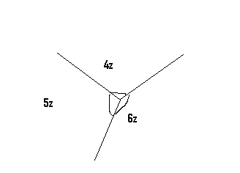

- Find the sizes of the angles marked by letters. 3mks
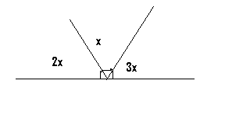

- 3 men working 10 hrs a day can do a certain job in 8 days. How would 2 men working 12hrs a day take to do the same job? 3mks

- Factorize and then simplify. 3mks
2mn - 2mk + 3pn - 3pk
n -k

- On a certain day, a boy spent ¼ of the time reading and 1/12 of the time eating. He spent ½ of the remaining time sleeping. What fraction of the day did he spend sleeping? 3mks

- Write down the prime factorization, in power form of 2272. 3mks

- Find the perimeter of the shape. 3mks

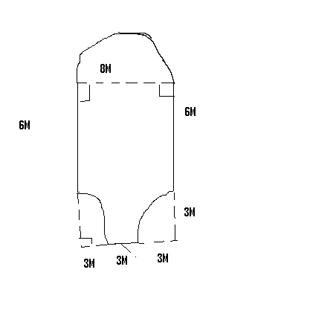

- A customer paid sh. 2340 for a commodity on which a discount of 2 ½ % was given. What was the marked price of the commodity? 3mks

