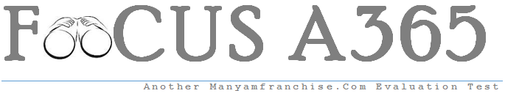

Gatitu Mixed Secondary School
Form 2 | Term 1 | 121 A - Mathematics | 07-Jan-16 | Opener
- When 55 is added to a certain number and the sum is divided by 3, the result is 4 times the original number. What is the original number? 2mks

- Six cows and five sheep cost ksh. 15, 7500. Five cows and four sheep cost ksh. 131,000. Find the cost of one cow and two sheep. 4mks

- Okeyo and Koech contributed sh. 120,000 and sh. 140,000 respectively to stat a business. They agreed that 25% of the profit will be shared equally, 25% of the profit will be shared in the ratio of their contributions, and 50% will be retained in the business. In the first year, the profit from the business amounted to sh. 195,000.
- How much did each receive? 6mks

- How much was retained in the business? 2mks

- Okeyo bought dairy cows with his share of the profit. How many cows did he buy if they cost sh. 16,000 each? 2mks

- Find the value of X and Y 2mks

