GATITU MIXED SECONDARY SCHOOL
MATHEMATICS FORM 2 END OF TERM 2 2015
- Use log tables to evaluate 4mks
0.5972 × 0.8467
0.7835 × 0.646

- Simplify the following, leaving the answer in simplified index form. 3mks
729^{4/3} × (1/243)^{-2/5} ÷ 27^{1/3}

- A line with a gradient 3/2 passes through the points(3,t) and (t,8). Find the value of t, hence express the equation of the line in the form ax + by =c(where a,b and c are constants) 3mks

- Given that y = 4x – 3/7 is line parallel to ax -2y + 4/5 = 0, find the value of a 2mks

- Using tables of reciprocals, find the reciprocals of the following numbers. 3mks
- 12.4

- 225.3

- 5257

- Three years ago, Vivian was three times as old as Peter. In two years time the sum of their ages will be 62 years. Determine their present ages. 3mks

- Simplify the expression 3mks
3x² - 4xy + y²
9x² - y²

- Expand 3mks
(2x +y) (x-y)

- Solve the following quadratic equation by factorization 3mks
9X ² – 12X – 5 =0

- Solve the inequality below and illustrate the solution on a number line. 3mks
- 3X +2 < 5

- 2X -11 ≥ -4X+1

- 8X -4 > 12 X + 2X

- The mean of the numbers 8,6,10,15,x and 9 is .find the mode and the median. 3mks

- Find the perimeter of the triangle PQR below is centimeters 3mks
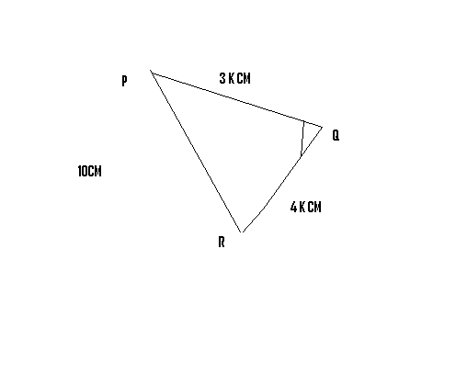

- Given that cos x= 3/2 , where x is an acute angle, find without using a calculator 3mks
- Tan x

- Sin (90 –x)

- Solve the equation in the domain 0≤x ≤90 3mks
- Cos 6x – sin 3x =0

- Cos 2x = sin 3x

- Cos (30 –x) = sin 4x

- The data below shows the number of words correctly spelt by a group of 30 students in an English lesson.
40 24 20 26 38 43
36 26 18 27 36 37
22 32 23 32 28 26
16 41 25 34 24 20
18 38 30 40 30 42
Use a frequency distribution table starting with class 15 -19 to .calculate:
- The mean number of words 3mks

- The median number of words 3mks

- State the modal class 1mk

