PERFECT STEPS PUBLISHERS
END TERM EXAMS 2015
0721 745374/ 0721 707626 NAIROBI

Name: …………………………………………………Adm no ............Class:……....….

FORM 3
MATHEMATICS
PAPER 2
121/2
TIME: 2 ½ HOURS

INSTRUCTIONS TO CANDIDATES:
- Write your name, admission no , and class in the spaces provided
- The paper contains two sections. Section I and Section II.
- Answer ALL the questions in section I and any five questions in section II.
- Answers and working must be written on the question paper in the spaces provided below each question.
- Show all steps in your calculations below each question.
- Marks may be given for correct working even if the answer is wrong.
.

SECTION 1
Question | 1 | 2 | 3 | 4 | 5 | 6 | 7 | 8 | 9 | 10 | 11 | 12 | 13 | 14 | 15 | 16 | TOTAL
Marks

SECTION II
Question | 17 | 18 | 19 | 20 | 21 | 22 | 23 | 24 | TOTAL
Marks
Grand Total

SECTION I (50 MKS) (Answer all the question in this section)
1. Evaluate without using tables or calculators. (4mks)
6 of 14 ÷ 80 x -20
7 3 0
- 2 x 5 + (14 ÷ 7) x3

2. The GCD of two numbers is 7 and their LCM is 140. If one of the numbers is 20, find the other number.

(2mks)

3. Simplify 3Z² – 12 (3mks)
3- (1 + Z)

4. Using a ruler and a pair of compasses only, construct triangle ABC in which AB = 6cm BC=8cm and
angle ABC = 45º. By construction find the shortest distance from A to BC. Measure the distance. (4mks)

5. A straight line through the points A (2,1) and B (4,m) is perpendicular to the line whose equation is
3y = 5-2x. Determine the value of m and the equation of line AB. (4mks)

6. Use reciprocal, square and square root table to evaluate to 4 significant figures, the expression
√
1 + 4.346²
24.56
Show steps in your working. (3mks)

7. Calculate the area of the shaded region below, given that AC is an arc of a circle centre B. Given that
AB = BC = 14cm, CD = 8cm and angle ABD = 75º
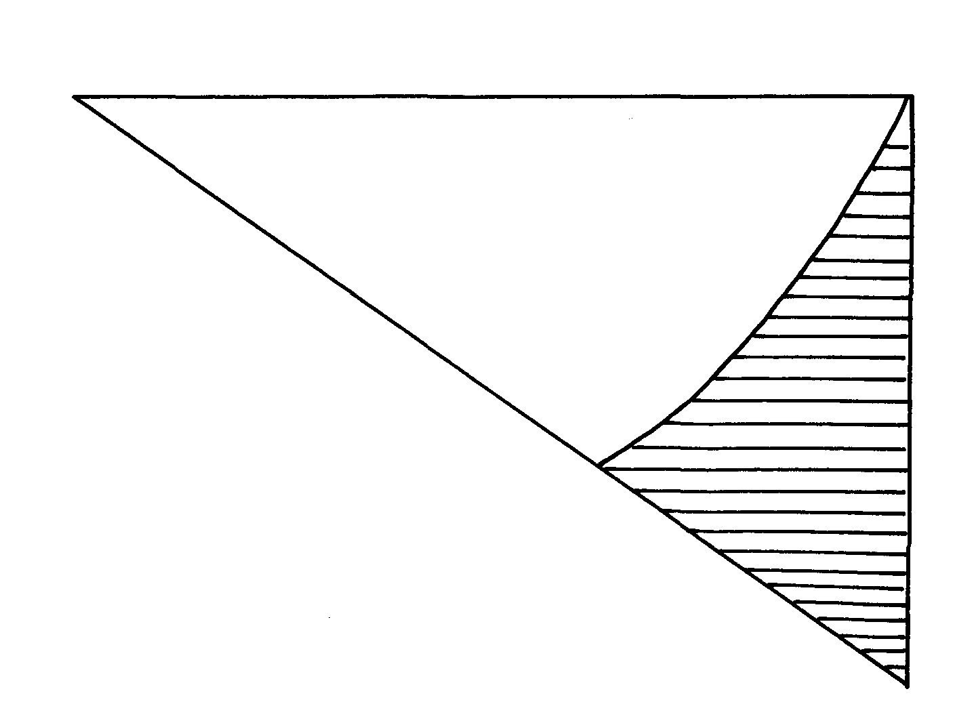
C
A
D
B

8 The cost of a camera outside is US$ 1000. James intends to buy one camera through an agent who deals
in Japanese Yen. The agent charges him a commission of 5% on the price of the camera and further 1260
yen as important tax. How many Kshs. will he need to send to the agent to obtain the camera ,given that:-
(3mks)
1US $ = 105.00 Yen
1US $ = Kshs. 63.00

9. The figure below represents a quadrilateral ABCD. Triangle ABX is an equilateral triangle. If angle
ADX = 50º, find angle AXD given that angle BAD = 90º (2mks)
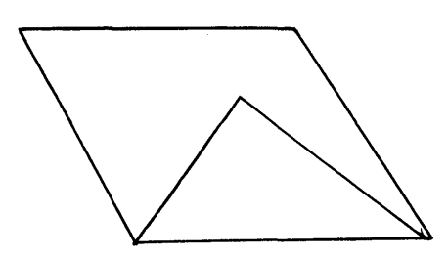
D
C

x

B
A

10. Draw the net of the solid below and calculate surface area of its surfaces (4mks)
V
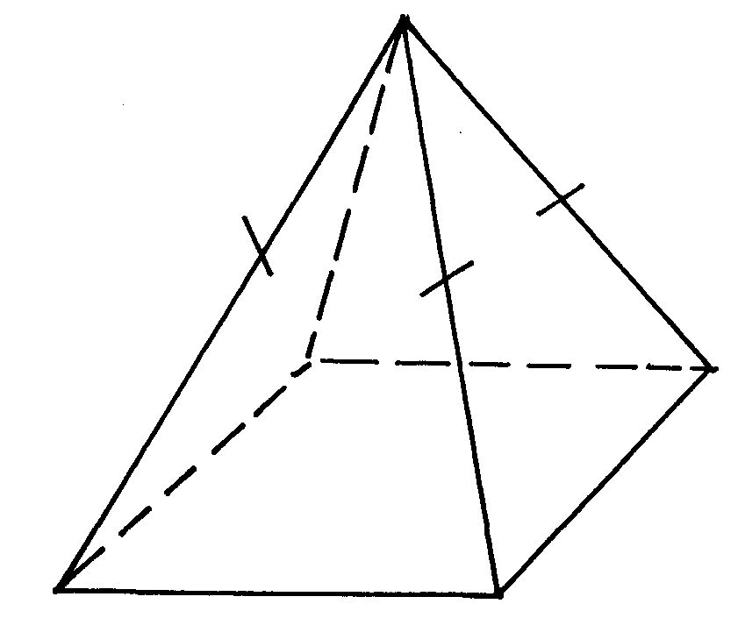

10 cm

D
C

6cm

6cm
B
A

11. A two –digit number is such that the sum of the ones digit and the tens digit is 10. If the digits are
reversed, the number formed exceeds the original number by 54. Find the number. (4mks)

12. Solve the simultaneous equation (3mks)
2x – y = 3
x² – xy = -4

13. Metal cube of side 4.4cm was melted and the molten material used to make a sphere. (3mks)
Find the radius of the sphere (take π = 22 )
7

14. Without using mathematical tables find θ given that (2mks)
Sin ( 2θ– 10) = Cos 6θ ; 0º ≤ θ ≤ 90º

15.Find the least number of steps in staircase if, when I go up 2 steps at a time, 3 steps
at a time or 4 steps at a time, there is always 1 step remaining at the top. ( 3 marks )

16. Solve 4x -3 ≤ 6x -1< 3x + 16 and state all the integral values. (3mks)

SECTION II (50MKS)
Answer any five questions from this section in the spaces provided.

17. The distance between towns A and B is 360km. A minibus left A at 8.l5am and traveled towards
B at an average speed of 90km/hr. A matatu left B two and a third hours later on the same day and
traveled towards A at an average speed of 110km/hr. (10mks)

a) i) At what time did the two vehicles meet?

ii) How far from A did the vehicles meet?

b) A motorist started from his home at 10.30am on the same day and travelled at an average
speed of 100km/hr. He arrived at B at the same time as the minibus. Calculate the distance from
A to his house.

18. The figure below represents Musau’s piece of land PQR divided into two triangular plots.

Q

32⁰

125m 84m
70m

P 65m S R

(a) Calculate the area of the plot PQR in square metres correct to two decimal
places. ( 4 marks)

(b) In the year 2008, Musau used 65% of the plot QSR for grazing and 40%
of the plot QPS for horticultural farming. Calculate, to the nearest square
metre, the piece of land left unutilized. ( 2 marks )

(c ) In the year 2009, the land grazing changed in the ratio 5 :3 while that for
horticultural farming changed in the ratio 2 : 3. Calculate, to two decimal
places the total area of land used for both grazing and horticultural farming. ( 4 marks )

19 A right conical frustrum of base radius 7cm and top radius 3.5cm, and height of 6cm is stuck onto a
cylinder of base radius 7cm and height 5cm which is further attached to a hemisphere to form a closed
solid as shown below
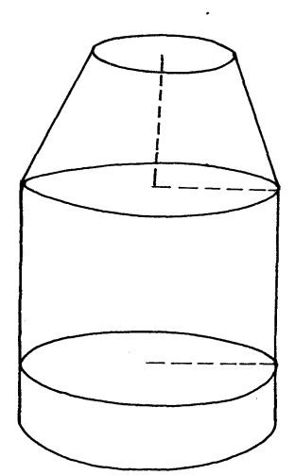
3.5
6cm

7cm

5cm

7cm

Find:
(a) The volume of the solid (5mks)

(b) The surface area of the solid (5mks)

20 In the figure below, ABCD is a cyclic quadrilateral and that angle ABD = 42°, angle BAC= 58° and
angle DBC 36°
E
B
A
D
C

Giving reasons, find the values of
(a) Angle DAC (2mks)

(b) Angle ADB (2mks)

(c) Angle ACD (2mks)

(d) Angle CDB (2mks)

(e) Angle CEB (2mks)

21. a) Complete the table of the functions Y = 1+x -2x² (2mks)
x | -3 | -2 | -1 | 0 | 1 | 2 | 3
-2x² | -18 |  |  | 0 | -2
1 | 1 | 1 | 1 | 1 | 1 | 1 | 1
y | -20 | -9 |  |  | 0

b) Draw the graph of the function Y = 1+x -2x² on the graph paper provided. (4mks)
Use your graph to find the value for x in the equation 1 + x -2x²=0

c) By drawing a suitable line graph on the same graph find the value for x which satisfies the
equation +5 + 2x -2x²=0 (3mks)
d) Stat e the maximum point of the function Y = 1+x -2x² (1mk)

22 Two business women jointly bought a minibus which could ferry 25 paying passengers when full.
The fare between two towns A and B was shs. 80 per passenger for one way. The minibus made
three rounds trips between the two towns daily. The cost of fuel was shs. 1,500 per day. The drivers
and the conductors were paid allowance of shs. 200 and shs 150 respectively. A further of shs. 4,000
per day was set aside for maintenance, insurance and loan repayment.

(a) One day the minibus was full on every trip.
(i) How much money was collected from the passengers that day. (3mks)

(ii) How much was the net profit. (2mks)

(b) On another day, the minibus was 80% full on average for the round trips how much did each
business woman get if the days profit was shared to the ratio 2:3? (5mks)

23. A(3, 7), B(5, 5), C(3, 1), D(1, 5)
(a) On the grid provided below, plot ABCD on a Cartesian plane (2mks)
(b) A¹B¹C¹D¹ is the image of ABCD under a translational T - 6 J. Plot A¹B¹C¹D¹ and
state its coordinates. -9 (2mks)
(c) Plot A¹¹B¹¹C¹¹D¹¹, the image of A¹B¹C¹D¹ after a rotation about (-1, 0) through a
positive quarter turn. State its coordinates. (3mks)
(d) A¹¹¹B¹¹¹C¹¹¹D¹¹¹ is the image of A¹¹B¹¹C¹¹D¹¹ after a reflection in the line Y=x + 2.
Plot A¹¹¹B¹¹¹C¹¹¹D¹¹¹and state its coordinates (3mks)

24. Wanjiku is standing at a point P. 160m south of a hill H on a level ground. From point P she
observes the angle of elevation of the top of the hill to be 67°
(a) Calculate the height of the hill (3mks)

(b) After walking 420m due east to the point Q Wanjiku proceeds to point R due east of Q
where the angle of elevation of the top of the hill is 35°. Calculate the angle of elevation of
the top of the hill from Q (3mks)

(c) Calculate the distance from P to R (4 mks)

PRINTED AND COMPILED BY PERFECT STEPS PUBLISHERS: 0721 745374/0721707626 NAIROBI

