Manyam Franchised Tests
Mathematics | KCSE/KNEC | 2012

Name…………..……………………..…………. School…………………….....………………Date………….

- What is 20075803 written in words?
- Two hundred million seven hundred fifty eight thousand and three
- Two hundred million seventy five thousand eight hundred and three
- Twenty million seven hundred fifty eight thousand and three
- Twenty million seventy five thousand eight hundred and three
- In the number 14205, what is the difference between the total values of the digits 4 and 2?
- 4000
- 3800
- 4200
- 200
- What is 4689.99975 rounded off to the nearest thousandths?
- 5000
- 4689.999
- 4690.000
- 4689.9998
- What is the value of: (16905 – 1500 + 1025 – 1225) $÷$ 5 ?
- 15205
- 3121
- 3041
- 2631
- Which one of the following expressions is correct?
- $\frac{7}{8}$ > $\frac{3}{4}$
- 72.5 – 2.57 < 49.9 + 20.03
- 506 + 45 < 49.9 + 222
- 0.65 < 0.065
- What is the value of $\frac{3}{5}$ + $\frac{1}{8}$ + $\frac{1}{4}$ $÷\frac{1}{2}$ ?
- $\frac{33}{40}$
- $\frac{14}{25}$
- $\frac{1}{5}$
- $\frac{9}{40}$
- What is the next number in the pattern below? 2, 6, 12, 20, 30, …………
- 52
- 44
- 42
- 40
- What is the square root of the number obtained, when 196 is multiplied by 4?
- 28
- 56
- 392
- 784
- In the figure below, line AB and CD are parallel. Line EF is transversal

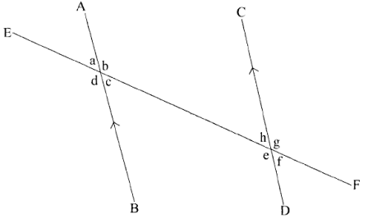

Which one of the following choices contains equal angles?
- a and e
- c and g
- b and f
- d and g
- What is the value of 2b (a + c) + ac when a= b = 3 and c=2?
- 66
- 36
- 30
- 21
- Andona bought 50 pineapples at sh 30 each and paid sh 100 for transport to the market. During transportation, 5 pineapples got spoilt. She sold the rest at sh 50 each. What percentage profit did she make?
- 56 ¼
- 46 $\frac{4}{8}$
- 43 $\frac{1}{3}$
- 40 $\frac{5}{8}$
- Interschool soccer competition started at 3.15 p.m. After 45 minutes, players went for a 15 minutes break. The game then took 55 minutes to end. At what time in the 24 hour system did the game end
- 17 10h
- 05 10h
- 16 55h
- 16 30h
- The figure below represents the net of a solid.
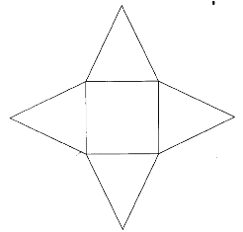
The net is folded to form the solid. How many edges will the solid have?
- 4
- 5
- 8
- 12
- The table below shows the number of people who attended an agricultural show.
Male Adults | Female Adults | Children
986 | 3145 | 5807
How many more children than adults attended the show?
- 1676
- 2662
- 4131
- 4821
- A kiosk owner bought 10 litres of milk on Monday. On Tuesday and Wednesday, a total of 50 litres were bought. Equal numbers of litres were bought on Thursday and Friday. Altogether 120 litres were bought during the five days. In a pie chart, what angle would represent the amount of milk bought on Friday?
- 30⁰
- 90⁰
- 150⁰
- 180⁰
- Two pickups were used to collect garbage from a market. Each pickup carried 2 tonnes 300kg of garbage per trip. Each pickup was to make five trips. After the fourth trip one of the pickups broke down and did not carry the garbage. What was the total mass of garbage collected?
- 23 tonnes 0kg
- 20 tonnes 700kg
- 18 tonnes 400kg
- 11 tonnes 500kg
- A company gives a commission on sales above sh 1000 000. In a certain month a salesgirl received a commission of sh 36 000 after selling goods worth sh 800 000. What was the percentage commission offered?
- 36
- 4
- 4 ½
- 5 $\frac{1}{7}$
- Paint was stored in three containers of 48 litres, 72 litres and 30 litres. The paint in each container was then repacked into smaller containers. The amount of paint in each of the smaller containers was the same. What was the capacity of the largest container used to repack the paint?
- 3 litres
- 6 litres
- 72 litres
- 720 litres
- Jane gave money to her three children. She gave 1/3 of the total amount to the first child. She was then left with sh 2 400 which she gave to the third child. How much money did she give out altogether?
- Sh 9 000
- Sh 6 000
- Sh 4000
- Sh 3 600
- The mean mass of four pupils was 49.5 kg. When the masses of another pupil and a teacher were included, the mean mass became 53 kg. If the mass of the pupil was 16kg less than that of the teacher, what was the teacher’s mass?
- 44kg
- 52kg
- 76kg
- 68kg
- On the triangle PQR drawn below, construct line RS parallel to line QP. Draw a perpendicular from P to meet line RS at T.
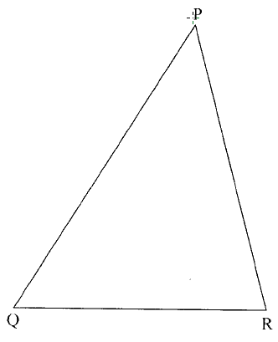
What is the length of the line PT?
- 4.8 cm
- 5.1 cm
- 6.8 cm
- 9.5 cm
- In the year 2008, there were 850 pupils in a school of whom 3/5 were boys. In the year 2009, ten girls joined the school and twenty boys transferred to another school. What was the ratio of boys to girls in the year 2009?
- 3:2
- 53:33
- 13:8
- 7:5
- A farmer harvested 900 bags of maize. She sold 0.7 of the bags and gave 0.1 of the remainder to a charitable organization. She then kept the rest. How many bags of maize were kept?
- 27
- 180
- 243
- 270
- What is the value of x in 3 (x + 4) – 10 = 32?
- 16 $\frac{2}{3}$
- 12 $\frac{2}{3}$
- 11 $\frac{1}{3}$
- 10
- In a right-angled triangle the length of the hypotenuse is 40 cm. which one of the following pairs are the possible lengths of the two shorter sides?
- 12cm, 5cm
- 25cm, 15cm
- 24cm, 7cm
- 32cm, 24cm
- Muli obtained a total score of 180 marks in English, Mathematics and Science. His score in English was half the score obtained in mathematics. The score in mathematics was 10 more than the score obtained in science. If the score obtained in science is represented by x, which one of the equations below can be used to get the value of x?
- 2 ½ x + 15= 180
- 2 ½ x – 15= 180
- 4x + 30= 180
- X + 15= 180
- The table below shows inland postal charges for letters.
Weight of letter | Sh ct
Up to 20g | 25 00
Over 20g up to 50g | 30 00
Over 50g up to 100g | 35 00
Over 100g up to 250g | 50 00
Over 250g up to 500g | 85 00
Over 500g up to 1 kg | 135 00
Over 1kg up to 2kg | 190 00
Wamu posted two letters each weighing 95g and another one weighing 450g. how much money did he pay at the post office?
- Sh 120
- Sh 135
- Sh 155
- Sh 240
- A trader deposited sh 300 000 at a bank that paid compound interest at the rate of 5% p.a. How much money was in her account in the bank, at the end of two years?
- Sh 330 750
- Sh 330 000
- Sh 315 000
- Sh 30 750
- On a map of scale 1:100 000 a rectangular plot of land measures 7cm by 4cm. What are the actual lengths of the plot in kilometers?
- 70 000 by 40 000
- 700 by 400
- 70 by 40
- 7 by 4
- The number of tree seedlings planted in a certain season increased by 20%. If there were 24,000 seedlings planted in that season, how many seedlings were there before the increase?
- 19 200
- 20 000
- 28 800
- 30 000
- Which quadrilateral has all the properties listed below?
All sides are equal
All angles are right angles
Diagonals are equal
Diagonals bisect each other at right angles
- Square
- Trapezium
- Rectangle
- Rhombus
- Kioko bought the following items to donate to a charitable organization:
2 bags of cabbage @ sh 2 500
4 bags of potatoes @ sh 2 000
20kg of cooking oil for sh 2 000
100kg of sugar @ sh 96
50 loaves of bread @ sh 35
He was given a 10% discount for all his purchases. How much did he pay for the items?
- Sh 23 715
- Sh 26 350
- Sh 57 915
- Sh 28 985
- Musa and Kayai left town P for town Q at the same time. Musa drove at an average speed of 80km/h and reached town Q after 3 hours. Kayai drove at an average speed of 50km/h for 1½h and then continued with the journey at an average speed of 70km/h. how many kilometers had kayai to cover at the time musa reached town Q?
- 240
- 180
- 165
- 60
- A plot of land is in the shape of a semi circle of diameter 28 metres as shown below.
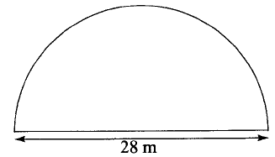
The plot was fenced by erecting posts 4 metres apart. How many posts were used? (Take $π$=$\frac{22}{7}$)
- 12
- 17
- 18
- 19
- Fifteen painters can paint a number of houses in 12 days. If the number of painters is increased by 5, how many days less would it take the painters working at the same rate to paint the houses?
- 24
- 9
- 4
- 3
- Construct triangle PQR in which PQ = 5cm, PR = 7cm and QR = 6.5 cm. bisect angle PRQ and let the bisector meet the line PQ at M.

What is the size of angle PRM?
- 22⁰
- 44⁰
- 63⁰
- 95⁰
- A cylindrical water tank has a diameter of 1.4m and a height of 3m. What is the volume of the tank in M³? (Take $π$=$\frac{22}{7}$)
- 4.62
- 13.2
- 16.28
- 18.48
- A baby woke up at 5.30 a.m. after sleeping for sleeping for 7 hours 45 minutes. At what time in a.m. /p.m. did the baby sleep?
- 9.45 a.m
- 1.15 a.m
- 9.45 a.m
- 2.15 p.m
- The diagram below represents a metal solid made up of a cylindrical bar fixed onto a cube. The cylindrical bar is 20cm long and has a diameter of 7cm. each side of the cube is 9cm long.
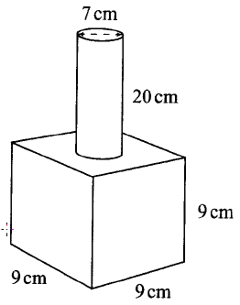

The surface of the solid was painted. What area in cm₂ was painted? (Take $π$=$\frac{22}{7}$)
- 1499
- 964.5
- 926
- 845
- The table below shows the distance in kilometers from Avedi’s home to school, health centre and market.
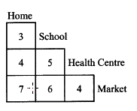
One day Avedi left home for the market but passed through the health centre. Later, Avedi left the market and went home directly. How many kilometers did Avedi travel that day?
- 14
- 19
- 18
- 15
- The perimeter of the isosceles triangle QRS shown belo is 48cm. the base of the triangle is 18cm.
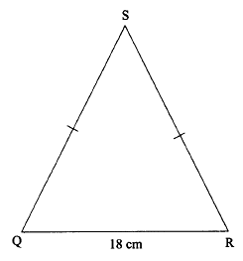

What is the area of the triangle?
- 54 cm²
- 108 cm²
- 135 cm²
- 435 cm²
- A factory packs water in half litre, one litre, two litre and five litre bottles. On a certain day, the factory packed 20 840 bottles of water. Out of these, 8 120 were half litre bottles and 3 960 were two litre bottles. One litre bottles were 2 000 more than the two litre bottles. The rest were five litre bottles. How many five litre bottles were there?
- 2 800
- 6 760
- 6 800
- 18 040
- Which one of the expressions below is the simplest form of $\frac{6\left(x+2y\right)+3x}{2\left(x+2y\right)-2y}$?
- $\frac{9x+12y}{2x+2y}$
- $\frac{6x+6y}{x}$
- $\frac{3+3x}{1-2y}$
- $\frac{9x+2y}{2x}$

- At a school prize giving day the number of men was half that of women. The number of children was three times that of women. The number of women who attended was 3x. what was the sum of men and children?
- 10 ½ x
- 2 ½ x
- 13 ½ x
- 21 x
- The cash price of a radio is sh 8 000. The hire purchase price is 50% more than the cash price. Amina bought a radio on hire purchase by paying a deposit of sh 2 400 and equal monthly instalments of sh 800. In how many months did she pay the installments?
- 18
- 15
- 12
- 10
- Mumbi paid sh 1 800 for a chair after 10% discount was allowed. How much would she have paid for the chair had she been allowed a 12% discount?
- Sh 2000
- Sh 1 700
- Sh 1 584
- Sh 240
- The graph below shows John’s journey from Kericho to Mombasa. On his way he stopped in two places.

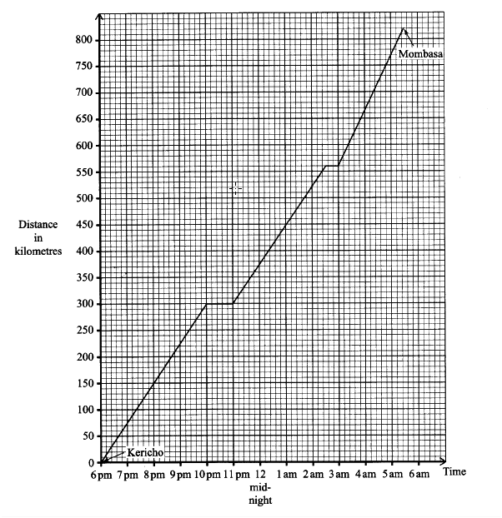

What was john’s average speed in km/h between the time he left the first stop and the time he arrived at the second stop?
- 75
- 74 $\frac{2}{7}$
- 71 $\frac{7}{23}$
- 52
- The diagram below represents a vegetable garden, which is in the shape of a rectangle and semi-circles.
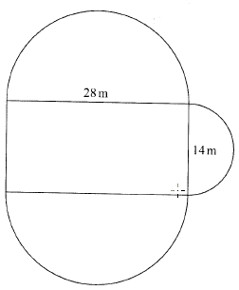
What is the area of the garden in square metres?
- 693
- 1008
- 1085
- 1162
- Safi packed 15 cartons each containing 20 bottles of juice. The amount of jiuice in each bottle was 500ml. what was the total amount of the juice, in litres, packed by Safi?
- 150
- 1 500
- 15 000
- 150 000
- Which one of the nets shown below is the net of a closed cube?
