## PERFECT STEPS PUBLISHERS

END TERM EXAMS 2015

**0721 745374/ 0721 707626 NAIROBI**

**Name: …………………………………………………………… Adm no ……..…...................................**

**Class: ……………………………………………………....….**

FORM 2

MATHEMATICS

TIME: 2 ½ HOURS

**INSTRUCTIONS TO THE STUDENT:**

* *Write your* ***name****,* ***admission no.*** *,* ***and class*** *in the spaces provided*
* *Answers and working* ***must*** *be written on the question paper in the spaces provided below each question.*
* *Show all steps in your calculations below each question.*
* *Marks may be given for correct working even if the answer is wrong.*

*.*

1. Evaluate without using a calculator or Mathematical tables leaving your answer in the

simplest form. (3mks)

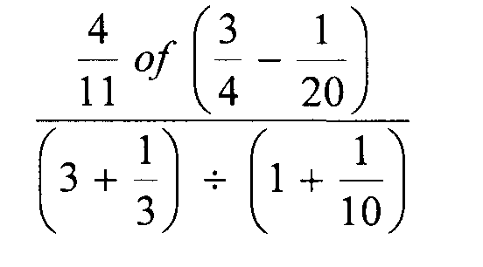

2. A Kenya bank buys and sells foreign currencies as shown.

**Buying (Ksh) Selling (Ksh)**

1 Euro 84.15 84.26

100 Japanese Yen 65.37 65.45

A Japanese travelling from France to Kenya had 5000 Euros. He converted all the 5000

Euros to Kenya shilling at the bank. While in Kenya, he spent a total of Ksh.289850

and then converted the remaining Kenya shilling to Japanese Yens at the bank.

Calculate the amount in Japanese Yen that he received. (4mks)

3. Line L1 passes through the points A (1, -2) and B (3, -4). Find the equation of line L2 passing through the mid-point of AB and perpendicular to L1, leaving your answer in the form ax+by+c=0. (4mks)

4. The curved surface area of a cylindrical container is 1980cm2. If the radius of the container is 21cm, calculate to one decimal place the capacity of the container in litres (3 mks)

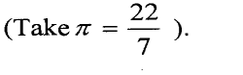

5. The scale 1 : 50,000 is used on a drawing. An area of a thicket on the drawing is found to be 20cm2. Calculate the area of the thicket on the actual ground in hectares. ( 3 mks )

6. Using a pair of compasses and a ruler only construct a triangle ABC such that AB= 4cm,

BC = 6cm and ZABC = 135°. (2mks)

(b) Construct the height of triangle ABC in (a) above taking AB as the base, hence

calculate the area of triangle ABC. (2 mks)

7. One interior angle of a polygon is equal to 800 and each of the other interior angles are 128°. Find the number of sides of the polygon. (3 mks)

8 . Simplify m + 2 - m – 1 - m – 3

3 5 4 (2 mks )

9. Simplify: (3 mks)

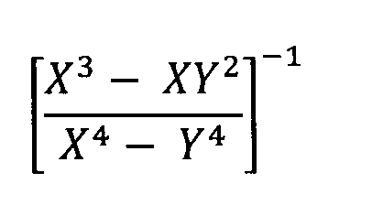

10. In the figure below, lines AB and XY are parallel.

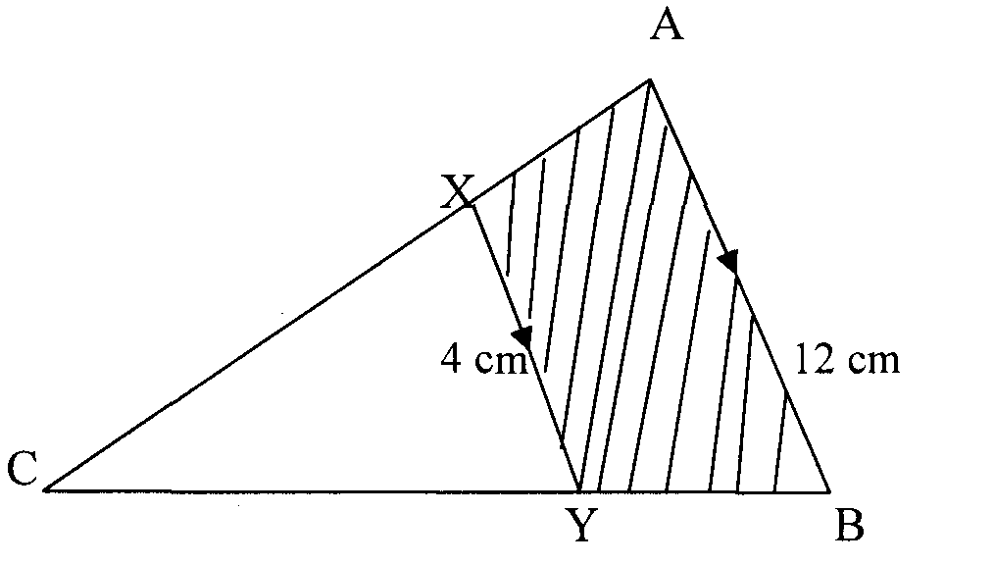

If the area of the shaded region is 36 cm2, find the area of triangle CXY. (3 mks)

11. The volumes of two similar containers are 625cm3 and 1080cm3 respectively. If the base area of the smaller container is 75cm2, find the base area of the bigger container. ( 3 mks )

12. All prime numbers between ten and twenty are arranged in descending order to form a number.

(i) Write down the number. (1 mk)

(ii) State the total value of the third digit of the number formed in (i) above. (1 mk)

13. The proceeds of a certain harambee was distributed among three secondary schools A, B and C. A received 1/3 of the total amount realized, B received 1/3 of the remainder while C received 4/5 of what B received. If the difference of what remained and B’s share was sh. 25,000, determine how much the harambee realized. ( 4 mks )

14. The marked price of a car in a dealer’s shop was Kshs 450,000. Wekesa bought the car at 7%

discount. The dealer still made a profit of 13%. Calculate the amount of money the dealer

had paid for the car. (3 mks)

1 5. Use tables of cubes, square roots and reciprocals to evaluate. (3mks)

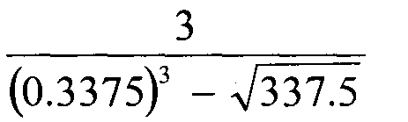

16.Without using tables or a calculator, evaluate (3mks)

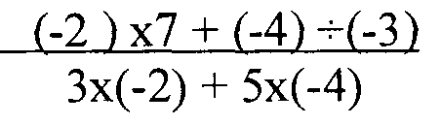

17. Mr. Owino spends ¼ of his salary on school fees. He spends 2/3 of the remainder on food and a fifth of what is left on transport. He saves the balance. In a certain month he saved sh. 3,400. What is his salary? ( 3 mks )

18. In the figure below, AC is an arc of a circle centre B, angle ABD = 600, AB = BC = 7cm and CD = 5cm. If AE is parallel to BD and AB is parallel to ED. Calculate the area of the shaded region.

(3 mks )

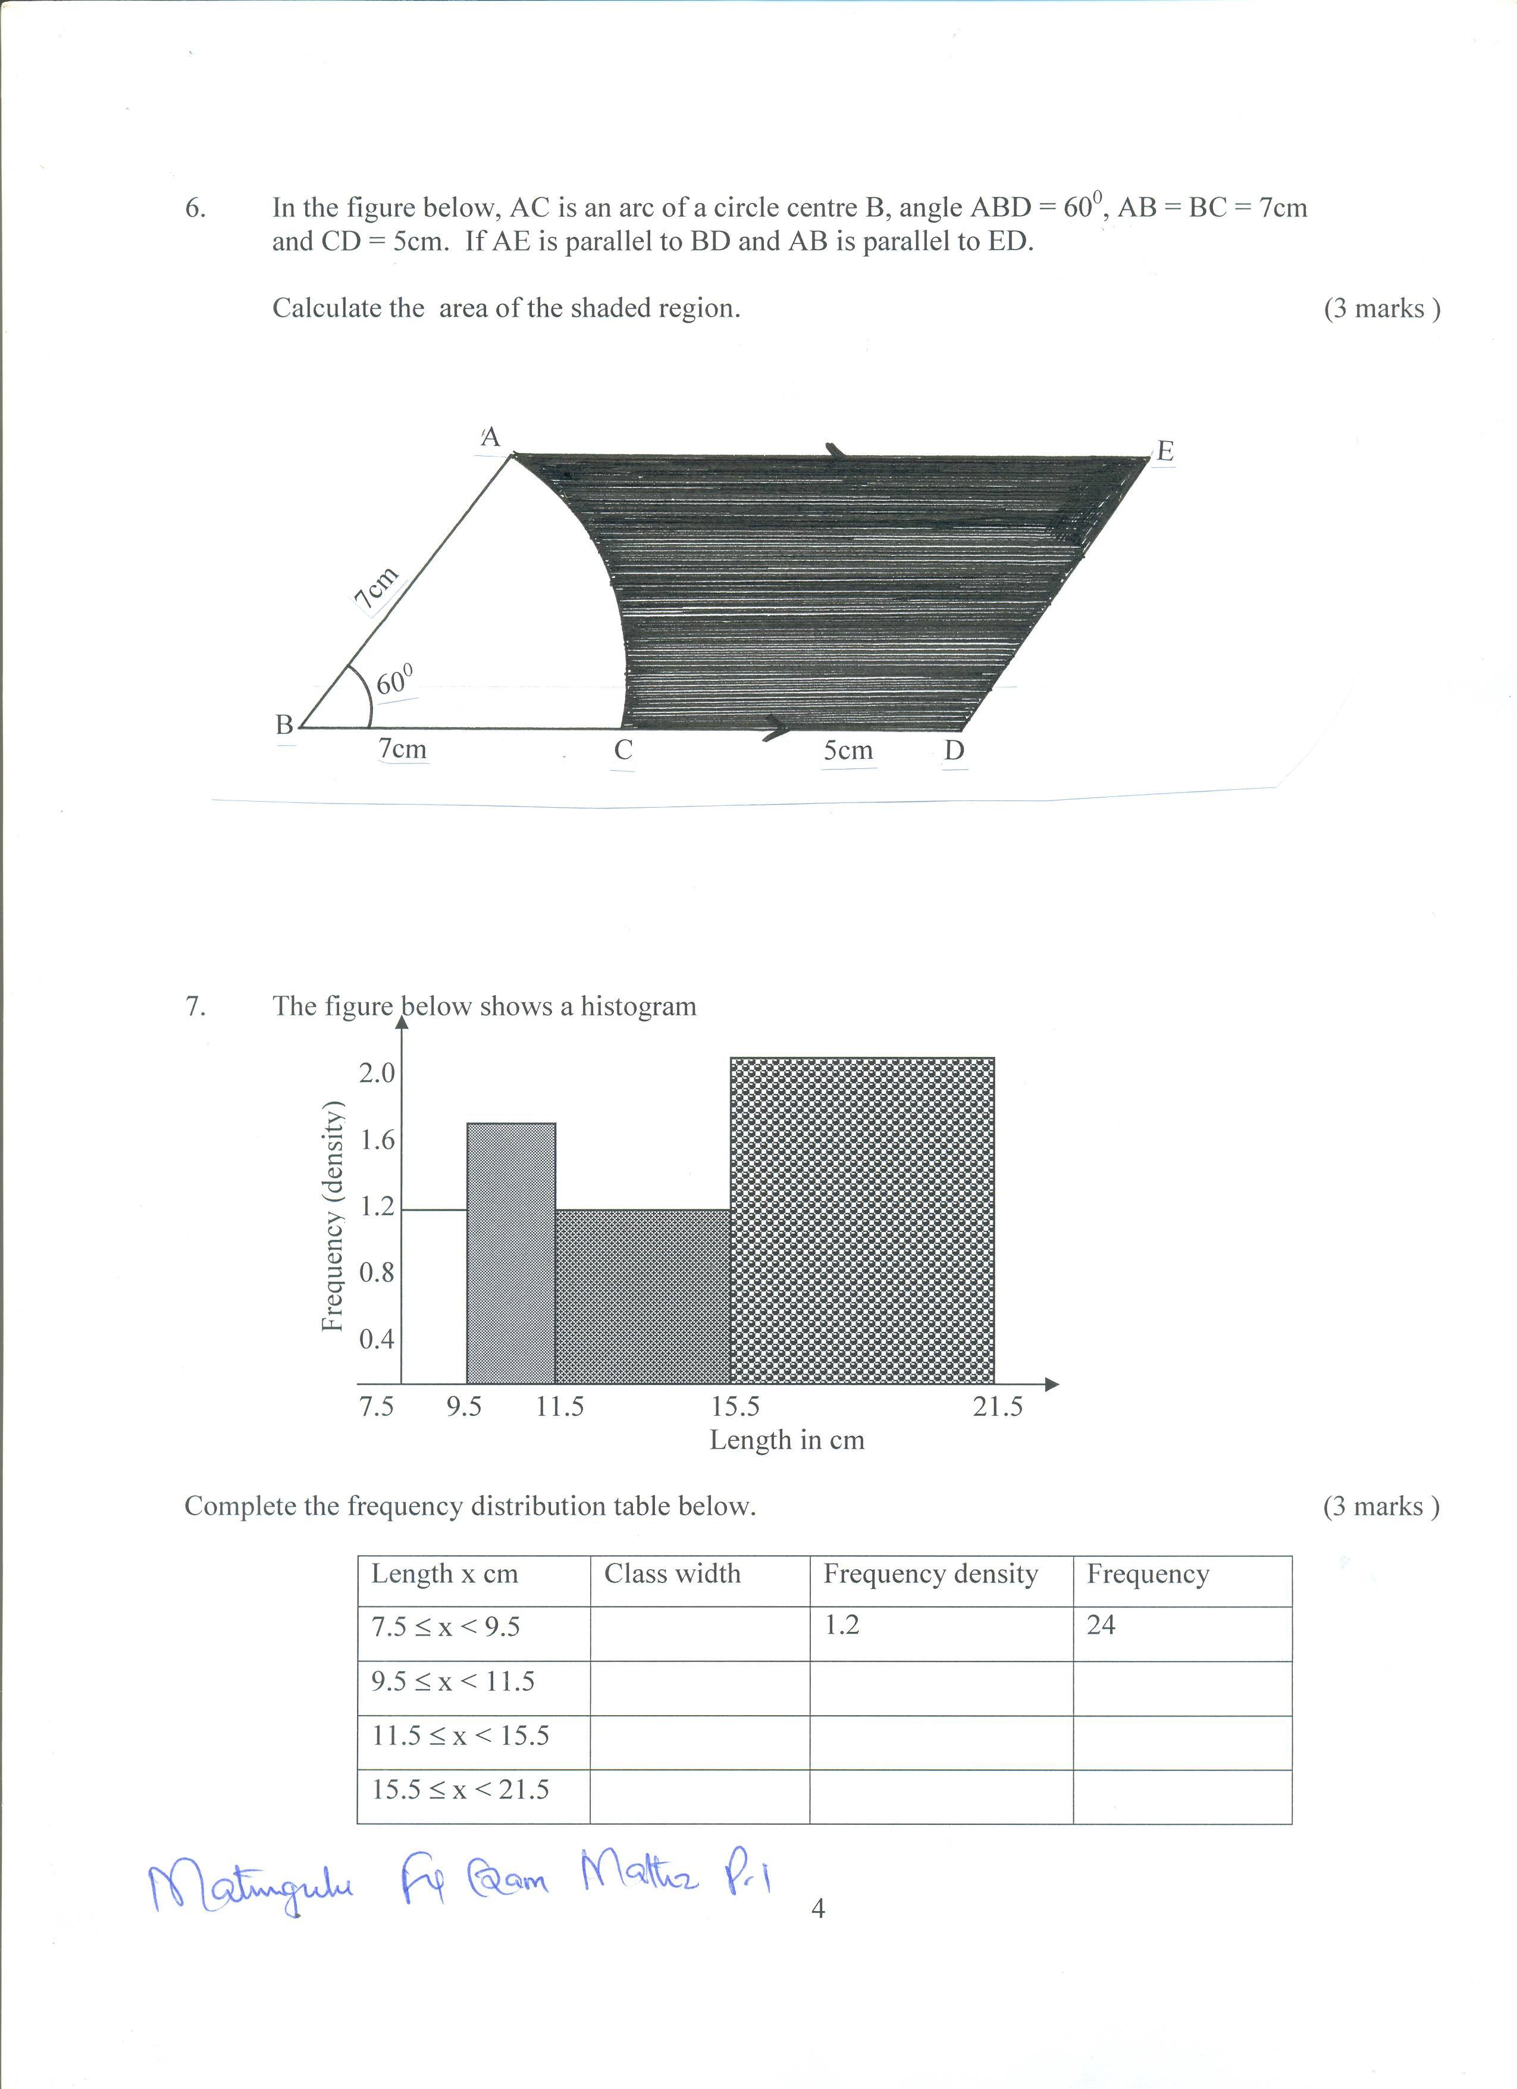

19. A square whose vertices are P(1, 1), Q (2, 1), R ( 2, 2) and S (1, 2) given an enlargement with centre at (0, 0). Find the images of the vertices if the scale factor is 3. ( 2 mks )

20. A bus and a car leave Nairobi at 7.30am and 9.30am respectively. If their speeds are 60km/h and 100km/h respectively, find the time when the car catches up with the bus. ( 3 mks )

21. A rectangular tank measuring 3m long, 2.4m wide and 1.2m high is initially half full of water . Water flows into the tank from 9.45 a.m and the tank is full at 1.21p.m. Determine the rate at which water flows into the tank in litres per minute (4 mks)

22. An artisan working on a construction job is paid sh. 30 for every normal working hour and sh. 50 for each hour worked overtime. During one week he worked for a total of 65 hours and was paid sh. 2,450 in wages. Determine the number of hours he worked overtime. ( 3 mks )

23. Simplify (4 mks)

( 8/27 ) -1/3 x (64/9) ½ x 2-1

24. Factorize completely.

5x2y2 + 2xy – 3 ( 3 mks )

25. Find the equation of the line which passes through the point of intersection of the lines y + 2x = 8 and 2y – x = 6 and the point ( 4, 3 ). ( 4 mks )

26. A piece of land is to be divided into 20 acres or 24 acres or 28 acres for farming and leave 7 acres for grazing. Determine the smallest size of such land. (3 mks)

27. The mean age of 4 girls is 15 yeas. The first and second are aged 13 years and 18 years respectively. The third girl is 3 years older than the first girl. Find the modal age. (3 mks)

28. The L.C.M of 15, 18 and a third number is 1260. Find the square of third number. (3 mks)

29. Express the following as fraction. (3 mks)

**. .**

0.92

30. The figure below shows a uniform cross-section of a swimming pool which is 4m wide. The depth of the pool increase gently from 1.5m to 3.0m.

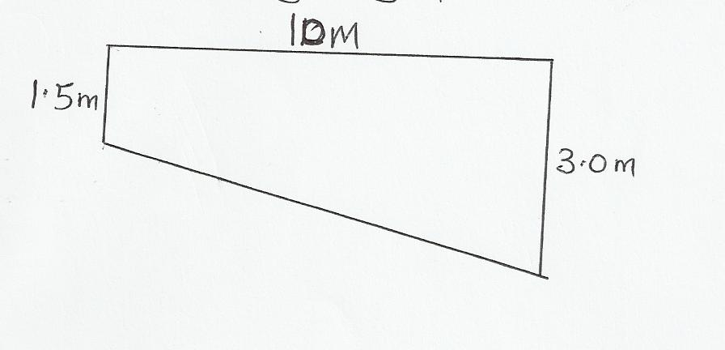

1. How much water in litres does it hold when full? (3 mks)
2. Calculate total internal surface area of the pool. (5 mks)
3. Find the angle at which the bottom of the pool inclines to the horizontal. (2 mks)

**MARKING SCHEME FORM 2 MATHS**

|  |  |  |  |
| --- | --- | --- | --- |
|  | Questions | Marks | Remarks |
| 1. | =  = | B1  B1  A1 |  |
|  |  |  |  |
| 2. | 500 x 84.15 – 289850  = 130,900  But 100 yens ≡ 65 – 45  ? 130900  = 200000 yens | M1  M2  A1 |  |
|  |  |  |  |
| 3. | Gradient L1 =  → Gradient L2 = 1  Mid- point AB = (2, -3)  ∴  → y + 3 = x-2  ∴ -x +y + 5 = 0 | B1  B1  M1  A1 |  |
|  |  |  |  |
| 4. | Πdh = 1980    h= 15cm  Vol =  = 20790cm3  = 20.79li | M1  M1  A1 |  |

|  |  |  |  |
| --- | --- | --- | --- |
| 5. | A.S.F = ( L.S.F)2  = ( 1 : 50,000)2  = 1 : 2,500,000,000  Actual area = 20cm2 x 2,500,000,000cm2  1cm2  = 50,000,000,000cm2  Area in hectares = 50,000,000,000cm2  10,000 x 10,000cm2    = 500 hectares | M1  M1  A1 |  |
|  |  |  |  |
| 6. |  |  |  |
| 7. | 80 + (n-1)128 = 180n – 360 or its equivalent  → 80 + 128n – 128 = 180n – 360  -52n = -312  n = 6 | M1  M1  A1 |  |
|  |  |  |  |
| 8. | 20 ( m + 2) – 12 ( m – 1) - 15 ( m – 3 )  60  20m + 40 – 12m + 12 – 15m + 45  60  20m + 2m – 15m + 40 +12 +45  = -7m +97  60 | M1  A1 |  |
|  |  |  |  |
| 9. |  | M1  M1  A1 |  |
|  |  |  |  |

|  |  |  |  |
| --- | --- | --- | --- |
| 10. | Let Area c x y = x  L.S. F =  A.S.F =  →  → 9x = x + 36  8x = 36  X = 4.5cm2 | M1  M1  A1 |  |
|  |  |  |  |
| 11. | 7. V.S.F = 625 : 1080  LSF = 5 : 6  ASF = 25 : 36  25 75  36 ?  36 x 75  25 = 108cm2 | M1  M2  A1 |  |
|  |  |  |  |
| 12. | i) 19, 171, 311  ii) 300 | B1  B1 |  |
|  |  |  |  |
| 13. | Let x be the amount realized  ∴ A = 1/3 x  B = ½ of 2/3x = -2/9 x  C = 4/5 of 2/9 x = 8/45 x B1  The total amount given = 1/3 x + 2/9 x + 8/45 x M1  15x + 10x + 8x  45  -33x  45  = 11/15 x  Remainder = 4/15 x  ∴ 4/15 x –  2/9 x = 25000  1  12x – 10x = 25000 x 45  45 45  12x – 10x = 1125000  2x = 1125000  x = Ksh. 562,500 | B1  M1  M1  A1 |  |
| 14. | 450000 ≡ 100%  ? ≡ 93%  Cash price = 418500 shillings  But 418500 ≡ 113%  ? ≡ 100%  = 370353.9823 shillings | A1 |  |
|  |  |  |  |
| 15. | (3.375 x 1/10)3 = 0.038441  (3.375 x 100) ½  = 18.372  =    = (-3)x(0.5455) x 1/10  = - 0.16365 | A1 |  |

|  |  |  |  |
| --- | --- | --- | --- |
| 16. | =  =  = | B1  B1  A1 |  |
|  |  |  |  |
| 17. | Food = ½  Trans = 1/20  Rem = 1/5  1/5 = 3400  5/5 = 5/5 x 5/1 x 3400  = 17,000 | M1  M1  A1 |  |
|  |  |  |  |

|  |  |  |  |
| --- | --- | --- | --- |
| 18  19  20 | 6. Sin 600 = h/7  H = 7 sin 600  Area of ABDE = ½ ( 12 + 12) 7 sin 600 = 72.75cm √  Area of sector BAC = 60/360 x 22/7 x 7 x 7  72.75 – 25.67 √  Shaded area 47.08cm2  P ( 1, 1) = P1 ( 1 x 3, 1 x 3 ) = M1 (3, 3)  Q (2, 1) = P1 ( 2 x 3, 1 x 3) = Q1 (6, 3) B1  R (2, 2) = R1 ( 2 x 3, 2 x 3 ) = R1 ( 6, 6) B1  S ( 1, 2) = S1 ( 1 x 3, 2 x 3 ) = ( 3, 6 )  120/40 = 3 hours  9 : 30  + 3 : 00  12 : 30 pm | M1  M1  A1 |  |
|  |  |  |  |

|  |  |  |  |
| --- | --- | --- | --- |
| 21 | Volume = ½ ( 300 x 240 x 120 ) litres  1000  = 4320 litres  Time taken to fill the tank  1321 hr  - 0945  3hr 36 min  = 216 mins  20  Rate of flow = ~~4320~~ L  ~~216~~ min M1  1  = 20 L /min |  |  |
|  |  |  |  |
| 22 | Let no. of hours worked overtime be x  Hours worked normal time is 65 – x  Amount earned overtime = sh. 50x M1  Amount earned normal hours = sh. 30 ( 65 – x )  ∴ 50x + 30 ( 65 – x ) = 2450  50x + 1950 – 30x = 2450 M1  20x = 500  x = 25  Hours worked overtime is 25 | M1  M1  A1 |  |
|  |  |  |  |
| 23  24 | ( 8/27) -1/3 x ( 64/9) ½ x 2-1  23 -1/3 x 8/3 x ½  23 -1/3 = 3/2  33 33  1 ~~4~~ 2  ~~3~~ x ~~8~~ x 1 M1 for √ 8/3 and ½  ~~2~~  ~~3~~ ~~2~~  1 1  = 2  5x2y2 + 2xy – 3  5x2y2 + 5xy – 3xy – 3  5xy ( xy + 1 ) – 3 ( xy + 1 )  ( 5xy – 3 ) ( xy + 1 ) | M2  M1  A1 |  |
|  |  |  |  |

|  |  |  |  |
| --- | --- | --- | --- |
| 25 | Solving simultaneous equations  2y – x = 6  y = 3 + x/2  y + 2x = 8  y = 8 – 2x  8 – 2x = 3 + x/2 M1  -5/2x = -5  x = 2  2y – 2 = 6  y = 4  Point of intersection ( 2 , 4 ) A1  Gradient of line : 4 – 3 = - ½  2 – 4 M1  4 – y = - ½  2 – x  4 – y = - ½ ( 2 – x )  -y = -5 + ½ x  y = 5 – ½ x | M1  M1  A1 |  |
|  |  |  |  |
| 26 | *2 20, 24, 26, 28*  *2 10 12 13 14*  *2 5 6 13 7*  *3 2 3 13 7*  *5 5 1 13 7*  *7 1 1 13 7*  *13 1 1 13 1*  *1 1 1 1*  *Size of the land = (23 x 3 x 5 x 7 x 13) + 7) aces*  *= 10920 + 7 = 10,927 aces* | M1  M2  A1 |  |
|  |  |  |  |

|  |  |  |  |
| --- | --- | --- | --- |
| 27 | 4 x 15 = 60kg  1st 13 yrs  2nd 18 yrs  3rd 13 + 3 = 16 years  Total 47 years  4th girl = 60 – 47 = 13  Modal age 13 years | M1  M1  A1 |  |
|  |  |  |  |

|  |  |  |  |
| --- | --- | --- | --- |
| 28  29 | 15 = 3 x 5  18 = 2 x 3 x 3  = 2 x 32  1260 = 22 x 32 x 5 x 7  x = 22 x 7  x2 = (22 x 7)2 = 24 x 72 = 784  Let r = 0.9292........  100r = 92.9292......  99r = 92  r=92/99 | M2  A1 |  |
| 27 |  | M1  M1  A1 |  |
| 30 | . 22. a) Volume = cross section A x width  = ½ (1.5 + 3.0) x 4 x 10  = ½ x 4.5 x 4  = 9m3 x 10 = 90m2  1m3 = 1000 litres  9m3 = 90 x 1000 = 90,000 litres.  b) 1.5 x 4 = 6m2  3.0 x 4 = 12m2  ½ (1.5 + 3) x 10 x 2 = 45m2    102 – 1.52 = 9.886  = 9.89m x 4 = 39.56m2  102.56m2  10  c)  1.5  Tan Ө = 1.5 = 0.15  10  Ө = 8.53o | M1  B1  A1 |  |
| 29 |  | M1  M1  A1 |  |
| 30 |  | M1  M1  A1  M1  M1  M1  M1  A1  M1  M1  A1 |  |
|  |  |  |  |
|  |  |  |  |
|  |  |  |  |
|  |  |  |  |

*2 20, 24, 26, 28*

*2 10 12 13 14*

*2 5 6 13 7*

*3 2 3 13 7*

*5 5 1 13 7*

*7 1 1 13 7* M2

*13 1 1 13 1*

*1 1 1 1*

*Size of the land = (23 x 3 x 5 x 7 x 13) + 7) aces* A1

*= 10920 + 7 = 10,927 aces*