NAME ………………………………………………… ADM. NO. ………… DATE……………

|  |
| --- |
| **KISIRIRI SECONDARY SCHOOL** |
| **P.O. BOX 93 -20500 NAROK. TEL. 0721451691**  **END OF FIRST TERM 2014 EXAMINATIONS**  ***MATHEMATICS FOR FORM TWO.***  **2 HOURS.** |

INSTRUCTIONS

* ***Write your name, admission number and date in the spaces provided.***
* ***This paper contains Sections I and II printed in 10 pages.***
* ***Answer all the questions in section I and in Section II.***
* ***All answers and working must be written on the question paper in the spaces provided below each question.***
* ***Show all steps in your calculations giving your answers at each stage.***
* ***Marks shall be given for correct working.***
* ***KNEC mathematical tables and geometric set may be used except where stated otherwise.***

**SECTION I (50 MARKS)**

1. Find the distance round the figure given below. ( take π =  ) (4mks)

**14cm 6cm**

**8cm 8cm**

**14cm**

**6cm**

2. Solve the equation. (3mks)

**x + 1 2x + 1** = 9

**+**

**2 3**

3. The figure below show s a right angled triangular prism of uniform cross- section AF = 6cm, AB = BC = 12cm and CE = 8cm. Find the surface area of the prism. (4mks)

E

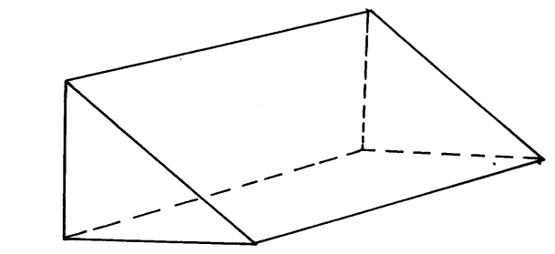

F

8 cm

D

C

6 cm

12 cm

B

12 cm

A

4. Use the mathematical tables to find:

(i) 86.462 (2 mark)

(ii)  (2 mark)

(iii) 0.5863673 (2mk)

(iv)  (2mks)

5. Agnes paid rent which was 1/10 of her net salary. She used ½ of the remaining amount to make a down payment for a plot. She gave her mother Kshs. 2,500 and did shopping worth Kshs. 7,500 for herself. She saved the remainder which was Ksh. 12,500. How much was the down payment that she made. (4mks)

6. A line passes through the point (-1, 2) and has gradient -½. Write down its equation in the form ***y = mx +c*** (3mks)

7. A Kenya company received US Dollars M. The money was converted into Kenya Shillings in a bank which buys and sells foreign currencies.

Buying (in Ksh) Selling (in (Ksh)

1 Sterling Pound 125.78 126.64

1 Us Dollar 75.66 75.86

(a) If the company received Ksh.15, 132,000, calculate the amount, M received in US Dollar. (2mks)

1. The company exchanged the above Kenya shillings into Sterling pounds to buy a car in Britain. Calculate the cost of the car to the nearest Sterling pound. (2mks)

8. From a balcony of a house, an observer notices that the angle of depression to the foot of a multi-storey building is 30o. The angle of elevation of the same building from the balcony is observed to be 500. Using a scale of 1 cm rep 10m, determine to the nearest meters the height of the building if the horizontal distance between the observer and the multi- storey building is 40m a part. (5 marks)

9. Solve for x in the equation

32(x-3) ÷8 (x-4) = 64 ÷2x (4mks)

10. use logarithms to evaluate  (4mks)

11. a) Fill in the table below for the given equations ( 2mks)

5x – 2y = 4

|  |  |  |  |
| --- | --- | --- | --- |
| X | -2 | 0 | 2 |
| Y |  |  |  |

X + y = 5

|  |  |  |  |
| --- | --- | --- | --- |
| X | -2 | 0 | 2 |
| Y |  |  |  |

b) write the two linear equations in the form ** = 1 (3mks)**

5x – 2y = 4 X + y = 5

c) copy and complete the table below. (2mks)

|  |  |  |
| --- | --- | --- |
| equation | y- intercept | x- intercept |
| 5x - 2y = 4 |  |  |
| X + y = 5 |  |  |

**Section II 50 marks**

12. A straight line L1 has a gradient ˉ½ and passes through point P (-1, 3). Another line L2 passes through the points Q (1, -3) and R (4, 5). Find.

(a) The equation of L1. (2mks)

(b) The gradient of L2. (1mk)

(c) The equation of L2. (2mks)

(d) The equation of a line passing through a point S (0, 5) and is perpendicular to L2. (3mks)

(e) The equation of a line through R parallel to L1. (2mks)

13. Four points A, B, C and D are situated on a horizontal plane such that B is 200m on a bearing of 0650 from A. C is 280m on bearing of 1200 from B and D is 160m due west of C.

(a) Draw a rough sketch showing the position of the four points. (1 mark)

(b) Using a scale 1cm rep 40m, draw an accurate scale drawing representing the position of A, B, C and D. (5 marks)

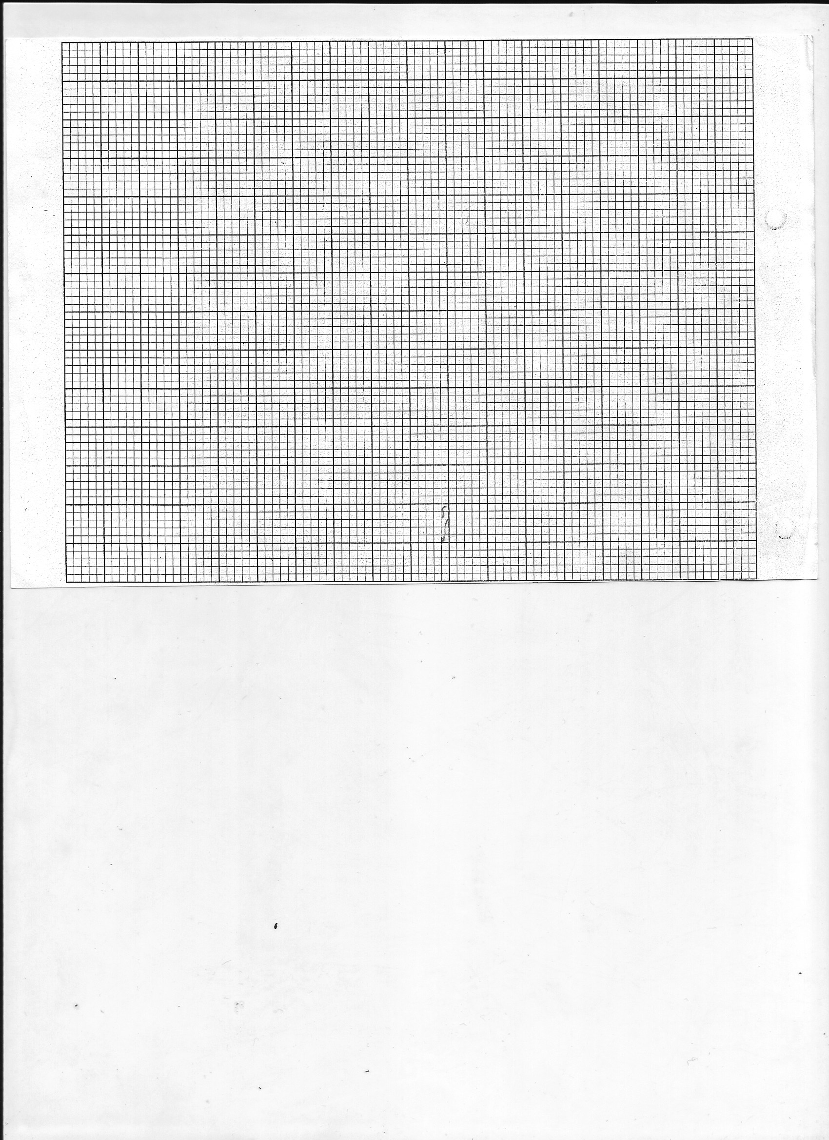

(c) By measurement use your scale drawing to find the distance and bearing of;

(i) D from A (2 marks)

(ii) B from D (2 marks)

14. A small field was surveyed and the measurements recorded in a surveyor’s field book as in the table below.

|  |  |  |
| --- | --- | --- |
|  | 100 | 0 **F** |
| **E** 30  **C** 20 | 65  50  30  20 | 40 **D**  25 **B** |
| **A** 0 | 0 |  |

(a) Using a scale of 1cm to 10m make an accurate drawing of the map of the field. (4mks)

(b) Find the area of the field. (3mks)

(c) Assuming that the baseline in (a) runs in a northern direction

(i) give the position of **D** relative to A using bearing and distance. (2mks)

(ii) Bearing of **D** from **B** (1mks)

15. Use a ruler and a pair of compasses only in this question.

1. Construct triangle ABC were AB = 6cm BC 7cm and ∠ ABC = 22½o  (3mks)
2. Drop a perpendicular from C onto line BA produced and measure its length, hence calculate the area of the triangle (4mks)
3. Construct a circle which touches the vertices of the above triangle. Measure length of its radius in cm. (3mks)

16. The figure below shows a frustum of a rectangular based pyramid. The height of the frustum is 12cm.

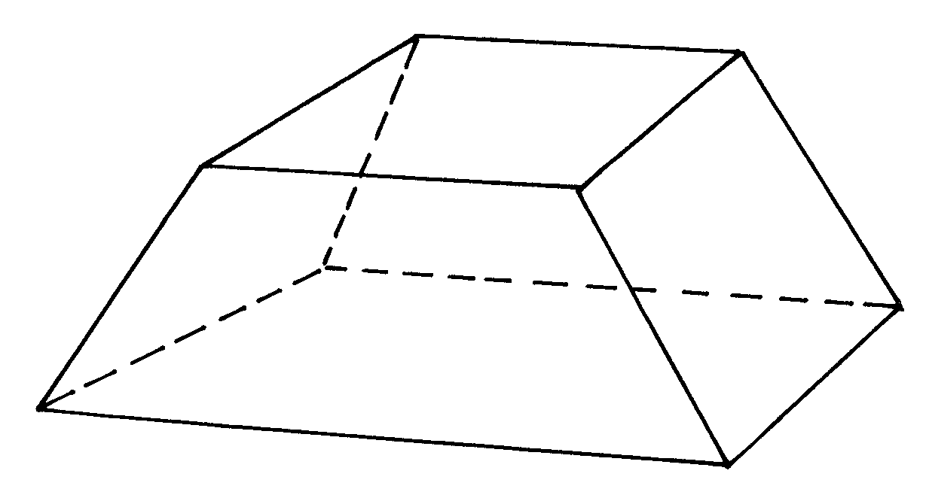

15 cm

5 cm

12 cm

4cm

12cm

1. Draw the net of the solid (4mks)
2. Find the area of the net. (6mks)