NAME…………………………………ADM NO…………DATE…………………
KISIRIRI SECONDARY SCHOOL
P.O. BOX 93-20500 TEL 0721-451-691
CAT ONE OF 3ND TERM 2013
FORM TWO
MATHEMATICS
ONE HOUR

- Find the equation of the line passing through (1,-2) and is parallel to the line 2y -3x + 4 = 0. Express your answer in the form ay + ax + c = 0 ( 4mks)

- The volume of water is measuring cylinder reads 200cm³. When a cube is immersed into the water, the cylinder reads 543cm^{3.} Find
a) the volume of the cube ( 1 mk)

b) The length of the side of the cube (2mks)

- Two similar cylindrical contains A and B have cross-section area in the ratio 9:16.

a) Determine the linear scale factor ( 1mk)

b) Find the radius of containers A if that of container b is 12cm (2mks)

- If sin A = 3/5 without using a calculator or mathematical tables find

a) Cos A (3mk)

b) Tan (90-A) (2mks)

- Find sin β and tan β given that cos β = 12/13 (4mks)

- Two similar jugs have capacities 0.25 litres and 2 litres respectively. If the circumference of the smaller jug is 5.8cm calculate the circumference of the larger jug. (3mks)

- The figure below represents s a hexagonal prism, whose height is 20cm. the cross – section
of the prism is a regular hexagon of side 5 cm.
- Calculate the volume of the prism; give your answer to 2dp (4mks)
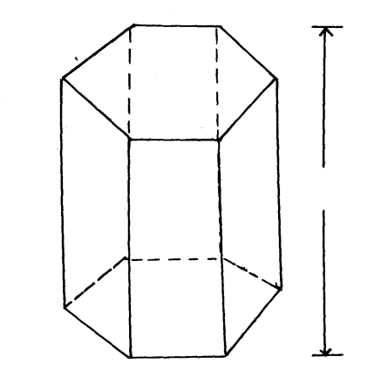
20cm
5cm

- If the above prism is a model of a solid of length 4m, calculate the volume of the solid (3mks)

- on the Cartesian plane below, triangle PQR has vertices P(2, 3), Q ( 1,2) and R ( 4,1) while triangles P” q “ R” has vertices P” (-2, 3), Q” ( -1,2) and R” ( -4, 1)
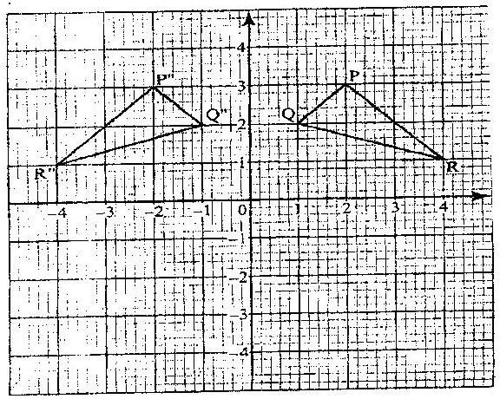

- Describe fully a single transformation which maps triangle PQR onto triangle P”Q”R” (2mks)

- On the same plane, draw triangle P’Q’R’, the image of triangle PQR,
under reflection in line y = -x (3mks)
(c) Describe fully a single transformation which maps triangle P’Q’R’ onto triangle P”Q”R (2mks)

(d) write the coordinates of triangle P”Q”R” which is an image of triangle PQR by a negative quarter turnabout (0, 0) (3mks)

6. a) Plot and draw trapezium ABCD where A(1,2) B(3,2) C(4,4) and D(0,4) on a graph paper ( 3mk)

Write down the image co-ordinates and draw images on the same set of axes
when trapezium ABCD is reflected in the lines shown.

b) Trapezium ABCE undergoes reelection in the line y =0 to give A₁B₁C₁D₁ (3mks)

c) Image A₁B₁C₁D₁ undergoes reflection in the line y= x to give A₂B₂C₂D₂ ( 3mks)

d) Draw and state equation of the line of symmetry of trapezium A₁B₁C₁D₁ ( 2mks)

e) Use trapezium above to state one pair of the trapezium that are oppositely
congruent ( 1mk)

