GATITU MIXED SECONDARY SCHOOL
MATHEMATICS FORM 2 END TERM CAT 1 TERM 3 2014
TIME: 1 ¼ HRS
- Evaluate using logarithm tables. 3mks
(79.36)³
8.2 × (9.2)²

- Without using tables or calculators, evaluate 3mks
Log 6 ¼ + log 1 3/5

- A straight line (L₁) has a gradient of - ½ and passes through the point p (-1, 3). Another straight line (L₂) passes through the point Q(1,-3) and R(4,5).find
- The equation of the line one(L₁₎ 2mks

- The gradient of line two (L₂) 2mks

- The equation of the line two(L₂) 2mks

- The equation of a line through R parallel to (L₁) 2mks

- The equation of a line passing through a point S (0,5) and perpendicular to L₂. 2mks

- When 55 is added to a certain number and the sum is divided by 3, the result is 4 times the original number. What is the original number? 2mks

- Six cows and five sheep cost ksh. 15, 7500. Five cows and four sheep cost ksh. 131,000. Find the cost of one cow and two sheep. 4mks

- Okeyo and Koech contributed sh. 120,000 and sh. 140,000 respectively to stat a business. They agreed that 25% of the profit will be shared equally, 25% of the profit will be shared in the ratio of their contributions, and 50% will be retained in the business. In the first year, the profit from the business amounted to sh. 195,000.
- How much did each receive? 6mks

- How much was retained in the business? 2mks

- Okeyo bought dairy cows with his share of the profit. How many cows did he buy if they cost sh. 16,000 each? 2mks

- Two translations T₁and T₂ are represented by the vectors 3 and 3 respectively. If L is the point (4,5), find -1 -2
- The image of L under T₁ 1mk

- The image of L under T₂ 1mk

- The image of L under T₁ followed by T₂ 1mk

- Find the value of X and Y 2mks

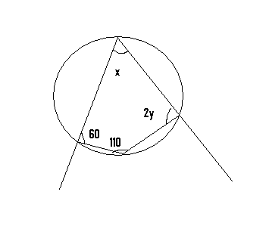

- Calculate the radius of a sphere whose volume is 259cm³ (take II=3.142) 3mks

