NAME ………………………………………… ADM NO ……………..
GATITU MIXED SECONDARY SCHOOL
MATHEMATICS FORM 2 TERM 3 2014 MID –TERM EXAM
Answer all the questions.
- Use logarithms to evaluate. 4mks
(0.07284)²

3√0.06195

- Without using a calculator evaluate 3mks
14 ÷ 1/3 of 5 ¼ -3 ¾ × 1 1/3

3/5 × 6 ¼ +1 ½

- The ratio of the lengths of the corresponding sides of two similar rectangular water tank is 3:5 .the volume of the smaller tank is 84m³. Calculate the volume of the larger tank. 3mks

- Find the value of x in the following equation. 3mks

49^{(x+1)} + 7^{2x} = 350

- Four farmers took their goats to the market. Mohammed had two more goats than Ali. Koech 3 times as many goats as Mohammed , whereas Oduboy had 10 goats less than both Mohammed and koech.
- Write a simplified algebraic expression with one variable, representing the total number of goats. 1mk

- Three hutches bought all the goats and shared them equally. If each butcher got 17 goats. How many did Oduboy sell to the butchers. 3mks

- Express 0.7373…….. as a fraction. 2mks

- The ages of Sarah and Rose are in the ratio of 4:5 . the ages of Rose and Anne are in the ratio of 3:2 if Anne is 20 years old,how old is Sarah. 3mks

- A motorist took 2 ¾ hrs to travel from town A to B . if he started the journey at 10.30a.m, determine the time the journey ended in:
- 24 hour system 3mks

- 12 hour clock system 2mks

- A perpendicular in the line x/4 + y/3 =1 passes through the point ( 4,-5) determine its equation. 3mks

- When the angle of elevation of the sun is 58 a vertical pole casts a shadow of length 5 m on a horizontal ground. Find the height of the pole. 3mks

- Solve the following inequalities and represent the solution on a number line. 3mks
2x -5 < x -3 < 3x -6

- show the region satisfied by the inequalities. 4mks
y <x , x ≤ 4 and x+ y <6

- A motorist covers a distance of 120 km at a speed of 80km/hr and a further 150km at a speed of 90km/hr. find his average speed for the whole journey. 3mks

- Solve the simultaneous equations. 3mks
3X – 2Y =7
5X +Y =3

- Solve the equation 2mks
X -2 - 3 - X = X - 2
3 4 2

- Factorise 3x² – 11x + 6 2mks

- The fig shows a circle centre O and a cyclic quadrilateral ABCD. Angle ACB =40⁰ angle DAC =20 and AOC is a straight line.
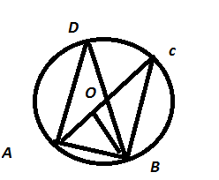
find the size of
- Angle ADB 2mks

- Angle BAC 2mks

- Angle ACD 2mks

- Angle CBD 2mks

- Reflex angle AOB 2mks

- The fig shows two circles centre A and B and radii 6 cm and 8 cm respectively. The circles intersect at P and Q angle PAB =42⁰ and ABQ =30⁰

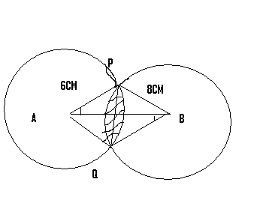

- Find the size of angle PAQ and PBQ 2mks

- Calculate to one decimal place the area of
- Sector APQ and PBQ 2mks

- Triangle APQ and PBQ 2mks

- The shaded area. (Take II = 22/7 ) 4mks

- The internal measurements of a lampshade below are 30 cm in diameter at the bottom and 20 cm at the top. Find the volume of the lampshade. 10mks
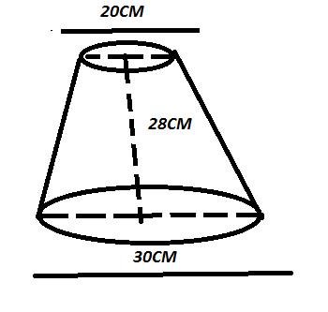

ALL THE BEST

