*MATHEMATICS FORM THREE MARKING SCHEME TERM I 2019*

1. *. $=\frac{+8+-4}{-24}+\frac{-22}{46-33-3}$* M1

*= $\frac{4}{-24}+\frac{-22}{33}$* M1

*= $\frac{-1}{6}-\frac{2}{3}$* M1

$=\frac{-5}{6}$ A1

$2^{x-3}×8^{x+2}=128$

$2^{x}×2^{-3}×2^{3(x+2)}=2^{7}$ M1

$$2^{x}×2^{-3}×2^{3x}×2^{6}=2^{7}$$

$2^{4x}×2^{3}=2^{7}$ M1

$$2^{4x}=\frac{2^{7}}{2^{3}}$$

$$2^{4x}=2^{4}$$

$$4x=4$$

$x=1$ A1

|  |  |  |
| --- | --- | --- |
|  | $$\frac{{4x}^{2}-{16x}^{2} }{{6x}^{2}- 8xy- {8y}^{2}}$$ $$\frac{\left(2x+4y\right)\left(2x-4y\right)}{\left(2x+4y\right)\left(3x-2y\right)}$$ $$\frac{2x-4y}{3x-2y}$$ | M1 for factorizing numerator and denominator M1  A1 |
|  |  | 3 Marks |

|  |  |  |  |
| --- | --- | --- | --- |
|  | NO. | LOGS |  |
|  | 1.6542  4.573X101  5.6X10-1  4.745X10-1  = 0.4745 | 0.2185X2 = 0.4370  1.6602  + $\overline{1}$ .7482  1.4084 =1.4084 $\overline{1}$ .0286  3 $\frac{-3}{3}$ + $\frac{2.0286}{3}$ = $\overline{1}$.6762 | M1  M1  M1  A1 |

1. (a) $\frac{2}{3}x+\frac{5}{7}y=1$

$$\frac{5}{7}y=-\frac{2}{3}x+1$$

$$y=\frac{-14}{15}x+\frac{7}{5}$$

Gradient of L $=\frac{15}{14}$ B1

(b) $\frac{15}{14}=\frac{y-11}{x-4}$ M1

$$14y-154=15x-60$$

$$14y=15x+94$$

$y=\frac{15}{14}x+\frac{47}{7}$ A1

$90(2n-4)=1260$

$2n-4=14$ M1

$$2n=18$$

$n=9 sides$ A1

Nonagon B1

|  |  |  |  |
| --- | --- | --- | --- |
| 1. 2s + 3t = 1750 x 2 M1   3s + 2t = 1500 x 3 M1  4s + 6t = 3500  9s + 6t = 4500  -5s = -1000  Shirt =shs.200  Trouser =shs. 450 A1 | | | |
|  | Ksh = 6000 x 84.15 -300,0000  = ksh. 204, 900  204, 900÷121.47= 1686. 84 | M1M1  A1 |  | |

|  |  |
| --- | --- |
| 7x – 4 ≤ 9x + 2 ..(i)  9x + 2 < 3x + 14(ii)  Solving (i)  7x – 4 ≤ 9x + 2  -2x ≤ 6  x ≥ -3  Solving equation (ii)  9x + 2 < 3x + 14  6x < 12  x < 2  Combining (i) and (ii)  -3 ≤ x < 2  -3 – 2 -1 0 1 2  Integral values are  -3, -2, -1, 0, 1 | ✓Solving equation (ii)  ✓Solving equation (ii)  ✓B1 Solution represented on number line  ✓A1 Integral values |
|
|  | 4 maks |

|  |  |  |  |
| --- | --- | --- | --- |
|  | LCM = 7920 = 24x32x5x11  GCD = 12 = 22x3  48 = 24x3  264 = 23x3x11  X = 22x32x5  X = 180 | M1  M1  A1 | Factor notation GCD and LCM  Factor notation 2numbers |
|  | Height of tower $=15×\tan{62}$ $=28.21$  Distance of John from the foot tower $=28.21÷\tan{30}$ $=48.86$ $$48.86-15=33.86M$$ | M1  M2  A1 |  |
|  | $$=\sqrt{\frac{2}{5.893×{10}^{-1}}-}\frac{1}{8.463×10}$$ $=\sqrt{2×0.1697×10-1×0.1182×{10}^{-1}}$ $$=\sqrt{3.394-0.01182}$$ $$=\sqrt{3.382}$$ $$=1.839$$ | M1M1  A1 | Reciprocals and **multiplication** |
|  | L.S.F $=\frac{8}{10}=\frac{4}{5}$ A.S.F. $=\frac{16}{25}$ S.A $=\frac{16}{25}×480$ $$=307.2$$ |  |  |
|  | Let the digits be x and y  x + y = 16 ……….. (i)  original no. = 10x + y  reversed no. = 10y + x  (10y + x) – (10x + y) = 18 ii  x + y = 16  9y – 9x = 18  9y + 9x = 144  9y – 9x = 18  18x = 126  x = 7  y = 9  The no. is 79 | B1  M1  A1 | Both equations (i) and (ii) |
|  | 1. (i) 4p – 3q =   P + 2q =    -11q =  q =        and | M1  M1 |  |
|  | Maximum perimeter = 2(12.05 + 8.05) = 40.2cm  Actual perimeter = 2(12.0 + 18.0)= 40.0cm  Error = 40.2cm – 40.0cm = 0.2cm  %error = (0.2 x100)  40  = 0.5% | M1  M1  A1 |  |
|  | 1. Let d be distance between N and M   Time taken from N-M  T= $\frac{d}{70}$ M-N= $\frac{d}{50}$ $$\frac{d}{50}-\frac{d}{70}=4$$ $$7d-5d=4×350$$ $$2d=1400$$ $$d=700km$$ $0.32×700=224l$ $$700×0.32×1.25=280l$$ Total $=224+280$ $$=504l$$ $65×504×3=98280$ $$98280×4×5=1965600$$ | B1  M1  M1  A1  M1  M1  A1  M1  M1A1 |  |
|  | (a)    (b) Area1 = ½ x 2 x 3 = 3cm2  Area2 = ½ x 4(5+3) = 16cm2  Area3 = ½ x 5 x 4 = 10cm2  Area4 = ½ x2x4 = 4cm2  Area5 = 4 x 4 = 16cm2  Area6 = ½ x 4 x 4 = 8cm2  Total area = (3+16+10+4+16+8)cm2  = 57cm2  Actual area = (57x100)m2  = 5700m2  (c) 10,000m2 = 1ha  5700m2 = ?  1 x 5700  10,000  = 0.57ha | S1  B1  B2  B1  B1  M1  A1  M1  A1 | Scale  Base line  Offsets (all – offsets) A want B1 for at least 2 |
|  | 1. (X + ¾ ) (x – 2/3) = 0   X2 – 2/3x + ¾ x – 6/12 = 0  X2 – 1/12x – 6/12 = 0  12x2 + x – 6 = 0   1. i) 9x + x2 – 136 = 0   x2 + 17x – 8x – 136 = 0  x(x + 17) – 8(x + 17) = 0  (x – 8) (x + 17) = 0  X = 8  Or x = -17  Perimeter = 50   1. 2x2 = 136 – 0.0064   2x2 – 135.9936  X2 = 97.9968  X= 8.246  Dimension 8.24m by 16.492m | M1  M1  A1  M1  M1 |  |

|  |  |  |  |
| --- | --- | --- | --- |
| 20. | a)PRS=200  (s in the semi-circle)  b) Obtuse POQ=1400( at the centre is twice that on the circumference)  Reflex POQ=2200(s at a point add up to 3600)  c)RPS=1800-(700+550+200+200)  (sum of angles in a triangle  d) PSR=1800-(700+550+200)  =350(opposite s of a cyclic quadrilateral add up to 1800)  e) Reflex POS=1800+1400  = 3200  or 3600-400  =3200(s at a point) | B1,  B1  B1,  B1  B1  B1  B1  B1  B1  B1 |  |
|  |  | 10mks |  |

21.

|  |  |  |  |  |  |
| --- | --- | --- | --- | --- | --- |
| Length  (cm) | Mid pt  (x) | F | xf | CF |  |
| 118 -126 | 122 | 3 | 366 | 3 |  |
| 127 – 135 | 131 | 4 | 524 | 7 |  |
| 136 – 144 | 140 | 10 | 1400 | 17 |  |
| 145 – 153 | 149 | 12 | 1788 | 29 |  |
| 154 – 162 | 158 | 5 | 790 | 34 |  |
| 163 – 171 | 167 | 4 | 668 | 38 |  |
| 172 – 180 | 176 | 2 | 352 | 40 |  |
|  |  | 40 | 5888 |  |  |
| (a) (i) Modal class ⇒ 145 – 153  (ii) Median class 145 – 153  (b) (i) Mean of feeding  x = $\frac{ xf}{f}$ = $\frac{5888}{40}$ 147.2  (ii) Median = L ( $\frac{\frac{n+1}{2}-c}{f}) i$ = 144.5 + ($\frac{\frac{41}{2}- 17}{12}$)9  144.5 + $\frac{20.5-17}{12}$ x 9  144.5 + 2.625  = 147.125 | | | | B1  B1 C.F column  B1 median class  B1 mid point  B1 xF column  M1  A1  M1 Substitution  M1 attempt to simplify  A1 | |
|

. 22.

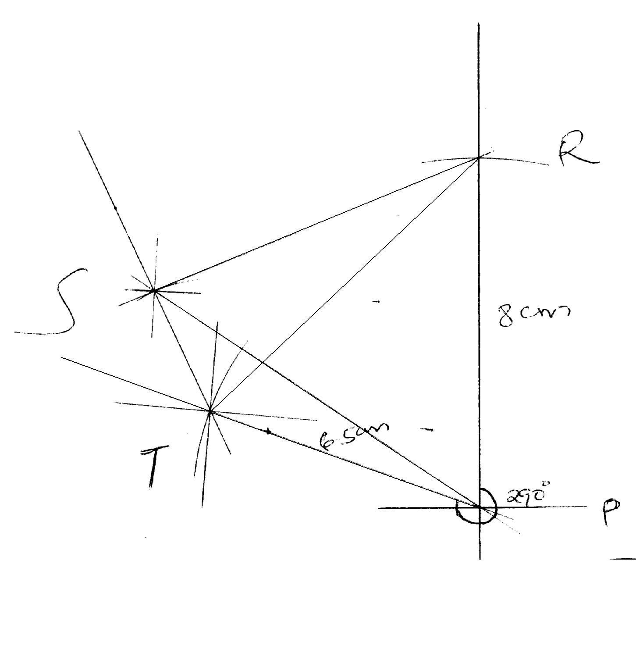

a) 84km, 0420

b) 80km, 0650

c) 1200

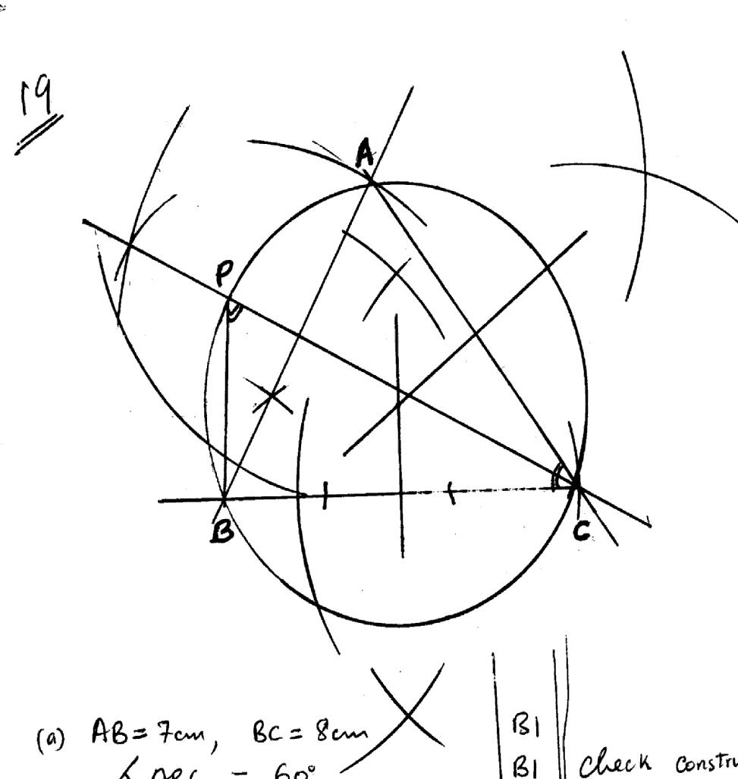23.

a) ∆ ABC line AB = 7 cm and BC = 8 cm.

Construction of ∡60o

(b) AC = 7.6 + 0.1 and

∡ ACB = 53 + 1o

(c) 2 sides bisector 1

Circle drawn radius 4.4. ± 0.1

(d) Bisect ∡ ACB

Bisection line to cut the circle to identify P

∡ PBC measure ≡

(a) AB = 7 cm, BC = 8 cm

∡ ABC = 60o

(b) AC = 7.6 + 0.1 cm

-

∡ ABC = 53o±0.1

(c) Perpendicular bisectors of any two sides.

Circle drawn

Radius = 4.4.±0.1. cm

(d) ∡ ACB bisected

Bisection line drawn to cut circle at P

∡BPC = ∡BAC = 67o

∡ PBC = 88 ± 0.1o

|  |  |  |  |
| --- | --- | --- | --- |
| 24. | a)    < PAQ = <PAM + <QAM  < PAM = sinθ1 =  Sin -1 (0.4286) = 25.380  < QAM = <PAM = 25.38  →<LAP = 25.38x2= 50.76  b) <PBQ = < PBM + <QBM  < PBM = sin∝1 =  Sin-1 (0.5357) = 32.390  < PBM = <QBM = 32.390  <PBQ = 32.390x 2 = 64.78  c)i)    area of segment = area of a section – area of D  Taking (i)  =  = 48.84 – 42.69 = 6.15cm2  Taking (ii)  =  = 39.89 – 31.92 = 7.97cm2  = (6.15 + 7.97) cm2 = 14.12cm2 | M1  A1  M1  A1  M1  B1  M1M1  B1  A1 |  |
|  |  |  |  |