NAME :…………………………………………………….……….ADM.NO ………...............CLASS…………………
SCHOOL………………………………………………………………………
MATHEMATICS
TIME: 2 ½ HOURS
FORM 3

MALIET –JOINT EXAM
Kenya Certificate of Secondary Education (K.C.S.E)

INSTRUCTIONS TO CANDIDATES:
- Write your name and Admission Number in the spaces provided above
- This paper contains two sections; Section I and section II.
- Answer all the questions in section I and only five questions from section II.
- All workings and answers must be written on the question paper in the spaces provided below each question.
- Marks may be given for correct working even if the answer is wrong.
- Non-programmable silent electronic calculators and KNEC mathematical tables may be used except where stated otherwise
- Show all the steps in your calculations, giving your answers at each stage in the spaces below each question
For Examiner’s Use Only;
Section I
1 | 2 | 3 | 4 | 5 | 6 | 7 | 8 | 9 | 10 | 11 | 12 | 13 | 14 | 15 | 16 | TOTAL
Section II

GRAND TOTAL
t
TOTAL
Question | 17 | 18 | 19 | 20 | 21 | 22 | 23 | 24 | TOTAL
Marks

SECTION 1(5OMARKS)
Answer ALL questions in the section

- Without using a calculator or mathematical tables, evaluate leaving your answer as a simple fraction. (4mks)
$\frac{\left(-4\right)\left(-2\right)+\left(-12\right)÷(+3)}{-9-15}+\frac{-20+4+(-6)}{46-(8+2)-3}$

- Find the value of x (3mks)
2^{(x-3)} x 8^{(x+2)} = 128

- Simplify the expression. (3mks)
$$\frac{{4x}^{2}- {16y}^{2}}{{6x}^{2}- 8xy- {8y}^{2}}$$

- Use logarithms to evaluate,$\sqrt[3]{\frac{{(1.654)}^{2}}{45.73×0.56}}$ (4mks)

- A line L is perpendicular to the line $\frac{2}{3}x+\frac{5}{7}y=1.$ Given that L passes through (4, 11), find:
- Gradient of L; (1mk)

- Equation of L in the form $y=mx+c,$ where m and c are constants. (2mks)

- The sum of the interior angles of an n-sided polygon is 1260º. Find the value of n and
hence deduce the polygon. (3mks)

- John bought two shirts and three pairs of trousers at ksh 1750.If he had bought three shirts and two pairs of trousers he would have saved sh 250.Find the cost of a shirt and a trouser (3mks)

- Foreign exchange on 27/5/2010 was given as follows:.
Currency | Buying (Kshs) | Selling (Kshs)
1 Euro | 84.15 | 84.26
1 Sterling pound | 118.35 | 121.47
A tourist came to Kenya from London with 6000 Euros which he converted to Kenya shillings at a bank. While in Kenya he spent a total of Kshs.300, 000 then converted the balance into sterling pounds at the same bank. Calculate the amount in sterling pounds he received. (3mks)

- Solve the following inequalities and represent the solution on a number line and hence state the integral values of x: 7x – 4 ≤ 9x + 2 < 3x + 14 (4 marks)

- The LCM of three numbers is 7920 and their GCD is 12. Two of the numbers are 48 and 264. Using factor notation find the third number if one of its factors is 9. (3mks)

- Peter is 15m away from the bottom of a tower. He spots a bird on top of the tower at an angle of elevation of 62⁰. Also John spots the same bird at an angle of elevation of 30⁰. Find the distance between John and Peter if they are on the same line. (3mks)

- Use tables of reciprocals and square roots to evaluate. (3mks)
$$\sqrt{\frac{2}{0.5893}-\frac{1}{846.3}}$$

- Two similar cans have different heights 8cm and the other one 10cm. If the surface area of the larger can is 480cm², find the surface area of the smaller can. (3mks)

- The sum of digits formed in a two digit number is 16. When the number is subtracted from the number formed by reversing the digits, the difference is 18. Find the number. (3mks)

- Given that $4p-3q=\left(\begin{matrix}10 \\ 5\end{matrix}\right)$ and $p+2q=\left(\begin{matrix}-14 \\ 15\end{matrix}\right)$ (3mks)

- A rectangular room has length 12.0 metres and width 8.0 metres. Find the maximum
Percentage error in estimating the perimeter of the room. (3mks)

SECTION II: (50 MARKS)
Answer only FIVE questions from this section
- Abus travelling from Nakuru to Mandera averages at a speed of 70km/hr and on the return journey, the bus averages 20km/hr slower and takes 4 hours longer than on the journey from Nakuru to Mandera.
a) Find the distance between Nakuru and Mandera. (4mks)

b) Diesel consumption is 0.32 litres per kilometre on the journey from Nakuru to Mandera. However, this rate increases by 25% on the return journey. Calculate the amount of diesel the bus consumes for the trip. (3mks)

c) If diesel costs sh.65 per litre and the bus makes 3 round trips in a week, determine the total cost of diesel required to run the bus for 5 months. (3mks)

- A field was surveyed and its measurements recorded in a field book as shown below.
E 40  C 40 | F  100  80  60  40  20  A | D 50  B 30

(a) Using a scale of 1cm to represent 10m, draw a map of the field. (4mks)

(b) Calculate the area of the field:
(i) in square metres. (4mks)

(ii) in hectares. (2mks)

- a) Find the quadratic equation whose roots are $\frac{-3}{4}and\frac{2}{3}$ and write it in the form
ax² + bx + c = 0 where a, b and c are integers. (3mks)

b).The length of a floor of a rectangular hall is 9m more than its width. The area of the floor is 136m².
- Calculate the perimeter of the floor (4mks)

- A rectangular carpet is placed on the hall leaving am area of 64cm². If the length of the carpet is twice its width, determine the width of the carpet (2mks)

- The figure below shows a circle centre O. PQRS is a cyclic quadrilateral and QOS is a straight line.
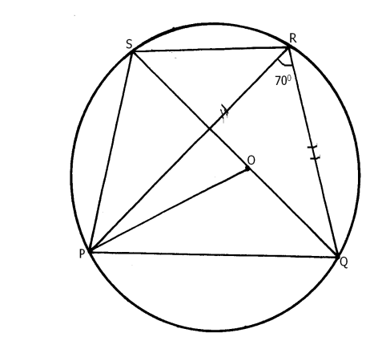
Giving reasons for your answers, find the value of:
a) <PRS. (2mks)

b) <POQ. (2mks)

c) <RPS. (2mks)

d) <PSR. (2mks)

e) Reflex <POS. (2mks)

- The table below shows the length of 40 seedlings.
Length in (mm) | Frequency
118-126 | 3
127 – 135 | 4
136 – 144 | 10
145 – 153 | 12
154 – 162 | 5
163 – 171 | 4
172-180 | 2
Determine
(a) (i) The modal class (1mk)

(ii) The median class (2mks)

(b) (i) The mean of the seedlings (4mks)

(ii) The median of the seedlings (3mks)

- Four towns P, R, T and S are such that R is 80km directly to the north of P and T is on a
bearing of 290° from P at a distance of 65km. S is on a bearing of 330° from T and a distance of 30 km. Using a scale of 1cm to represent 10km, make an accurate scale drawing to show the relative position of the towns. (4mks)

Find:
(a) The distance and the bearing of R from T. (3mks)

(b) The distance and the bearing of S from R. (2mks)

(c) The bearing of P from S (lmk)

- Use ruler and a pair of compasses only in this question.
- Construct triangle ABC in which AB = 7 cm, BC = 8 cm and ∠ABC = 60⁰.

- Measure
(i) Side AC
(ii) ∠ ACB
- Construct a circle passing through the three points A, B and C. Measure the radius of the circle.

- Construct ∆ PBC such that P is on the same side of BC as point A and
∠ PCB = ½ ∠ ACB, ∠ BPC = ∠ BAC measure ∠ PBC.

24. The figure below shows two circles of radii 10.5 and 8.4cm and with centres A and B respectively. The common chord PQ 9cm.
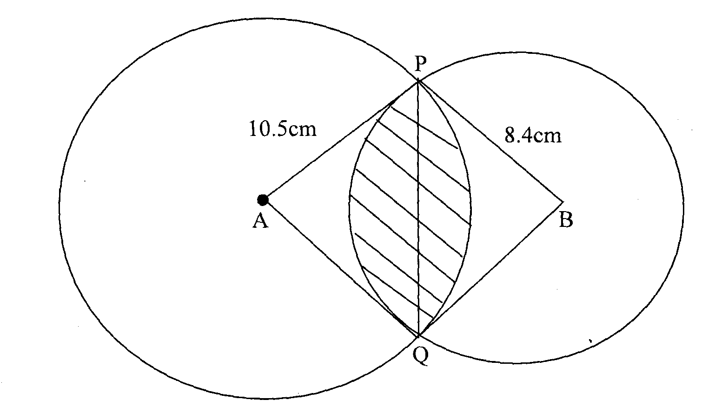
(a) Calculate angle PAQ. (2mks)

(b) Calculate angle PBQ. (2mks)

(c) Calculate the area of the shaded part. (6mks)

