NAME …………………… …………………INDEX NO ………………………….……
SCHOOL.…………………………………. CANDIDATE’S SIGN……...…… DATE……………..
121/1
MATHEMATICS ALT. A
Paper 1
MARCH/APRIL 2019
Time: 2 ½ Hours
MALIET EXAM-2019
Kenya Certificate of Secondary Education. (K.C.S.E)

121/1
MATHEMATICS ALT. A
Paper 1
Time: 2 ½ Hours
INSTRUCTION TO CANDIDATES
a) Write your name and Index number in the spaces provided above.
b) Sign and write the date of examination in the spaces provided above.
c) The paper consists of two sections. Section I and Section II.
d) Answer ALL the questions in Section I and any FIVE questions in Section II.
e) Show all the steps in your calculations, giving your answer at each stage in the spaces provided
below each question.
f) Marks may be given for correct working even if the answer is wrong.
g) Non-programmable silent electronic calculators and KNEC Mathematical tables may be used
except where stated otherwise.
h) Candidates should answer the questions in English.
i) This paper consists of 16 printed pages.
j) Candidates must check the question paper to ascertain that all pages are printed as indicated
and that no question(s) is/are missing.

FOR EXAMINER’S USE
SECTION I
1 | 2 | 3 | 4 | 5 | 6 | 7 | 8 | 9 | 10 | 11 | 12 | 13 | 14 | 15 | 16 | Total

SECTION II

17 | 18 | 19 | 20 | 21 | 22 | 23 | 24 | Total

Grand Total

SECTION I: (50 MARKS
- Without using calculators evaluate: (3mks)

- Find the possible values of X in the equation $9^{X^{2}}$ = 27^{(2X + 12)} (3mks)

- . A Kenyan tourist left Germany for Kenya through Switzerland. While in Switzerland he bought a watch worth 52 Deutsche marks. Find the value of the watch in:-
(a) Swiss Francs
(b) Kenya shillings (3 marks)
Use the exchange rates below
1 Swiss Franc = 1.28 Deutsche marks
1 Swiss Franc = 45.21 Kenya shillings

- Juma, Ali and Hassan share the profit of their business in the ratios 3:7:9 respectively. If Juma receives sh 60 000. How much profit did the business yield? (3mks)

- Simplify the expression. (3 Marks)
$$\frac{{4x}^{2}- {16y}^{2}}{{ 6x}^{2}- 8xy- {8y}^{2}}$$

- Given that x is an acute angle and cos x° = ²/₅√5 find, without using mathematical tables or a calculator, tan (90 — x) °. (2 marks)

- Find the equation of the line perpendicular to 3x – 7y – 20 = 0, and passes through the point (5,2)
(3 Marks)

- The sum of the interior angles of a regular polygon is 1080⁰. Calculate
- The number of sides of the polygon (2 Marks)

- The sizes of the exterior and interior angles of the polygon. (2 Marks)

- The diagram below shows a region R bounded by three lines L₁, L2 and L₃
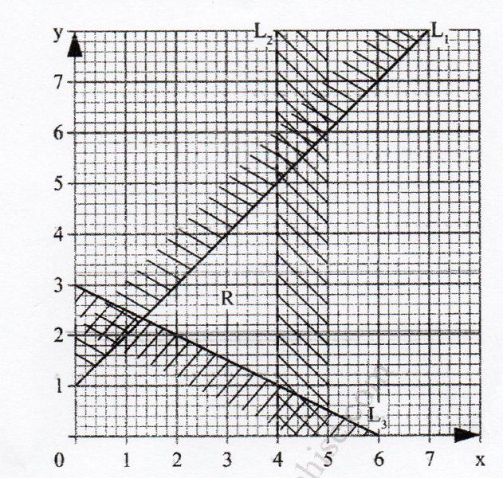
Form three inequalities that satisfy the given region R (3Marks)

- The figure below shows a net of solid (measurements are in centimeters).

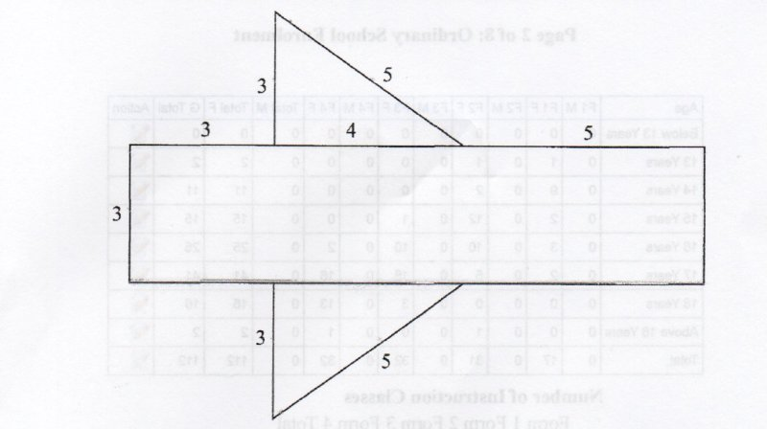

Below is a part of the sketch of the solid whose net is shown above. Complete the sketch of the solid, showing the hidden edges with broken lines (3Marks)

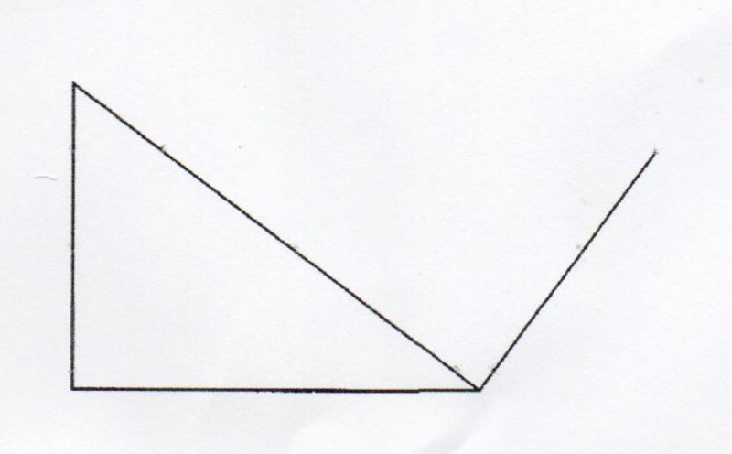

- Use tables of cubes, square roots and reciprocals to evaluate (3 mks)
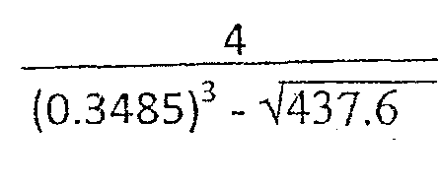

- Peter is 15m away from the bottom of a tower. He spots a bird on top of the tower at an angle of elevation of 62⁰. Also John spots the same bird at an angle of elevation of 30⁰. Find the distance between John and Peter if they are on the same line. (3mks)

- Three similar pieces of timber of length 240cm, 320cm and 380cm are cut into equal pieces. Find the largest possible area of a square which can be made from any of the three pieces.(3 Marks)

- Two similar containers have capacities of 540cm³ and 160cm³. The small one has a base area of 25cm². Find the height of the larger one. Leave your answer to (4sf) (4marks)

- Wanza sold a bag of potatoes for Sh. 420 and made a profit. If she sold it at Sh. 320, she could have made a loss. Given that the profit is thrice the loss, how much did she pay for the bag of potatoes? (3 Marks)

- A rectangular water tank measures 2.6m by 4.8m at the base and has water to a height of 3.2m. Find the volume of water in liters that is in the tank. (4marks)

SECTION II (50 MARKS)
Answer Only Five Questions in This Section

- Four towns A,B,C and D are such that B is on a bearing of 247º and 6km from A. C is due SE and 4.8km from B. D is to the south of A and the bearing of C from D is S44ºW
(a) Make a scale drawing showing the relative positions of A,B,C and D using the scale 1cm represents 1km (4marks)

(b) Use your drawing to determine
(i) The bearing of A from C (1mark)

(ii) The distance between C and D (1mark)

(iii) How far D is east of B (1mark)

(c) The average speed of a cyclist from C to A if he takes 30 minutes between A and D and
20 minutes between D and A (3mks)

- In the figure below, O is the centre of the circle TOR is the diameter and PRV is tangent to the circle at R.
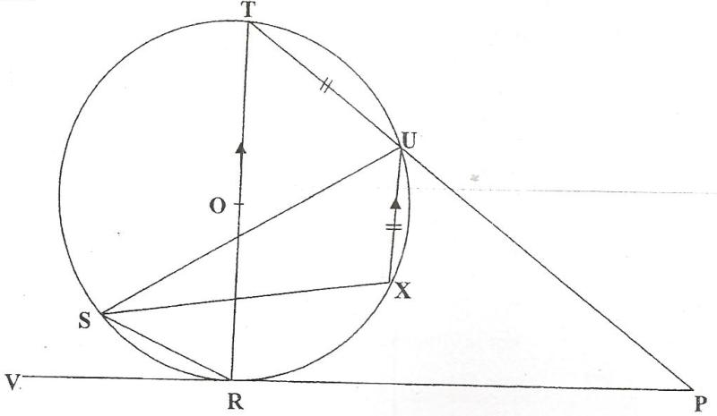

Given that <SUR = 25⁰, <URP = 60⁰, TU = UX is parallel to the diameter; giving reasons calculate;
- <TOU (2 marks)

- <XUP (2 marks)

- <STR (2 marks)

- Reflex <SXU (2 marks)

- <RPU (2 marks)

- The diagram below shows the speed-time graph for a bus travelling between two stations. The bus
begins from rest and accelerates uniformly for 30 seconds. It then travels at a constant speed for 60
seconds and finally decelerates uniformly for 40 seconds.
Speed
(m/s)
Time in seconds

Given that, the distance between the two stations in 2090m. Calculate
(a) The maximum speed, in km/h the bus attained (3 Marks)

(b) The acceleration (2 Marks)

(c) The distance travelled during the last 20 seconds (2 Marks)

(d) The time the bus takes to travel the first half of the journey (3 Marks)

- (a) complete the table below for the function y = 2 x ² + 4 x -3 (2marks)

X | -4 | -3 | -2 | -1 | 0 | 1 | 2
2x² | 32 |  | 8 | 2 | 0 | 2
4x-3 |  |  | -11 |  | -3
Y |  |  | -3 |  |  | 3 | 13
(b) Draw the graph of the function y = 2x² + 4x – 3 on the grid provided. (3marks)
(c) Use your graph to estimate the roots of the equation 2x² + 4x – 3 = 0 (1mark)

- Use your graph to obtain the roots of the equation 2x² + x – 5 = 0 to 1 decimal place. (3marks)

- Draw the line of symmetry to pass through the turning point of this curve. (1mark)

- . The diagram given below show triangle OAB. OA = a, OB = b C divides OA in the ratio 2:3 and D
divides OB in the ratio 3:4 while AD and BC meet at E.

A
B
D
O
C

Find in term of a and b
~
~
(a) (i) OC (2 Marks)
~

(ii) CB (4 Marks)
~

(b) Given that CE = mCB and DE = nDA where m and n are scalars
~
~
~
~
(i) Write down two distinct expressions for OE (2 Marks)
~

(ii) Hence find the values of m and n (4 Marks)

(iii) Find OE in terms of a and b only (1 Mark)
~
~
~

- Find
2.8cm
3.5.cm
h = 5cm

(a) The surface area of the frustrum (5 Marks)

(b) The volume of frustrum shown. (5 Marks)

- The table below gives a field book showing the results of a survey of a section of a piece of land
between A and E. All measurements are in metres.
D33  C21  B 42 | E  95  90  70  30  25  A | F 36  G 25  H 40
(a) Draw a sketch of the land. (4marks)

(b) Calculate the area of this piece of land in hectares (6marks)

- (a) Given that A = 3, X and B = 1, 2 find values of x for which AB is singular matrix.
x+1, 2 3, 0 (4marks)

(b) Mambo bought 3 exercise books and 5 pens for a total of ksh 165. If Mambo had bought 2 exercise books and 4 pens, he would have spent ksh 45 less. Taking x to represent the price of an exercise book and y to represent the price of a pen:
(i) Form two equations to represent the above information (1mark)

(ii) Use matrix method to find the price of an exercise book and that of a pen. (3marks)

(iii) A teacher of a class of 36 students bought 2 exercise books and 1 pen for each student. Calculate the total amount of money the teacher paid for the books and pens (2marks)

