**MALIET 121/2 MARKING SCHEME TERM 1 2019**

|  |  |  |
| --- | --- | --- |
| 1 | No. Log  1.23 0.0899  +  0.0468 2.6702  2.7601  Log6 = 0.7782 1.8911  2.8690÷3 $\sqrt[3]{}$ 3+1.8690  3  1+0.6230  4.198 x 10-1 1.6230  or 0.4198 | M1 All logs  M1 Operations + and -  M1 dividing by 3  A1 in stand form or equivalent |
|  |  | 4 Marks |
| 2. | $$\frac{1}{2+ \frac{1}{\sqrt{2}}}$$ $$\frac{1}{2+ \frac{2}{\sqrt{2}}}$$ $\frac{2}{4+ \sqrt{2}}$ x $\frac{(4- \sqrt{2})}{(4-\sqrt{2})}$ $$\frac{ 8-2\sqrt{2}}{14}$$ $\frac{4}{7}$- $\frac{1}{7}\sqrt{2}$ | M1 Sin 450 rationalized  B1 Attempt to rationalize  M1  A1 |
|  |  | 3 Marks |
| 3 |  | B1  M1  A1 |
|  |  | 3marks |
| 4. | S2 =  S2n = r2 + 2xb  r2 = S2n – 2xb  r = ± | M1 Removal of sign  M1  A1 |
|  |  | 3 Marks |
| 5. | Total cost of blend  = $\frac{\left(84 x 350\right)+ (140 x 105)}{350+140}$ = KSh. 90  = KSh. 90  KSh. 90 = 100%  ? = 125% $\frac{125 x 90}{100}$ = Sh. 112.50 | M1ALT  A1  B1 |
|  |  | 3marks |
| 6. |  | M1 for apply laws of log  M1 for quadratic equation  A1 for both correct values of x |
| 7. |  | M1 for the equation  M1 for factors  A1for Centre |
| 8 | (a)    (b) | M1 for expansion  A1for correct answer  M1 For substitution  A1 for the answer |
| 9 | (2i – j – 2k) – (i + 2j – 3k)  i – 3j + k    |AB| = | M1 or equivalent  A1 or equivalent to 4 figures |
|  |  | 2 Marks |
| 10 |  | B1  M1for equation  M1 for solving  A1 for rate |
| 11. | (i) Ø = Ar + $\frac{b}{R^{2}}$ a + b = 3 ………… (i) $\frac{1}{2}$ a + 4b = 5………...(ii)  7b = 7  b = 1  ∴a = 3 – 1 = 2  Ø = 2R + $\frac{1}{R^{2}}$ | M1 Attempt to solve simultaneously  A1  B1 |
|  | (ii) Ø = 2 x $\frac{3}{2}$ + $\frac{1}{{(3/2)}^{2}}$ 3 + $\frac{4}{9}$ = 3 $\frac{4}{9}$ | B1 |
|  |  | 4 Marks |
| 12 |  | M1 for substitution  M1for solving equation  A1 For sin x  B1 for values of x |
| 13 | Inverse = $\frac{1}{2}$ $\left(\begin{matrix}4 & -2 \\ -5 & 3\end{matrix}\right)$ = $\left(\begin{matrix}2 & -1 \\ -2.5 & 1.5\end{matrix}\right)$ $\left(\begin{matrix}3 & 2 \\ 5 & 4\end{matrix}\right)$ $\left(\begin{matrix}x \\ y\end{matrix}\right)$ = $\left(\begin{matrix}4 \\ 9\end{matrix}\right)$ $\frac{1}{2}$ $\left(\begin{matrix}4 & - \\ -5 & 3\end{matrix}\right)\left(\begin{matrix}3 & 2 \\ 5 & 4\end{matrix}\right)$ = $\frac{1}{2}$ $\left(\begin{matrix}4 & -2 \\ -5 & 3\end{matrix}\right)\left(\begin{matrix}4 \\ 9\end{matrix}\right)$ $\left(\begin{matrix}x \\ y\end{matrix}\right)$ = $\frac{1}{2}$ $\left(\frac{-2}{7}\right)$ = $\left(\begin{matrix}-1 \\ 3.5\end{matrix}\right)$ x = -1, y = 3.5 | B1  M1  A1 Both values |
| 14 |  | M1 for one hour  M1for solving  A1 |
|  |  | 3marks |
| 15. | (AX.CX) = (DX.XB)  6.CX = 5x 4.5  CX = 3.75cm  AC x CT = (BT)2  (BT)2 = (6 + 3.75) x 8  (BT)2 =  BT = 8.832cm (4 s.f) | M1  A1 |
|  |  | 2Marks |
| 16 |  | M1  A1 |

|  |  |  |
| --- | --- | --- |
| 17 | a) Mean (x) = A + ∑fd  ∑f  157.5 + 60  50  157.5 + 1.2  X = 158.7 | B1  B1 for d and cf  M1 for fd  M1for solving  A1 for answer  B1  B1 for both d and fd2  M1for sum of fd2  M1 for solving s  A1correct answer for s |
|  |  | 10marks |

|  |  |  |
| --- | --- | --- |
| 18 | C:\Users\Bett Alf\Desktop\1220190312_15210814.jpg | M1M1  A1  M1M1  A1 |
|  |  | 10marks |
| 18. | Red  B 1 2 3 4 5 6  1 2 3 4 5 6 7  2 3 4 5 6 7 8  3 4 5 6 7 8 9  4 5 6 7 8 9 10  5 6 7 8 9 10 11  6 7 8 9 10 11 12  (a) P (X) = $\frac{1}{6}$ (b)P (x and z )= P (x)x P (z)  = $\frac{1}{6}$ x $\frac{1}{6}$ = $\frac{1}{36}$ (c) Event Y  (d) Event Z  (e) P (Y) = $\frac{5}{36}$ | B2  MM1A1  B1  B2  M1A1 |
|  |  | 10marks |
| 20 |  | M1  M1  A1  M1M1  A1  B1  M1  M1  A1 |
|  |  | 10MKS |

**21**

**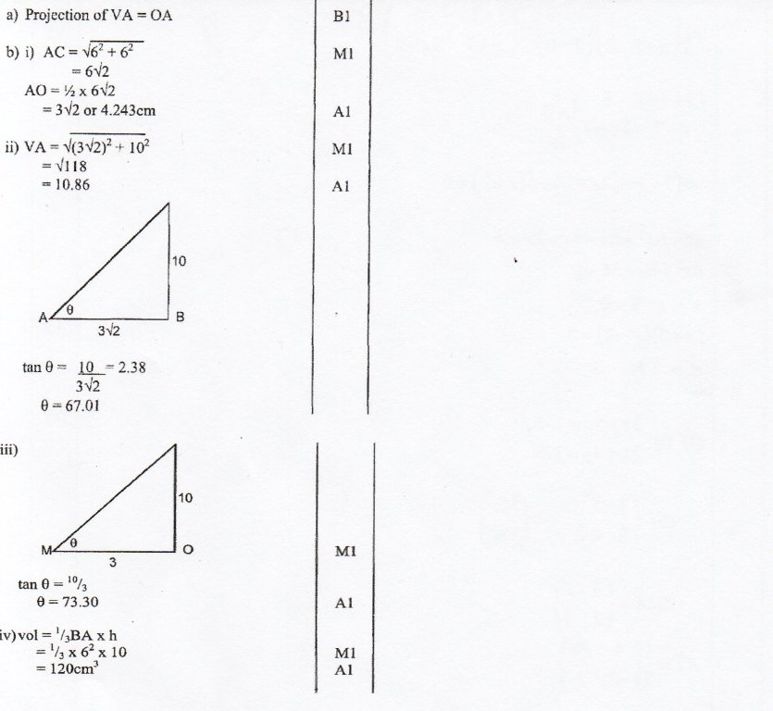**

|  |  |  |
| --- | --- | --- |
| 22 | (a) (i) Total money after 3 years = sh. 358400  Interest per year = sh. 12800  Total interest for 3 years = 3 x 12800  = 38,400  Money deposited = 358400 – 38,400  = sh. 320,000  (ii) R x 320000 = 12800  100  R = 12800 x 100  320000  = 4%  (b) M.P =sh. 40,000  H.P = sh. 56,000  (i) Deposit = 25/100 x 56000  = sh. 14,000  Rem amount = 56,000 – 14000  = sh. 42,000  Instalments = sh. 2625  No. of instalments, n  n = 42000  2625  = 16 instalments  (ii) 12 ½ % discount on M.P  Amount paid (C.P) = 87 ½ % x sh. 40,000  = sh.35,000  H.P =sh.56,000  Difference = 56,000 – 35000  = sh. 21,000  As % of cash price  = 21000 x 100  35000  = 60% | **M1**  **A1**  **M1**  **A1**  **M1**  **M1**  **A1**  **M1**  **M1**  **A1** |
|  |  | **10mks** |

|  |  |  |
| --- | --- | --- |
| 23 | (a) | B1  B1  M1  M1  A1  B1  M1A1  M1A1 |
|  |  | 10 MKS |

|  |  |  |
| --- | --- | --- |
| 24 | x 150 600 1500 1650  4 Cos 2x 3.46 3.46  2sin (2x + 30) 1.00 -1  C:\Users\Nzambia\AppData\Local\Microsoft\Windows\Temporary Internet Files\Content.Word\ggkkkkkkkkkkpppppppp---------.jpg  (c) (i) Amplitude of  y = 4 Cos 2x ⇒4 Units  (ii) Periods = 1800  (d) 4 Cost 2x – 2sin (2 x +  30) =  4Cos2x = 2sin (2x + 30)  ∴ x = 300 or 1200 | B2  S1  P2  C2  B1  B1  B1 |
|
|
|
|
|
|  |  |  |