Name…………………………………………………… Index Number……………………

Candidate’s Signature………………………………….. Date……………………………..

**121/2 MATHEMATICS**

**Paper 2**

**2 ½ hours**

**FORM 4 KCSE MALIET EXAMS 2019**

**Kenya Certificate of Secondary Education**

**MATHEMATICS**

**Paper 2**

2 ½ hours

**CANDIDATES INSTRUCTIONS**

1. *Write your name and index number in the spaces provided above.*
2. *Sign and write the date of examination in the spaces provided above.*
3. *This paper consists of* ***TWO*** *sections:* ***Section I*** *and* ***Section II.***
4. *Answer* ***ALL*** *the questions in* ***Section I*** *and* ***only five*** *questions from* ***Section II****.*
5. *All answers and working must be written on the question paper in the spaces provided below each question.*
6. ***Show all the steps in your calculations, giving your answers at each stage in the spaces below each question.***
7. *Marks may be given for correct working even if the answer is wrong.*
8. ***Non-programmable*** *silent electronic calculators* ***and*** *KNEC Mathematical tables may be used except where stated otherwise.*
9. ***This paper consists of 14 printed pages.***
10. ***Candidates should check the question paper to ascertain that all the pages are printed as indicated and that no questions are missing.***

For examiner’s use only

**Section I**

|  |  |  |  |  |  |  |  |  |  |  |  |  |  |  |  |  |
| --- | --- | --- | --- | --- | --- | --- | --- | --- | --- | --- | --- | --- | --- | --- | --- | --- |
| 1 | 2 | 3 | 4 | 5 | 6 | 7 | 8 | 9 | 10 | 11 | 12 | 13 | 14 | 15 | 16 | Total |
|  |  |  |  |  |  |  |  |  |  |  |  |  |  |  |  |  |

**Section II**

|  |  |  |  |  |  |  |  |  |
| --- | --- | --- | --- | --- | --- | --- | --- | --- |
| 17 | 18 | 19 | 20 | 21 | 22 | 23 | 24 | Total  Grand Total |
|  |  |  |  |  |  |  |  |  |

**Section I (50MKS) Answer all the questions**

1. Use logarithms to evaluate **(4 Marks)**

$\sqrt[3]{\left(\frac{1.23 x 0.0468}{{Log}_{6}}\right)}$

1. Express in surd form. $\frac{1}{2+Sin {45}^{0}}$**(3 Marks)**

hence rationalize the denominator

1. Make r the subject of the formula. **(3 Marks)**

S = $\sqrt{\frac{r^{2}+ 2xb}{n}}$

1. By correcting each number to one significant figure, approximate the value of 788 x 0.006. Hence calculate the percentage error arising from this approximation. **(3mks)**
2. A merchant blends 350kg of tea costing Sh. 84 kg with 140kg of tea costing Sh. 105 per kg. At what price must he sell the mixture to gain 25%  **(3 Marks)**
3. Solve the equation

2 log x — log (x—2) = 2 log 3. **(3 marks)**

1. A circle whose equation is (x — l) 2 + *(y — k) 2* = 10 passes through the point (2, 5). Find the value of *k.* **(3 marks)**
2. (a)Expand the expression (1 + ½x) 5 in ascending powers of x, leaving the coefficients as fractions in their simplest form. **(2 marks)**

(b) Use the first three terms of the expansion in (a) above to estimate the value of (l1/20)5**. (2 marks**)

1. Given that OA = i + 2j – 3k and OB = 2i – j – 2k

~

~

~

~

~

~

~

~

Find |AB| **(2 Marks)**

~

1. An arc 11 cm long subtends an angle of 70° at the centre of a circle. Calculate the length,

Correct to one decimal place, of a chord that subtends an angle of 90° at the centre of the same circle.

**(4 marks)**

1. Quantity Q partly varies as quantity R and partly varies inversely as the square of R. Given that Q = 3 when R = 1 and Q = 5 when R = $\frac{1}{2}$

(i) Find the equation connecting Q and R **(3 Marks)**

(ii) Find the value of Q when R = $\frac{3}{2}$**(1 Mark)**

1. Find in radians, the values of **x** in the interval **0c < x < *2πc***for which **2 cos2x — sin x = 1.**

(Leave the answer in terms of ***π****)* **(4 marks**)

1. Find the inverse of the matrix $\left(\begin{matrix}3 & 2 \\ 5 & 4\end{matrix}\right)$**(4 Marks)**

Hence or otherwise solve the simultaneous equations

3x + 2y = 4

5x + 4y = 9

1. Mogutu and Onacha working together can do a piece of work in 6days. Mogutu working

alone takes 5days longer than Onacha. How many days does it take Onacha to do the work alone?

**(3Marks)**

1. In the diagram below, BT is a tangent to the circle at B. AXCT and BXD are straight lines. AX = 6cm, CT = 8cm, BX = 4.8cm and XD = 5cm.

5cm

4.8cm

6cm

8cm

X



D

B

A

C

Find the length of BT. **(2 Marks)**

1. The area of triangle FGH is 21 cm3. The triangle FGH is transformed using the matrix

4, 5

1, 2

Calculate the area of the image of triangle FGH **(2 marks)**

**SECTION II (50MARKS)**

**Answers only five questions in this section**

1. The following frequency distribution table shows the heights of students in a school.

Height (cm) Number of students

146 – 150 3

151 – 155 9

156 – 160 20

161 – 165 14

166 – 170 4

Using assumed mean of 157.5, calculate

1. The mean height correct to 3 decimal place **(5mks)**
2. The standard deviation correct to 4 s.f. **(5mks)**
3. A triangle formed by A(1, 3), B(3, 1) and C (2, -1) is rotated through a positive

quarter about ( 1, 1). Find the coordinates of the resulting triangle A1B1C1. **(3 marks)**

(b) Triangle A1B1C1 is transformed by the matrix 1 2 into A11B11C11 .

Find the coordinate ofA11B11C11. -1 3 **(3 marks)**

(c ) Draw accurately all the three triangles. **(4 marks)**



1. A red and black dice are rolled and the events X, Y and Z are defined as follows.

X - The red die shows a 4

Y – The sum of the scores of the two dice is 6

Z – The black die shows a 3

(a) Find the probability of event X **(2 Marks)**

(b) The probability of events X and Z **(3 Marks)**

(c) Which event is mutually exclusive to X **(1Mark)**

(d) Which event is independent of X **(2Marks)**

(e) The probability of event Y **(2 Marks)**

1. A tourist took 1 hour 20 minutes to travel by an aircraft from town **T(3°S, 35°E)** to town **U(9°N, 35°E).** (**Take the radius of the earth to be 6370km and *π=22/7)***

(a) Find the average speed of the aircraft.  **(3 marks)**

(b) After staying at town U for 30 minutes, the tourist took a second aircraft to town

**V (9°N, 5°E).** The average speed of the second aircraft was 90% that of the first aircraft. Determine the time, to the nearest minute; the aircraft took to travel from U to V. **(3 marks)**

(c)When the journey started at town T, the local time was 0700 h. find the local time at V when the tourist arrived.  **(4 marks)**

1. The figure below is a square based pyramid **ABCDV** with AD=DC = 6cm and height V = 10cm.

a) State the projection of VA on the base ABCD. **(1 mark)**

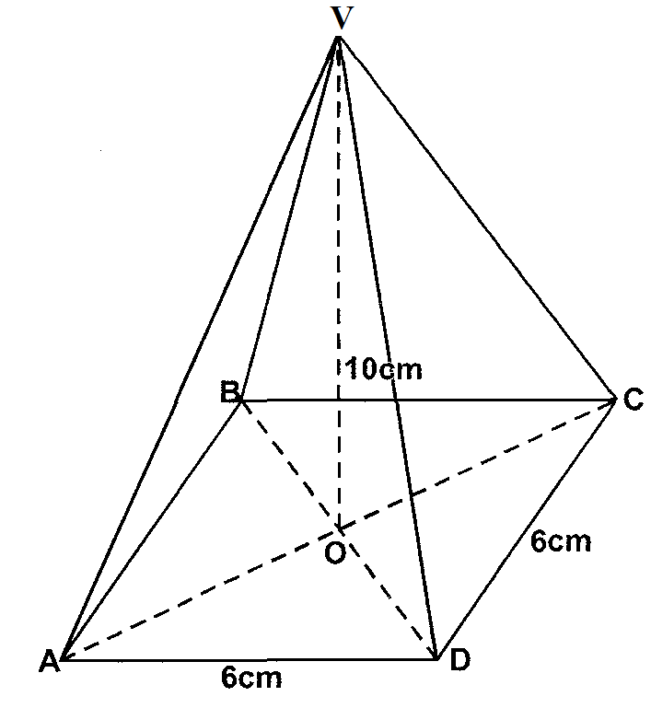

b) Find:

i) The length of VA **(3 marks)**

ii) The angle between VA and ABCD **(2 marks)**

iii) The angle between the planes VDC and ABCD **(2 marks)**

iv) Volume of the pyramid (**2 marks)**

1. (a) A certain sum of money is deposited in a bank that pays simple interest at a certain rate.

After 3 years the total amount of money in the account is sh. 358,400. The interest earned each year is sh. 12,800.Calculate:

(i) The amount of money which was deposited. **(2marks)**

(ii) The annual rate of interest that the bank paid. **(2marks)**

(b) A computer whose marked price is sh. 40,000 is sold at sh. 56,000 on hire purchase

terms.

(i) Kioko bought the computer on hire purchase terms. He paid a deposit of 25% of the hire

purchase price and cleared the balance by equal monthly instalments of sh. 2625.

Calculate the number of instalments. **(3 marks)**

(ii) Had Kioko bought the computer on cash price terms he would have been allowed a

discount of 12 ½ % on marked price. Calculate the difference between the cash price and

hire purchase price and express it as a percentage of the cash price.  **(3marks)**

1. The first, fifth and seventh terms of an arithmetic progression (AP) correspond to the first three consecutive terms of a decreasing Geometric Progression (G.P.). The first term of each progression, is 64, the common difference of the AP is d and the common ratio of the G.P. is r.

(a) (i) Write two equations involving d and r. **(2 marks)**

(ii) Find the values of d and r. **(4 marks)**

(b) Find the sum of the first 10 terms of:

(i) The arithmetic progression (A.P.);  ***(2 marks)***

(ii) The Geometric Progression (G.P.) **(2 marks)**

1. (a) Complete the table given below by filling the blank spaces.

|  |  |  |  |  |  |  |  |  |  |  |  |  |  |
| --- | --- | --- | --- | --- | --- | --- | --- | --- | --- | --- | --- | --- | --- |
| **X** | **00** | **150** | **300** | **450** | **600** | **750** | **900** | **1050** | **1200** | **1350** | **1500** | **1650** | **1800** |
| **4 Cos 2x** | 4.00 |  | 2.00 | 0 | -2.00 | -3.46 | -4.00 | -3.46 | -4.00 | -3.46 | -2.00 |  | 4.00 |
| **2 Sin**  **(2x + 30)** | 1.00 | 1.73 | 2.00 | 1.73 |  | 0 | -1.00 | -1.73 | -2.00 | -1.73 |  | 0 | 1.00 |

**(2 Marks)**

(b) On the grid provided draw the graph of **y = 4 Cos 2x** and **y = 2 Sin (2x + 300)** for 00 ≤ x 1800. Take the scale 1cm for 150 on the x – axis and 2cm for 1 unit on the y-axis. **(5 Marks)**

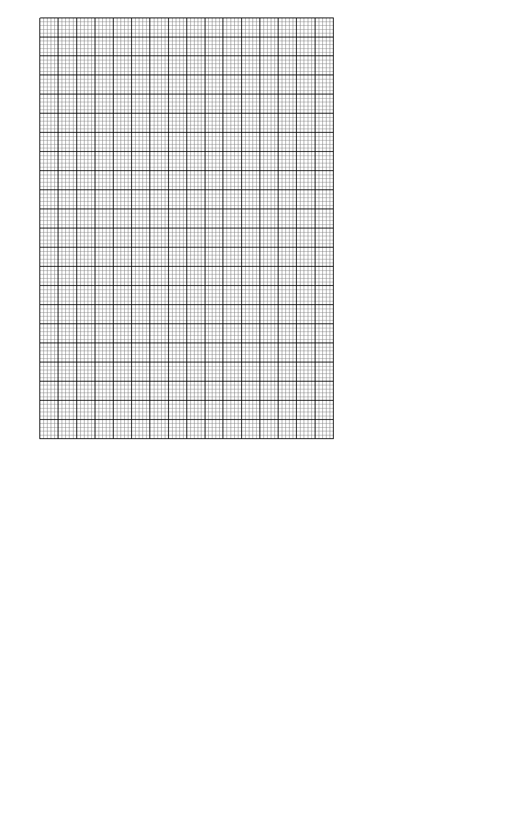

(c) (i) State the amplitude of y = 4 Cos 2x **(1 Mark)**

(ii) Find the period of y = 2 Sin (2x + 30)0 **(1 Mark)**

(d) Use your graph to solve 4 Cos 2x – 2Sin (2x + 30) = 0 **(1 Mark)**