**Name……………………………………………….Adm No………..Class……**

**Index No………………………..** Signature…………………………

**121/2**

**Mathematics Paper 2**

**March Exams**

**Form 4**

**2 ½ Hours**

**Term 1, 2019**

**MOMALICHE 2 CYCLE 6**

***Kenya Certificate of Secondary Education (K.C.S.E)***

**INSTRUCTIONS TO CANDIDATES**

* Write your name and Admission number in the spaces provided at the top of this page.
  + This paper consists of two sections: Section I and Section II.
  + Answer ***ALL*** questions from section I and ***ANY FIVE*** from section II
  + All answers and workings must be written on the question paper in the spaces provided

below each question.

* + Show all the steps in your calculation, giving your answer at each stage in the spaces

below each question.

* + Non – Programmable silent electronic calculators and KNEC mathematical tables may be

used, except where stated otherwise.

**FOR EXAMINERS USE ONLY**

**SECTION I**

|  |  |  |  |  |  |  |  |  |  |  |  |  |  |  |  |  |
| --- | --- | --- | --- | --- | --- | --- | --- | --- | --- | --- | --- | --- | --- | --- | --- | --- |
| **1** | **2** | **3** | **4** | **5** | **6** | **7** | **8** | **9** | **10** | **11** | **12** | **13** | **14** | **15** | **16** | **TOTAL** |
|  |  |  |  |  |  |  |  |  |  |  |  |  |  |  |  |  |

|  |  |  |  |  |  |  |  |  |
| --- | --- | --- | --- | --- | --- | --- | --- | --- |
| **17** | **18** | **19** | **20** | **21** | **22** | **23** | **24** | **TOTAL** |
|  |  |  |  |  |  |  |  |  |

**SECTION II**

**SECTION I**

1. Use logarithms tables to evaluate

 (4mks)

1. T is a transformation represented by the matrix under T, a square of area 10cm2 is mapped onto a square of area 110cm2. Find the value of x (3mks)
2. Given that find x where  (3mks)
3. Make A the subject of the formula

 (3mks)

1. A quantity P is partly constant and partly varies inversely as square of t. P = 6 when t = 6 and p = 18 when t = 3. Find t when p = 11 (3mks)
2. i) Expand up to the term in x3. (2mks)

ii) Use your expansion to estimate the value of . Correct to one decimal place. (2mks)

1. Solve for x in the equation. (3 Mks)

Log8 (x + 6) – Log8 (x – 3) =

1. Solve for x and y in the simultaneous equation below. (3 mks)

xy + 6 = 0

x – 2y = 7

1. The size of each interior angle of a regular polygon is five times the size of the exterior angle. Find the number of sides of the polygon. (3mks)
2. If  , find the value of a, b and c (3 mks)
3. The data below shows marks scored by 8 form four students in Molo district mathematics contest

44, 32, 67, 52, 28, 39, 46, 64.Calculate the mean absolute deviation. (3 Mks)

1. Steve deposited ksh.50, 000 in a financial institution in which interest is compounded quarterly. If at the end of second year he received a total amount of ksh79, 692.40. Calculate the rate of interest p.a (3 Mks)
2. The points with coordinates (5,5) and (-3,-1) are the ends of a diameter of a circle

Centre A

Determine:

(a) The coordinates of A (1mk)

(b) The equation of the circle, expressing it in form x2 + y2 + ax + by + c = 0 Where a, b, and c are constants (2mks)

1. Pipe x can fill an empty tank in 3 hours while pipe y can fill the same tank in 6 hours. When the tank is full, it can be emptied by pipe z in 8 hours. pipe x and y are opened at the same time when the tank is empty. If one hour later pipe z is also opened, find the total time taken to fill the tank. (3marks)
2. Fatima bought maize and beans from Kami. She mixed the maize and beans in the ratio

3: 2 she bought the maize at sh.90 per kg and the beans at sh.150 per kg. If she was to make

a profit of 30% what would be the selling price of 1kg of the mixture. (3mks)

1. Given  and  find A‾1 B-1 (3mks)

**SECTION II**

17. a) A figure whose co-ordinates are A(-2, -2), B(-4, -1), C(-4, -3) and D (-2, -3) undergoes

successive transformations ERS; where E, R and S are transformations represented by the matrices,



On the grid provided, show the figure ABCD and its image under the successive transformations ERS. (6mks)



b) Find the matrix representing the single transformation mapping the image found in (a) above back the object figure ABCD. (2mks)

c) Triangle PQR has vertices at P(2, 2), Q(4, 1) and R(6, 4). On the same grid, show the image of triangle PQR under a shear with line y = 2 invariant and point R(6, 4) is mapped onto R1(2, 4). (2mks)

18. The following are marks by form four students in a mathematics test.

|  |  |  |  |  |  |  |  |  |  |
| --- | --- | --- | --- | --- | --- | --- | --- | --- | --- |
| Marks | 10-19 | 20-29 | 30-39 | 40-49 | 50-59 | 60-69 | 70-79 | 80-89 | 90-99 |
| Frequency | 2 | 6 | 10 | 16 | 24 | 20 | 12 | 8 | 2 |

Using an assumed mean of 54.5, calculate the

(a) Mean mark (4mks)

(b) Variance (4mks)

(c) Standard deviation (2mks)

19. The diagram below represents a Cuboid **ABCDEFGH** in which **FG** =4.5cm, **GH** =8cm **HC**=6m

**A**

8cm

6cm

**B**

**E**

**D**

**C**

**H**

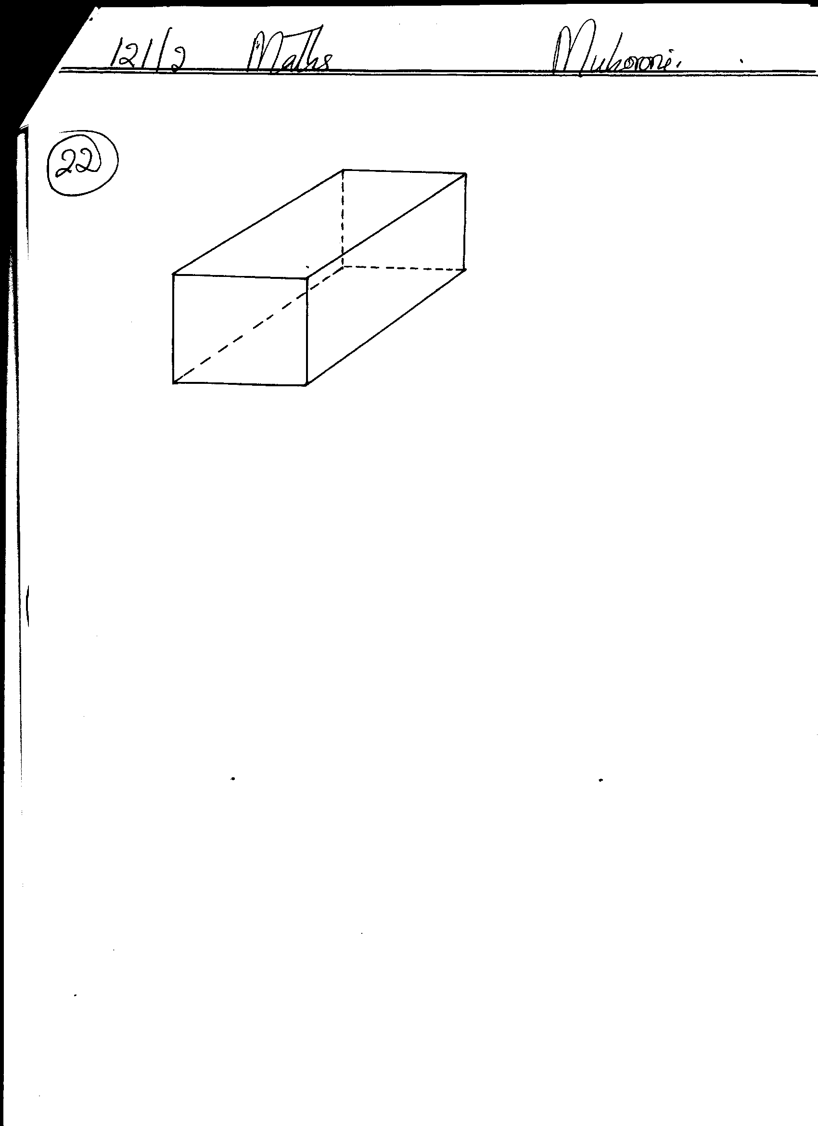

4.5cm

**G**

**F**

(a) Calculate the length **FC**  (2mrks)

(b) (i) The size of the angle between the lines **FC** and **FH** (2mks)

(ii) Size of the angle between the line **AB** and **FH.**  (2mks)

(c) The size of the angle between the planes **ABHE** and the plane **FGHE.**(2mks)

(d) The total surface area of the cuboid (closed) (2mks)

20. Complete the table below, giving all your values correct to 2 d. p. for the functions *y = cos x* and *y = 2cos (x + 30)0*

|  |  |  |  |  |  |  |  |  |  |  |
| --- | --- | --- | --- | --- | --- | --- | --- | --- | --- | --- |
| *x***0** | 00 | 600 | 1200 | 1800 | 2400 | 3000 | 3600 | 4200 | 4800 | 5400 |
| Cos *x* | 1.00 |  |  | -1.00 |  | 0.50 |  |  |  |  |
| 2cos(*x* + 30) | 1.73 |  | -1.73 |  | 0.00 |  |  |  |  |  |

(b) For the function *y = 2cos (x + 30)0*

State:

(i)The period (1mk)

(ii)Phase angle (1mk)

(c) On the same axes draw the waves of the functions*y = cos x* and *y = 2cos (x + 30)*0 for 00 ≤ x ≤ 540.Use the scale 1cm rep 300 horizontally and 2cm rep 1 unit vertically. (4mks)

(d)Use your graph above to solve the inequality 2cos (x + 30o) ≤ cos x (2mks)

21. A teacher had 5 red, 6 black and 9 blue pens in a box. The pens were all identical except for the colour.

(a) If one pen is picked from the box, what is the probability that it is

(i) Red. (1mk)

(ii) Not black. (1mk)

1. The teacher asked a student to pick two pens from the box, one at a time, without replacement. Find the probability that

(i) Both pens are of the same colour. (3mks)

(ii) They are of different colours. (2mks)

1. If the first student was allowed to take away two blue pens and another student was asked to pick two pens without replacement. What is the probability that the second student picked pens of same colour? (3mks)

22. In the figure below, PQR is the tangent to the circle at Q. TS is a diameter and TSR and QUV are straight lines. QS is parallel to TV. Angle SQR = 35° and TQV = 60°.

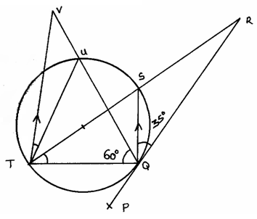

1. Find the following angles, giving reasons for each answer.

(i) QTS. (2mks)

(ii) QRS. (2mks)

(iii) QVT. (2mks)

(iv) UTV. (2mks)

(v) QUT. (2mks)

23. Use ruler and a pair of compasses only in this question

a) Construct triangle ABC such that AB = 6cm, AC=BC and angle ACB = 135 $°$ 4mks

b) On one side only construct the locus of P such that:

i) < APB = 67.5° 1mk

ii) area of triangle , APB = 9cm² 3mks

c) i) Locate P1 and P2 the two possible positions of P which satisfy the two conditions above 1mk

ii) Measure the distance between P1 and P2. 1mk

24. An arithmetic progression has the first term a and the common difference d.

(a) Write down the third, ninth and twenty – fifth terms of the progression. (3 Mks)

(b) The progression is increasing and the third, ninth and twenty-fifth terms form the first three

Consecutive terms of a geometric progression. If the sum of the seventh term and twice the sixth term of the arithmetic progression is 78.

Calculate

(i) The first term and the common difference (5 Mks)

(ii) The sum of the first nine terms of the arithmetic progression (2 Mks)