3KNT FRATERNITY EXAM 2017
TERM II FORM 4
MATHEMATICS PAPER II MARKING SCHEME
All logs M1
+/- M1
X/÷ M1
C.A.O M1
1. No log
60.31 1.7804
5.251 0.7203
0.06594 2.8192
1.5395 ÷ 2
2 + 1.5395
2

1.7698
102.4 2.0106

2. v³ = ax²h M1
b – h

v³b – v³h = ax²h

x² = v³b – v³h M1
ah
x = ± v³b – v³h
ah A1

3. 80,000 (1 - ${18}/{100 }x 1/2$) ^{2x2} M1

80,000(0.91)⁴

80,000 x 0.86857 M1

54859.97 A1

4. log (15 – 5x) – log 10 = log(3x – 2)

Log (15 – 5x) = log (3x – 2) M1
10
15 – 5x = 3x – 2 M1
10
15 – 5x = 30x – 20

x = 1 A1

5.

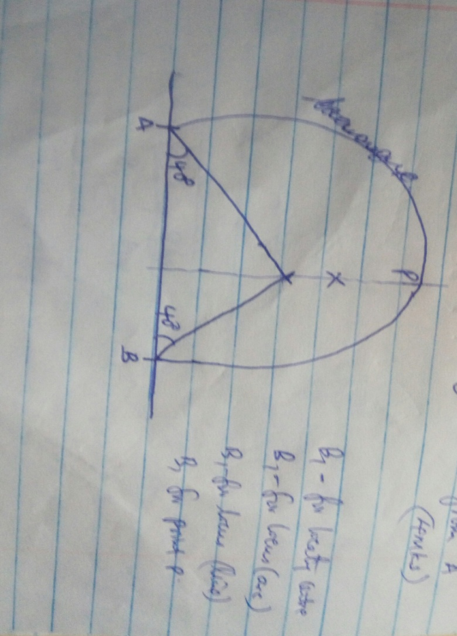

6. tan(2Ø + 45) = 0.7321
= 60⁰ or -120⁰ B1
2 Ø + 45 = 60⁰, -120⁰ B1
2 Ø = 15⁰, -165⁰
Ø = 7.5⁰, -82.5⁰ B1

7. 3( $\sqrt{2}$ - $\sqrt{5}$ ) - 2 ( $\sqrt{2}$ + $\sqrt{5}$ )
M1

M1

A1
( $\sqrt{2}$ + $\sqrt{5}$ ) ( $\sqrt{2}$ - $\sqrt{5}$ )

3$\sqrt{2}-3\sqrt{5}- 2\sqrt{2} -2\sqrt{2}$
2 – 5
$\sqrt{2}$ - 5 $\sqrt{5}$
-3

= -$1/3\sqrt{2}$ + $5/3\sqrt{5}$

8.a) 64 - 384 + 960 - 1280 + … A1
X x² x³

b) x = 8
= 64 – 384 + 960 – 1280 M1
8 64 512

= 28.5 A1

9.a) dy = 15x² – 14 x +3
dx

At x = 1

= 15 (1)² - 14(1) + 3 M1

= 4 A1

b) M1M2 = -1

M2 = -$1/4$ M1

y – 3 = - $1/4$
x – 1

y = $1/4$x + 3$1/4$ A1

10. x² – 3x + y² + 9y = $7/2$ M1

(x - $7/2$)² + (y + $7/2$)² = $7/2$ + $9/4$ + ${81}/4$ M1

Centre ($3/2$, -$9/2$) A1 (For both centre and radius)

Radius = $\sqrt{26}$

= 5.099 units

11. PQ = -9i + 3j B1

PN = $5/3$PQ B1

PN = $5/3$ (-9i + 3j)

= - 15i + 5j B1
12. P = KQ
T

Pc = K0.8Q x T = 0.64 M1
Po 1.25T KQ

%c = (1 – 0.64) 100 M1
= 36% A1
13. (7.55 X 5.25) – (7.45 x 5.15) x 100 M1
2 x 7.5 x 5.2x M1

= 1.628 A1

14.i) MQ
MQ x 4 = 8 x 6
MQ = 12 B1

ii) XT² = 26 X 10 M1
XT = $\sqrt{260}$
XT = 16.12 A1

15. R = 3800 X 100 = 1.9% M1
40,000 X 5

3420 = P x 1.9 x 7.5
100 M1

P = 3420 X 100
1.9 X 7.5

= 24000 A1

16. ʃ (x² – x – 6) dx = ʃ (x2 – x – 6)dx M1
x
x³ – x² – 6x + c A1
3 2

X⁰ | 60 | 120 | 150 | 210 | 240 | 270 | 300 | 330
2sin (x + 30)⁰ |  |  | 0 |  | -2 |  | -1
1 – 2 cos (2x)⁰ | 2 | 2 |  | 0 |  | 3 |  | 0
17.
B1
B1

c)i) 60⁰, 150⁰, 180⁰ and 330⁰ (BI for each 2 values correct)

ii) 195⁰ and 285⁰ ( B1 for the two values correct)

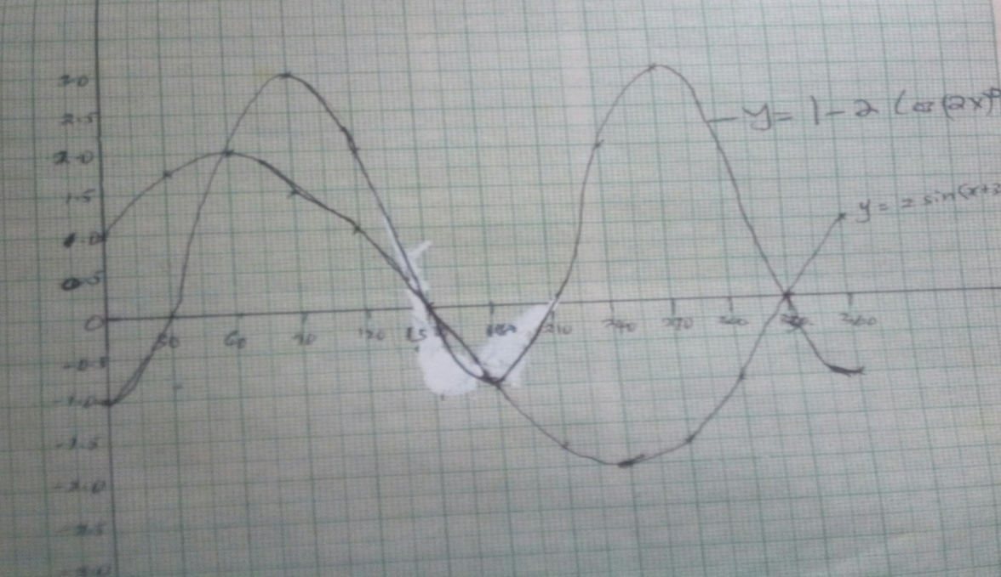
S1
C2
P2

18.a) Gross tax = PAYE + Relief
= (5400 + 1093)12 M1
= Ksh.77916 PA A1

b) Income Rate Tax
5208 5208 x 10 x 20 10416
100
4536 4536 x 15 x 20 13608 M1
100
4548 4548 x 20 x 20 18192
100
4558 4558 x 20 x 25 22740
100
X X x 30 x 20 12960
100
77916 M1

60 x = 12960
100

x = 2160 M1

Gross income = 18840 x 2160 = K 21000 Pa
Gross income in Shs. Pm = 21000 x 20 M1
12
= Shs.35000Pm

B. Salary = 35000 –
9000 M1
26000 A1

c) Net Pay = 35000 – (2000 + 2500 + 5400) M1
= Ksh.25100 A1
19.
OA = a OC = b
AP: PC = 4: 3
OP: PB = 3: 2
ai) AC = AO + OC
= -a + b B1

ii) OP = OA +AP
a + $4/7$ AC B1
a + $4/7$ (-a + b) BI
7a – 4a + 4b B1
7 7

= 3a + 4b BI
7 7

iii) OB = OP: PB = 3: 2
OP = $3/5$ (OB) B1
OB $3/5$($3/7$a + $4/7$b) B1
= $5/7$a + ${20}/{21}$b B1

b) CB = ha + rb B1
h = $5/7$ r = ${20}/{21}$ B1

20.a)i) $\sqrt{{24}^{2}+{18}^{2}}$ = 30cm A1

ii) x = 8 x = 30 x 8
30 24 24

= 10cm A1

b) h = 26² – 10² = 24cm M1 A1

c)i) Tan 24
20

= Tan ⁻¹ 24
20 M1

= 50.190 A1

ii) Tan = 24
10
= Tan-1 24
10 M1

= 67.38 A1

iii) FG = 8, FG = 18 x 8 = 6cm
18 24 24

Cos Ø = ${12}/{26}$ M1

= 62.51 A1

G = $2/{10}$ x $1/9$ B2 Drawing the tree diagram and
$1/9$ B1 probabilities correctly
B1
21. $2/{10}$ G $5/9$ Y B1 Correct multiplication
B1 Correct answer
$3/9$ R B1
$2/9$ G B1
$5/{10}$ Y $4/9$ Y = $5/{10}$ x $4/9$ B1
$3/9$ R 10

$2/9$ G
$3/{10}$
$5/9$ Y
R

$2/9$ R = $3/{10}$ x $2/9$

b)i) $2/{10}$ x $1/9$ + $5/{10}$ x $4/9$ + $3/{10}$ x $2/9$

$2/9$ + ${20}/{90}$ + $6/{90}$

${28}/{90}$ = ${14}/{45}$

ii) $3/9$ x $2/9$ = $1/{15}$

I - $5/{10}$ x $4/9$ + $5/{10}$ x $3/9$ + $3/{10}$ x $5/9$ + $3/{10}$ x $2/9$

I - ${20}/{90}$ + ${15}/{90}$ + ${15}/{90}$ + $6/{90}$

I - ${56}/{90}$ = ${34}/{90}$ = ${17}/{45}$

22.a)

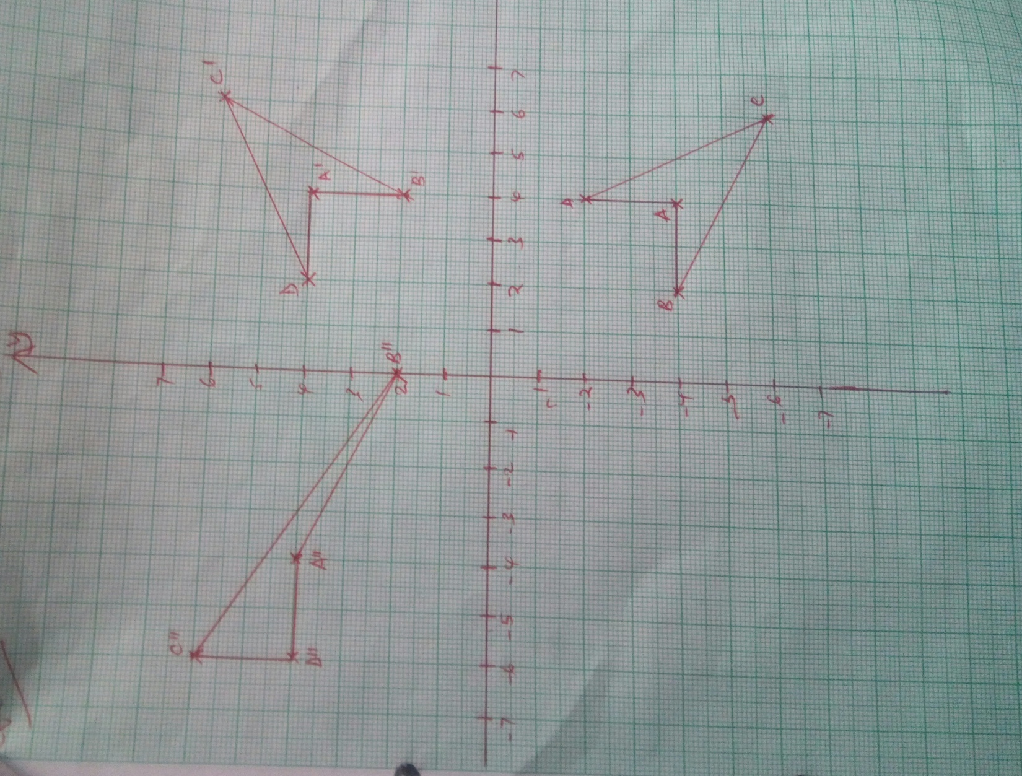
B1
B1
B1

A B C D A¹ B¹ C¹ D¹ B1 B1
b) 0 -1 4 2 6 4 4 4 6 2
1 0 -4 -4 -6 -2 4 2 6 4

Positive quarter turn about the origin B1

A^{I} B^{I} C^{I} D^{I} A^{II} B^{II} C^{II} D^{II}
c)i) 0 -2 4 4 6 2 -4 0 -6 -6 B1
0 1 4 2 6 4 4 2 6 4

A^{II} (-4, 4) B^{II}(0, 2) C^{II} (-6, 6) and D^{II}(-6, 4) B1

ii) See the graph

A B C D A^{II} B^{II} C^{II} D^{II} M1
d) a b 4 2 6 4 -4 0 -6 -6
c d -4 -4 -6 -2 4 2 6 4

4a – 4b = -4 4c – 4d = 4
2a – 4b = 0 2c – 4d = 2

A = -2, b = -1, c = 1, d = 0

Matrix -2 -1
1 0 A1

23.a)i) Angle OSR = 90 – 50 =40⁰ B1

Angle ORS = 40⁰ B1

ii) Angle RTS = 30⁰ and Angle RPS = 50⁰

angle USP = 30⁰ + 50⁰ = 80⁰ B1

iii) Angle PQR = 180⁰ – 50⁰ B1
= 130⁰ B1

b)i) PT x TR = TS2
(7 x X) (7) = 92 M1
7X = 81 – 49 = 32

X = 32 = 4.57 A1
7

ii) Angle ORP = 40⁰

cos 40⁰ = ½ x 4.57 M1
r

r = ½ x 4.57 = 2.98 M1A1
Cos 40

24.a) 3rd = a + 2d
9th = a + 8d B1 (For all three)
25th = a + 24d

b) 7th term = a + 6d
6th term = a +5d

a + 6d + 2 (a + 5d) = 78
3a + 16d = 78 M1

a + 8d = a + 24d M1
a + 2d a + 8d

16d2 = 10ad

a = $8/5$ d M1

3 x $8/5$d + 16 d = 78 M1

${24}/5$d + 16d = 78
d = 3.75 A1
a = 6 A1

c) $9/2$ (2 x 6) + (8 x 3.75) M1

$9/2$ (12 + 30)

$9/2$ x 42 M1

= 189 A1

