DARAJANI BOYS’ SCHOOL, P.O BOX 20, 90129 NGWATA

MATHEMATICS CAT 1 TERM 2 2015

FORM FOUR

NAME………………………………………… ADM.NO…………….. CLASS…………

ANSWER ALL THE QUESTIONS IN THE SPACES PROVIDED

1. Given that , **determine** the values of a and b (2mks)

1. Quantities P and q are 0.325 and 0.650 correct to three significant figures. **Find** the percentage error in calculating (3mks)
2. **Solve** for  in  for  (3mks)
3. In the figure below RS is a tangent to the circle at S and PQR is a straight line. If PQ=8cm, QR= (x-2) cm and RS is cm, **Calculate** the value of . (3mks)

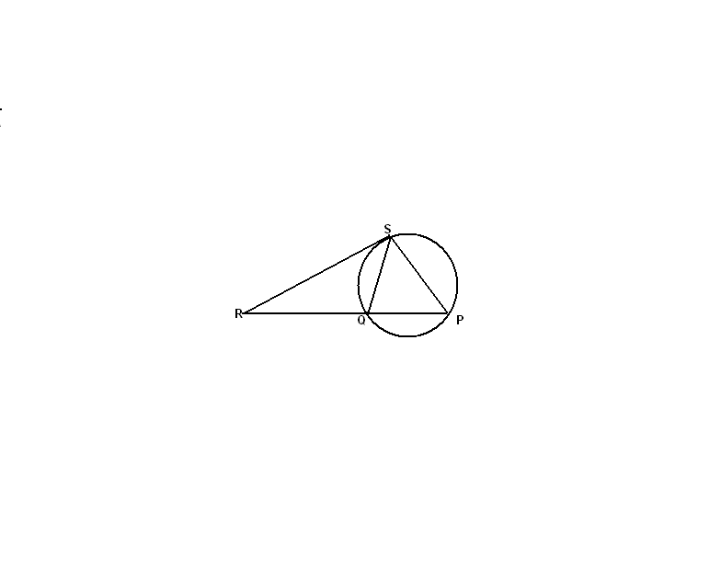

1. The cost of hiring a tractor is partly constant and partly varies with the square of distance covered. When the distance covered was 20km the cost was shs 3200 and when the distance covered was 30km the cost was shs 3450 .**Determine** the cost of hiring the tractor for 40km.

(3mks)

1. A triangle whose area is 6.5cm2 is mapped onto a triangle whose area is 13cm2 by the matrix  . **Find** the value of x (3mks)
2. Find the value of *x* that satisfy the equation

Log(*x* + 5) = log 4 – log (*x +* 2) (3mks)

8. A plane leaves an airport P at (10S, 62E) and flies due north at 800km/h

(a) **Find** its position after 2hrs (3mks

The plane turns and flies at the same speed due west. It reaches Q longitude of 12w

(b) **Find** the distance it has travelled in nautical miles (3mks)

(c) Find the time it has taken (Take the radius of the earth to be 6370km and 1 nautical mile

to be 1.853km) (2mks)

(d) If the local line at p was 1300hrs when it reached Q. **Find** the local time at Q when it landed

at Q (2mks)