Name……………………………………………….Adm No………..Class……
Index No……………………….. Signature…………………………Date……….

121/1
Mathematics Paper 1
July/ August
Form 4
2 ½ Hours
Term 2, 2019

INSTRUCTIONS TO CANDIDATES
- Write your name and Admission number in the spaces provided at the top of this page.
  - This paper consists of two sections: Section I and Section II.
  - Answer ALL questions from section I and ANY FIVE from section II
  - All answers and workings must be written on the question paper in the spaces provided
below each question.
  - Show all the steps in your calculation, giving your answer at each stage in the spaces
below each question.
  - Non – Programmable silent electronic calculators and KNEC mathematical tables may be
used, except where stated otherwise.

FOR EXAMINERS USE ONLY

SECTION I
1 | 2 | 3 | 4 | 5 | 6 | 7 | 8 | 9 | 10 | 11 | 12 | 13 | 14 | 15 | 16 | TOTAL

SECTION II
17 | 18 | 19 | 20 | 21 | 22 | 23 | 24 | TOTAL

GRAND TOTAL

SECTION I
(Answer all the questions in the spaces provided)
- Evaluate $\frac{8\frac{1}{8} - 2\frac{1}{2}}{5\frac{3}{20} - 1\frac{1}{6}of 1\frac{1}{5}}$ (3mks)

- A bus service number 4 leaves a terminus every 15 minutes. Services 8 and 3 leaves after every 20 and 30 minutes respectively. If all the three services leave together at 6.00 am, what is the earliest time the three buses will leave together again? (3mks)

- Use tables of reciprocals and square roots to evaluate. (3mks)
$$\sqrt{\frac{2}{0.5893}+ \frac{1.06}{846.3} }$$

- A Line passes through A (1, 1) and B(x, y). The mid-point of AB is (3, 5). If line BC is perpendicular to AB, find the equation of line BC. (3mks)

- Solve for the equation ${\left(\frac{27}{8}\right)}^{x+7}-{\left(\frac{4}{9}\right)}^{-3x}=0$ (3mks)

- Elvis exchanged Ksh.600,000 to Sterling pounds. After settling the bills worth £1200, he changed the balance to Euros. He then purchased goods worthy 200 Euros. Using the exchange rates below, calculate his balance in Kenyan shillings. (3mks)
 | Buying (Ksh) | Selling (Ksh)
1 Sterling pound | 114.20 | 114.50
1 Euro | 101.20 | 101.30

- Find the mass of a wooden beam 4m long, 25cm wide and 18cm deep if the density of the wood is 625kg/m³. (3mks)

.

- Solve the inequality below hence represent the solution in a number line (3mks)

- In the diagram below ABE is a tangent to a circle at B and DCE is a straight line.
If <ABD = 60º, <BOC = 80º and O is the centre of the circle.

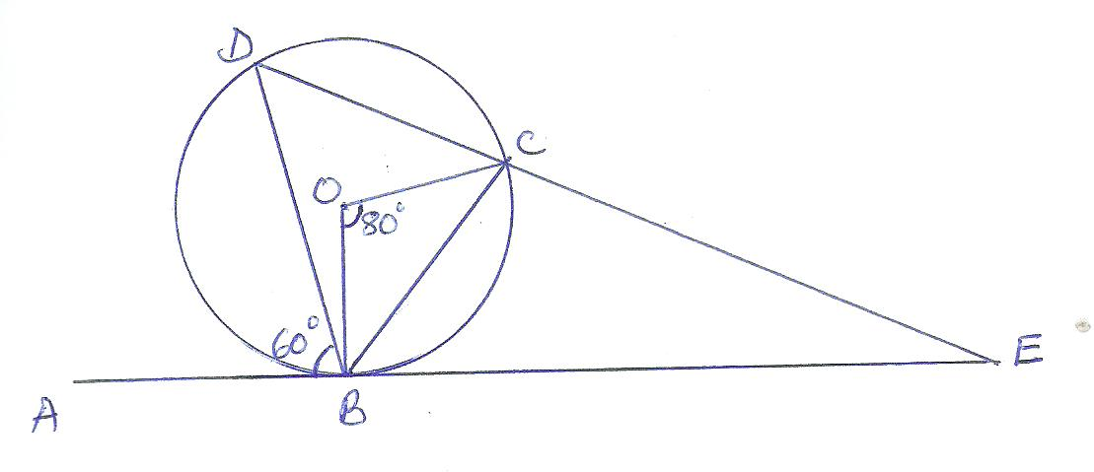
Find the value of <BEC and give reasons. (3mks)

- The marks obtained by 10 pupils were 15, 14, 12,13,9,16,11,12, 13 and 17. Calculate the standard deviation correct to 4 s.f. (4mks)

- Each exterior angle of a regular polygon is a fifth of the interior angle.
- Find the size of the exterior angle (2mks)

- Find the number of sides of the polygon (2mk)

- The figure below shows a solid prism:-

A
10cm
6cm
7cm
5cm
E
D
F
B
C

Sketch the net of the prism above and show with arrows the path ACDB and F via E (3mks)

- Solve the equation 2sinx $=1$ for 0⁰≤ x ≤360⁰ (3mks)

- Solve for y in the equation. (3mks)
$$\log_{10}\left(3y+2\right)-1=\log_{10}{(y-4)}$$

- The angle of elevation of the top of a flag post from a point x on level ground is 13º. The angle of elevation of the top of the flag post from another point y nearer the flag post and 120 metres from x is 30º. Y is between A and the bottom of the flag post and the three points are collinear. Find the height of the flag post. (3mks)

- Simplify the expression $\frac{x-1}{x}$ -$\frac{2x-1}{3x}$ . Hence solve the equation $\frac{x-1}{x}$ -$\frac{2x-1}{3x}=\frac{2}{5}$ (3mks)

SECTION II
(Answer ANY FIVE questions in the spaces provided)
- Town B is 20km N60⁰W from village A. Town B is 25km 040⁰ from town C. Village D is due East of town C and dues South of village A
- Using a scale 1:500,000 draw a diagram showing a relative position of town B,
town C, village A and village D (3mks)

- Determine;
- Distance between village A and town C (1mk)

- Distance between town C and village D (1mk)

- Compass bearing of town C from village A (1mk)

- Compass bearing of village D from town B (1mk)

- Determine the area enclosed by the diagram in (a) above in hectares (3mks)

- John bought 3 brands of tea A, B and C. The cost price of the three brands were sh.25, sh.30 and sh.45 per kilogram respectively. He mixed the three brands in the ration 5:2:1 respectively. After selling the mixture he made a profit of 20%.
a) How much profit did he make per kilogram of the mixture? (3mks)

b) After one year the cost price of each brand was increased by 12%.
i) How much did he sell one kilogram of the mixture to make 20% profit? Give your answer to the nearest 5cents. (4mks)

iii) What would have been the percentage profit if he sold one kilogram of the mixture at Ksh.40.25. (3mks)

- The distance S meters from a fixed point O, covered by a particle after t seconds B given by the equation S = t³ – 6t² + 9t + 5
(a) Calculate the gradient of the curve at t = 0.5 seconds (3mks)

(b) Determine the values of S at the turning points of the curve (3mks)

(c) Sketch the curve in the space provided. (4mks)

- The figure below shows a frustrum made from a right pyramid, such that AB=DC=16cm, BC=AD=10cm, FG=EH=18cm, GH=FE=7.5cm, CH=BG=AF=DE=15cm. If the altitude of the frustrum is 14.6cm, find:
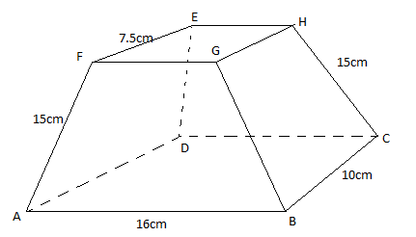
- The altitude of the pyramid made from the frustrum. (2mks)

- The surface area of the frustrum. (5mks)

- The volume of the frustrum. (3mks)

- Alex and James live in two towns 240km apart. One day at 9.45am, Alex left his town and drove towards James’ town at an average speed of 60km/h. James left his town at 10.50 a.m. on the same day and drove towards Alex’s town at an average speed of 80km/h. Determine
- the distance form Alex’s town where the two met. (7mks)

- the time of day they met (3mks)

22. The intersecting circles centres S and R have radii 28 and 35 respectively. A common chord AB = 38cm.
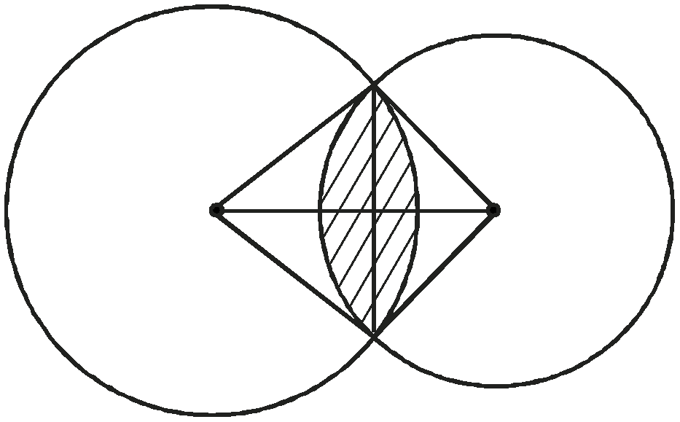
A

S R

B

a) Calculate
i) Angle ASB (2 marks)

ii) Angle ARB (2 marks)

b) Calculate the area of the shaded region. (6 marks)

23(a) The members of a photography club decided to buy a camera worth Ksh 4000 by each one contributing the same amount of money. Fifteen members fail to pay their contribution and as a result each of the other members has to pay Ksh 60 more. Find the number of members in the club. (8mks)

(b) What is the percentage increase in the contribution per member? (2mks)

$$x$$ | $$0^{c}$$ | $${\frac{π}{6}}^{c}$$ | $${\frac{π}{3}}^{c}$$ | $${\frac{π}{2}}^{c}$$ | $${\frac{2π}{3}}^{c}$$ | $${\frac{5π}{6}}^{c}$$ | $$π^{c}$$ | $${\frac{7π}{6}}^{c}$$ | $${\frac{4π}{3}}^{c}$$ | $${\frac{3π}{2}}^{c}$$ | $${\frac{5π}{3}}^{c}$$ | $${\frac{11π}{6}}^{c}$$ | $${2π}^{c}$$
$$3sin x$$ |  |  | 2.6 | 3 |  |  | 0 | -1.5 | -2.6 | -3 |  | -1.5
$$2cosx$$ |  | 1.7 | 1.0 |  |  | -1.7 | -2 | -1.0 |  |  | 1.0 | 1.7 | 2
24 (a) Complete the table below for the functions $y = 3 sin x$ and$y = 2 cos x$. (2mks)
(b) Using a scale of 2cm to represent 1 unit on the y- axis and 1cm to present 30º on the x-axis ,draw the graphs of y =3sinx and y = 2cosx on the same axes on the grid provided. (5mks)

(c) From your graphs:
(i) State the amplitude of y = 3sin x. (1mk)

(ii) Find the values of x for which $3sin x – 2$cos $x = 0.$ (1mk)

(iii) Find the range of values of x for which 3sin x ≥ 2cos x (1mk)

