MJET
MATHEMATICS FORM 1
END OF TERM III 2019
Marking scheme
NO | WORKING
NUMERATOR
-3 X6 -9÷3 + 2
-3 X 6 – 3 + 2
-18 - 3 +2 = -19 √ 1mk

DENOMINATOR
-2 x 4 – 3 x2
8- 6 =2 √ 1mk
=- ¹⁹ ∕ ₂ √ 1mk
2 | 30 | 36 | 45
2 | 15 | 18 | 45
3 | 15 | 9 | 45
3 | 5 | 3 | 15
5 | 5 | 1 | 5
 | 1 | 1 | 1
=2 x2x3x3x5= 180 √ 1mk
180 +7 = 187 √ 1mk

3. | Turkey = x  Chicken =y  x-y = 6 x-y = 6  ⅓ x - ¼ y = 6 4x + 3y =360 √ 1mk  4(x-y=6)  1(4x +3y=360)  4x-4y=24  - 4x +3y= 360  -7y= -336  7 7 y= 48 √ 1mk  x-48= 6  x=6 + 48  x= 54  48 + 54= 102 √ 1mk
4 | 0.0168 x 2.46 x 7 x 1000000 = 168 x 246 x 7  5.74 x 0.112 x 1000000 = 574 x 112 10  = 0.45 = 45/100 = 9/20 √ 1mk
5 | = 3² + 2² + 7²  = 9 + 4+49 √ 1mk  = 62 √ 1mk  =7.874 √ 1mk
6 | Let r = 0.7333333…………..(i)  10r = 7.33333333……………..(ii) m1  100r = 73. 333333…………….(iii)  Substituting (ii) from (iii)  90r = 66 m1  $$r= \frac{66}{90}$$  =$\frac{11}{15}$ A1
7 | Njoroge’s before increase= 100/112 x 5600= 5,000  3/5 x 5000= 5000= 3,000  9,600-5600= 4000 √ 1mk  4000-3000=1000 √ 1mk  1000/3000 x100= 33⅓% √ 1mk
8 | 3.142 x 16 x ½ =25.136  3.142x 8 x1/2 =12.568 √ 1mk  3.142 x24 x ½= 37.704 √ 1mk  25.136 +12.568 +37.704= 75.408 √ 1mk
9 | 3a =5b= 20  6a- 5b= 12  9a =32  9 9  a= ³²/₉ √ 1mk  3(³²/₉ +5b =20 √ 1mk  ⁹⁶/₉ +5b=20  5b= ²⁸/₃  _{b=}²⁸/₁₅ √ 1mk
10 | 480 x 7= 3360  7.5 x 50 =375 √ 1mk  145 x 13= 1885  34 x 30= 1020  25 x50 =1250 √ 1mk  3360 + 37 +1885 +1020 +1250= 7890 √ 1mk
11 | X+100- x+160+3x-5 = 360 √ 1mk  x-x +3x +100 +160-5 =360  3x +260=360 +5  3x=360+5-260  3x/3=105/3 √ 1mk  X=35⁰ √ 1mk
12 | NUMERATOR  ½ X⅓ = 1/6  ¼ +⅕ ÷ 1/6  ¼ + ⅕ X ⁶/₁  ¼ + ⁶/₅= ²⁹/₂₀ √ 1mk  DENOMINATOR  ⁴/₅- ¾ + ½ = ¹¹/₂₀ √ 1mk  ½ X ¹¹/₂₀ = ¹¹/₄₀ √ 1mk  ²⁹/₂₀ ÷ 11/20 = ²⁹/₂₀ X 40/11 = ⁵⁸/₁₁ √ 1mk
13a) | 1600H -0800H= 730 √ 1mk  = 7H 30 MIN √ 1mk
b) | D= s xt  300 = s x 7 ½ √ 1mk  ²/₁₅ x 300= s x15/2 x ²/₁₅  S = 40km/h √ 1mk
14 | Kshs 5000 x 72.23= 36,1150 √ 1mk  361,150-214500= 146,650  ¹⁴⁶⁶⁵⁰/_{135.97} x 1 √ 1mk  = 1078.55 sterling pounds
15 | 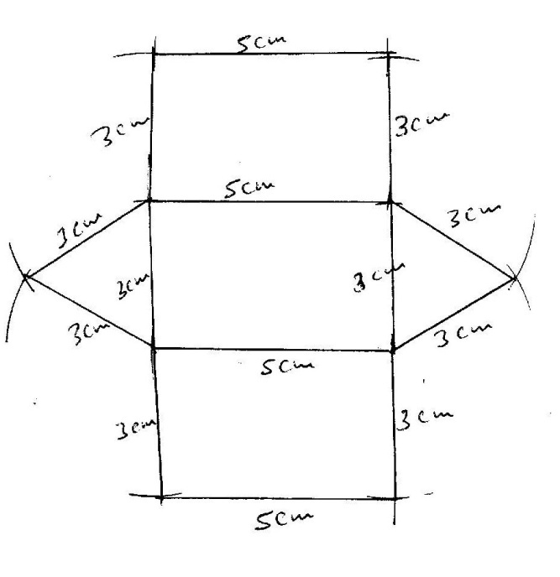
16. | 1044 + (1006×180) √ 1mk  1006×180=181080 √ 1mk  1044+181080= 182,124 √ 1mk
17. a) | Volume= cross section area x height  (12 x 5) x 15 √ 1mk  60 x 15  =900cm³ √ 1mk
b) | 12 x 5 x 2 =120  5x 15 x2 √ 1mk  12 x 15 x2= 360 √ 1mk  360 + 150 +120= 630cm² √ 1mk
c) | Density =mass/volume  8.6= ^{M}/₆₃₀ √ 1mk  M = 630 x 8.6  M= 5418 g √ 1mk  = 5418/1000 = 5.418 kg √ 1mk
d) | (4.5 x 100) x (3.92 x 100)x (10x100) =17600000 √ 1mk  =17600000/630 = 280,000 √ 1mk
18. a) | 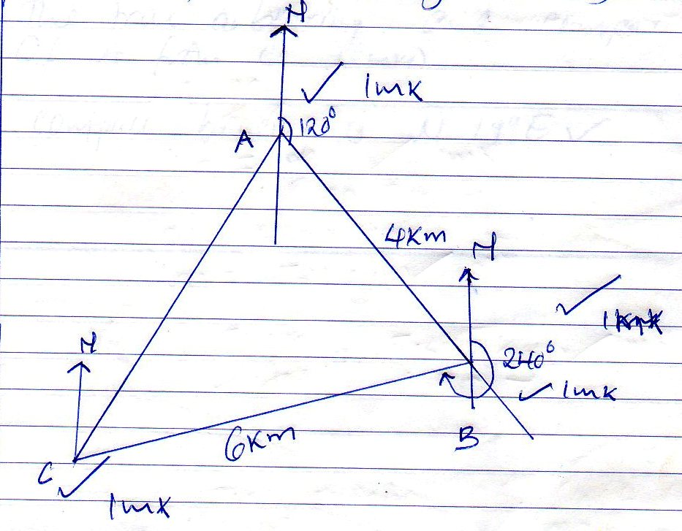
b) i) | 5.3 cm √ 1mk  5.3 x 1 = 5.3 km √ 1mk
ii) | True bearing 199⁰ √ 1mk  Compass bearing S 19⁰ W √ 1mk
iii) | Compass bearing is N 19⁰ E  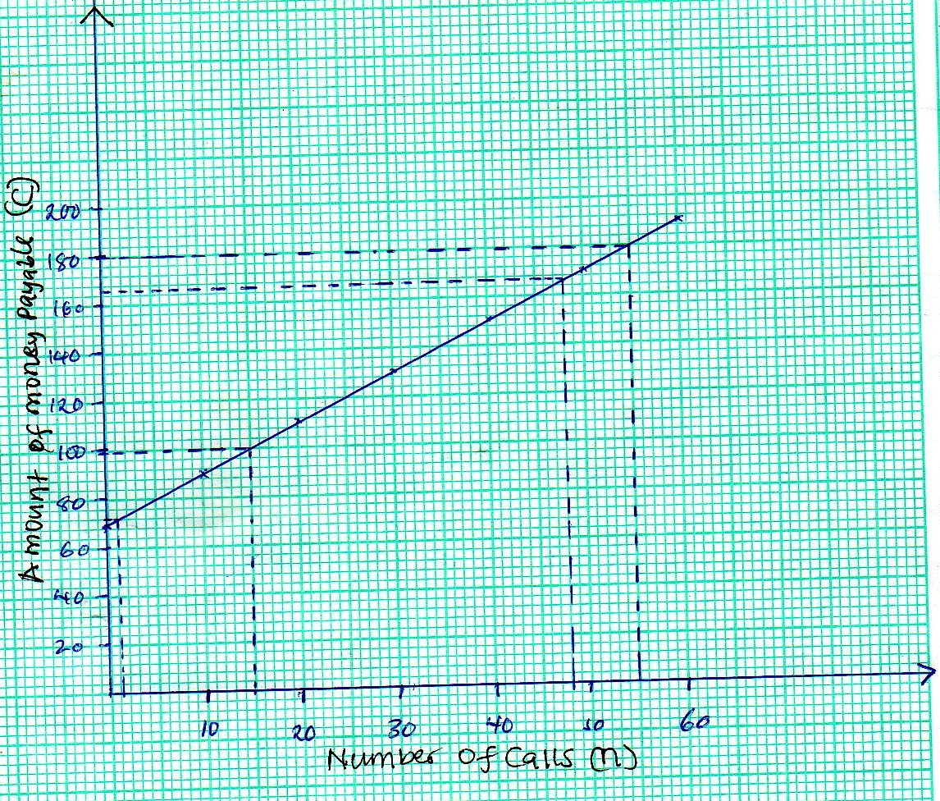
19. a)
b) i | Sh 100 √ 1mk
ii | Sh 180 √ 1mk
c) i | 1 call √ 1mk
ii | 48 calls
d | Sh 70
20. a) | 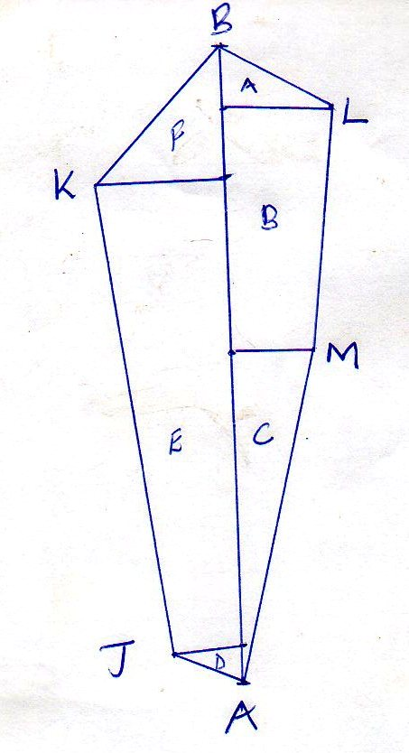
b) | A = ½ X 50 X 120= 3000  B= ½ (120 +90) X 300= 31,500  C= ½ X 350 X 90 =15750  D= ½ X 60 X 40= 1200  E =1/2 (60 + 150) X 410=43050  F=1/2 X 150X 150= 11250  TOTAL= 105,750  105750/10000 = 10.575 Ha
21. a) | 14,000 x 280 =3,920,000 √ 1mk
b i) | No of sets 90/100 x 280 = 252 √ 1mk  Cost of one set = 125/100 x 14000= 17,500 √ 1mk  Total amount =252x17500= 4,410,000 √ 1mk  4,410,000- 3920000 x 100 =12.5 % √ 1mk  3920000
ii) | 9/8 x 14 000 = 15750 √ 1mk  15750 x 250 = 3,937,500 √ 1mk
c) | Total ratio = 10  ²/₁₀ = 8  ⁵/₁₀ = x  X= ⁵/₁₀ x 8 x ¹⁰/₂  X= 20 cm  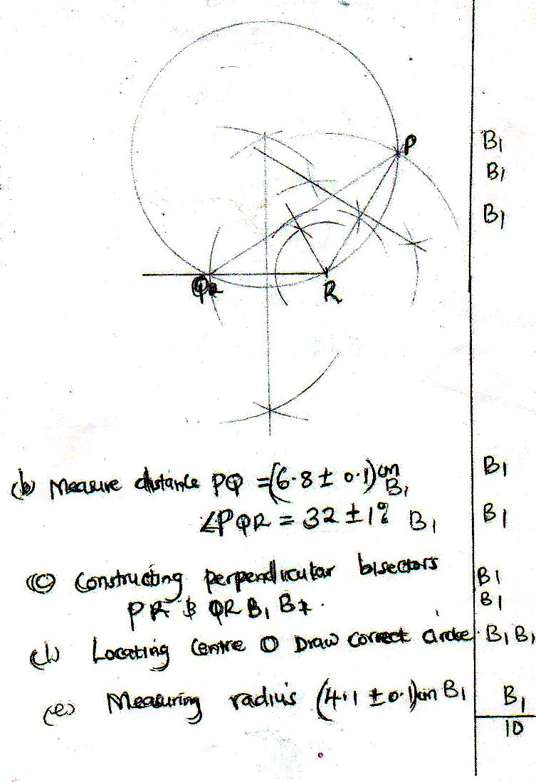
22 a)
23 a) | 8x4 = 320 √ 1mk  60  15  20  70  + 10  120  615 minutes √ 1mk
b) | 1730hrs  -1015 √ 1mk  715 = 7:15am
c) | 7:15am √ 1mk  +1:15am  8:30 am √ 1mk
d) | 40 x 3 =120  40 x3 =120  120 +120= 240  240 +20=260  260/60 = 4 hrs 20 min √ 1mk  8:30 am  +4:20  12.50  12:50 Pm√ 1mk
e) | 5:30 pm  -2.00  3:30pm √ 1mk  3:30  -10  3:20 PM
24 a) | 360 x 500 = 180,000  180,000-100,000=80,000 √ 1mk  2/100 x 800,000=1600  12,000  +1600  13,600 √ 1mk
b) i) | 110/100 x 12,000 = 13,200 √ 1mk  17600 -13,200 = 4,400 √ 1mk  2/100 x X = 4,400 √ 1mk  4,400 x 100/2 = 229,000 √ 1mk  100,000  + 220,000  320,000 √ 1mk
ii) | 320,000/500 = 640 √ 1mk

