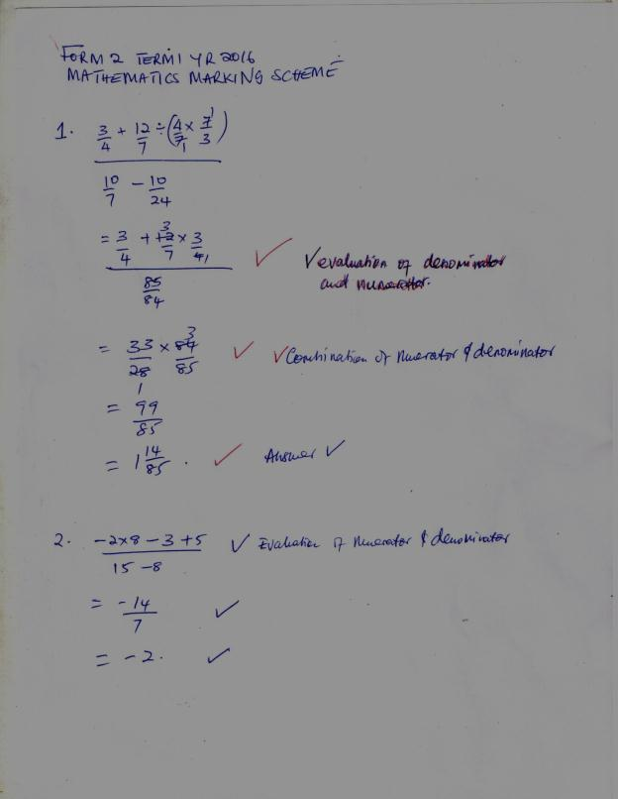

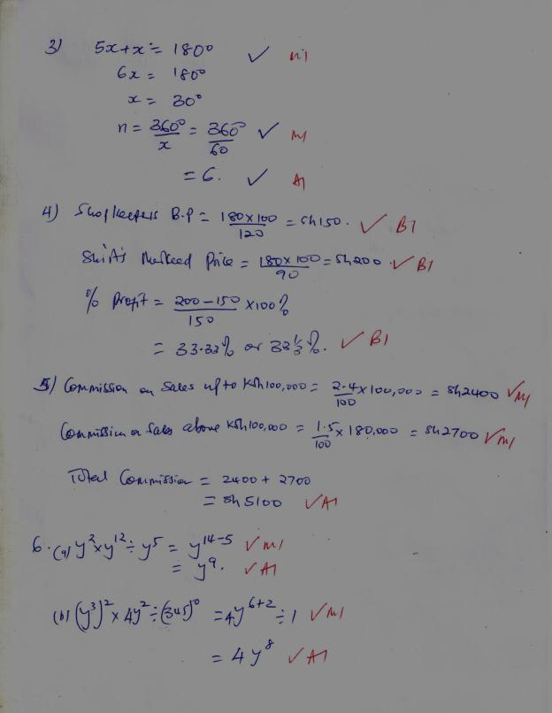

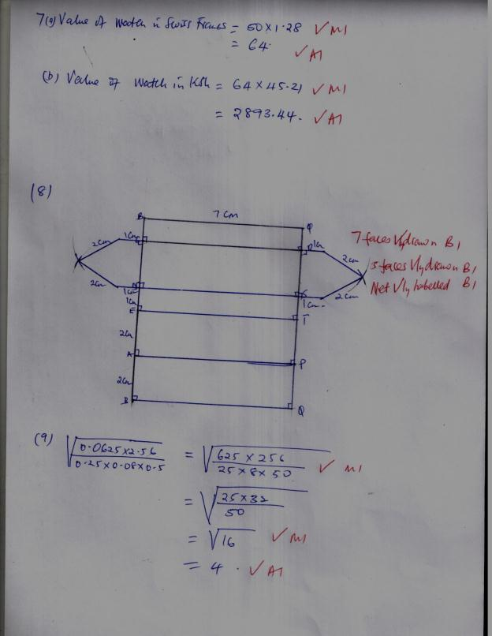

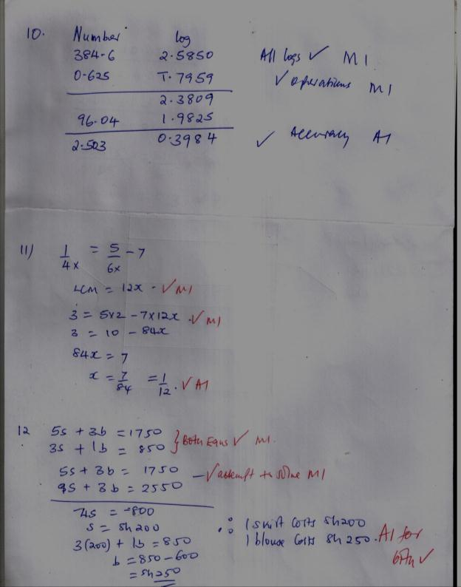

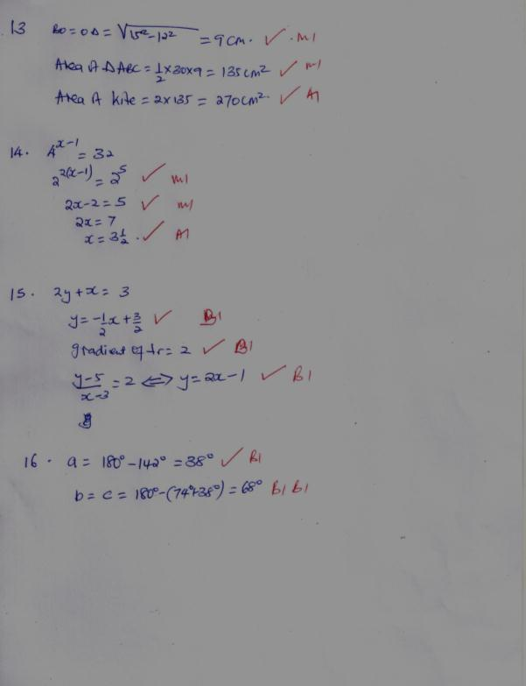

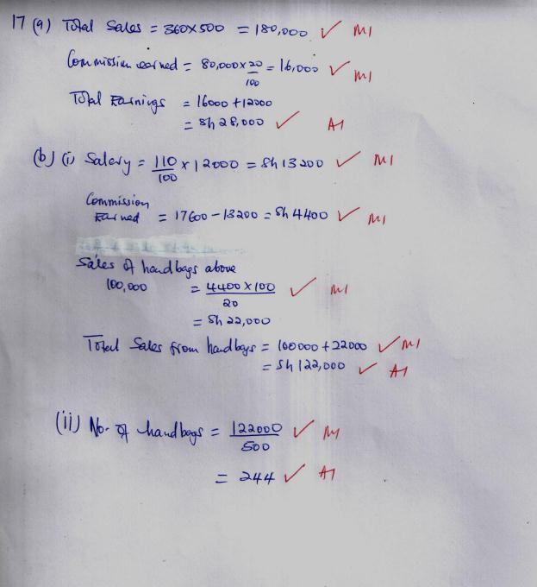

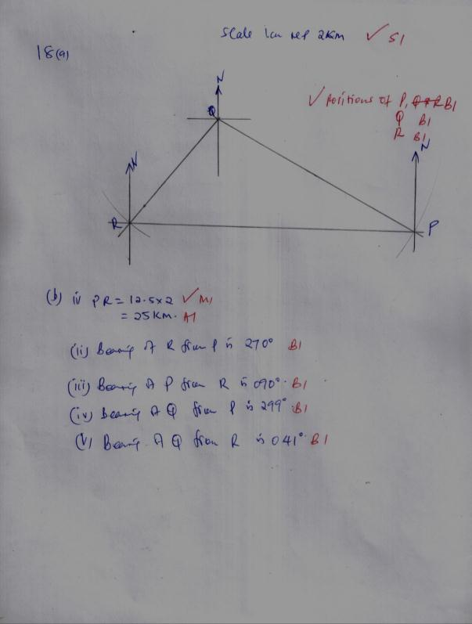

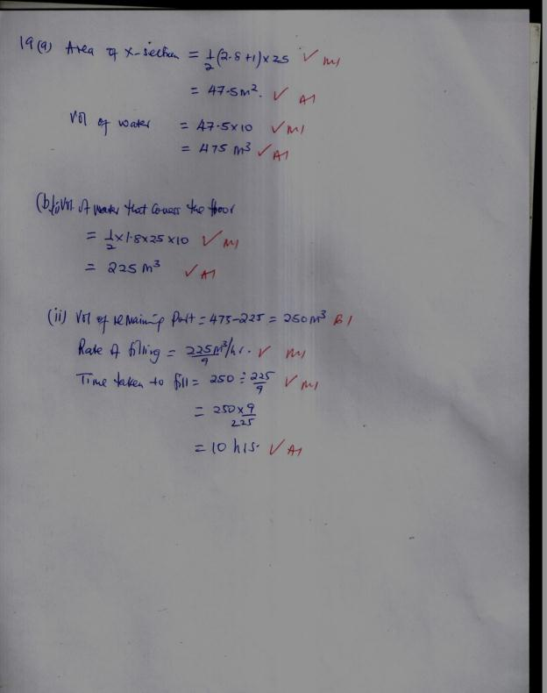

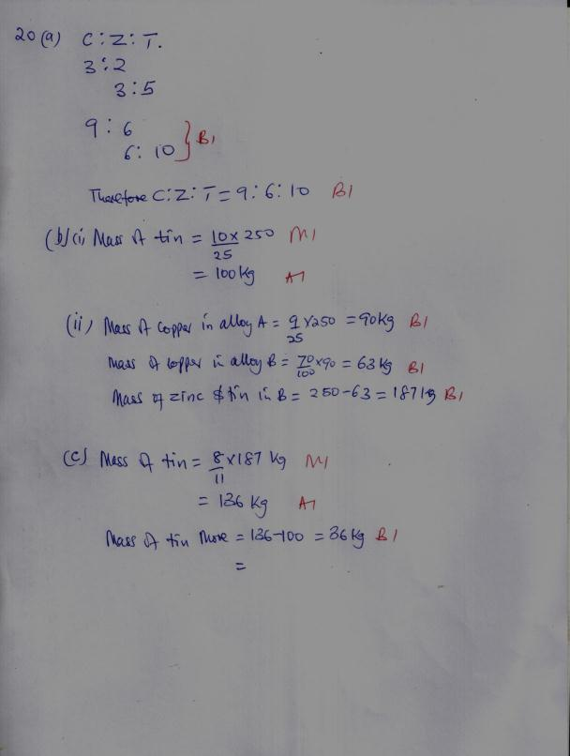

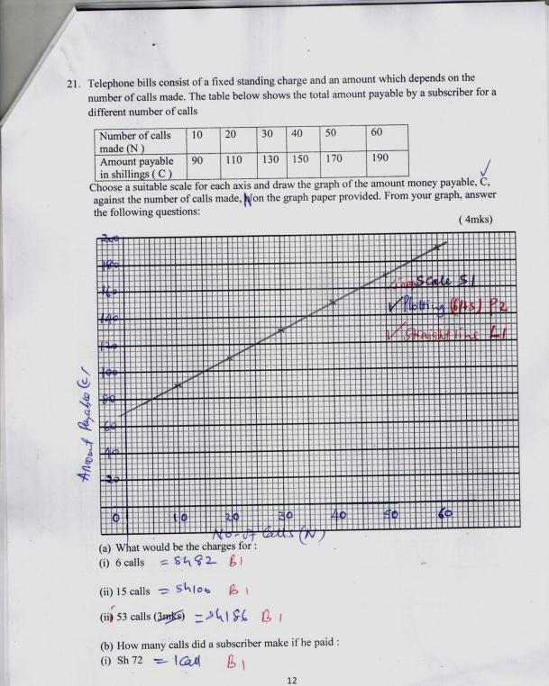
(ii) Sh 166 48 calls (1mks)
(b ) What is the standing charge? Sh 70 (1mk)
- The vertices of quadrilateral OPQR are O (0, 0), P (2, 0),Q(4,2) and R (0,3). The vertices of its image under a rotation are O’ (1, -1), P’ (1,-3), Q’ (3, - 5) and R’ (4, - 1).
(a) (i) On the grid provided, draw OPQR and its image O’P’Q’R’. (2 marks)
Rectangle OPQR correctly drawn B1
Rectangle O’P’Q’R’ correctly drawn B1
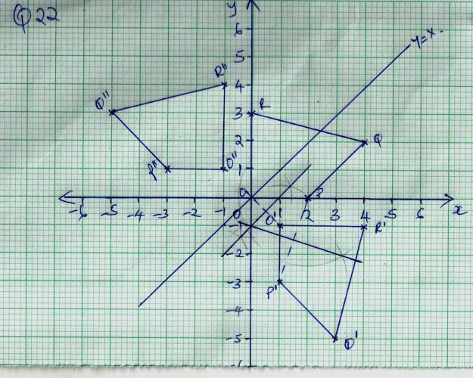
(ii) By construction, determine the centre and angle of rotation. (3 marks)
Construction of any two correct perpendicular bisectors……..B1
Cecntre (0, -1)
Angle of rotation -90˚ or +270˚
(b) On the same grid as (a) (i) above, draw O” P”Q”R”, the image of O’P’Q’R’ under a reflection in the line y = x. (2 marks)
Line y = x. correctly drawn B1
O” P”Q”R” correctly drawn B1
(c) From the quadrilaterals drawn, state the pairs that are:
(i) Directly congruent; (1 mark)
OPQR and O’P’Q’R’ B1
- Oppositely congruent. (2 marks)

O’P’Q’R’ and O’P’Q’R’ B1
OPQR and O” P”Q”R” B1

