**NAME……………………………………………ADM.NO………CLASS………**

**DATE:………/……./ 2016**

**MWAKICAN JOINT EXAMINATION (MJET) – 2016)**

**END OF TERM 1 FORM 2 MATHEMATICS EXAM**

**TIME: 2½ HRS.**

**INSTRUCTION TO STUDENTS:**

1. *Write your* ***name****,* ***admission number*** *and* ***class*** *in the spaces provided above.*
2. *Write the* ***date*** *of examination in spaces provided.*
3. *This paper consists of* ***two*** *Sections; Section* ***I*** *and Section* ***II****.*
4. *Answer* ***ALL*** *the questions in Section* ***I*** *and only* ***five*** *questions from Section* ***II****.*
5. *All answers and working must be written on the question paper in the spaces provided below each question.*
6. *Show all the steps in your calculation, giving your answer at each stage in the spaces provided* ***below*** *each question.*
7. *Marks may be given for correct working even if the answer is wrong.*
8. *KNEC Mathematical tables* ***may be*** *used, except where stated otherwise.*
9. *Candidates should check the question paper to ascertain that all the pages are printed as indicated and that no questions are missing.*
10. ***Candidates should answer the questions in English.***

**FOR EXAMINER’S USE ONLY:**

**SECTION I**

|  |  |  |  |  |  |  |  |  |  |  |  |  |  |  |  |  |
| --- | --- | --- | --- | --- | --- | --- | --- | --- | --- | --- | --- | --- | --- | --- | --- | --- |
| 1 | 2 | 3 | 4 | 5 | 6 | 7 | 8 | 9 | 10 | 11 | 12 | 13 | 14 | 15 | 16 | TOTAL |
|  |  |  |  |  |  |  |  |  |  |  |  |  |  |  |  |  |

**SECTION II GRAND TOTAL**

|  |  |  |  |  |  |  |
| --- | --- | --- | --- | --- | --- | --- |
| 17 | 18 | 19 | 20 | 21 | 22 | TOTAL |
|  |  |  |  |  |  |  |

***Ensure that all the pages are printed and no question(s) are missing***

**SECTION I**

1. Evaluate  (3 marks)

2. Without using a calculator evaluate, $\frac{-2\left(5+3\right)-9÷3+5}{-3×(-5)+-2×4}$ (3 marks)

3. The size of each interior angle of a regular polygon is five times the size of the exterior angle. Find the number of sides of the polygon. (3 marks)

4. Musa paid sh180 for a shirt after getting a discount of 10%. The shopkeeper made a profit of 20% on the sale of this shirt. What percentage profit would the shopkeeper have made if no discount was allowed? (3 marks)

5. A salesman gets a commission of 2.4% on sales up to Kshs 100,000. He gets an additional commission of 1.5% on sales above this. Calculate the commission he gets on sales worth Kshs 280.000 (3mks)

6. Evaluate the following

1. y2 y12y5 (2mks)
2. (y3)2 4y2345)0 (2mks)

7. A Kenyan tourist left Germany for Kenya through Switzerland. While in Switzerland he bought a watch worth 50 deutsche Marks.

Use the exchange rates below:

1 Swiss Franc = 1.28 Deutsche Marks.

1 Swiss Franc = 45.21 Kenya Shillings

Find the value of the watch in:

(a) Swiss Francs. (2mks)

(b) Kenya Shillings (2mks)

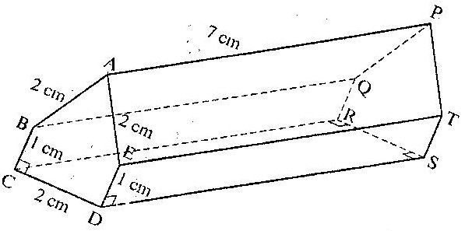8. The figure below represents below represents a prism of length 7 cm AB = AE = CD = 2 cm and BC and ED = 1 cm

Draw a well labelled net of the prism (3 marks)

9. Evaluate without using mathematical tables

 (3 marks)

10. Using logarithms tables evaluate ( 3 marks)

384.6 x 0.625

96.04

11. Solve the equation = - 7 (3 marks)

12. The cost of 5 skirts and 3 blouses is Kshs 1750. Mueni bought three of the skirts and one of the blouses for Kshs 850. Find the cost of each item( 3 marks)

13. The figure below represents a kite ABCD, AB = AD = 15cm. The diagonals BD and AC intersect at O. AC = 30cm and AO = 12 cm.

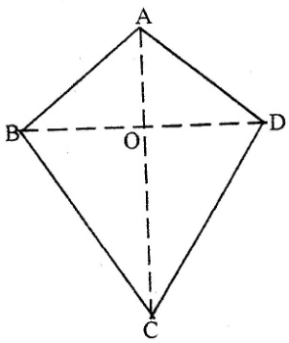

Find the area of the kite (3mks)

14. Solve for x in 4*x*-1 = 32 (3marks)

15. A perpendicular is drawn from a point (3, 5) to the line 2y + x = 3. Find the equation of the perpendicular. (3marks)

1. Calculate the angles marked by letters in each of the following figures:(3mks)

142˚

a

c

74˚

b

**SECTION II**

17. A saleswoman is paid a commission of 20% on goods sold worth over Ksh 100,000.She is also paid a monthly salary of Ksh 12,000.In a certain month, she sold 360 handbags at Ksh 500 each.

a) Calculate the saleswoman’s earnings that month. (3 marks)

b) The following month, the saleswoman’s monthly salary was increased by 10%.Her to total earnings that month were Ksh 17,600.

Calculate:

* 1. The total amount of money received from the sales of handbags that month. (5marks)
  2. The number of handbags sold that month (2 marks)

1. Three towns P, Q and R are such that P is on a bearing of 120˚ and 20km from Q.Town R is on a bearing of 220˚ and 12km from Q.
2. Using a suitable scale, draw the position of P, Q and R.(4mks)
3. Find:
4. The distance between P and R in kilometers (2mks)
5. The bearing of R from P (1mk)
6. The bearing P from R (1mk)
7. The bearing of Q from P (1mk)
8. The bearing of Q from R (1mk)

19. The diagram below represents a rectangular swimming pool 25m long and 10m wide. The sides of the pool are vertical.

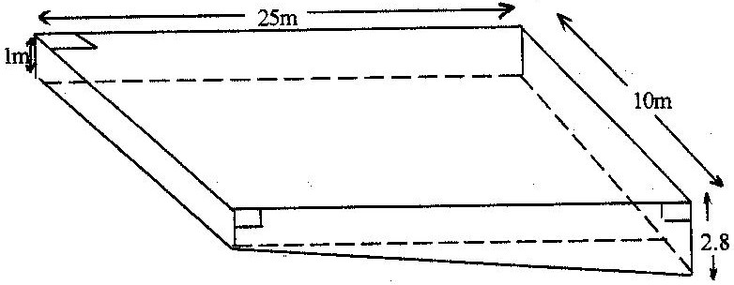

The floor of the pool slants uniformly such that the depth at the shallow end is 1m at the deep end is 2.8 m.

(a) Calculate the volume of water required to completely fill the pool. (4mks)

b) Water is allowed into the empty pool at a constant rate through an inlet pipe. It takes 9 hours for the water to just cover the entire floor of the pool.

Calculate:

1. The volume of the water that just covers the floor of the pool (2 marks)
2. The time needed to completely fill the remaining of the pool. (4 marks)

20. Two alloys, A and B, are each made up of copper, Zinc and Tin. In Alloy A, the ratio of copper to zinc is 3:2 and the ratio of zinc to tin is 3:5.

1. Determine the ratio, copper : zinc : tin in alloy A (2marks)
2. The mass of alloy A is 250kg. Alloy B has the same mass as alloy A but the amount of copper is 30% less than that of alloy A.

Calculate:

1. The mass of tin in alloy A (2marks)

1. The total mass of zinc and tin in alloy B (3marks)
2. Given that the ratio of zinc to tin in alloy B is 3:8, determine the amount of tin in alloy B more than in alloy A. (3marks)
   * + 1. Telephone bills consist of a fixed standing charge and an amount which depends on the number of calls made. The table below shows the total amount payable by a subscriber for a different number of calls

|  |  |  |  |  |  |  |
| --- | --- | --- | --- | --- | --- | --- |
| Number of calls made (N ) | 10 | 20 | 30 | 40 | 50 | 60 |
| Amount payable in shillings ( C ) | 90 | 110 | 130 | 150 | 170 | 190 |

Choose a suitable scale for each axis and draw the graph of the amount money payable, C, against the number of calls made, N on the graph paper provided. From your graph, answer the following questions:

( 4mks)



* + - 1. What would be the charges for :
         1. 6 calls

(ii) 15 calls

* + - * 1. 53 calls (3mks)
      1. How many calls did a subscriber make if he paid :
         1. Sh 72

(ii) Sh 166 (1mks)

* + - 1. What is the standing charge? (1mk)
      2. The vertices of quadrilateral OPQR are O (0, 0), P (2, 0),Q(4,2) and R (0,3). The vertices of its image under a rotation are O’ (1, -1), P’ (1,-3), Q’ (3, - 5) and R’ (4, - 1).

(a) (i) On the grid provided, draw OPQR and its image O’P’Q’R’. (2 marks)



(ii) By construction, determine the centre and angle of rotation. (3 marks)

(b) On the same grid as (a) (i) above, draw O” P”Q”R”, the image of Q’P’Q’R’ under a reflection in the line y = x. (2 marks)

(c) From the quadrilaterals drawn, state the pairs that are:

(i) Directly congruent; (1 mark)

1. Oppositely congruent. (2 marks)