MWAKICAN JOINT EXAM

NAME____________________________________________________ADM NO_________________-

121/2

FORM III MATHEMATICS PAPER 2

NOV. 2016

2½ HOURS

INSTRUCTIONS TO CANDIDATES

a) Write your name and admission number in the spaces provided.

b) This paper consists of TWO sections. Section 1 and section 11.

c) Answer all the questions in section 1 and only five from section 11.

d) Show all the steps in your calculations, giving your answers at each stage in the spaces provided below each question.

e) Marks may be given for correct working even if the answer is wrong.

f) Non-programmable silent electronic calculators and mathematical tables may be used.

g) This paper consists of 16 printed pages.

h) Check the question paper to ascertain that all the papers are printed as indicated and that no questions are missing.

For examiners use only

Section 1

|  |  |  |  |  |  |  |  |  |  |  |  |  |  |  |  |  |
| --- | --- | --- | --- | --- | --- | --- | --- | --- | --- | --- | --- | --- | --- | --- | --- | --- |
| 1 | 2 | 3 | 4 | 5 | 6 | 7 | 8 | 9 | 10 | 11 | 12 | 13 | 14 | 15 | 16 | total |
|  |  |  |  |  |  |  |  |  |  |  |  |  |  |  |  |  |

Section II

|  |  |  |  |  |  |  |  |  |  |  |
| --- | --- | --- | --- | --- | --- | --- | --- | --- | --- | --- |
| 17 | 18 | 19 | 20 | 21 | 22 | 23 | 24 | total | Grand  total |  |
|  |  |  |  |  |  |  |  |  |

SECTION I

Answer all the questions in this section.

1. Use logarithms to evaluate

$\frac{1.46 x 183}{0.97 x 0.041}$ (3mks)

1. Find the integral values of x which satisfy the inequalities. (3mks)

2(2-x) < 4x – 9 $≤$ x + 11

1. Make v the subject of the formula

4N = $\frac{M}{p+ \frac{1}{V}}$ +**N** (3mks)

1. Solve the equation

9x + 3 = 243 (2mks)

1. Mutua bought 8 pairs of trousers and six shirts at Sh. 4140. Had he bought twice as many shirts and half as many trousers, he would have saved Sh. 180. Find the cost of each item. (3 marks)
2. Determine the equation of the perpendicular bisector of a line joining the points

P(-2,-4) and Q(4,8) (3mks)

1. The volume of a cube is 9.261cm3. Find
2. the length of the cube (1mk)
3. the perimeter of one of it’s faces (1mrk
4. the total surface area of the cube (2mks)
5. Simplify leaving your answer in surd form.

$\frac{1+3\sqrt{2}}{1- \sqrt{3}}$ (3mks)

1. A play station can be purchased on cash at sh 30,000. It can also be purchased on hire purchase terms at a deposit of sh 10,000 followed by twelve equal monthly installments of sh. 3200 per month. Determine the percentage rate of interest per month. (3mks)
2. The floor dimensions of a rectangular tank were measured as 3.4cm by 2.7m. calculate the percentage error in calculating the area of the floor of the tank. (3mks)
3. The mean mass of 18 form 4 boys is 64 kg. When their class teacher is added the mean becomes 65 kgs. What is the mass of the class teacher in kilograms. (3mks)
4. The sum of four consecutive odd numbers is 88. Find the numbers. (3mks)
5. Solve the equation

4 cos(2x – 60) = 2 for the range 00o (3mks)

1. Given that log y = 3.143 and log x = 2.425,evaluate

4 log y3 – 3 log (3mks)

1. Given OP= $\left(\begin{matrix}4 \\ 5\end{matrix}\right)$, OQ = $\left(\begin{matrix}3 \\ 8\end{matrix}\right),$ and OR = $\left(\begin{matrix}7 \\ -4\end{matrix}\right)$
2. Express in column form p – 2q – 3r (1mk)
3. Express PQ and QR as column vectors, hence write QR in terms of PQ. (2mks)
4. Triangle ABC is right angled at C. BC = 8cm and AC = 6cm. A perpendicular from C cuts AB at D. Find the length CD. (4mks)

**SECTION 11**

**Answer only 5 questions from this section.**

1. Plot trapezium ABCD with vertices A(2,0), B(4,0),C(3,2) and D(2,2) (1mk)
2. Find the area of trapezium ABCD. (1 mk)



1. ABCD is reflected in the x – axis to give the image A1 B1 C1 D1. Plot the image and write down its co-ordinates. (2mks)
2. The image of A1BICI D I under a negative quarter turn about the origin is AIIIBIIICIIIDIII. Plot this image and write down its co-ordinates. (2mks)
3. Plot AIIIBIIICIIIDIII the image of AIIBIICIIDII under an enlargement scale factor -½ and centre (O,O) (1mk)
4. Describe fully a transformation that will map AIIBIICIIDII onto ABCD. (2mks)
5. In triangle PQR, PQ=20m,QR=30m and angle PQR=70o.

(a) Calculate

(i) the area of triangle PQR. (2mks)

(ii) the length PR (2mks)

(iii) the angle QPR (2mks)

(b) T is the top of a 10m pole standing vertically on point Q.

Find

(i) length TP (1mk)

(II) length TR (1mk)

(iii) area of triangle TPR (1mk)

1. A container in the shape of a frustrum of a cone has an internal base diameter of 18cm and internal top diameter of 28cm. the container is open at the top and has a depth of 30cm as shown below.

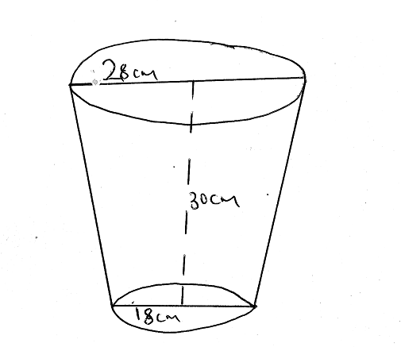

1. Calculate

(i) the slant height of the container (3mks)

(ii) the capacity of the container in litres (3mks)

1. The container is half-filled with water. Calculate the surface area of the container that is in contact with water. (4mks)
2. In triangle OAB, O(O,O) ,A(2,8) and B(10,2). C is the midpoint of OA and E is the midpoint of AB
3. Find

(i) the co-ordinates of C and E (3mks)

(ii) the magnitude of CE and OB (3mks)

1. Express the vector CE in terms of OB (1mk)
2. Given that OM=OE + 2CE, find

(i) the co-ordinates of M (2mks)

(ii) the co-ordinates of the image of M under a translation $\left(\begin{matrix}-8 \\ -2\end{matrix}\right)$ (1mk)

1. A married man earns a basic salary of sh. 10800 per month and is housed by his employer for a nominal rent of sh. 500 per month. His taxable income is hence deemed to be 115% of his basic earning less the rent paid. He is entitled to a family relief of sh. 1160 per month and a life insurance relief at a rate of 10% of insurance premium of sh. 600 p.m.
2. calculate his taxable income in £p.a. (1mk)
3. calculate relief on his insurance in sh p.a (1mk)
4. Using the income tax table below

(i) calculate the gross amount of tax he pays in sh p.a (4mks)

Income in £ p.a Rate in sh per £

|  |  |  |
| --- | --- | --- |
| 1- 2100 | 2 |  |
| 2101 -4200 | 3 |  |
| 4201- 6300 | 4 |  |
| 6301- 8400 | 5 |  |
| Over 8400 | 6 |  |

(ii)Calculate his net tax in sh. per month (2mks)

(d)Apart from tax,he is also deducted sh 280 for NHIF. Calculate his net earnings in sh per month. (2mks)

1. Marks scored by students in a class were recorded as shown below.

35 30 45 64 62 52 37 43 55 49

60 39 54 37 42 59 62 48 57 32

46 64 31 44 56 35 47 38 53 61

46 59 45 51 49 47 40 45 36 46

1. Complete the frequency table below with uniform classes as shown in the first class.

|  |  |  |  |  |  |  |  |
| --- | --- | --- | --- | --- | --- | --- | --- |
| Marks | 30-34 |  |  |  |  |  |  |
| No. of students | 3 |  |  |  |  |  |  |

1. determine the modal class. (1mk)
2. calculate

(i) the mean mark. (4mks)

(ii) the percentage of students who scored between 45 and 54 marks. (2mks)

(III) The simplified fraction of students who passed the exam if the pass mark was 45. (1mk)

1. The effort E required to lift a load L is partly constant and partly varies as L. Use the table below for values of E and L to answer the questions that follow.

|  |  |  |  |  |  |  |
| --- | --- | --- | --- | --- | --- | --- |
| L | 2 | 4 | 6 | 8 | 10 | 12 |
| E | 5.5 | 6 | 6.5 | 7 | 7.5 | 8 |

(a) Write an expression for E in terms of L. (1mk)

(b) Draw a graph of E against L (3mks)



c) From the graph,determine

(i) gradient of the graph (2mks)

(ii) the E-intercept of the graph. (1mk)

d) Write the equation connecting E and L. (1mk)

e) Find from the graph

(i) the effort when the load is 7. (1mk)

(ii) the load that can be lifted by an effort of 6,25. (1mk)

1. In the figure below, O is the centre of the circle. Chord AB of the circle is 8cm long. CM is perpendicular to AB and CM=AB.

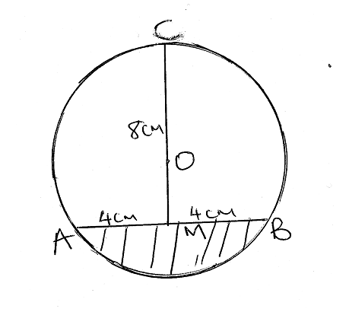

Calculate

(a) the radius of the circle (3mks)

b) the obtuse angle AOB (2mks)

c) the shaded area (3mks)

d) the unshaded area (2mks)