Name …………………………………………………………………………Adm. No. ……………………………..
Class …………………………………….
121/2
MATHEMATICS ALT A
PAPER 2
MARCH/APRIL 2016
2½ HRS
MWAKICAN(MJET) END OF TERM 1 EXAM
Instructions
(a) Write your name, class and admission number.
(b) Answer all the questions in section A and ONLY Five in section B.
(c) Show all the calculations in the spaces provided
(d) KNEC mathematical tables and non-programmable calculators may be used.
For Examiners Use
Section 1
1 | 2 | 3 | 4 | 5 | 6 | 7 | 8 | 9 | 10 | 11 | 12 | 13 | 14 | 15 | 16 | Total

Section 11
17 | 18 | 19 | 20 | 21 | 22 | 23 | 24 | total
Grand total

SECTION A
- Use logarithm tables to evaluate; [4 Marks]
$$\sqrt[3]{\frac{146.34^{2}×0.0063}{\cos{54 }}}$$

- A number $n$ is such that when it is divided by 3,7,11 or 13, the remainder is always 1. Find the number. [2 Marks]

- A square has an area of 144m². Calculate its perimeter. [2 Marks]

- Factorise$2x^{2}-x-6$ hence solve the quadratic equation
$2x^{2}-x-6=0$ [3 Marks]

- List all integral values of $x$ that satisfy the combined inequality; Represent the solutions on a single number line. [4 Marks]

- A body accelerates at 5m/s² to reach a velocity of 60m/s in 5 seconds. Calculate the initial velocity. [2 Marks]

- Draw a triangle STR and put arrows on its side to show that TS +SR = TR [ 2 Marks]

- A point P(2,5) is translated to P’(1,6)
- Find the translation vector [2 Marks]

- The image of $X$(3,0) under the same translation. [2 Marks]

- Solve for $x$ in [3 Marks]
$9^{x}+3^{2x}=54$

- The sum of interior angles of a regular polygon is 3240⁰. Find the size of each exterior angle.
[3 Marks]

- Write 1936 and 1728 in terms of its prime factors hence evaluate;
$\frac{\sqrt[3]{1728}}{\sqrt{1936}}$

- Use reciprocal tables to evaluate; [4 Marks]
$\frac{16}{2.674}+\frac{24}{0.1396}$

- Evaluate; [3 Marks]
$\frac{\frac{1}{2}of 3\frac{1}{2}+1\frac{1}{2}(2\frac{1}{2}-\frac{2}{3})}{\frac{3}{4}of 2\frac{1}{2}÷\frac{1}{2}}$

- Use substitution method to solve; (3 Marks)
$$2x+3y=1$$
$$3x-2y=8$$

- The straight line joining the points P(a,7) and Q(13,a) is parallel to the line whose equation is $3y+2x=9$. Find the value of a. [3 Marks]

- The ratio of the areas of two circles is 16:25
- What is the ratio of their radii. [2 Marks]

- If the smaller circle has a diameter of 28cm, find the radius of the larger circle. [2 Marks]

SECTION B
Answer any 5 Questions
- The marks of 30 girls in a class were recorded as follows.
220 250 204 230 210 227 221 252
200 228 208 225 200 202 240 228
212 225 252 216 212 226 227
240 248 203 201 251 242 216
- Construct a frequency table with a class width of 5 Marks beginning with 199 marks. [3 Marks]

- What is the modal class? [1 Mark]

- Estimate the mean [3 Marks]

- Estimate the median [3 Marks]

- The initial velocity of a body is 30m/s. the body accelerates uniformly to a velocity of 60m/s in 6 seconds. It moves at this constant velocity for 5 seconds before decelerating in 3 seconds.
- Using the graph paper provided, draw a velocity time graph to illustrate the information above. [4 Marks]

- Calculate the initial acceleration [2 Marks]

- Calculate the total distance covered. [4 Marks]

- The diagram below shows two circles that share a common chord XY which is 13cm long. Calculate;
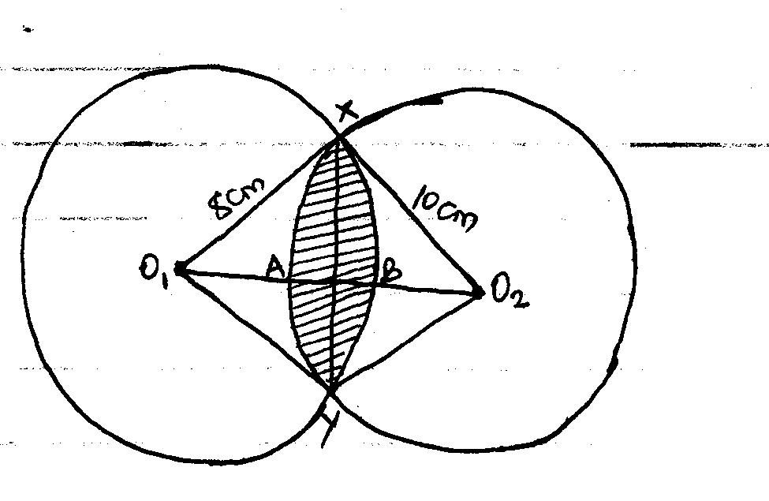
- <XO₁Y [1 Mark]

- < XO₂Y[1 Mark]

- The area of the sector O₁XBY [2 Marks]

- The area of the sector O₂YAX [2 Marks]

- The area of the shaded part [4 Marks]

- a. The diagram below shows a triangle OAB

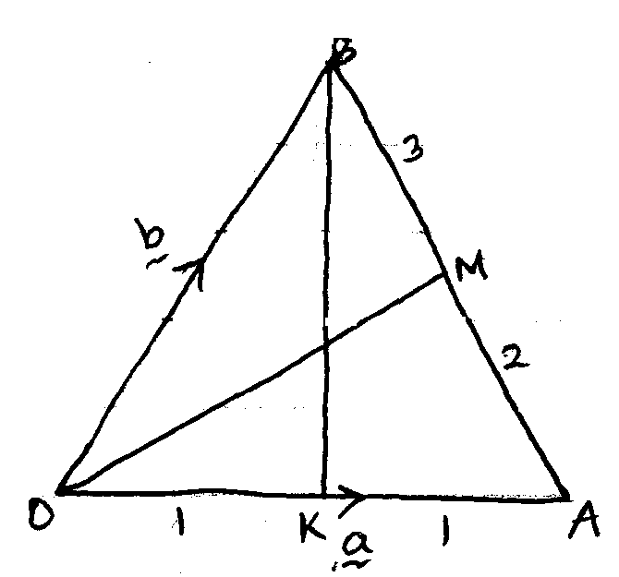
Points M and K are on AB and OA respectively such that;
AM:MB=2:3 and K is the mid point of OA.
Express the following vectors interms of a and b.

- AB [1 Mark]

- OM [2 Marks]

- BK [2 Marks]

b. The co-ordinates of P and Q are (6,10) and (8,14) respectively. Calculate;

- PQ [1 Mark]

- The mid-point of line PQ [2 Marks]

c. Given that $a=\left(\begin{matrix}3 \\ 4\end{matrix}\right)b \left(\begin{matrix}2 \\ 1\end{matrix}\right)and c=(\begin{matrix}3 \\ -4\end{matrix})$. Another vector P is such that $p=2a-b+4c$. Evaluate $\left|p\right|$correct to 2 decimal places. [2 Marks]

- The diagram below shows a frustrum that was cut from a right cone.
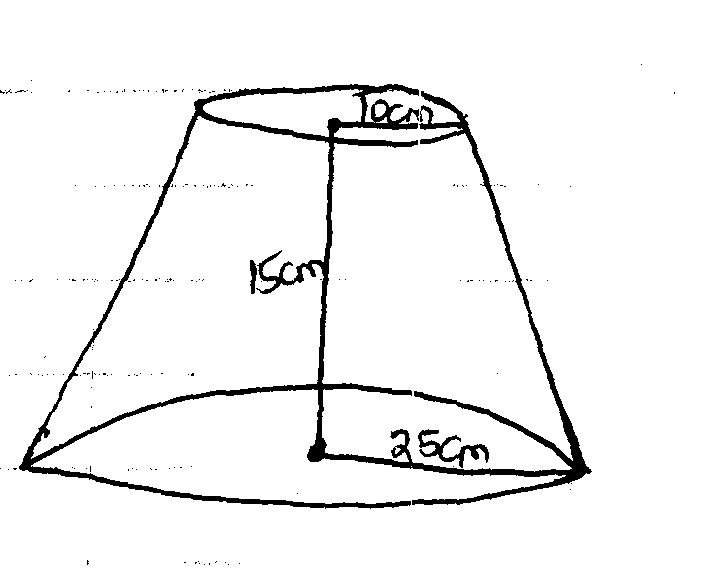
Calculate;
- The highest of the cone [2 Marks]

- The volume of the frustrum [4 Marks]

- The surface area of the frustrum [4 Marks]

- A line L₁ has the equation $3x+4y=12$
- Calculate
- The gradient of line L₁[2 Marks]

- The coordinates of P and Q where the line cuts the x-axis and y-axis respectively [4 Marks]

- Another line L₂ is perpendicular to L₁ and passes through (-4,5). Determine the equation of line L₂ in the form $y=mx+c$ [4 Marks]

- Form all inequalities that define Region R [10 Marks]
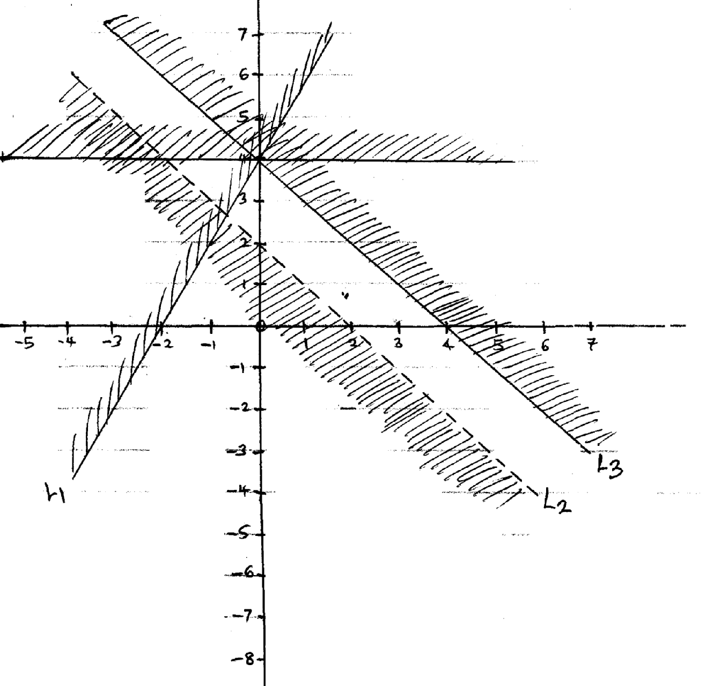

- a. Two trains T1 and T2 travelling in opposite directions on parallel trucks are just beginning to pass
each other. Train T1 is 72m long and is travelling at 108km/hr and T2 is 78m long travelling at
72km/hr. Find the time in seconds it takes the two trains take to completely pass one another.
[3 Marks]

- A rally car travelled for 2 hours 40 minutes at an average speed of 120km/hr. the car consumes an average of 1 litre of fuel for every 4 kilometres.
A litre of fuel costs sh. 64. Calculate the amount of money spent on the fuel. [4 Marks]

- Mwangi and Otieno live 40km apart. Mwangi starts from his home at 7.30am and travels towards Otieno at 16km/hr. Otieno starts from his home at 8.00am and cycles at 8km/hr towards mwangi. At what time do they meet? [3 Marks]

