MWAKICAN JOINT EXAMINATIONS (MJET)
Name………………………………………………………………..Adm.No…………………Class…………...

121/1
END OF TERM 3 EXAM
FORM 3MATHEMATICSPAPER 1
YEAR 2019
TIME: 2½ HRS.
INSTRUCTION TO STUDENTS:
- Write your name, admission number and class in the spaces provided above.
- Write the date of examination in spaces provided.
- This paper consists of two Sections; Section I and Section II.
- Answer ALL the questions in Section I and only five questions from Section II.
- All answers and working must be written on the question paper in the spaces provided below each question.
- Show all the steps in your calculation, giving your answer at each stage in the spaces provided below each question.
- Marks may be given for correct working even if the answer is wrong.
- KNEC Mathematical tables may be used, except where stated otherwise.
- Candidates should check the question paper to ascertain that all the pages are printed as indicated and that no questions are missing.
- Candidates should answer the questions in English.
FOR EXAMINER’S USE ONLY:
SECTION I
1 | 2 | 3 | 4 | 5 | 6 | 7 | 8 | 9 | 10 | 11 | 12 | 13 | 14 | 15 | 16 | TOTAL

17 | 18 | 19 | 20 | 21 | 22 | 23 | 24 | TOTAL
SECTION II
GRAND TOTAL

Ensure that all the pages are printed and no question(s) are missing

SECTION 1 (50 marks)
- Without using a calculator, evaluate. (3mrks)
-8+(-5) x(-8)-(-6)
-3+(-8) ÷ 2 x 4

- Evaluate without using a calculator (2mrks)
$$\frac{\left(23/7-1 5/6\right)÷5/6}{2/3 of 21/4-11/7}$$

- In fourteen years time, a mother will be twice as old as her son. Four years ago, the sum of their ages was 30 years. Find how old the mother was, when the son was born. ( 4 mks)

- A Kenya bank buys and sells foreign currencies as shown below
Buying Selling
(In Kenyan shillings) (In Kenyan shillings)
1 Hong Kong dollar 9.74 9.77
1 South African rand 12.03 12.11
A tourist arrived in Kenya with 105000 Hong Kong dollars and changed the whole amountto Kenyan shillings. While in Kenya, she spent Kshs. 403,897 and changed the balance to South Africa rand before leaving for South Africa. Calculate the amount, in South African rand that she received. (3 mrks)

- a) Using a ruler and a pair of compasses only, construct a quadrilateral PQRS in which PQ= 5cm, PS = 3cm, QR = 4cm,$<$PQR = 135$°$and $<$SPQ is a right angle. (2mrks)

b) The quadrilateral PQRS represents a plot of land drawn to a scale of 1:4000. Determine the actual length of RS in meters. (2mrks)

- The ratio of goats to cows in a farm is 2:5 while the ratio ofsheeps to cows is 3:4. If there are 15 sheep, how many animals are there in farm farm. (2mrks)

- Mr.Maina who deals in electronics sells a radio to a customer at Ksh. 1440 after giving a discount 0f 10% but find that he makes a 20% profit. Find the profit Mr. Maina would make if he does not give a
discount. (3mrks)

- use the reciprocal and square table to evaluate to four significant figure, the expression.(3mrks)
$\frac{1}{0.03654}$- ${4.151}^{2}$

- Simplify the following expression completely. (3mrks)
$$\frac{{12a}^{2}-{3b}^{2}}{{2a}^{2}-ab-b^{2}}$$

- Given that sin (x + 60)° = Cos (2x)°, find tan (x + 60)°. (3mrks)

- The figure below shows triangle PQR in which PR = 12 cm, T is a point on PR such that TR = 4cm. line ST is Parallel to QR
P
T
R
S
Q

If the area of triangle PQR is 336 cm², find the area of the quadrilateral QRTS. (3mrks)

- A square brass plate is 2 mm thick and has a mass of 1.05 kg. The density of the brass is 8.4 g/cm³. Calculate the length of the plate in centimeters (3 mks)

- The diagram below represent a solid made up of a hemisphere mounted on a cone. The common radius is 6 cm and the height of the solid is 15cm.
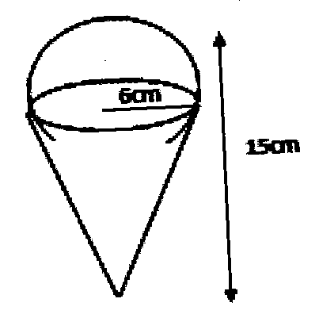

Calculate the external surface of the solid (4 Mrks)

- Solve the simultaneous inequalities given below and list all the integral values of x (3mks)
$\frac{3-x}{2}≥\frac{x+1}{3}≥\frac{2x+1}{-3}$

- A construction company employs technicians and artisans. On a certain 3 technicians and 2 artisans were hired and paid a total of Ksh9000.
On another day the firm hired 4 technicians and one artisan and paid a total of Ksh 9500. Calculate the cost of hiring two technicians and 5 artisans in a day

- 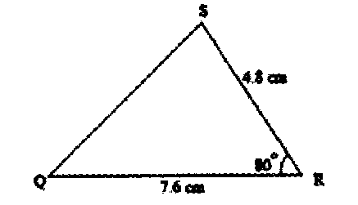The figure below is not drawn to scale.

80⁰

Find correct to 1 decimal place;
(a) Length PQ. (2 mark).

(b) Angle ABC (2 mark)

SECTION II(50 marks)
CHOOSE ANY FIVE QUESTIONS IN THIS SECTION
- Two lines L₁: 2y - 3x - 6 = 0 and L₂: 3y+x-20 = 0 intersect at point A.
(a) Find the coordinates of A. (3 Mrks)

(b) A third line L₃ is perpendicular to L₂ at point A. Find the equation of L₃ in the form y = mx +c, where m and c are constants. (3 mark)

(c) Another L₄ is parallel to L₁ and passes through (-1, 3). Find the x and y intercepts of L_{4.} (4 mark)

- Town B is 180km on a bearing 050⁰ from town A. Another town C is on a bearing of 110° from town A and on a bearing of 150° from town B. A fourth town D is 240 km on a bearing of 320° from A.Using scale drawing, such that 1cm rep 30km,

(a) Show the relative position of the towns (4 mks)

(b) Using the diagram, find
(i) Distance AC (2 mrks)

(ii) Distance CD (2 mrks)

(iii) Compass bearing of C from D (2 mrks)

- The table shows the marks obtained by 40 candidates in an examination
Marks | 5-14 | 15-29 | 30-34 | 35-44 | 45-49
Frequency | 2 | 12 | 7 | 15 | x
a) Find the value of X (1mk)

b) Calculate the mean mark (2mrks)

c) On the grid provided below draw a histogram to represent the data (4mrks)

d) drawing a straight line on the graph above determine the median mark (3mrks)

- The figure below shows a triangle ABC inscribed in a circle. AC = 10cm, BC = 7cm and AB = 10cm.
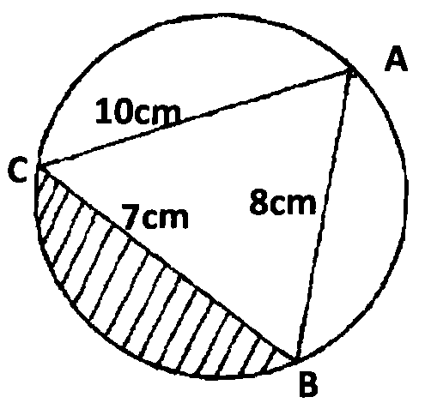
(a) Find the size of angle BAC. (3 Mks)

(b) Find the radius of the circle. (2 Mks)

(c) Hence calculate the area of the shaded region. (5 Mks)

- The figure below represents a speed time graph for a cheetah which covered 825m in 40 seconds.
- State the speed of the cheetah when recording of its motion started (1 mk)

- Calculate the maximum speed attained by the cheetah (3mks)

- Calculate the acceleration of the cheetah in:
- The first 10 seconds (2mks)

- The last 20 seconds (1mk)

- Calculate the average speed of the cheetah in first 20 seconds (3mks)

- Given the quadratic function y=3x² + 4x - 1
a) Complete the table below for values of x ranging - 4$≤$x $≤$3. (2mks)
X | -4 | -3 | -2 | -1 | 0 | 1 | 2 | 3
Y
b) Using the grid provided draw the graph of y = 3x² + 4x —2 for -4$≤$ x$≤$ 3 (3mks)

c) Using the graph, find the solution to the equations.
i) 3x²+4x-2=0 (2mks)

ii) 3x²+7x+2=0 (3mks)

- The diagram represents a solid frustum with base radius 21cm and top radius 14cm. The frustum is 22.5cm high and is made of a metal whose density is 3 g/cm3.
(Take $π$=$\frac{22}{7}$)
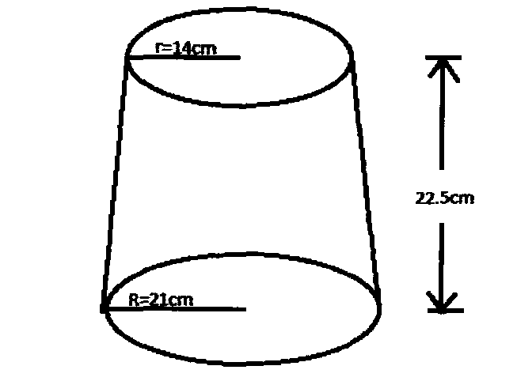
a) Calculate
(i) The volume of the metal in the frustum. (5 marks)

(ii) The mass of the frustum in kg. (2 marks)

b) The frustum is melted down and recast into a solid cube. In the process 20% of the metal is lost. Calculate to 2 decimal places the length of each side of the cube.
(3 marks)

- A saleswoman is paid a commission of 2% on goods sold worth over Ksh 100,000. She is also paid a monthly salary of Ksh 12,000.In a certain month, she sold 360 handbags at Ksh 500 each.
a) Calculate the saleswoman’s earnings that month. (3 mks)

b) The following month, the saleswoman’s monthly salary was increased by 10%. Her total earnings that month were Ksh 17,600.
Calculate:
i) The total amount of money received from the sales of handbags that month.
(5 mks)

ii) The number of handbags sold that month. (2 Mks)

