121/1
MATHS
PAPER 1
MARKING SCHEME TRAIL 2 2019
1 | Num = $\frac{-67}{35}$ LCM = 1085  Den = 31  $-\frac{67}{35} ÷31+\frac{3}{35}= \frac{93-67}{1085}$  = $\frac{93-67}{1085}=\frac{26}{1085}$ | M1  A1
 |  | 02
2 | ( $\frac{1}{34.52}+ \sqrt[3]{0.787}+ {\left(0.934\right)}^{3}$  $\frac{1}{3.452 x 10}+ \sqrt[3]{\frac{787}{1000}}$ + ${\left(\frac{9.34}{10}\right)}^{2}$  0.2901 x 0.1 + 9.233 x 0.1 + 814.8 x 0.001  0.02901 + 0.9233 + 0.8148  = 1.76711 | M1  M1  A1
 |  | 03
3 | 2^{3(2y – 1 )} x 2^{5y} = 2^{4(y + 1)}  2^{(6y – 3 + 5y)} = 2^{4y + 4}  ∴ 11y -3 = 4y + 4  7y = 7  y = 1
4 | $\frac{97.5}{100}$ x 120,000 = 117,000  $\frac{5}{100}$ x 117000 = 5850  9000 + 5850  = Sh.14,850 | M1  M1  A1
 |  | 03
5 | x = y + $\sqrt{x^{2}+ a^{2}}$  x – y = $\sqrt{x^{2}+ a^{2}}$  (x – y)² x² + a²  (x – y)² x² = a²  + $\sqrt{\left(x-y+x\right)(x-y-x)}$ = a  + $\sqrt{\left(2x-y\right)\left(-y\right)}$ = a  + $\sqrt{{(y}^{2}- 2xy)}$ = a
6 | Interior angle be x  Interior angle = 120º + x  120º + x + x = 180º  120º + 2x = 180º  2x = 60º  x = 30º  n = $\frac{{360}^{0}}{{30}^{0}}$  n = 12 sides | M1  A1  B1
 |  | 03
7 | 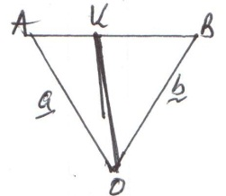  OK = $\frac{3}{5}OA+\frac{2}{5}OB$  = $\frac{3}{5} \left({-8 \atop 4}\right)+\frac{2}{5} \left({-2 \atop -12}\right)$  = $\left({\frac{-28}{5} \atop \frac{-12}{5}}\right)$  Co-ord = (-5.5, -2.4)  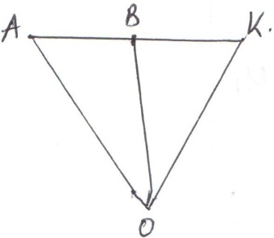  OK = $-\frac{1}{4}OA+\frac{5}{4}OB$  = $-\frac{1}{4} \left({-8 \atop 4}\right)+\frac{5}{4} \left({-2 \atop -12}\right)$  = $\left({0.5 \atop -16}\right)$  Co-ord = (0.5, -16) | M1  A1  M1  A1
 |  | 04
8 | GCD = 3  LCM = 1008 = 2⁴X3²X7  48= 2⁴X3  72= 2³X3²  X = 3X7 = 21
 |  | 03
9 | + 1 2 3 4 5 6  1 2 3 4 5 6 7  2 3 4 5 6 7 8  3 4 5 6 7 8 9  4 5 6 7 8 9 10  5 6 7 8 9 10 11  6 7 8 9 10 11 12  P(7 and above) = $\frac{21}{36}$  = $\frac{7}{12}$ | M1  M1  A1
 |  | 03
10 | x = $\frac{1+5y}{2}$  4 ${\left(\frac{1+5y}{2}\right)}^{2}$ + 25y² = 41  y = $\frac{4}{5}$ or -1  $∴x=2\frac{1}{2} or -2$  $\left(2\frac{1}{2},\frac{4}{5}\right) and (-2, -1)$ | M1  M1  A1 | Express x interms of y  Form quadratic function and solve
 |  | 03
11 | 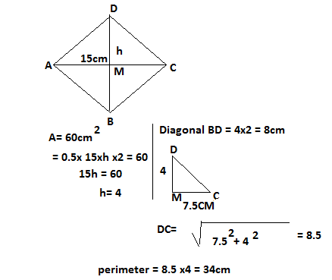
11 | x + x + 10º + 120º + 130º = 360 º  2x + 260 º = 360 º  2x = 100 º  x = 50º  Total no of animals = y  $\frac{120}{360} ×y=30$  $\frac{360}{120} ×30$ = y = 90  $Camels$ = $\frac{60}{360} ×90=$15 camels | B1  M1  A1  B1
 |  | 04
12 | x + x + 10º + 120º + 130º = 360 º  2x + 260 º = 360 º  2x = 100 º  x = 50º  Total no of animals = y  $\frac{120}{360} ×y=30$  $\frac{360}{120} ×30$ = y = 90  $Camels$ = $\frac{60}{360} ×90=$15 camels | B1  M1  A1  B1
 |  | 02
13 | 3x – (-4x + 5) = 0  3x + 4x – 5 = 0  7x = 5  x = $\frac{5}{7}$ | M1  A1
 |  | 03
14 | Max value of $\frac{x+y}{z}= \frac{10+7}{4}$ = 4.25  Min value of $\frac{x+y}{z}= \frac{3+5}{6}$  = 2.1667  Actual value of $\frac{x+y}{z}= \frac{9+6}{5}$ = 3  Absolute error = $\frac{4.25-2.1667}{2}$ = 1.0417  Percentage error = $\frac{1.0417}{3} ×100$  = 34.72% | M1  M1  M1  A1 | max and min values  actual values  absolute error  answ
 |  | 03
15
16 | 2x – 1 < x + 3  x < 4  x + 3 < 12(x + 4)  x + 3 < 12x + 48  $\frac{-11x}{-11} < \frac{45}{-11}$  x > - 4 $\frac{1}{11}$  Range of values  - 4 $\frac{1}{11} < x < 4$ | M1  M1  A1
 |  | 03
17 | Let the number of sh.100 tickets be x  Let the number of sh. 50 tickets be y  Total amount collected = 100x + 50y = 100,000  If 30% more of y were sold, the amount = $\frac{130}{100}$ x 50y  If 40% less of x were sold, the amount = $\frac{60}{100}$ x 100x  (65y + 60x = 112500) x 10……….(i)  (50y + 100x = 100,000) x 13……..(ii)  650y + 600x = 1125000…………(iii)  650y + 1300x = 1300000………..(iv)  Subtract eqn (iv) from eqn (ii)  700x = 175000  x = 250  $∴$ 50y + 100 x 250 = 100,000  50y $÷$ 25000 = 100,000  50y = 100000 – 2500  50y = 75000  y = 1500  Number of tickets costing sh.50= 1500  Number of tickets costing sh.100 = 250 | M1  M1  M1  M1  A1  M1  M1  A1  B1  B1 | For both expansions
 |  | 10

18 | 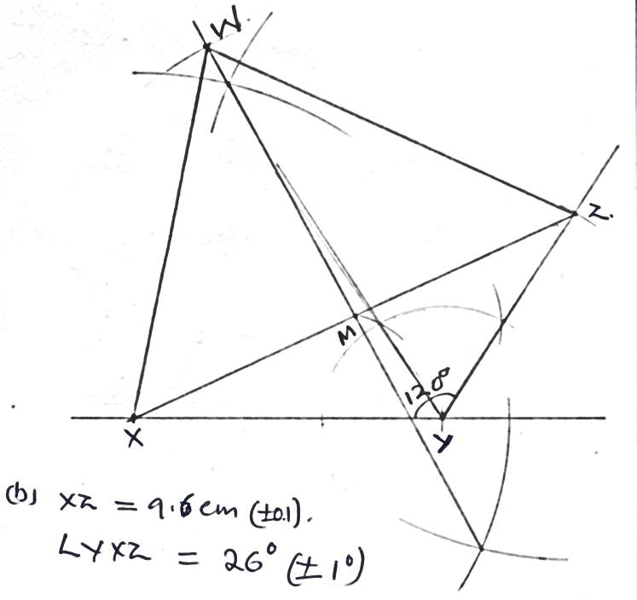  c) WM = 6.4 cm ($±$0.1)  Area of ΔXZW  ½ b x h = ½ x 96 x 6.4  = 30.72 cm² | B1  B1  B1  B1  B1  B1  B1  B1  M1  A1 | For 120º construction  Complete construction of ΔXYZ  Length  Angle YXZ  Perp bisec of XZ to M  Correct location of W  Complete ΔXZW  Length WM  ½ x 6.4 x 9.6  For 30.72 cm²
 |  | 10
19 | a)  x f d = X - A fd d² d²f  2.2 2.7 3.2 3.7 4.2 4.7 5.2 5 15 24 40 10 4 2 -1.5 -1.0 -0.5 0 0.5 1.0 1.5 -7.5 -15 -12 0 5 4 3 2.25 1 0.25 0 0.25 1 2.25 11.25 15 6 0 2.5 4 4.5  $\sum{f=100}$ $\sum{fd=-22.5}$ $\sum{d^{2}f=45.25}$  b) i) Mean = 3.7 + $\frac{-22.5}{100}$ = 3.475  = 3.48  ii) Standard deviation  $\frac{45.25}{100}- {\left(\frac{-22.5}{100}\right)}^{2}$ = 0.3819  $s.d= \sqrt{0.3819}$ = 0.617980  $=0.62$ | M1  M1  M1  M1  M1  M1  M1  A1  M1  A1 | d = X – A  fd  d²  d²f  $\sum{fd}$  $\sum{d^{2}f}$
 |  | 10

 |  | 10
20 | a) Area of the carpet (x + 4) (x – 1)  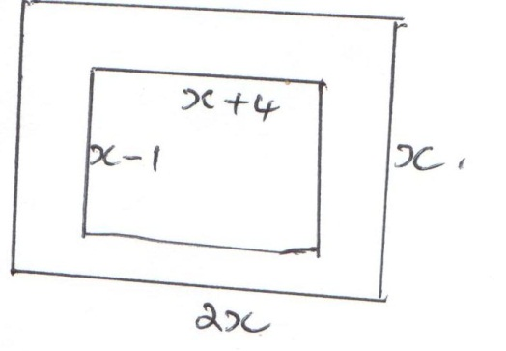  (x + 4) (x – 1) = 36  x² – x + 4x – 4 = 36  x² + 3x – 40 = 0  x² + 8x – 5x – 40 = 0  x(x + 8) – 5(x + 8) = 0  (x + 8) (x – 5) = 0  x = 5 or x = 8  x = 5m  Area of uncarpeted floor  2x² – {(x + 4) (x – 1)  2 x 25 – (9 x 4)  50 – 36 = 14m²  b) No. of tiles = $\frac{14 ×100 ×100}{20 ×20}$  = 350 tiles  Cost: (350 x 100) + (36 x 300)  = sh.45,800 | M1  M1  M1  A1  M1  A1  M1  A1  M1  A1
 |  | 10
21 | a)  x -3 -2 -1 0 1 2  2x² 18 8 2 0 2 8  +3x -9 -6 -3 0 3 6  -6 -6 -6 -6 -6 -6 -6  y 3 -4 -7 -6 -1 8  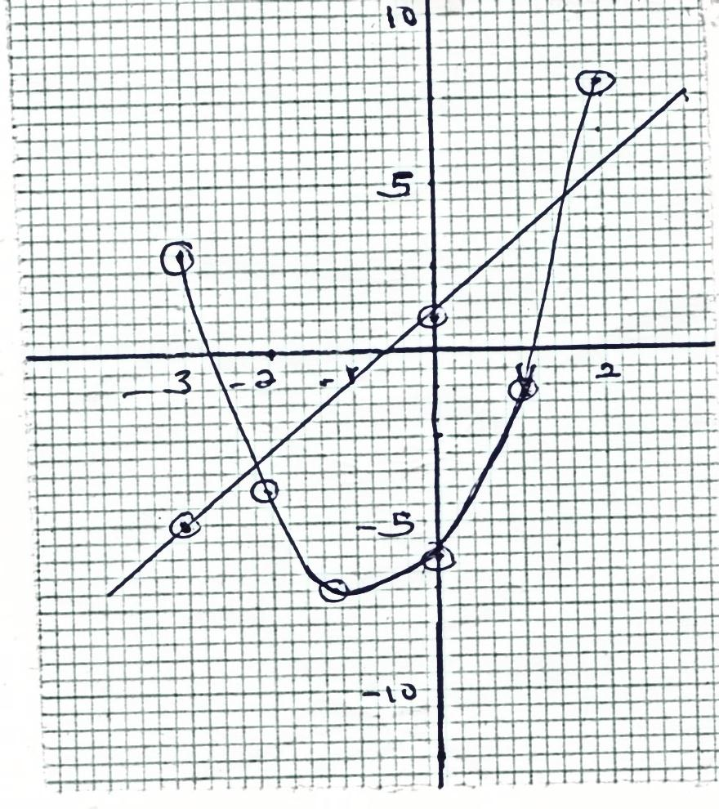  b) i) x = 2.6 and 2.1  ii) y = 2x² + 3x – 6  0 = 2x + 3x – 36  y = -3  x = 0.7 and -2.2  c) y = 2x² + 3x – 6  0 = 2x + x – 7  y = 2x + 1  x -3 0  y -5 1  x = 1.6 and x = -2.1 | B2  S1  P1  C1  L1  B1  B1  B1  B1
 |  | 10
22 | a)  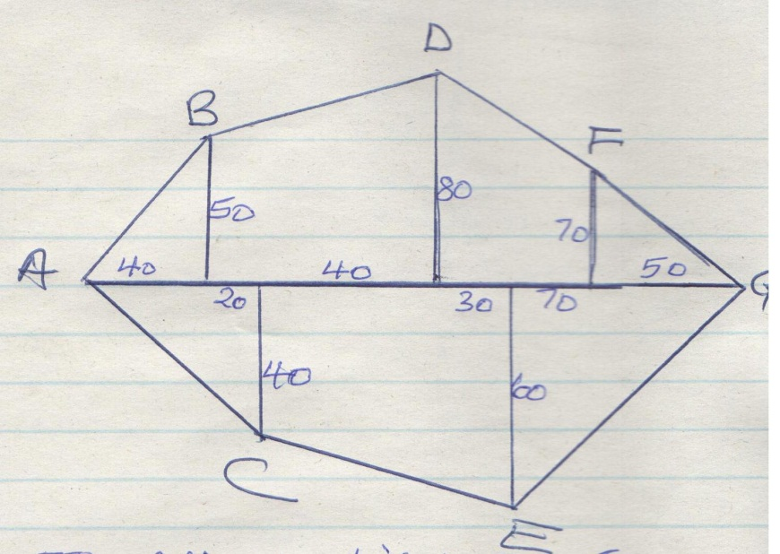  b) 1cm represents 20m  Drawing lengths  $\frac{250}{20}=12.5cm,\frac{40}{20}=2cm,\frac{80}{20}=4cm,\frac{60}{20}=3cm$  $\frac{70}{20}=3.5cm,\frac{50}{20}=2.5cm$  D  F  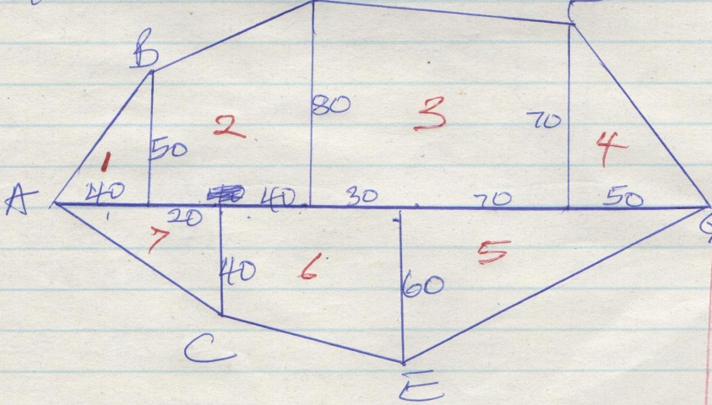  Area in m²  A₁ = ½ x 40 x 50 = 1000m²  A₂ = ½ x (50 + 60)60 = 3900 m²  A₃ = ½ x (80 + 70)100 = 7500 m²  A₄ = ½ x 70 x 50 = 1750 m²  A₅ = ½ x 120 x 60 = 3600 m²  A₆ = ½ x (60 + 40)70 = 3500 m²  A₇ = ½ x 60 x 40 = 1200 m²  Total area = (1000 + 3900 + 7500 + 1750 + 1750 + 3600 + 3500 + 1200) m²  = 22450 m²  1 ha = 10000 m²  22450  10000  2.245 ha | B1  B1  B1  B2  G  M1  M1  M1  M1  A1
 |  | 10
23 | - Acute ∠ROS = 2∠RTS  (∠ at centre)  2 x 35 = 70º  - ∠RQS = ∠RTS  ∠s in the same segment  = 35º  - ∠PQS = 90o (∠ made by a tangent and radius)  ∠PQR = ∠PQS + ∠RQS  = 90º + 35º  = 125º  - ∠QOT = ∠ROS = 35º  (vertically opposite angles)  In ΔPOQ, ∠QPT = 180º – (90 – 70)º  = 20º (Sum of ∠s in a Δ)  - In ΔPQR, ∠PRQ = 180º – (125 + 20)º  = 35º (∠ sum of Δ)  ∠PQT = ∠PRQ (∠s in alternate segment)  = 35º | B1  B  B1  B1  B1  B1  B1  B1  B1  B1
 |  | 10
24 | - Distance travelled  = Area of trapezium OAPC  = ½ x (AB + OC)V  920 = ½ (35 + 80)V  1840 = 115V  V = $\frac{1840}{115}=16$  - Acceleration during first 15 sec  = gradient of OA  = $\frac{16}{15}$  = 1 $\frac{1}{15}$ m/s²  - Distance travelled during the last 40 seconds  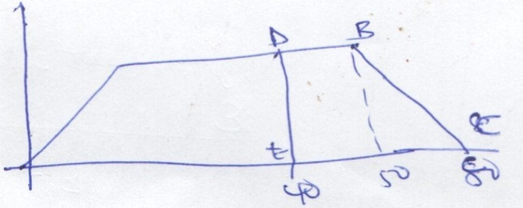  Area under DBC  = ½ x (DB + EC) 16  = ½ (10 + 40)16  = 400m | M1  M1  M1  A1  M1  M1  A1  B1  M1  M1  A1

