NAME:…………………………………………………………....ADM NO:…………………
SCHOOL…………………..………………………………….CLASS:……………………SIGNATURE:………………………
DATE:………………………..
121/1
MATHEMATICS
PAPER 1
SEPTEMBER 2021
2 ¹/₂HRS

KASSU JET EXAMINATION 2021
Kenya Certificate of Secondary Education (K.C.S.E) Trial Exam
MATHEMATICS PAPER 1
2 ¹/₂HRS
INSTRUCTIONS
- Write your name, school ,class and Admission number in the spaces provided above.
- Sign and write date of examination in the spaces provided above
- This paper consist of two sections; Section I and Section II
- Answer all questions in sectionI and only 5 questions from SectionII
- Show all the steps in your calculations, giving your answers at each stage in the spaces provided below each questions
- Marks may be given for correct working even if the answer is wrong
- Non- programmable silent electronic calculators and KNEC Mathematical tables may be used, except where stated otherwise.

For Examiners Use Only
Section I
1 | 2 | 3 | 4 | 5 | 6 | 7 | 8 | 9 | 10 | 11 | 12 | 13 | 14 | 15 | 16 | Total

Section II
17 | 18 | 19 | 20 | 21 | 22 | 23 | 24 | Total  Grand  Total

SECTION Ⅰ (50 MARKS)
ANSWER ALL THE QUESTIONS IN THIS SECTION
- Work out leaving your answer in its simplest form. (3 marks)

$\frac{\frac{2}{5} ÷ \frac{1}{2} of \frac{4}{9} - 1\frac{1}{10}}{\frac{1}{8} - \frac{1}{6} × \frac{3}{8}}$

- Find the equation of a line L₁ passing through the point (3,0) and perpendicular to the line $3y + x = 6$. Leave your answer in the double intercept form.(3marks)

- Find the values of x and y in $2^{3x+y}×3^{4x-y}=648$ (4 marks)

- A tourist from United Kingdom arrived in Kenya with 5000 sterling pounds and exchanged the money using the exchange rates below through an agent at a commission of 1.5% .
 | Buying (ksh) | Selling(ksh)
1 sterling pound | 135.50 | 136.20
1 us dollar | 99.20 | 101.30
While in Kenya, the tourist spent Ksh 250, 000 on accommodation and travelling and converted the rest into US dollars. Calculate to the nearest US dollar, the amount of money the tourist left Kenya with? (3 marks)

- Draw a line segment AB = 7cm and locate a point P which divides AB in the ratio 7: -2 (3marks)

- Use tables of reciprocals and cubes to evaluate to four significant figures.
(4 marks)
$\frac{3}{{\left(0.375\right)}^{3}}- \frac{2}{981.7}$

- The exterior angle of a regular polygon is an eighth of the interior angle. Calculate the sum of its interior angles. (3marks)

- Two similar solids have surface areas of 81cm² and 100 cm², respectively.
The larger solid has a mass of 12 kg, calculate the mass of the smaller solid.
(3marks)

- Generate the inequalities that satisfy the region labelled R. (3 marks)
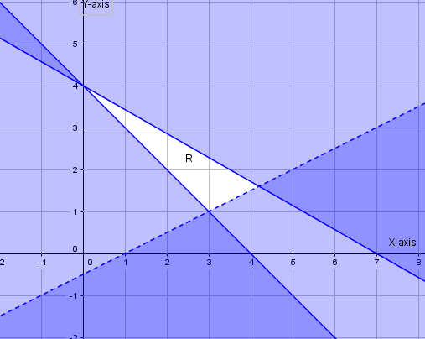

- Simplify the following expression. (3 marks)

$\frac{{3x}^{2}-14xy- {5y}^{2}}{{3x}^{2}- {75y}^{2}}$

- A solid in the shape of a regular hexagon with distance from the centre to any vertex as 10cm and length 3.5m has a density of 850kg/m³. Calculate the mass of the solid in grams correct to one decimal place. (3 marks)

- From a point T 20m away on a level ground the angle of elevation of the lower part of a window is 27and that of the upper part from the same point T is 32 .Calculate the height of the window. (3marks)

- A rectangle of area 6cm² is mapped onto another rectangle of area 30cm² under a transformation whose matrix is $\left(\begin{matrix}1 & 2 \\ y & 1\end{matrix}\right)$. Find the value of y. (3marks)

- 5men can erect 2 cottages in 21 days,how many more men,working at the same rate,will be needed to construct 6 cottages in the same period. (2marks)

- The position vectors of points A and B are $\left(3,-2\right)$ and $\left(9, 3\right)$ respectively. Given that a point K divides line AB in the ratio $8:-3.$Find the vector position of K in terms of $i and j$. (3 marks)

- Sketch the net of the solid shown in the figure below, measurements are in centimetres (3marks)
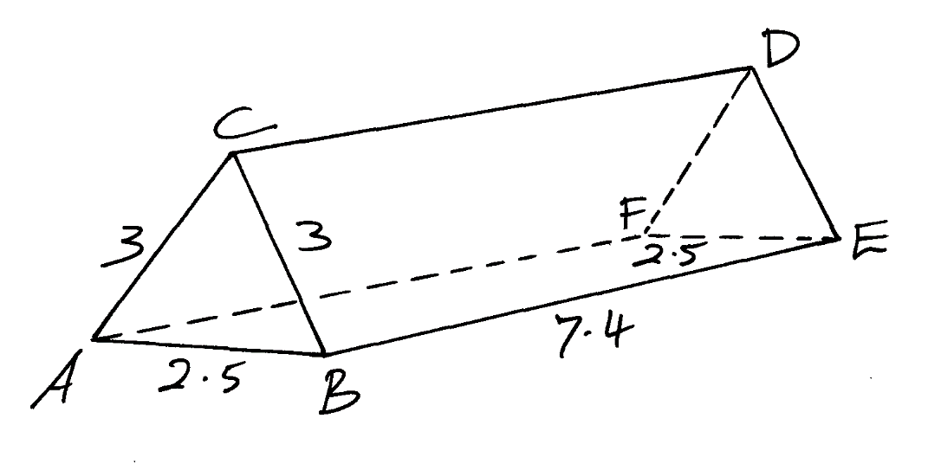
A
9
C
6
6
B
12
D
E
F

9

SECTION Ⅱ
ANSWER ONLY FIVE QUESTIONS IN THIS SECTION
- (a) On the grid below, draw triangle ABC with vertices $A(-4,1), B(-3,4)$ and
$C(-1,2)$ (1mark)
(b) Draw A^{I}B^{I}C^{I} the image of triangle ABC under translation vector$\left(\begin{matrix}3 \\ 1\end{matrix}\right)$.
(2 marks)

(c) A^{II} (5, 2), B^{II} (3, -4) and C^{II} (-1, 0) is the image of triangle A^{I}B^{I}C^{I} under transformation M. Describe the transformation. (3 marks)

(d) Draw A^{III}, B^{III}, C^{III} the image of triangle A^{II}B^{II}C^{II} under reflection in the line
$y = -x$. Hence state the co-ordinates. (3marks)

(e) State a pair of triangles that are oppositely congruent (1 mark)

- A tour van travelling at 60 km/hr takes 1 hour 20 minutes more than a speed car travelling at 80 km/hr to cover the distance from Nairobi to Maasai Mara.
(a)Calculate the distance from Nairobi to Maasai Mara. (2 marks)

(b)If the tour van leaves Nairobi at 2230 hrs and the speed car leaves 30 minutes later, find the time the speed car catches up with the tour van. (3 marks)

(c) At 2330hrs a saloon car left Maasai Mara for Nairobi travelling at 120km/hr and met the speed car at Maa.

Find:
(i) The time they met. (3 marks)

(ii) The distance between Maa and tour van at the time in (c) (i) above.(2 marks)

- The figure below shows an open tank in the form of a frustum with a depth of 2.5 m and other dimension as shown in the diagram.
8m
1.5m
2.5m
4m
3m

(a) Calculate the surface area of the tank. (6 marks)

(b) If the water in a full tank is used at a rate of 2500 litres per day, calculate how long, in days, it will sustain an institution. (4 marks)

- The following data shows the sample of age distribution of the people who reside in a certain village in years in Nandi county
Age group | 1-5 | 6-10 | 11-20 | 21-30 | 31-50 | 51-55 | 56-65
Frequency | 4 | 8 | 8 | 6 | 40 | 3 | 3

- Draw a histogram to represent this information (4marks)
- Find the mean of the age group. (4 marks)

(c) Using the histogram estimate the median using the histogram. (3marks)
- In the figure below ABC is a tangent to the circle at B. Given that angle
ABG =${40}^{0},$ BGD=${45}^{0}$ and DBE=${25}^{0}$ as shown below. Giving reasons, find the sizes of the following angles
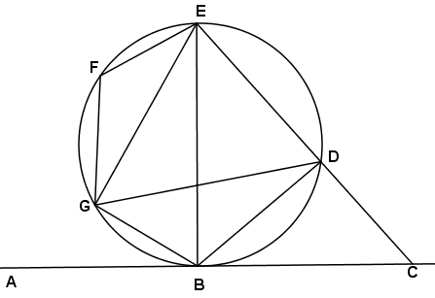
(a). BDG (2 marks)

(b). DGE (2 marks)

(c). EFG (2 marks)

(d). DBC (2 marks)

(e). BCD (2 marks)

- Points A,B,C and D are form corners of an Island and are such that B is 200km from A on a bearing of N60⁰E. C is 380km from B and on a bearing of 140⁰. Point C is on a bearing of 060⁰ from D and D is due south of B.
- Using a scale of 1cm represents 50km, show the positions of A,B,C and D. (4 marks)

- Use the scale drawing to determine
- Distance AC (2 marks)

- Distance DC (2 marks)

- Bearing of A from C (1 mark)

- Bearing of D from A (1 mark)

- An institution intended to buy a certain number of chairs at sh. 16200. The supplier agreed to offer a discount of sh. 60 per chair which enabled the institution to by 3 more chairs. Taking x as the originally intended number of chairs.
(a) Write an expression for;
(i) Original price per chair. (1 mark)

(ii) price per chair after the discount. (1 mark)

(b) Determine:
- The number of chairs the institution originally intended to buy.(4 marks)

- price per chair after the discount (2 marks)

(iii) The amount of money the institution would have saved per chair if it had bought the intended number of chairs at a discount of 15%. (2 marks)

- Triangle PQR is inscribed in the circle PQ= 7.8cm, PR = 6.6cm and QR = 5.9cm. Find:

R
Q
P
7.8cm
6.6cm
5.9cm

- The radius of the circle, correct to one decimal place (4marks)

- The angles of the triangle (2marks)

- The area of shaded region (4marks)

