Kenya Certificate of Secondary Education 2019

121/ 1 Mathematics Paper 1

END TERM 1– Time :2 ½ hours

Name …………………………………………….……… Index Number…………………………..
Candidate’s Signature ………………….…...……….. Date ……………………………………

Instructions to candidates
- Write your name, admission number and class in the spaces provided above.

- The paper contains two sections: Section I and Section II.
Answer ALL the question
- s in Section I and ANY FIVE questions from Section II.
- All working and answers must be written on the question paper in the spaces provided below each question.
- Marks may be awarded for correct working even if the answer is wrong.
- Negligent and slovenly work will be penalized.
- Non-programmable silent electronic calculators and mathematical tables are allowed for use.
- This booklet contains 17 printed pages. Please confirm that all the pages exist and are properly printed before starting the exam.

For Examiner’s use only
Section I
1 | 2 | 3 | 4 | 5 | 6 | 7 | 8 | 9 | 10 | 11 | 12 | 13 | 14 | 15 | 16 | Total
Section II
17 | 18 | 19 | 20 | 21 | 22 | 23 | 24 | Total
 |  |  |  |  |  |  |  |  | Grand Total %

Mathepatics Pp 1
2019

Turn over
SECTION I (50 MARKS)
Answer all the questions in this section.
- Without using mathematical tables or a calculator, evaluate
$\frac{2\frac{2}{7}-4\frac{1}{5}}{4- {\left(-3\right)}^{3}}$ + $\frac{1}{35} of 3$ (3 marks)

- Using tables evaluate. (3marks)
$$\frac{1}{34.52}+ \sqrt[3]{0.787}+ {\left(0.934\right)}^{3}$$

- Solve for y in the equation 8 ^{(2y – 1)} x 32^{y} = 16 ^{(y + 1)}. (3marks)

- A sales man earns a basic salary of sh. 9000 p.m. In addition he is also paid a commission of 5% for sales above sh.15,000. In a certain month he sold goods worth sh.120,000 at a discount of 2½%. Calculate his total earning that month. (3 marks)

- Make a the subject of the formula:
x = y $+\sqrt{x^{2}+ a^{2}}$ (3marks)

- Each interior angle of a regular polygon is 120⁰ larger than the exterior angle. How many sides does the polygon has? (3 marks)

- Given that A is the point (-8, 4) and B is the point (-12, -12), find the coordinates of a point K on AB such that :
- AK:KB = 2:3 (2 marks)

- AK:KB = 5: -1 (2 marks)

- The GCD and LCM of three numbers are 3 and 1008 respectively. If two of the numbers are 48 and 72 respectively, find the least possible value of the third number. (3 marks)

- Two fair dice are tossed and the outcome on each dice is recorded. Find the probability that the sum on both dice is greater than or equal to 7. (3 marks)

- Solve 2x – 5y = 1
4x² + 25y² = 41 (4 marks)

- The area of a rhombus is 60cm². Given that one of its diagonal is 15cm long. Calculate the perimeter of the rhombus. (3 marks)

- A farmer has four types of animals on his farm. The pie chart below represents the number of animals on the farm. If the number of goats were 30, calculate the number of camels on the farm. (4 marks)
(x + 10)º
xº
130º
120º

- Find the value of x for which $\left(\begin{matrix}3 & x-1 \\ -4 & x\end{matrix}\right)$ is a singular matrix. (2 marks)

- Solve for x in log₃ (4 + 3x) + 3log₃3 – 2 = log₃(x + 6) (3marks)

- A water tank has a capacity of 70litres. A similar model tank has a capacity of 0.25litres. If the larger tank has a height of 150cm. Calculate the height of the model tank. (3 marks)

- The figure below shows triangle ABC and its image A¹B¹C¹ after the transformation. Describe the transformation fully. (3 marks)
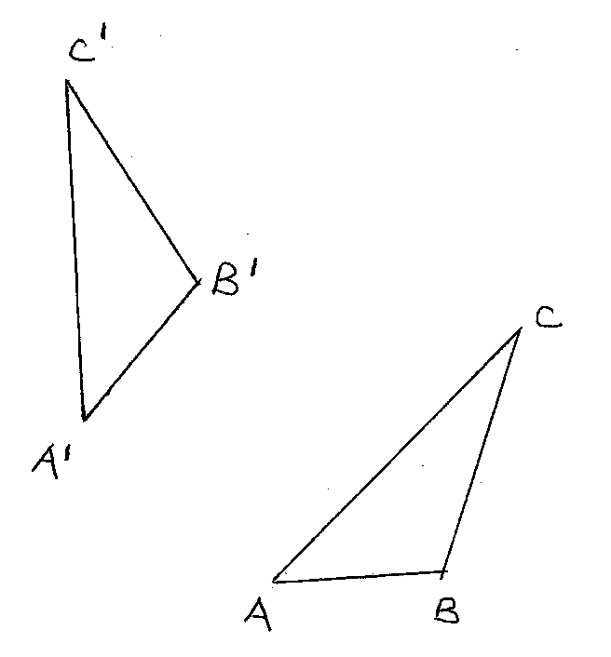

SECTION II (50 MARKS)
Answer any FIVE questions in this section.
- Tickets for a football match cost 100 shillings and 50 shillings and tickets to the value of Ksh.100,000 were sold. If 30% more tickets of sh.50 and 40% fewer tickets of sh.100 had been sold, the income would have increased to Ksh.112, 500. How many tickets of each category were sold? (10 marks)

- Use a ruler and compass only for all the constructions in this question.
- Construct a triangle XYZ in which XY= 6cm, YZ =5cm and angle XYZ= 120⁰. (2 marks)

- Measure XZ and angle YXZ. (2 marks)

- Construct the perpendicular bisector of XZ and let it meet XZ at N. (1 mark)
- Locate a point W on the opposite of XZ as Y and that XW = ZW and YW =9cm and hence complete triangle XZW. (2 marks)
- Measure WM and hence calculate the area of triangle XZW. (3 marks)

- The table below shows the masses of newly born babies at a maternity home.
- Complete the table and use it to answer the questions below. Take A = 3.7 (6 marks)
Mass (kg) | X | f | d= X - A | fd | d² | fd²
2.0 – 2.4 | 2.2 | 5 | -1.5 | -7.5
2.5 – 2.9 | 2.7 | 15
3.0 – 3.4 | 3.2 | 24
3.5 – 3.9 | 3.7 | 40 | 0 | 0
4.0 – 4.4 | 4.2 | 10
4.5 – 4.9 | 4.7 | 4
5.0 – 5.4 | 5.2 | 2 | 1.5 | 3.0
 |  | ∑f= 100 |  | ∑fd= |  | ∑fd²=

- Use the method of assumed mean to calculate to two decimal places.
- The mean mass of the babies. (2 marks)

- The standard deviation of the distribution. (2 marks)

- a) A carpet measuring (x+4)m by (x-1)m laid down in a rectangular room measuring 2x m by x m leaving out uncovered floor near the walls round the room. If the carpet is 36m², calculate the area of the uncarpeted floor. (6 marks)

b) If 20cm square tiles were to be used to carpet the uncarpeted section of the floor in (a) above, calculate the cost of carpeting the whole floor if the carpet costs sh.300 per square metre and each tile costs sh.100 per square metre. (4 marks)

- Income tax is charged on annual income at the rate shown below.
Taxable income K£p.a | Rate Ksh/£.
1-2300 | 2
2301- 4600 | 3
4601- 6900 | 5
6901- 9200 | 7
9201- 11500 | 9
11501 and over | 10

Mr. Kipsoroi earn a basic salary of Ksh.15,000 per month and lives in a company house for which he pays nominal rent of Ksh.1250 per month. He enjoys personal relief of Ksh.1056 per month and insurance relief of Ksh.270 per month.
Calculate;
- His taxable income in K£.p.a. (3 marks)

- The amount of tax he pays per month in Kenya shillings. (5 marks)

- His net monthly salary in shillings. (2 marks)

- In the figure below OF is the radius of the circle centre O chords EDC and CB are extend to meet at A and OE is perpendicular to DF at E. OF = 61cm, AB= 30cm, BC = 50cm, AD= 40cm.
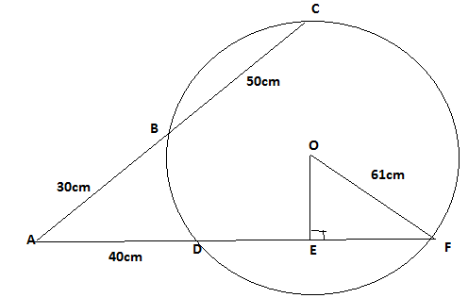
- Calculate the length of
- DF ( 2marks)

- OE (2marks)

- Calculate correct to 1dp
- Size of angle EOF ( 3marks)

- The length of the minor arc DF ( 3marks)

- A sector of angle 108⁰ is cut from a circle of radius 20 cm. It is folded to form a cone.
Calculate:
- The curved surface area of the cone. (2 mks)

- The base radius of the cone. (2 mks)

- The vertical height of the cone. (2 mks)

- If 12 cm of the cone is chopped off to form a frustrum as shown below.
12cm

Calculate the volume of the frustum formed. (2 mks)

- A village Q is 7 km from village P on a bearing of 045⁰. Village R is 5 km from village Q on a
bearing of 120⁰ and village S is 4 km from village R on a bearing of 270⁰.
- Taking a scale of 1 m to represent 1 Km, locate the three villages. (3 mks)

- Use the scale drawing to find the:
- Distance and bearing of the village R from village P. (2 mks)

- Distance and bearing of village P from village S. (2 mks)

- Area of the polygon PQRS to the nearest 4 significant figures. (3 mks)

