MWAKICAN JOINT EXAM (MJET)
MATHEMATICS FORM 1
END OF TERM II 2016
TIME: 2 ½ HRS

INSTRUCTIONS
- This paper consists of two sections I and II.
ANSWER ALL Questions
- All Answers and working MUST be written in the space provided.
- Show all the necessary steps in your calculations.
- Calculators SHOULD NOT be used.
Mathematical tables may be used.

SCORE
SECTION I | SECTION II | TOTAL SCORE

SECTION I (50 MARKS)

- Evaluate : (3mks)
-12÷(-3)×4-(-20)
-6×6÷3+(-6)

- factorize each of the following expression
- 3px-4ap +3qx-qy (2mks)

- a²- 4ap- 4p+a (2mks)

- The G.C.D of three numbers is 30 and their L.C.M is 900. Two of the numbers are 60 and 150. What is the least possible value of the third number? (3mks)

- Three people Odawa, Mliwa and Amina contributed money to purchase a flour mill. Odawa contributed ⅓ of the total amount, Mliwa contributed ⅜ of the remaining amount and Amina contributed the rest of the money. The difference in contribution between Mliwa and Amina was sh.40,000. Calculate the price of the flour mill. (4mks)

- Arrange the following fractions in ascending order (3mks)
⅞ , 5∕6, 7∕12, 2∕3

- Evaluate the following (3mks)
2.4×3.2×0.0096
0.018×0.064×96

- In fourteen years time a mother will be twice as old as her son, four years ago the sum of their ages was 30 years. Find how old the mother was when the son was born. (4mks)

- Three bells ring at intervals of 20 minutes, 30 minutes and 45 minutes. The bells will ring together at 12.40 pm. Find the time the bells had last rang together. (3mks)

- W hen 10 is added to twice a number and the result doubled, the final result is 32. Find the number.
(3mks)

3.256

- Express sa a fraction (3mks)

- Use mathematical tables to find the squareroot of 0.001952 (3mks)

- The shaded region below shows the area swept out on a flat windscreen by a wiper, calculate the area of the region. (3mks)
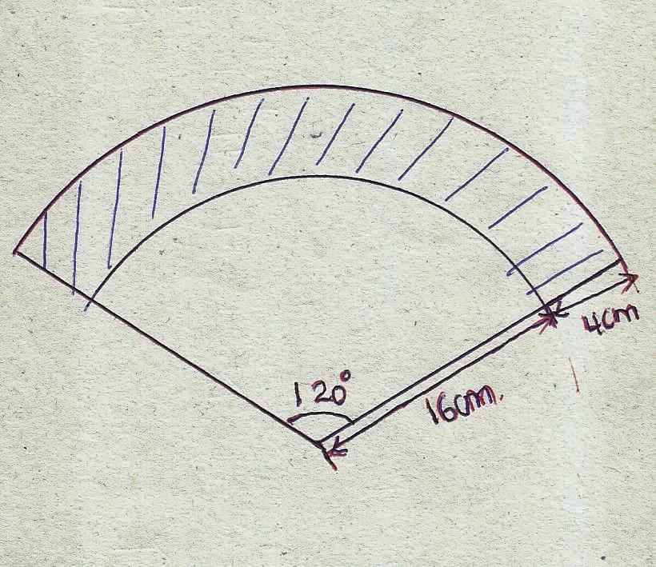

- The length of an arc of a circle is one-eighth the circumference of the circle. Find the angle subtended by this arc at the centre if the radius of the circle is 14cm.(Take Pie =22/7) (4mks)

- The price of an article was raised by 20% and a week later the price was lowered by 20%. What is the new price if the original price was Sh.50. (3mks)

- The acceleration due to gravity on the moon is 1.6N/Kg. An astronaut weighs 670N on the earth surface. Find
- His mass (2mks)

- His weight on the moon’s surface (2mks)

SECTION II (50MKS)
- Three business partners Bela, Joan and Trinity contributed Ksh.112,000,Ksh.128,000 and Ksh.128,000 respectively to start a business. They agreed to share their profit as follows:
30% to be shared equally
30% to be shared in the ratio of their contributions
40% to be retained for the running of the business.
If at the end of the year the business realized a profit of ksh. 1,350,000
Calculate :
- The amount of money retained for the running of the business at the end of the year (1mk)

- The difference between the amounts received by Trinity and Bela (6mks)

- Express Joan’s share as a percentage of the total amount of money shared between the three partners. (3mks)

- The net of the solid of a cuboid consists of a series of rectangles. By drawing the net of the solid determine:
- The surface area of the cuboid
- Its volume
Given that it measures 6cm by 3cm by 2cm. (10mks)

- A tin has a square base whose sides measures 32cm. the vertical sides are 50cm high. Cake mixture is poured into the tin and leveled off at the 38cm mark above the base.
Find:
- Surface area of the tin (3mks)

- The capacity of the tin (3mks)

- The volume of the cake mixture in the tin in cm³ (2mks)

- The volume of the space unoccupied by the cake in cm³ (2mks)

- A cylindrical water tank with no top was constructed. If the diameter of the tank was 2.8m and height 4.8m. calculate:
- Its volume (3mks)

- Given that it was filled with a liquid of density 0.8g/cm³, calculate the mass of the liquid inside the cylinder (3mks)

- Given that the cost of painting was 50 shillings for every 1m², calculate the cost of painting the water tank (4mks)

- Study the diagram below and answer the questions that follow.
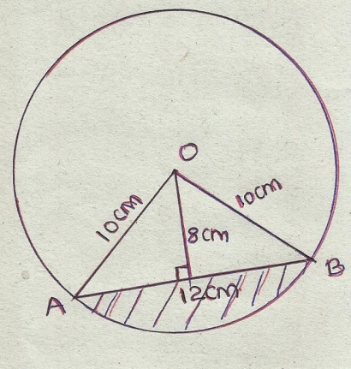

Given that <AOB=120⁰, calculate
- Area of the minor sector (3mks)

- Area of the triangle OAB (2mks)

- Area of the shaded region (2mks)

- By calculating the area of the circle first, calculate the area of unshaded region (3mks)

