Name ……………………………………………………………………………………Adm. No. ………………………

Class …………………………………….
121/1
MATHEMATICS ALT 1
FORM 3
JULY/AUGUST 2016
2½ HRS
MWAKICAN(MJET) END OF TERM II EXAM
Instructions
(a) Write your name, class and admission number.
(b) Answer all the questions in section I and ONLY Five in section II.
(c) Show all the calculations in the spaces provided
(d) KNEC mathematical tables and non-programmable calculators may be used.

For Examiners Use
Section 1
1 | 2 | 3 | 4 | 5 | 6 | 7 | 8 | 9 | 10 | 11 | 12 | 13 | 14 | 15 | 16 | Total

Section 11
17 | 18 | 19 | 20 | 21 | 22 | 23 | 24 | Total
Grand total

SECTION I
- Evaluate without using a calculator. [1 Mark]
$\frac{(2\frac{3}{7}-1\frac{5}{6})÷\frac{5}{6}}{\frac{2}{3}of2\frac{1}{4}-1\frac{1}{7}}$

- The equation of a straight line L₁ is $3y+4x=12$
    - Find the gradient of L₁ [1 Mark]

    - The equation of another line L₂ which is perpendicular to L₁ and passes through (1,2) [2 Marks]

- Evaluate using mathematical tables only expressing your answer to 4 significant figures. [3 Marks]
$\frac{3}{0.2311}+({0.7918)}^{2}$

- Given that:
$\sin\left(3x-35\right)=\cos{(x+20)}$. Find $x$ [2 Marks]

- The size of an interior angle of a regular polygon is (3$x)°$ while the exterior angle is ($x-20)°$. Find the number sides of the polygon [3 Marks]

- Three bells ring at intervals of 9 minutes, 15 minutes and 21 minutes. The bells will next ring together at 11.00pm. Find the time the bells had last rung together.
[3 Marks]

- Find all the integral values of $x$ which satisfy the following inequalities [3 Marks]
$2\left(2-x\right)<4x-9<x+11$

- At a party, every two people shared a plate of Ugali between them. Every 3 people shared a plate of soup and every 4 people shared a plate of meat. If 65 plates were used in total. How many people were there? [3 Marks]

- Find the value of $x$ which satisfies the equation; [3 Marks]
${16}^{x^{2}}=8^{4x-3}$

- Mary and John live 140km apart. Mary starts from her home at 7.00am and drives towards John’s home at 80km/hr. John starts at 7.30am and drives towards Mary’s home at 100km/hr. at what tome did they meet? [3 Marks]

- Two points P and Q have coordinates (-2, 3) and (1, 3) respectively. A translation maps point P to P¹ (10,10).
  - Find the translation vector [1 Mark]

  - Find the coordinates of Q the image of Q under the translation. [1 Mark]

  - Find the values of M and N if;
$mP-nQ=\left({-12 \atop 9}\right)$ [3 Marks]

- A Kenyan company received $100,000 US dollars. The money was converted into Kenya shillings in a bank which buys and sells foreign currencies as follows;
Buying. Selling
1 US Dollar ($) 77.23 78.11
1 Sterling Pound (£) 121.04 122.93
  - Calculate the amount of money, in Kenya shillings the company received[2 Marks]

  - The company exchanged the Kenya-shilling calculated in (a) above into sterling pounds to buy a car from Britain. Calculate the cost of the car to the nearest sterling pound. [2 Marks]

- In the figure below, O is the centre of the circle. Angle OAB=30⁰ and angle BAC = 23⁰. Find angle ABC. [3 Marks]
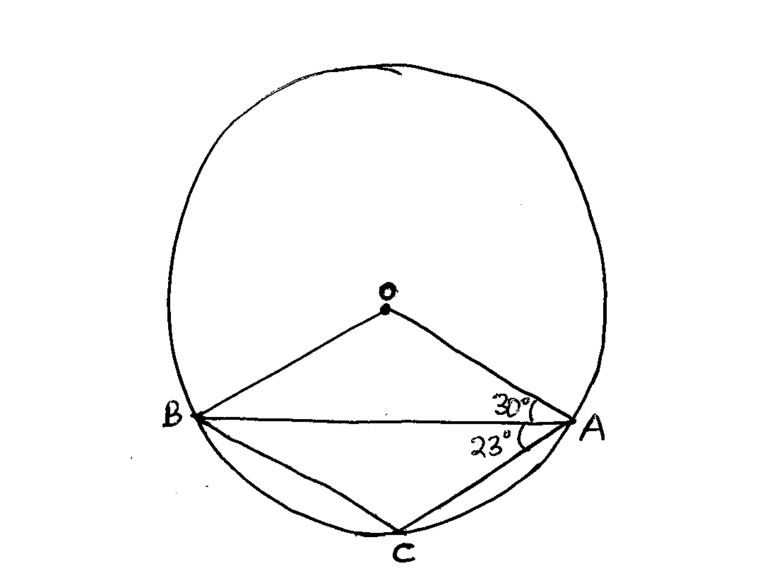

- A number n is such that when it is divided by 27, 30 or 45, the remainder is always 3. Find the smallest value of n. [2 Marks]

- A particle accelerates uniformly from rest and attains a maximum velocity of 30m/s. after 16 seconds. It travels at this constant velocity for 20 seconds before decelerating to rest after another 8 seconds.
Calculate the total distance travelled by the particle. [4 Marks]

- The figure below shows a rhombus PQRS with PQ=9cm and $<SPQ=60°, S×Q$ is a circular arc center P.
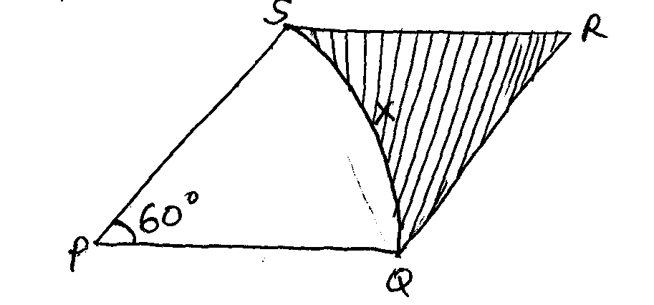
Calculate the area of the shaded region correct to 2 decimal places. [3 Marks]

SECTION II
Answer any 5 Questions in this Section. (50 Marks)
- A salesman received a basic salary of sh. 50,000 a year together with a commission of 6% on the value of goods sold and a car allowance of sh. 2.50 per km.
  - Find the total amount he received in a year in which he sells goods worth sh. 625,000 and travels 10,000km. [4 Marks]

  - The next year he travels 12,000km and receives a total of sh. 134,000.
    - Calculate the value of goods sold. [4 Marks]

    - Calculate the percentage increases in the value goods sold. [2 Marks]

- The following measurements were recorded in a field book at a farm using XY=400m as the baseline.
 | Y
C 60  B 100  A 120 | 340  300  240  200  140  80 | 120 D  100 E  160 F
 | X

  - Using the scale of 1:4000 (1cm represents 40m) draw accurately the map of the farm. [4 Marks]

  - Determine the actual area of the farm in hectares. [4 Marks]

  - If the farm is on sale at Ksh. 80,000 per hectare, how much does the farm cost?
[2 Marks]

- The minor arc PQ of a circle radius 21cm subtends an angle of 120⁰ at the centre of the circle as shown below.
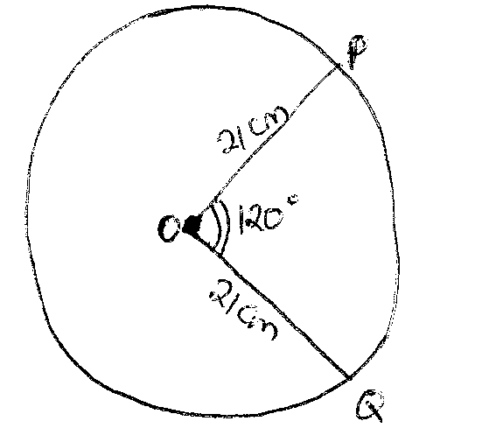
  - Find the area of the minor sector POQ [2 Marks]

  - Find the perimeter of the minor sector POQ [3 Marks]

  - The minor sector POQ is folded to form a right circular cone.
Calculate:
    - The radius of the cone. [3 Marks]

    - The height of the cone. [2 Marks]

- A triangular piece of land ABC has sides AB=100m, BC=150m and AC=190m.
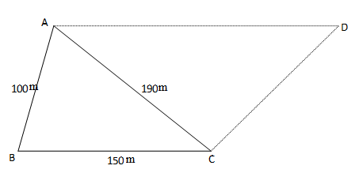
- Calculate the area of the triangular piece of land ABC [2 Marks]

- Calculate the value of angle ACB. [3 Marks]

- A new piece of land ABCD is a trapezium with AD//BC whose area is three times that of triangle ABC, calculate the perimeter of ABCD. [5 Marks]

- Three business partners, Bela, Joan and Trinity contributed Kshs. 112, 000, Kshs. 128, 000 and Kshs. 210, 000 respectively to start a business. They agreed to share their profits as follows:
30% to be shared equally
30% to be shared in the ratio of their contributions
40% to be retained for the running of the business.
- If at the end of the year, the business realised a profit of Kshs. 1. 35million
Calculate:
- The amount of money retained for running the business at the end of the year. [1 Mark]

- The difference between the amounts received by Trinity and Bela. [6 Marks]

- Express Joan’s share as percentage of the total amount of money shared between the three partners. [3 Marks]

- In the figure below, O₁ and O₂ are the centres of the circles whose radii are 4 cm and 7 cm respectively. The circles intersect at A and B and angle AO₁O₂ = 60˚
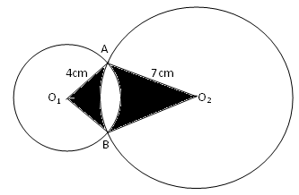
Find by calculation; take π = 3.142
  - The angle AO₂O₁ [1 Mark]

  - The area of the quadrilateral AO₁BO₂ [4 Marks]

  - The shaded area [5 Marks]

- Members of a certain group decided to raise sh. 225,000 to buy a plot of land, with each contributing the same amount. Before the due date for collection of the contribution, ten of the members withdrew from the project.
  - Letting $n$ represent the original membership of the group, show that the increase in contribution per member was $\frac{2250000}{n\left(n-10\right)}$ [4 Marks]

  - If the increase in contribution per person was sh. 1125, what was the original number of members in the group? [4 Marks]

  - Calculate the percentage increase in the contribution per person caused by the withdrawal of the members. [2 Marks]

- In the figure below, O is the center of the circle. <AEB=50⁰, <EBC=80⁰ and <ECD=30⁰
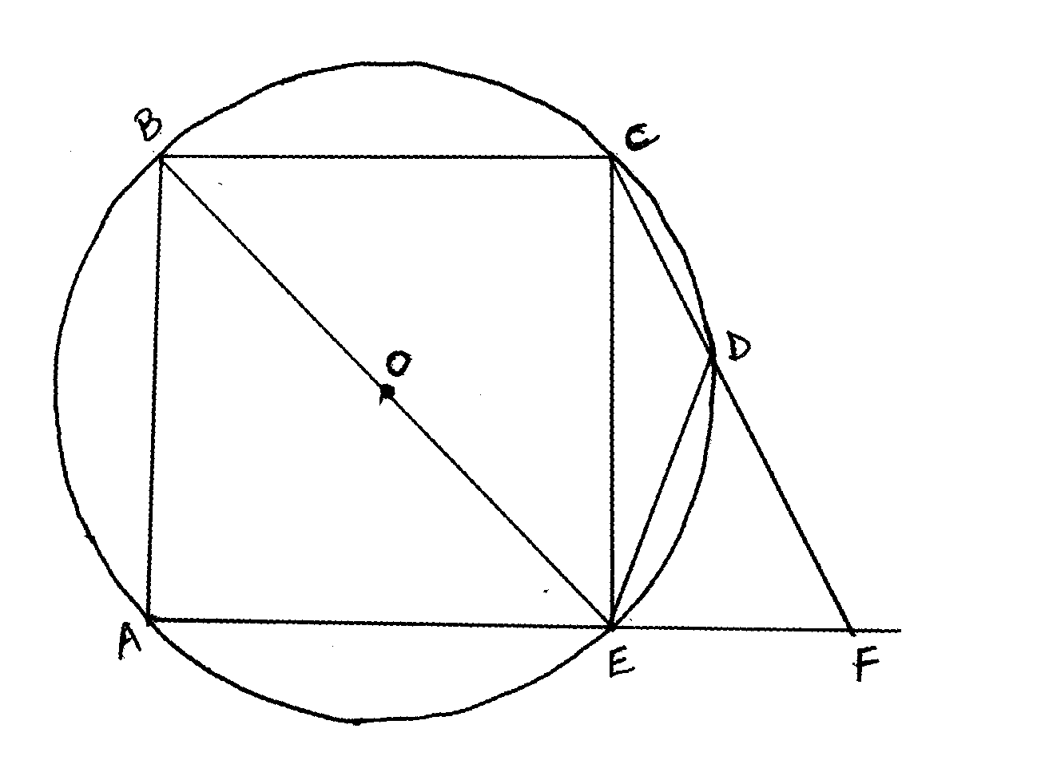
Giving reasons calculate
    - <CDE [2 Marks]

    - <DFE [2 Marks]

    - Obtuse <COE [2 Marks]

    - <ADE [2 Marks]

    - <CAE [2 Marks]

