NAME:……………………………………………INDEX NO:………………………………...

CANDIDATE’S SIGNATURE:……………

DATE:……………………………………...

121/1
MATHEMATICS
JULY, 2019
PAPER 1
TIME: 2½ HOURS

BUURI EAST STANDARDS
Kenya Certificate of Secondary Education
MATHEMATICS Alt. A
2 ½ Hours

Instructions to candidates.
- Write your name and index number in the spaces provided above.
- Sign and write the date of the examination in spaces provided above.
- This paper consists of two sections: Section I and II.
- Answer all the questions in section I and only five questions from section II.
- Show all the steps in your calculations, giving your answer at each stage in the space provided.
- Marks may be given for correct working even if the answer is wrong.
- Non-programmable silent electronic calculators and KNEC mathematical tables may be used, except where stated otherwise.
- Candidates should check the question paper to ascertain that no questions are missing.
- Candidates should answer the questions in English.

For examiner’s use only

SECTION I
1 | 2 | 3 | 4 | 5 | 6 | 7 | 8 | 9 | 10 | 11 | 12 | 13 | 14 | 15 | 16 | TOTAL

SECTION II
17 | 18 | 19 | 20 | 21 | 22 | 23 | 24 | TOTAL
GRAND
TOTAL

SECTION I (50 MARKS): Answer all the questions in this section in the spaces provided.
- Evaluate without using tables or a calculator the value of $\frac{1.33×0.15}{0.19×0.0017}$(3marks)

- When a certain number is divided by 48, 72 or 100 the remainder is 3 in each case. Find the number. (3marks)

- Using logarithm table evaluate $\sqrt[3]{\frac{849.6×2.41}{3941}}$. (4marks)

- A 890kg culvert is made of a hollow cylindrical material with outer radius of 76cm and an inner radius of 62cm. It crosses a road of width 3m. Determine the density of the material used in its construction in Kg/m³ correct to one decimal place. (3marks)

- Evaluate the value of x in${81}^{x+1}+3^{4x}=246$(3marks)

- Simplify the equation $\frac{{4x}^{2}-9}{{2x}^{2}+5x+3}$.(3marks)

- The diagram below represents a prism whose Cross-section is a right angled triangle. Draw the net of the solid. (3marks)

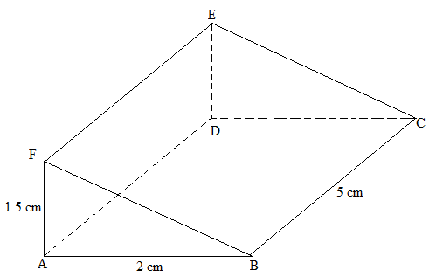

- During an annual general meeting at Elimu Mixed Day, goats and chicken were slaughtered. The number of heads for both chicken and goats were 45. The total number of legs were 100. Determine the exact number of goats and chicken slaughtered.(3marks)

- In a mixed school there are 900 students, out of these 600 are girls.
- Find the ratio of boys to girls. (2marks)

- What is the percentage of boys in this school?(1mark)

- Find the value of t in the equation$\frac{t-1}{3}-\frac{4+t}{4}=0$(3marks)

- The sum of interior angles of a polygon is 1980⁰. Find the number of sides of the polygon and name the polygon. (3marks)

- Using trapezoid rule, estimate the area under the curve $y=\frac{1}{2}x^{2}-2$ bounded by lines, x =2 and x=8 and x –axis use six strips. (3marks)

- Lines K whose equation is $2y-6=4x$is perpendicular to another line Q. Find the equation of line Q if it passes through point. (-2,7). (3 marks)

- The figure below is not drawn to scale.
Find correct to 1 decimal place;
- Length PQ.(2 marks)

- Angle ABC (2 marks)

- The marked price of a car ina dealers shop was Ksh.450 000. Kawira bought the car at 7% discount. The dealer still made a profit of 13%. Calculate the amount of money the dealer had paid for the car to the nearest shillings. (3marks)

- The figure below shows triangle T with vertices P(2,4), Q(6,2) and R(4,8). It is mapped onto triangle T/ with vertices P/(10,0), Q/(8,-4) and R/(14, -2) by a rotation.
- Draw on the same axis T/ the image of triangle T. (1 mark)
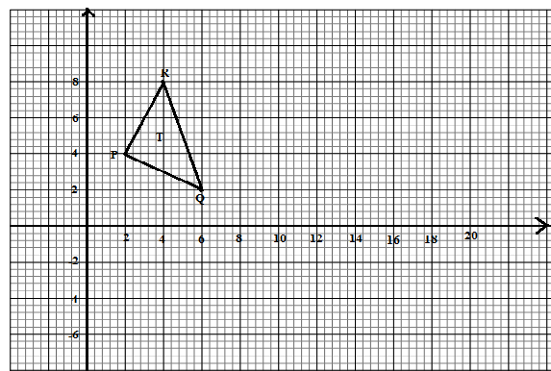
- Determine the center and angle of rotation. (2marks)

SECTION II(50 marks). Answer only five questions in this section in the spaces provided.

- The diagram below shows a solid made of a hemisphere and a cylinder. The radius of both the cylinder and the hemisphere is 3cm. The length of the cylinder is 12cm.

- i) Calculate the volume of the solid. (3marks)

ii) The solid fits in a box in the shape of a cuboid 15 cm by 6cmby 6cm. Calculate
thevolume of the box not occupied by the solid correct to four significant figures.
(2marks)

- i) Calculate the total surface area of the solid correct to four significant figures.
(3marks)

ii) The surface of the solid is to be painted. One millilitre of paint covers an area of
8cm².The cost of paint is Ksh 900 per litre. Calculate the cost of the paint
required. (2marks)

- The table below shows the age groups and number of people who are HIV/ AIDSpositive, in a certain sub county in Kenya.

Age group | 10 – 19 | 20 – 29 | 30 – 39 | 40 – 49 | 50 – 59 | 60 – 69 | 70 – 79
No. of people | 12 | 15 | 16 | 25 | 18 | 10 | 4

- State the modal age group. (1mark)

- Calculate the mean age of the people who are HIV/AIDS Positive. (3marks)

- Calculate the median of the age group. (3marks)

- Draw on the grid provided a histogram to represent the above information. (3marks)

- A trader bought 2 cows and 9 goats for a total of Ksh. 98,200. If she had bought 3 cows and 4 goats, she would have spent Ksh. 2, 200 less.
- Form two equations to represents the above information. (2marks)

- Use the matrix method to determine the cost of a cow and that of a goat. (4marks)

- The trader later sold the animals she had bought making a profit of 30% per cow and 40% per goats.
- Calculate the total amount of money she received. (2marks)

- Determine corrects to 4 significant figures the percentage profit the trader made from the sale of animals. (2marks)

- Two towns, Meru and Maua are 80km a part, Kimathi started cycling from Meru to Maua at 10:00 30a.m at an average speed of 40km/h. Mutuma started his journey from Maua to Meru at 10:30 a.m and travelled by car at an average speed of 60km/h.
- Calculate:
i) The time taken by Kimathi and Mutuma to meet. (3marks)

ii) The distance from Meru when Kimathi and Mutuma met. (2marks)

iii) The time of the day when the two met. (2marks)

- Murianki cycled from his home to a school 6km away in 20minutes. He stopped at the school for 5 minutes, before taking a motorbike to a town 40 km away. The motorbike travelled at 75km/h. On the grid provided, draw a distance time graph to represent Murianki’s journey. (3marks)
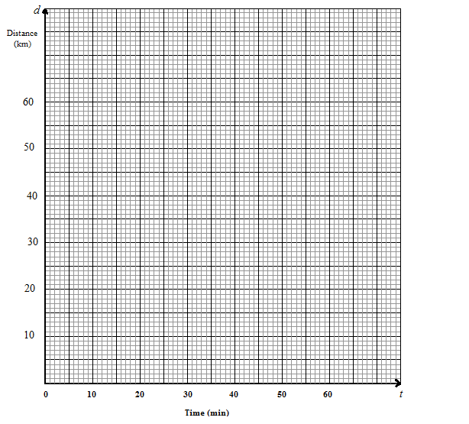
- In the figure below OAB is a triangle in which M divides OA in the ratio 2:3 and N divides OB in the ratio 4:1. AN and BM intersects at X.
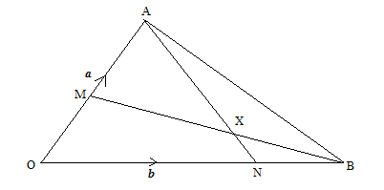

- Given that OA = a andOB=b express in terms of a and b.
- AN(1 mark)

- BM(1mark)

- AB(1mark)

- If AX= sAN and BX = tBMwheres and t are constants.
- Write two expressing for OX in terms of a, b, s and t. (2marks)

- Find the value of s and t, and hence express OX in terms of a and b. (5marks)

- A particle moving in a straight line is such that its distance from a fixed point O is given by $S= \frac{1}{3}t^{3}-\frac{1}{2}t^{2} =10$.Where t is the time in seconds after the particle passes O.
- Find :
- An expression for velocity. (1mark)

- The time when the particle is at rest. (3marks)

- Calculate the velocity when t= 3 seconds. (2marks)

- Find an expression for acceleration. (1mark)

- Calculate the acceleration when t=2 seconds and t=6 seconds.(3 marks)

- Using a pair of compass and ruler only construct.
- Triangle PQR in which PQ =5cm$∠$QPR = 30⁰ and $∠$PQR=105⁰. (3marks)

- A circle that passes through the vertices of the triangle PQR. Measure its radius.
(3marks)

- The height of triangles PQR with PQ as the base. Measure the height. (2marks)

- Determine the area of the circle that has outsides the triangle correct to 2 decimal places
(2marks)

- Members of a group decides to raise k£ 100 towards a charity. Five of them were unable to contribute. Each of the rest had therefore to pay k£ 1 more, inorder to raise the same amount.
  - If the original number of member was x, writes downs :
- An expression of how much each was originally to contribute. (1mark)

- Two distinct expressions of how much each contributed after the five pulled out.
(2marks)

b) Calculate the value of x.(3marks)

c) Solve the equation $\frac{y+3}{24}=\frac{1}{y-2}$ (3 marks)

This is the last printed page

