Manyam Franchised Tests
ENGLISH | PR-UNIT | MF-TRIALS

Name…………..……………………..…………. School…………………….....………………Date…………

MATCH THE PICTURES WITH THEIR NAMES
boy cat dog pot log box fox cross doll dot
p_________________ | b______________________
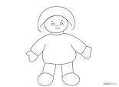d_____________ | 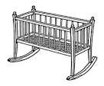c___________
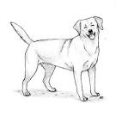d__________________ | .d__________
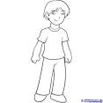b__________________ | 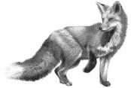f__________
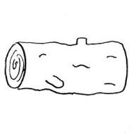l___________ | 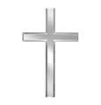c__________________

