Manyam Franchised Tests
English | PR-unit | mf-trial

Name…………..……………………..…………. School…………………….....………………Date…………
Match the pictures with their names
bus cup gun hut jug sun
bud nut tub pub
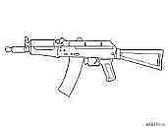g___________ | s___________
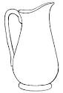j______ | 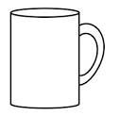c___________
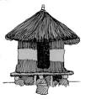h_______ | 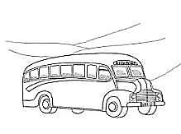b_______
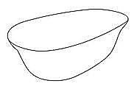t_______ | 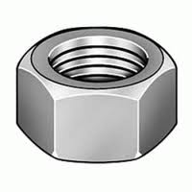n_______
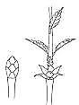b______ | 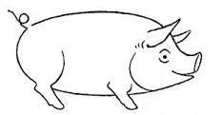p_____

