Manyam Franchised Tests
English | Pr-Unit | MF-trials

Name…………..……………………..…………. School…………………….....………………Date…………
Match the pictures with their names
clock cock sock duck sack
pick neck kick lock tacks
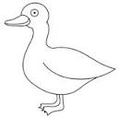d____________ | 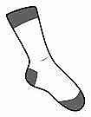s______________
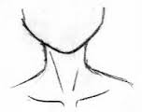n____________ | 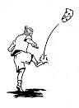k____________
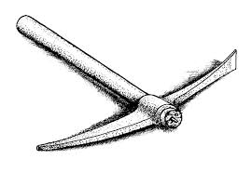p____________ | 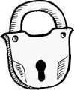l______________
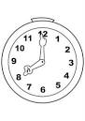c______________ | 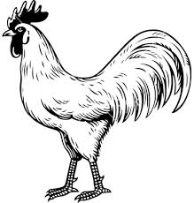c_____________
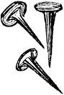t______________ | s______________

