Manyam Franchised Tests
english | pr-unit | mf-trials

Name…………..……………………..…………. School…………………….....………………Date…………

CK say K
Read the words then take dictation
rack neck tack
tick duck tock
sack rack peck
lock clock pack
suck back kick
lick luck sock
hack muck sick
Fill the gaps with “CK”
Then read the words
si__ mo__ ja__
ba__ wi__ ta__
do__ de__ mu__
pi__ mi__ flo__
ki__ pe__ thi__
ha__ clo__ li__

Let’s read “CK”
- His back is bent
- Go and get a duck
- A duck has big eggs
- I will pick an egg
- It is not his sack
- Pack his cups well
- Pick his red mug
- I am very sick
- It is ten o’clock
- It is a big rock
- A boy can kick a tin
- A man has a neck
- His door has a lock
- It is his sock

Match the pictures with their names
Path father moth thumb thorn
Thimble bath cloth thermos there
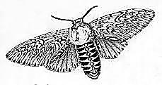m___________ | ___mb
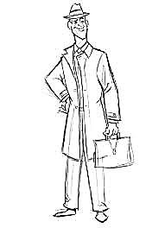f____________ | 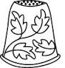_____mble
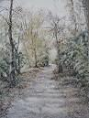pa______ | 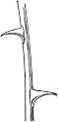th_________n
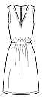clo_________ | 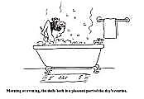ba_____
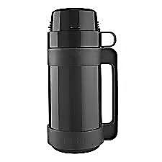th____os | 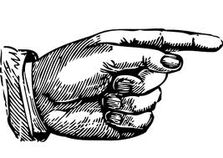th____e

