NAME……………………………………………CLASS_______ADM NO__________
SIGNATURE_________________________DATE_______________________________
233/2 :CHEMISTRY
PAPER 2
TIME: 2HRS
MARCH / APRIL 2015
MWAKICAN FORM 4 JOINT EXAMINATION – 2015 KENYA CERTIFICATE OF SECONDARY EDUCATION
INSTRUCTIONS TO CANDIDATE
Write your name and admission number in the spaces provided.
Sign and write the date of examination in the spaces provided
Answer all the questions in the spaces provided
All working must be shown where necessary
Electronic calculators and mathematical tables may be use.
FOR EXAMINERS USE ONLY
Questions | 1 | 2 | 3 | 4 | 5 | 6 | 7 | Total score
Max score | 12 | 11 | 11 | 14 | 12 | 11 | 10 | 80
Candidates score

This paper consists of 12 Printed pages.

- Study the information given below and answer the questions that follow.
Element | Atomic radius(nm) | Ionic radius nm | Formula of oxide | Melting point(⁰c)
A | 0.364 | 0.421 | A₂ O | -119
D | 0.830 | 0.711 | D O₂ | 837
E | 0.592 | 0.485 | E₂ O₃ | 1466
G | 0.381 | 0.446 | G ₂O₃ | 242
J | 0.762 | 0.676 | J O | 1054

- Which elements are non-metals .Give a reason?(2mks)

- I)Write a formula of a compound formed when J combines with A(1mk)

ii)What type of bond exist between J and D.(1mk)

- Explain why the melting point of the oxide of E is higher than that of the oxide of G.(2mks)

- i)Which two elements would react with each other most vigorously.Give a reason.(2mks)

ii)Which element would be suitable for making utensils for boiling water.State two properties that make the elements suitable for the use.(2mks)

- Elements Qand R haveelectronic configuration 2.8.2 and 2.8.6. respectfully.
i)Explain why the ionic radius of R is expected to be greater than its atomic radius.(1mk)

ii)Write the equation for the reaction between Q and R.(1mk)

- The chromatogram below is of and acid enzyme x and y and three simple sugar P,Q and R.

- I)Name two simples sugars present in both x and y.(2mks)
ii)Name lines L and M. (2mks)

L-

M-

iii)What property is exhibitaed by simple sugar x.(1mk)

b.Two pieces of paper were lowered into different Bunsen burner flames and removed quickly.The results were as shown below.
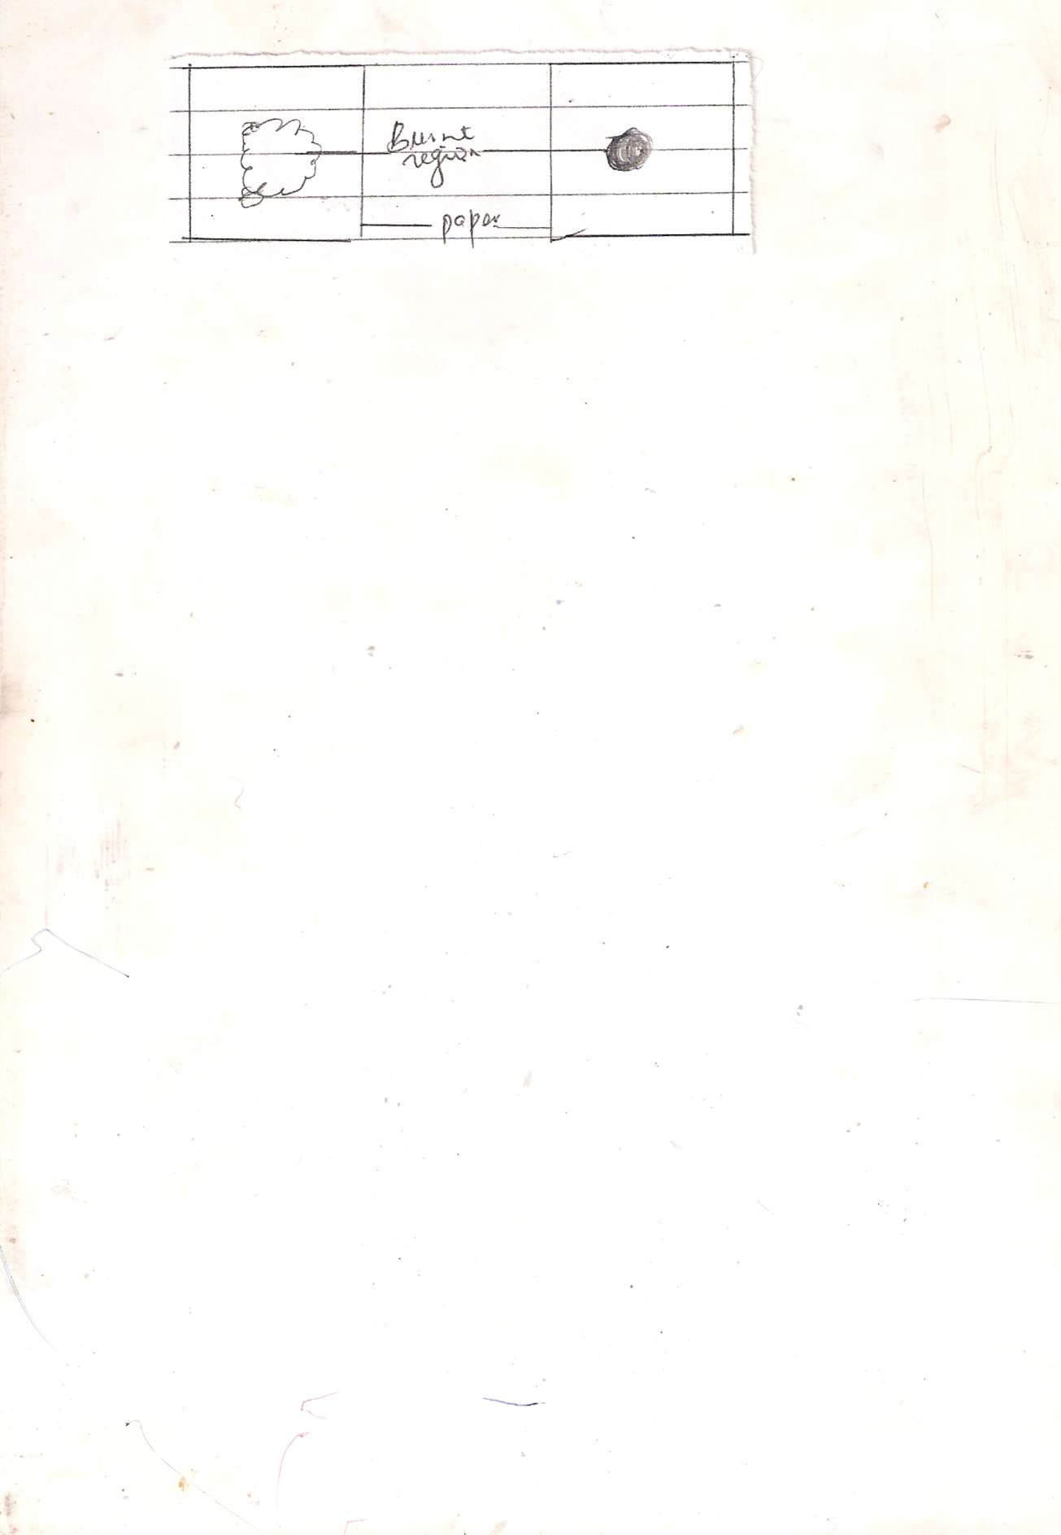

i.)Which paper was lowered into a Bunsen burner whose air hole were closed.Explain(2mks)

c.Oxygen can be obtained industrially by fractorise distribution of liquid air
i. Why is the gas mixture passed through sodium hydroxide solution.(1mk)

ii) In the final stage,which gas is distil out fuse.explain.(1mk)

iii)Name two commercial uses of oxygen gas.(1mk)

- Study the flow diagram and answer the questions below.

U
residue
White ppt,
I
White ppt
(II)
Colourless solution
II
Colourless solution
I
Few drops Filter and
ofNaoH heat
Dilute hydrochloric acid

Pb(NO₃)
Colourless solution III
Excess
NaoH
- Identify
- White ppt I (1mk)

- Solution II (1mk)

- Residue II (1mk)

- Write ionic equation for the reactions colourless solution (II) with Pb(NO₃) 1mk

- Write observations that would be made when ammonia solution is added drop wise till in excess to the colourless solution(II) 2mks

- Below are P^{H} values of some solutions
Solution | Z | Y | X | W
P^{H} | 6.5 | 3.5 | 2.2 | 7.2

- Which solution is likely to be
- Acidic rain (1mk)

- Potassium hydroxide (1mk)

- A basic substance V reacted with both solutions Y and X.What is the nature of V.(2mks)

- Name two substances that shows this characteristics in question (ii) above.(2mks)

- A sample of crude oil was heated and its vapour passed over red-hot pumicestore. A mixture of gases was evolved which decolourised bromine in tetra chloromethane and burnt in air with a yellow flame.
- What process id taking place when the vapour from the crude oil passes over heated pumice.(1mk)

- Name the most likely type of compound causing decolourisation of the bromine solution.(1mk)

- Name two compounds formed when the gas mixture above burns in air.(1mk)

ii.Study the flow chart below and answer the questions that follow.
Ethanol
E
White ppt
Gas F
B
C
D
Conc H₂ SO₄
A
high
pressure
H₂

O₂(Excess)

Line water

Na
Gas G

- Identify substances (4mks)
A-
B-
F-
G-

- Write down the equation for the formation of
- Substance C

- E and F

- Gas G

- Substance D was formed to have molecular mass of 42,000 .Determine the number of molecules present in the substances(H+1 ,C=12) 2mks

- State
- The condition necessary for the conversion of ethanol to substance A.(1mk)

- The catalyst required in the conversion of A and B.(1mk)

- The table below gives the solubility of hydrated copper(ii) sulphate in mol dm⁻³ at different temperatures.
Temperature(⁰) | Solubility mol dm⁻³
20 | 8 x 10⁻²
40 | 12 x 10⁻²
60 | 16 x 10⁻²
80 | 22 x 10⁻²
100 | 30 x 10⁻²

- On the drid provided plot a graph of solubility of copper(II) sulphate (vertical axis) against temperature.(3mks
- From the graph ,determinee the mass of copper(II) sulphate deposited when the solution is cooled from 70⁰c to 40⁰.(Molar mass of hydrated copper(ii) sulphate = 250g)

b.In an experiment to determine the solubility of sodium chloride ,5.0 cm³ of a saturated solution of sodium chloride weighing 5.35g were placed in a volumetric flask and diluted to a total volume of 250cm^{3.}
25.0 cm³ of the dilute solution of sodium chloride completely reacted with 24.1 cm³ of 0.1 M silver nitrate solution.
Ag No_{3(aq)} + NaCl_{(aq)} Ag Cl_{(s)} + NaNO₃(aq)
Calculate;
- Moles of silver nitrate in 24.1cm³ of solution.(1mk)

- Moles of sodium chloride in 25.0cm³ of solution.(1mk)

- Moles of sodium chloride in 250cm³ of solution(1mk)

- Mass of sodium chloride in 5.0cm³ of saturated chloride solution (Na=23.0 Cu=35.5) (1mk)

- Mass of water in 5.o cm³ of saturated solution of sodium chloride(1mk)

- The solubility of sodium chloride in g/100 g of water.(2mks)

- The flow chart below shows some of the processes involved in large scale production of sulphur((vi) acid .
Use it to answer the questions that follow.

Sulphur(iV)oxide
Absorption tower
Reaction chamber
oxygen sulphur (vi) oxide Oleum

Water

- Name the process

- I)Name substance A.(1mk)

ii)Write an equation for the process that takes place in the absorption tower.(1mk)

- Vanadium (v) oxide is commonly used catalyst in the process.
- Name another catalyst which can be used for this process.(1mk)

- Give two why reasons vanadium (v) oxide is commonly used catalyst.(2mks)

- Sate and explain the observations made when concentrated sulphuric (vi) acid is added to crystals copper(ii) sulphate in a beaker(2mks)

- The reaction of concentrated sulphuric (vi) acid with sodium chloride produces hydrogen chloride gas.State the property of concentrated sulphuric (vi) acid illustrated in the reaction.(1mk)

- Name two uses of sulphuric (vii) acid.2mks

- The above diagram shows a set up that can be used for industrial manufacture of hydrochloric acid.Study it and answer the questions that follow.

- Name
- Produce F

- Substance E

- Explain are application of hydrochloric acid in textile industry.(1mk)

- Hydrochloricb acid was added to iron powder in a test tube and shaken thoroughly to mix to 1cm³ of the resulting solution ,six drops of acqueous solution of ammonia were added .
- State the observation made on adding ammonia solution.(

- Explain the observation sated above and white an ionic equation for the reaction.(2mks)

- Concentrated hydrochloric is 35% pure with density 1.18g/cm³.Calculate it’s concentration in moles per litre..(3mks)

