SECTION A (40 Marks)

Answer ALL the questions in the spaces provided.
- Describe the following computer memories.

  - i) Register (1mk)

A special high speed storage location or ( memory within the CPU that temporarily stores data/ information/ instructions during processing.

ii) Cache A fast memory within the computer that stores frequently used data/ instructions for fast access by the CPU.

  - Give two differences between a compiler and an interpreter. (2mks)
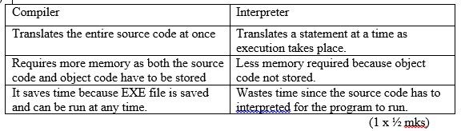

- List any four threats to a computer system

- Computer viruses.

- Power fluctuations.

- Poor handling of storage media.

- Unauthorized access.

- Theft

- Sabotage (1x ½ mks)

- In database the field properties specify finer details related to the fields and table entries expected. Explain the functions of the following

  - Caption (1mk)

This property displays the name that will be used to capture data in tables, forms and reports.

  - Required (1mk)

Its values are Yes or No. When set to Yes the user has to enter a value in a field i.e a field cannot be left blank. If set to No the user can leave a field blank.

  - Input mask (1mk)

Defines how data will be displayed and printed when keyed in.

- a) State four reasons why fibre optic is a number one choice in today’s data communication. (2mks)

Cannot be tapped

Fast data transmission

Has low attenuation

Wide bandwidth

b) What is meant by the term virtual reality? (1mk)

- Use of computers to visualize manipulate and interact with complex data.

- The ability of a computer to mimic human behaviour.
- Distinguish between relative and absolute cell references as used in spreadsheet.

Relative cell reference – Cell address used in a formula that adjusts itself to reflect its new position in the worksheet. (1 mk)

Absolute cell reference - acell address that keeps on referring to a specific cell regardless of its position in the worksheet.
- Convert the binary number 1010,11110,10110111.01 to its

  - Octal equivalent (show most the working) (1 mark) 1010
  - Hexadecimal equivalent (show most the working) (1 mark)

(method ½ mk)
- Consider the module flowchart extract below.

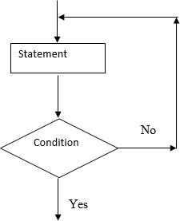
  - Name the looping structure demonstrated REPEAT ... UNTIL loop. (1 mark)

  - After scanning images in DTP, you can either crop them or resize them. Distinguish between

cropping and resizing of images. (2 marks)

Cropping – Chopping off some of the parts of an object. (1 mark) Resizing - Adjusting the size of an object. (1 mark)
- (a) List four advantages of secondary storage devices which make them indispensable /popular
part of a computer system. (2 marks)

-High storage capacity

-Non-volatile

-Cheaper than primary storage

-Portable

(b) Give two reasons why magnetic tape is not a popular secondary storage device.

- Its bulky

- Low storage capacity

- Its contents can only be accessed sequentially i.e slow (2 marks)
- Describe the functions of the following network components.

- Router (1 mark)

A device that interconnects different networks and directs the transfer of data packets form source to destinations.

- Hub (1 mark)

A device that provides a central location for the cables in network that has a common architecture

- State 2 reasons why an organisation may use other strategies of software acquisition other than developing their own. (2 marks)

- Tailor made programs can have errors

- Tailor made programs are usually very expensive

- Developing the programs, testing and implementing takes a long time. (mark first 2 points)

- Given below is an algorithm that will never end. Set count to 0 While count is non-negative Print the count Add 1 to count

- Explain why the loop will never end. (1 mark) Statement
Condition
This is because the value of count will not get to negative. The value of count starts from zero and increments.

- What changes would you make to the algorithm so that it ends executing the loop once. Make changes to the statement add 1 to count to read Subtract 1 from count (1 mark)
- Consider the worksheet given below

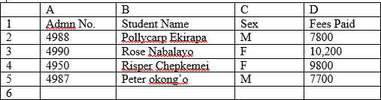
  - Give a formula that can be typed in cell D6 to return the fees paid by female students = Sumif ( C2:C5,’F’,D2:D5) (2 marks)

  - Give a formula that can be typed in cell C6 to return the number of male students.
=COUNTIF(C2:C5,’M’) (1 mark)
- (a) Identify the four main application areas of artificial intelligence (2 marks)

- Robotics (Robot control)

- Medical diagnosis.

- Stock control

- Finance

- Heavy industry

- Online and telephone customer service.(Neural language)

- Toys and games

- Aviation

- News, publishing and writing.

- Data mining. (½ mark each)

(b) Define the following as used in work processing (1 mark)

- Word wrap A feature that automatically moves the cursor or text to the next line when the end of the line is reached.

- Drop cap A character or a group of characters at the beginning of the paragraph that spreads in more than one line.
- As regards database systems:

- Distinguish between a primary key and a foreign key (2 marks) Primary key –A field that uniquely identifies a record in a database.
Foreign key – A field use in a table that appears as a primary key in another table.

- Define the term normalization. (1 mark) Process of reducing duplicated data items.
- (a) What is the difference between simplex and full –duplex transmission? (2 marks)

Simplex –Communication in only one direction

Full –duplex-Communication in both direction concurrently. (b)Give any two advantages of telecommuting. (1 mark)
- Less pollution since few people commute to their places of work.

- Some employee can put in more hours since they will be working from home.

- The company will spent less on office furniture since employees will not be working from the office

- An employee can attend to other obligations as he works for the company. For example taking care of the sick or attending to aged parents.

SECTION B (60 Marks)

Answer question 16 and any other three questions from this section in the spaces provided.
- . (a) What will be the value of product when printed in the following flow chart? Show how you arrive at your answer
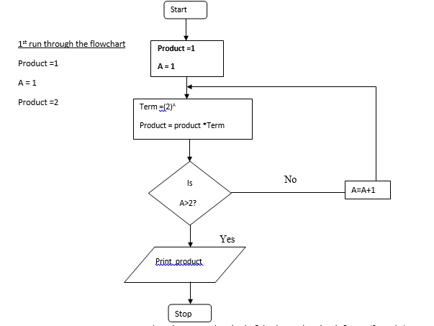

- Explain what happens when the expression A=A+1 is changed to A =A-1 (2 marks) Indefinite loop –execution will not come to an end since the value of A will never be greater 2

- Study the flowchart below and answer the questions that follow

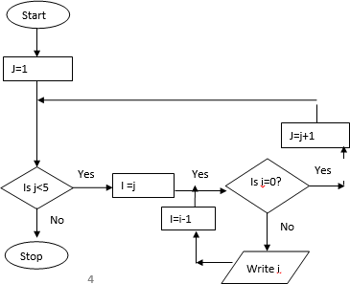
- (i) State the main type of control structure used in the flowchart (1 mark) Iteration (looping)

(ii) Dry run the above flowchart (5 marks) 1,2,2,3,3,3,4,4,4,4

- Dr. Fundi would like to demonstrate a concept using a computer program on his laptop to members of his village health committee.

Give two reasons why he would prefer a laptop to his desktop computer.

- A laptop is portable

- A laptop has a rechargeable battery. (2 marks)

- (a) Describe two health issues related to working with computers and give a remedy for each. (4 marks)
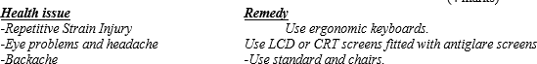
- Robots are introduced into a factory which makes car engines. Describe three ways this could affect the workers. (6 marks)

-job replacement

-job creation

-job displacement (6 marks)
- Name any two computer related courses that are offered at public universities in Kenya. (1 mark)

- BSC Computer Science

-BSC Information Technology

-BSC Hardware and Software Engineering

- List two duties performed by the following personnel

- database administrator (2 marks)

- Designing and developing database applications.

- Setting up security measures needed to control access to data and information.

- Keeping databases up to date by adding new records, modifying or deleting unnecessary records.

- Computer trainer (2 marks)
- Training people on how to use the computer and application programs.

- Developing training reference materials.

- Guide learners on how to acquire knowledge

- Preparing learners for ICT exams

- (a) Give any two factors one should consider before enrolling for an ICT course in a college. (2 marks)

- Whether it offers ICT courses recognised both locally and internationally.

- The cost of training with such an institution.

(b)With the aid of a sketch, explain the main stages of data processing cycle. (3 marks)
- Data collection

- Data input

- data processing

- data output

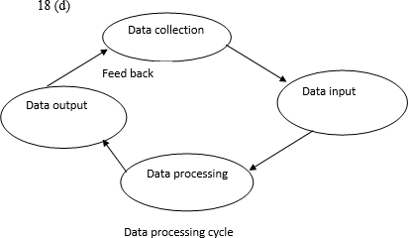

(c). State and explain any three system changeover strategies that one can use to replace on old system with a computerized system. (6 marks)
- Direct changeover.

- Phased changeover
- Parallel

- State three reasons for developing a new system.

- New opportunities

- Problems with current system

- Directive –new requirements imposed by the government, management or external influences.

- Define the term feasibility study as used in system development. (1 mark) This is an evaluation of and analysis of the potential of the proposed system.
- . (a) Differentiate between a database and DBMS. (1 mark)

Database – A collection of organised data.

DBMS –Programs that help the user to enter, store, edit, retrieve and print databases. (b)List four advantages of using electronic database systems. (2 marks)
- ..Has unlimited storage capacity

- Has forms that provide a user friendly way of entering records in a database

- The output is presentable

- Editing of records is easy

- Has in-built queries that can help the user extract records that meet the conditions he specifies

(c) In a database system, data integrity ensures the correctness and completeness of the data in the database.

Differentiate the following types of integrity constraints:- (i)Validity integrity (1 mark)
This ensures that the data entered in the database is correct.

- Entity Integrity (1 mark)

This is a database concept that ensures that there are no duplicate records within the table and that the field that identifies the record is unique.

- Referential integrity (1 mark)

This is a database concept that ensures relationships between tables remain consistent. (d)Briefly describe any three database models (3 marks)
- Net work model –entities form network of objects.

- Flat file model – keeps one set of data.

- Relational model –uses tables/relations

- Hierarchical model –data items arranged in tree form.

- (a) Namarome a form one student out of curiosity loads three programs namely Yahoo Messenger, Ms –Word and Windows multimedia player. She realizes she can use the three programs simultaneously i.e. typing her notes, listening to her favourite song and answering incoming chat Data collection
Data input
Data processing Data output Feed back
Data processing cycle
messages. She does not understand how a computer can perform such magic. She approaches you for an explanation. Explain to her how the computer does this. The processor assigns each task time slices. Within that short time period the task will have sole access tot eh resources of the computer before the control is switched to another task.

(b)(i)Define an expert system (1 mark)

This is a software that has been designed to make a computer operate at the level of a human expert in a specific narrow area of specialization. (ii)Describe the three components of an expert system (6 marks)

- Knowledge base

- Inference engine

- User interface

- State two advantages and one disadvantage of using an expert system in passing judgement in courts of law. (3 marks)

- Gives general solutions

- Does not have common sense

- State two advantages of command line interface operating system over graphical user interface operating system. (2 marks)

- User has got greater control over the system.

- It offers the user flexibility because a single command can be executed with a variety of arguments.

- It can also present certain commands that ate completely unavailable in GUI

