MOMALICHE 4 CYCLE 8 JOINT EXAM

312/2
GEOGRAPHY PAPER 2 MARKING SCHEME

SECTION A

1. (a) Apart from floods, name two other environmental hazards experienced in Kenya
- Drought
- Volcanic eruption
- Lightening
- Pests and diseases
- Earthquakes
- windstorms (2mks)

(b) Outline three methods used to control floods
- Construction of dams
- Afforestation
- Building of dykes
- Dredging
- directing canals (3mks)

2. (a) (i) Define an anadromous fish?
Fish that spend part of life in the sea and the rest in rivers where they spawn
(ii) Example of anadromous fish (2mk)
- Salmon (1mk)

(b) Reasons for encouraging fish farming
- Allow better use of land/ water resources
- Create employment/ income opportunities
- Contribute to meeting demand for food/ fish/ protein
- Lead to development of related industries
- Fish exported to earn foreign earnings
- Free from international conflicts (3mks)

3. (a) Two formations in which mineral ore occur
- Veins and lodes
- Beds and seams
- Weathering products
- Alluvial/ placer deposits (2mks)

(b) Effects of land dereliction on the environment
- Leads to wastage of Agricultural land/ industrial land and settlement
- Ugliness/ scars on land
- Loss of diversity – plants and animals
- Triggers landslides
- Health hazards – breeding grounds for mosquitoes (3mks)

4. (a) Differentiate between horticulture and market gardening
- Horticulture is the intensive cultivation of vegetables, fruits and flowers while market gardening is the intensive cultivation of vegetables and fruits for the nearest urban centres (2mks)

(b) Three problems facing horticulture in Kenya
- Price fluctuation
- Climatic hazards e.g. hailstones that destroy crops
- Inadequate capital to run the farms
- Pests and diseases that destroy crops
- High degree of perishability (3mks)

5. (a) Functions of the Central Business District (CBD)
- Administration e.g. offices
- Commercial centre/trading centres
- Transport and communication center (2mks)

(b) Factors that may lead to rural – urban migration
- Search for jobs
- City life attraction
- Shortage of land in rural areas
Social amenities in townse.g education, hospitals etc (3mks )

SECTION B
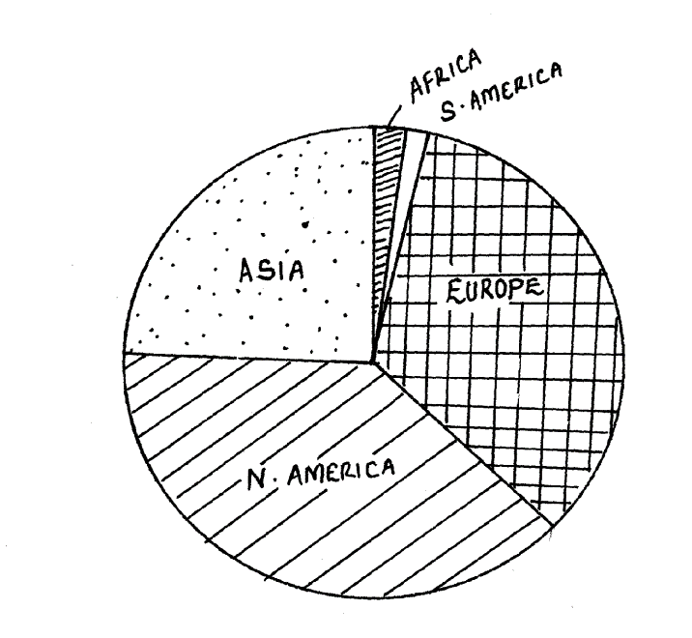

6. (a)

Drawing the circle of correct radius 1 mk
Segments entered well = 2¹_{/ 2} mks
Calculations =2¹/₂mks
Key= 1mk
Title=1mk
Total= 8mks
a) Europe 87467 x 360
240752
= 131º
Africa 1840 x 360
240 752
= 3⁰
N. America = 87580 x 360
240752

= 131º
S. America = 1,561 x 360
240,752
= 2⁰

Asia = 62,304 x 360 = 93⁰
240,752
Calculations and drawing / angles indicated well = 8mks

b) i) Nuclear power is derived from uranium(1mk)
ii) South Africa (1mk)
iii) Electricity production
Nuclear bombs 1 x 2 = 2mks

iv) Disadvantages of nuclear power
- Cannot be conserved / reserved
- It is a heavy pollutant
- It produces radioactive waves 2 x 1 = 2mks

c) Benefits from Aswan high dam.
- Large areas have been put under irrigation
- Floods have now been controlled in the lower Nile and the flow of the Nile is greatly regulated eased transportation
- The dam has brought into existence a large man-made lake which has eased navigation.
- Hydro-electric power is now available.
- The man- made lake has enhanced the fishing industry.
- The availability of electricity has led to industrial expansion in Egypt.
- The dam and the large man – made lake are today a beautiful tourist attraction
3 x 1 = 3mks
d Factors responsible for production of hydro- electric power in U.S.A
- The numerous sites on the American rivers which are ideal for establishing
power generating projects
- U.S.A has heavy industries which have high demand for hydro- electric power.
- High technological know- how which enabled many hydraulic engineers to develop
the science of dam construction.
- Huge base of capital – to be invested in power generations. 4 x 2 =84mks

7.a) - Trans- Nzoia
- Nakuru
- Bungoma
- Uasin Gishu (Any 2 x 1 = 2mks)

b)
- Temperature 18º- 27º moderate/high temp
- 140 frost free days
- High/moderate rainfall/ between 635- 1145 mm
Well distributed rainfall
- Soils - Fertile and well drained loam soils.
- Prefers lowlands or undulating topography for mechanization
Any 4 x 1 = 4mks

c) - Low prices when production is high demoralizes farmers
- High prices of inputs especially fertilizer that reduces profit margins
- Drought and floods leads to low yields
- Attack by weevils especially Osama weevil / pests and diseases (mosaic smut) lead to low quality and low yields
- Poor roads leads to delay of produce to the market
- Inadequate capital to invest in maize production that limits expansion Any 4 x 2 = 8mks
Any explained well facts can be awarded a mark

d)i) National food policy is an agricultural development strategy aimed at increasing food production output and self-sufficiency in food supply 2x1 = 2mk

ii) - Ensure that food stuffs distribution is adequate such that every member of the population has a
nutritionary adequate diet.
- Assist in achieving some degree of security in food supply for each area of the country
- Maintain a position of broad self- sufficiency in main foodstuffs inorder for the nations to feed herself without using scarce foreign exchange in food imports.
- Reduce prices inputs like fertilizers
- Prompt payment to farmers will make them not to turn to alternative crops.
Any 3 x 1 = 3mks
e)i) - High prices of farm inputs e.g fertilizers, seeds etc.
- Over reliance and emphasize on cash crops.
- Low purchases prices offered by N.C.P.B
- High population growth rates
- inadequate vocational training for maize farmers.
- insufficient credit offered to farmers
- Poor research and inadequate extension services
- Adverse weather like drought and flood
- Poor land tenure policy making most land to be idle due to absentee farmer

ii) - Ensure there is adequate supply of fertilizers, seeds etc.
- Improving the training of farmers and extension staff. Any 5 x 1 = 5mks
- Develop demonstration farms
- Improving on the distribution of farming guides
- Provides better equipment through credit terms
- Improving weather monitoring and Dissemination of weather information
- Giving incentives to maize farmers
- Offering high purchase prices to farmers(maize)
- Improve storage facilities Any six x ½ = 3mks

8.a) (i) Difference between two-way road and one-way road systems.
-Two-way road refers to a road divided into two with a yellow line and traffic flow in two different ways. One-way road is a double carriage where two roads are built parallel to each other and, on each road, traffic flows in one direction.

(ii) Causes of accidents on Kenyan roads.
-Careless drivers cause accidents.
-Some drive under the influence of alcohol or drugs causing accidents.
-Some drivers are not qualified as they forge driving licenses leading to accidents.
-Many drivers over-speed beyond 80kmph (public vehicles) or over 110kmph for private cars leading to accidents
-Many roads have many port holes that cause accidents.
-Some roads have steep gradients and sharp bends that leads to accident.
-Some roads are very narrow leading to accident.
-Some vehicles are not road worthy or are no well-maintained leading to accidents
-Some roads don’t have signs or posters to guide the drivers leading to accidents
-Traffic police are careless instead they are corrupt allowing mistakes leading to accident
-Overloading of vehicles that leads to accidents.
Any 8 x 1 =8mrks.
b) (i)Towns marked J-Cape town
K-Harare
L-Cairo (3marks)
(ii) Countries where Trans-Africa Railway is not completed.
-Sudan
-Central Africa Republic
-Bukina Faso
-Mali (3mks)

c). (i)Reasons why railway transport is not well developed in Africa.
-Most of them were developed by colonial powers without the interest of indigenous people.
-They are expensive to construct hence not widespread.
-Rail transport is not flexible therefore unsuitable for short distances.
-Railway wagons and engines are expensive to buy.
-Engines and wagons are expensive to maintain.
Different rail gauges in different countries.
Political differences in different countries (4mks)

(ii) The role of the St. Lawrence sea-way.
-The sea-way has made the interior of Canada and U.S.A open to trade. This has increased the volume of trade goods even to external market leading to high income.
-There is cheap availability of hydro electrical power which is used in industries.
-The whole project has attracted many tourist leading to steady flow of foreign exchange.
-The project created many employment opportunities where many people work.
-It contributed to many urban centers with large population which provided market for goods locally produced.

9.(a ()i) Life expectancy
- The average age to which the people of a country expect to live or the average age at which people die (2mks)
(ii) Name three counties with low population in Kenya.
- Samburu
- Turkana
- Marsabit
- Mandera
- Isiolo
- West Pokot
- Garrissa (3mks)

(b) Explain how Relief, Govt policy and Development of industries influence population distribution in Kenya
Relief : Gently sloping and flat lands attract population settlement/ population while rugged / slopy/ steep landscape has sparse population or low/ nil population because they are difficult to cultivate
(2mks)
Govt policy: May discourage or encourage settlement in some areas i.e. Kenya government discourages population settlement on the water catchment areas/ gazetted forests and national parks. Also the government may influence the settling of people in an area through settlement schemes where people who were rendered homeless settle (2mks)
Development of industries: Establishment of industries in urban areas attract population/ influence population distribution because such areas offers employment opportunities hence they are densely populated (2mks)

(c) Explain four efforts the Kenya government is making to check on high mortality rate
- Creation of more hospitals and health centres so as to improve on medication
- Increased immunization programmes to check on disease incidences e.g. measles
- Encouraging family planning through seminars to improve the health of pregnant mothers
- Educating the people to improve on nutrition to minimize malnutrition diseases e.g. marasmus (8mks)

d) Explain three factors for the reduction of fertility rate in Kenya
- Cost of bringing up children has gone up forcing parents to limit the number of children
- Increased use of birth control measures limiting births
- Modern career opportunities have limiting influence on women’s fertility rate
- There is increase in the number of women opting to remain single thus reducing the fertility rate
- More girls are attending school and pursuing higher education limit their child bearing (6mks)
Subtotal = 25mks

10. (a) Define the following.
(i) Internal trade Is the trade that involves the exchange of goods and services within a country, while International trade is the trade that involves the exchange of goods and services on global scale/between many countries of the world. 2 x 1 =21mk

(b) State three problems faced by Kenya in International Trade. 3mks
- Fluctuation of prices in the world market leads to low earnings.
- Kenya produces goods similar to those manufactured in other African states and
this limits the market.
- Kenya imports manufactured goods which are very expensive hence unfavorable
balance of trade.
- The quota system limits the amount of goods Kenya can export.
- Goods produced in Kenya are priced by developed countries which give them low
price hence low returns. Any 3 x 1 = 3mks

(c) (i) Identify three major exports from Kenya. 3mks.
- Tea
- Coffee
- Soda ash
- Fluorspar.
- Flowers.
- Cement
- Canned pineapple. Any 3 x 1 = 3mks.

(ii) Give three reasons why Kenya should protect her local industries. 3mks.
- In order to develop home and infant industries.
- To promote trade in home made goods.
- To correct the unfavourable balance of trade.
- To promote exports hence increase her earnings.
- In order to raise the level of employment.
- In order to prevent dumping of inferior goods. Any 3 x 1 = 3mks

(d) (i) What is unfavourable balance of trade? 2mks
- Is when the value of imports exceeds the value of exports in a country’s foreign trade. 1 x 2 = 2mks

(ii) Explain three reasons why Kenya experiences unfavourable balance of trade.
- Kenya exports agricultural product such as tea, coffee which fetch low prices.
- She imports manufactured goods such as crude oil, pharmaceuticals,
heavy machinery which are very expensive.
- Goods exported from Kenya face stiff competition in the world market leading
to low earnings.
- Quotas imposed on Kenyan goods by some countries limits the amount of products
that can be exported leading to reduced sales and earnings.
- Some goods exported from Kenya are of very low quality earning very little.
Any 3 x 2 = 6mks

(iii) Explain three measures taken by the Kenya government to reduce her
unfavorable balance of trade.
- Kenya has developed other sources of energy such as HEP, solar and geothermal
to reduce the importation of crude oil.
- Encouraging the masses to conserve imported oil to reduce the amount consumed.
- Establishing import substitution industries to reduce import of goods.
- Kenya has restriction on importation of luxury goods.
- Kenya has encouraged local assembling of motor vehicles and heavy machinery
instead of importing complete units.
- Diversifying exports both agriculture and manufacturing to increase export earnings.
- Promoting tourism in order to increase the number of tourists into the country
which would increase foreign exchange.
- Finding new market for exports in order to have more goods getting into the market.
- Increasing invisible trade such as shipping in order to increase foreign exchange.
Any 3 x 2 = 6mks

