**MOMALICHE 4 CYCLE 8**

**MATHEMATICS 121/1**

**MARKING SCHEME**

|  |  |  |  |  |  |  |  |  |  |  |
| --- | --- | --- | --- | --- | --- | --- | --- | --- | --- | --- |
| 1. | Numerator  9 ÷ - 3 + $\frac{5}{2}$ x $\frac{3}{-5}$ -3 - $\frac{3}{2}$ = - $\frac{9}{2}$ Denominator $\frac{1}{2}$ + $\frac{15}{4}$ x $\frac{4}{3}$ = 5 $\frac{1}{2}$ $\frac{N}{D}$ = $\frac{-9}{ 2}$ ÷ $\frac{11}{2}$ = $\frac{-9}{ 2 }$ x $\frac{2}{11}$ = $\frac{-9}{11}$ | | | M1 ✓ Numerator  M1 For denominator  A1 | 4 | | $\frac{dy}{dx}$ = 2x – 1 y = $x^{2}$- x + c  5 = 1 – 1 + c c = 5  y = $x^{2}$- x + 5 | | M1 Partial integration with c  M1 ✓ Attempt to substitute  equation  A1 | |
|  |  | | | 03 Marks |  | |  | | 3 Marks | |
| 2. | 3y = -2x + 9  y = -2/3 x + 3  g= $\frac{-2}{3}$ $g=\frac{7-a}{a-13}=\frac{-2}{3}$    -2a + 26 = 21 – 3a  a = -5 | | | B1  M1 ✓ Equation formed  A1 | 5 | | 2x $\left(3^{4}\right)$   x $3^{3x}$ = $3^{6}$ $3^{2x}$ $3^{8x}$ x $3^{3x}$ = $3^{6}$ ${ 3}^{2x}$ $3^{11x}$ x $3^{3x}$ = $3^{6}$ $3^{2x}$  9x = 6  x = $\frac{2}{3}$ | | M1 Equation expressed in based 3  M1 Expressing powers  A1 | |
|  |  | | | 3 marks |  | |  | | 3 Marks | |
| 3. | 7x – 4 ≤ 9x + 2 ..(i)  9x + 2 < 3x + 14(ii)  Solving (i)  7x – 4 ≤ 9x + 2  -2x ≤ 6  x ≥ -3  Solving equation (ii)  9x + 2 < 3x + 14  6x < 12  x < 2  Combining (i) and (ii)  -3 ≤ x < 2  -3 – 2 -1 0 1 2  Integral values are  -3, -2, -1, 0, 1 | | | ✓Solving equation (ii)  ✓Solving equation (ii)  ✓B1 Solution represented on number line  ✓A1 Integral values | 6. | | 6480 = 24 x 34 x 5  7200 = 25 x 32 x 52  GCD = 24 x 32 LCM = 25 x 35 x 52 x 73 x  Third number: 24 x 33 x 73 = 148,176 | | M1  M1  A1 | |
| 7. | | Cost of the car in USD  = 5000 + $\frac{20}{100}$ x 5000  = 5000 + 1000  = USD 6000  If 1USD = 105 yen  ? = 80,325 $\frac{80325}{105}$   = 765 USD  Total cost in US$ = 6765  Amount needed in KSh.  KSh. 63 x 6765  KSh. 426,195 | | M1 ✓ Cost obtained  M1  A1 | |
|  |  | | | 4 marks |  | |
| 8 | 5 x $\frac{1}{8.29 x{10}^{-2}}$- 14 x $\frac{1}{5.81 x {10}^{-1}}$ 5 x 0.126 x ${10}^{2}$- 14 x  0.1721 x 10  = 60.3 – 24.094  = 36.206 | | | M1  M1  A1 |  | |  | | 3 marks | |
| 14. | | A.S.F = $\frac{750}{120}$ = $\frac{25}{4}$ L.S.F = $\sqrt{\frac{25}{4}}$ = $\frac{5}{2}$ 3  V.S.F = $\left(\frac{5}{2}\right)$ = $\frac{125}{8}$ V.S.F = $\frac{125}{8}$ = $\frac{V}{{400cm}^{2}}$ V = $\frac{125}{8}$ x 400 = 6250cm3  Volume in litres = $\frac{6250}{1000}$ = 6.25L | | M1 L.S.F  M1  A1 | |
|  | | | 4 Marks |  | |  | | 3 Marks | |
| 9. | $\frac{a}{12 -a}$ = $\frac{x}{3x}$ = $\frac{1}{3}$ 3a = 12 – a  4a = 12  A = 3cm  ∴TB = 3cm | | | M1  M1  A1 | 15 | | ∠SPQ = 900  ∠TSP = 900 – 560 = 340  ∠PSQ = 900 – 280 = 620  ∠PRQ = ∠PSQ (Subtd by same chord)  ∠PRQ = 620 | | B1  B1 | |
|  |  | | | 3marks |  | |  | | 2Marks | |
| 10. |  | | | B1 correct image  B1 ✓correct labelling | 16. | | (x – 3)2 – (3x – 9)  (x + 3 (x – 3)  x2 – 6x + 9 – 3x + 9  (x + 3) (x – 3)  x2 – 9x + 18  (x + 3) (x – 3)  (x – 3) (x – 6)  (x + 3) (x – 3)  x – 6  x + 3 | | M1  M1  A1  A1 | |
|  |  | | | 3 Marks |  | |
| 11. | $\frac{12}{2}$ = 1.2 x k  k = $\frac{6}{1.2}$ = 5  Length in cm Frequency  7.5≤ x ≤ 9.5 12  9.5 ≤ x ≤ 11.5 5 x 1.6 = 16  11.5≤x ≤ 15.5 5 x 0.8 x 4 = 16  15.5≤ x ≤ 21.5 5 x 2 x 6 = 60 | | | B1 ✓Constant  B1  B1 |  | |
|  |  | | | 3 Marks |  | |  | | 10 Marks | |
| 12. | Let ${Log}_{2}$ x = y $y^{2}$ - 3y – 4 = 0  (y – 4) (y + 1 ) = 0  y = 4 or y = -1 ${Log}_{2}$ x = 4 and ${Log}_{2}$ x = 1  x = 16 or x = $\frac{1}{2}$ | | | M1 ✓Quadratic equation  M1 ✓Factorization  A1 For both values of y  B1 for both values of x | 17. | | (a) 250 x 14 x 2 x 2 = 14000  Net profit = 14000 – 6000  = KSh. 8000  (b) 8000 x 25 = 200,000  = 190,000  (c) Saving: $\frac{40}{100}$ x 190,000  = 76000  Remaining profit = $\frac{36}{100}$ x 190,000  = 68,400  Muthoka’s share $\frac{45,600}{3}$ + $\frac{2}{9}$ x 68,400  = 30,400  (d) 475,000 x 3 x 100  95  = 1,500,000 | | M1 ✓Profit  A1  B1 ✓Profit  M1 ✓Equation for equal share  A1  M1 ✓Expression of M uthoka’s share  A1  M1  M1  A1 | |
|  |  | | | 4 Marks |
| 13. | 8t + 6s = 4160  4t + 12s = 4000  4t + 3s = 2080  -  t + 3s = 1000  3t = 1080  t = 360  s = 213 $\frac{1}{3}$ Trouser = Sh. 360  Shirt = Sh. 213.33 | | | M1 ✓ Simultaneous equations formed  M1 ✓Attempt to eliminate  A1 For both |
|  |  | | | 3 Marks |  | |  | | 10 Marks | |
| 18. | i) (4000 x 12) +(1100 x 12)  = Sh. 61,200  (ii) 1st slab 4200 x2= 8400  2nd slab 3800 x 3 = 11400  3rd slab 4600 x 5 = 23000 42800  4th slab x 6 = (61,200 – 42800)  = K₤ 3066.70  = Taxable income  (12600 + 3066.70  = K₤ 15666.7  (iii) $\left(\frac{15666.7 x 20}{12}\right)$- 10800  = KSh. 15,311.20  (iv) 26111.20 – 4000  Sh. 22,311.20 | | | M1  A1 or 5100 x 2  M1  1st to 3rd slab  4th slab  M1  M1  A1  M1  A2  M1 | 19. | | (a)   |  |  |  |  |  |  |  |  |  |  |  |  |  |  | | --- | --- | --- | --- | --- | --- | --- | --- | --- | --- | --- | --- | --- | --- | | x | -8 | -7 | -6 | -5 | -4 | -3 | -2 | -1 | 0 | 1 | 2 | 3 | 4 | | 2x2 | 128 | 98 | 72 | 50 | 32 | 18 | 8 | 2 | 0 | 2 | 8 | 18 | 32 | | 5x | -4 | -35 | -30 | -25 | -20 | -15 | -10 | -5 | 0 | 5 | 10 | 15 | 20 | | -12 | -12 | -12 | -12 | -12 | -12 | -12 | -12 | -12 | -12 | -12 | -12 | -12 | -12 | | y | 76 | 51 | 30 | 13 | 0 | -9 | -14 | -15 | -12 | -5 | 6 | 21 | 40 | | | | |
|  | | B1 – For half + correct values B1B1 for all values.  (b) (i) 2x2 + 5x – 12 = y  2x2 + 5x – 12 = 0  0 = y  x = -4 or 1.5  (b)(ii) = 2x2 + 5x- 12 x -3  0 = -3x2 – 7x + 3 x 2  -3y = -6x2 – 15x + 36  0 = -6x2 – 14x + 6  -3y = -x - 30  y = $\frac{1}{3}$ x + 10  x = -4.7 or 2.3 | | | Graph  B1B1  B1  B1 |
|  |  | | | 3 Marks |
| 20 | (a) $\frac{1}{2}$ x 30h+ $\frac{1}{2}$ x40h+60h = 2090  95h = 2090  h = 22m/s  max speed = $\frac{22 x 3600}{1000}$ = 79.2 km/h  (b) a = $\frac{22}{30}$ = $\frac{11}{30}$ (c) $\frac{1}{2}$ x 20 x 11 = $\frac{220}{2}$ = 110m  (d) Time for half journey $\frac{1}{2}$ x 22 (30 + t + t) = $\frac{1}{2}$ x 2090  11 (30 + 2t) = 1045  330 + 22t = 1045  22t = 919  t = 32.5 | | M1  A1  B1  M1  A1 v 0.7333 m/s  accept km/h  M1  A1  M1  M1  A1  FTQ | | 21 | (a) 400 – Angle subtended by the same  arc: MN  (b) 250 – Diameter of a circle subtends  900 at the circumference of a circle.  (c) 650 – Alternate segment theorem  (∠LNP is alternate to ∠LKN)  (d) 100 – Sum of angles in a triangle  add up to 180  (e) 500 – Alternate segment theorem or  sum of angles in a straight line add  up to 1800. | | B1 ✓Angle  B1 ✓Reason  B1 ✓Angle  B1 ✓Reason  B1 ✓Angle  B1 ✓Reason  B1 ✓Angle  B1 ✓Reason | | |
| 22 |  | | | | 23. | P  S  O  Q  R  T | |  | | |
|  |  | | |
|  | (a) 2 $πr^{2}$ = 2 x $\frac{22}{7}$ x 35 x 35 = 7700cm2  60  x  354  (b)  (c) $\frac{60+x}{x}$ = $\frac{35}{14}$ 120 + 2x = 5x  x = 40cm  Slant height= 60 + 40 =100cm  (c) $πRL$- $πrl$ $\frac{ 22}{7}$ x 35 x 100 - $\frac{22}{7}$ x 14 x 40  11000 – 1760 = 9240cm2  Base area ()  = x 14 x 14 = 616cm2  Total surface area  7700 + 616 + 9240 = 17,556cm2 | B1 ✓Area  M1 ✓Expression  M1✓ Equation  M1A1✓Equation for slant height  ✓Accuracy  M1 Expression  M1  M1  M1A1 | | |
|  | OS = $\frac{1}{3}$ OP QT = $\frac{3}{4}$ OS OR = $\frac{1}{3}$ OQ  (i) SR = SO + OR = $\frac{1}{3}$ P + $\frac{1}{3}$ Q  = $\frac{1}{3}$ (Q – P)  (ii) QS = QO + OS= Q + $\frac{1}{3}$ P  = $\frac{1}{3}$ P – Q  (iii) PT = PS + ST  = - $\frac{2}{3}$ P + $\frac{1}{4}$ (-QS)= - $\frac{2}{3}$ p + $\frac{1}{4}$ (Q - $\frac{1}{3}$ P)  =- $\frac{2}{3}$ p + $\frac{1}{4}$ q - $\frac{1}{12}$ p  =- $\frac{9}{12}$ p + $\frac{1}{4}$ q = $\frac{1}{4}$ q - $\frac{3}{4}$ p  (iv) TR = TQ + QR  = $-\frac{3}{4}$ QR - $\frac{2}{3}$ Q  = - $\frac{3}{4}$ ($\frac{1}{3}$ p – q) - $\frac{2}{3}$ Q  = - $\frac{1}{4}$ p + $\frac{3}{4}$ q - $\frac{2}{3}$ q = - $\frac{1}{4}$ P + $\frac{1}{12}$ Q  = $\frac{1}{12}$ Q - $\frac{1}{4}$ P  PT = $\frac{1}{4}$ Q - $\frac{3}{4}$ P  TR = $\frac{1}{12}$ Q - $\frac{1}{4}$ P  ∴ PT = 3TR or $\frac{1}{3}$ PT = RT  Common point T  PT is a multiple of TR  PT = 3TR  Hence PTR are collinear | B1  M1  A1  M1  A1  M1  A1  M1 (both seen)  M1 (both seen)  A1 conclusion | | |
|  |  | | 10 Marks | | |
| 24 | (a) Initial acceleration is at t = 0 $V=\frac{ds}{dt}$ = - 6 $t^{2}$ + 3t + 3  a = $\frac{dv}{dt}$ = -12t + 3  when t = 0, a =[ 0 + 3  ∴ a = 3m/s2  (b) (i) at rest V = 0  -6 $t^{2}$ + 3t + 3 = 0  (2t + 1) (t-1) = 0  t = - $\frac{1}{2}$ or t = 1 (t = - $\frac{1}{2}$ not applicable)  (ii) S = - ${2t}^{3}$ + $\frac{3}{2}t^{2}$ + 3t  When t =m 1, s = -2 ${(1)}^{3}$ + $\frac{3}{2}$ ${(1)}^{2}$ + 3 (1)  2.5M  (c) When velocity is maxium, a = 0  -12t + 3 = 0  t = $\frac{1}{4}$ Max v = -6 ${\left(\frac{1}{4}\right)}^{2}$ + 3 $\left(\frac{1}{4}\right)$ + 3 = 3.375 m/s | | M1  M1  A1  M1  M1  A1 for t = 1  M1 Substitution  A1  M1For substitution  A1 | | |
|  |  | 10 Marks | | |  |  | |  | | |

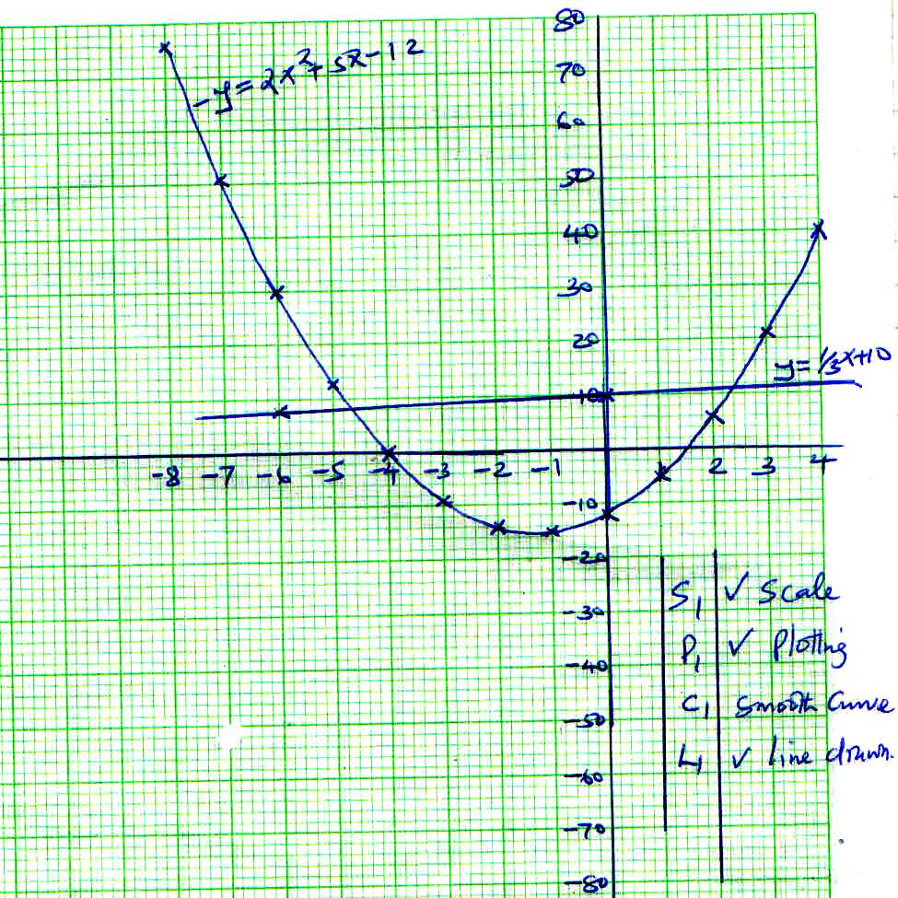NO. 19