NAME: ………………………………………..…CLASS……………….. ADM NO:…………
SIGNATURE:……………………………INDEX NO:……………………………

232/1
PHYSICS
PAPER 1
DECEMBER 2021

MOMALICHE CYCLE 8
Kenya Certificate of Secondary Education
PHYSICS THEORY PAPER 1

Instructions to candidates

- This paper consists of two sections A and B.
- Answer ALL the questions in sections A and B in the spaces provided.
- ALL working MUST be clearly shown.
- Mathematical tables and silent electronic calculators may be used.
- Take: Acceleration due to gravity g = 10 ms⁻².
- Atmospheric pressure = 76 cmHg
- Density of mercury $≡$13600 kg/m³

For examiners use only
SECTION | QUESTION | MAX MARKS | CANDIDATE’S SCORE
A | 1 – 12 | 25
B | 13 – 18 | 55
TOTAL |  | 80

SECTION A (25 MARKS)
Answer ALL the questions in the spaces provided.

1. Figure 1 shows a section of partly graduated micrometer screw gauge of pitch 0.50mm.
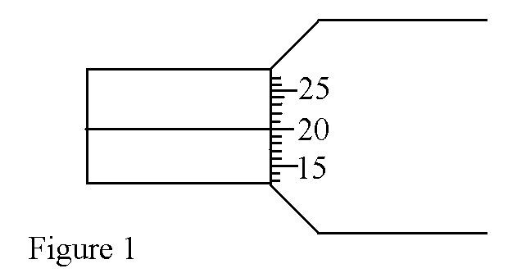
Insert divisions on the sleeve to represent a reading of 4.70mm. (2 marks)

2. Explain why the level of a liquid in a glass thermometer slightly rises before falling
when put in ice cold water. (2 marks)

3. The figure 2 below shows a body of mass 1000Kg which moves along a circular path
in vertical plane.
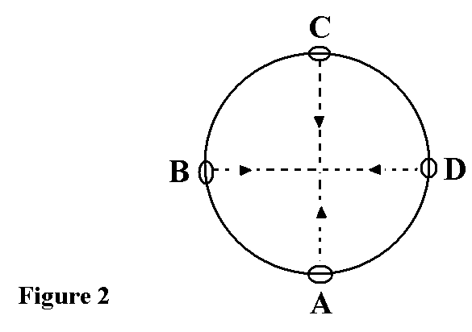
If the radius of the circular path is 10m and the body moves with a velocity of 200ms⁻¹,
calculate the force which acts on the body at point C. (2 marks)

4. Figure 3 shows a uniform wooden plank, which weighs 10N. The plank is balanced at 0.8m from one end by a mass of 2.5Kg.
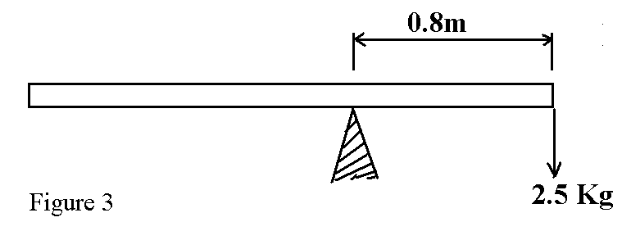
What is the length of the wooden plank in metres. (3 marks)

5. Explain why deflating the tyres of a motor vehicle reduces extend of sinking of the wheels into a soft ground. (2 marks)

6. A block of copper of mass 2Kg and specific heat capacity of 400JKg⁻¹K⁻¹ initially at 121⁰c is immersed in water art 20⁰c, determine the mass of water.(Specific heat capacity of water=4.2x10³JKg⁻¹K⁻¹) (2 marks)

7. A student blew air over the mouth of a tube with varying cross-sections as shown in figure 4.
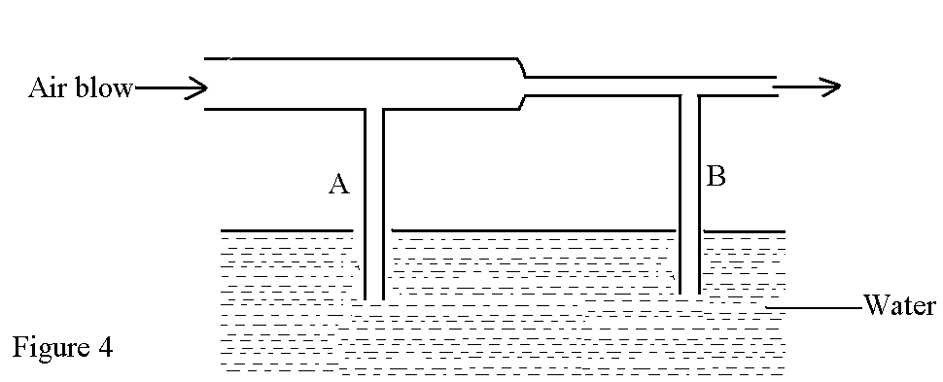
The vertical tubes A and B have the same cross-section areas.
Describe the observation made and give an explanation. (2 marks)

8. Figure 5 shows velocity-time gravity for a body.
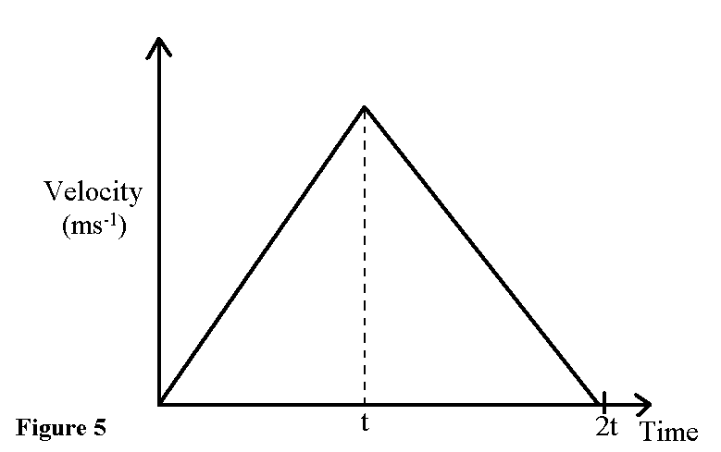

Describe this motion. (2 marks)

9. The pointer of a spring loaded with a mass of 0.12Kg reads 38cm. A pan in which a mass of 0.21Kg is placed is suspended from the spring and the pointer reads 48cm. Determine the mass of the pan if the pointer of the unloaded spring is 22cm. (3 marks)

10. Explain how heat loss by radiation is minimized in a thermos flask. (1 mark)

11. Figure 6 shows weighted spirit burner floating upright in water.
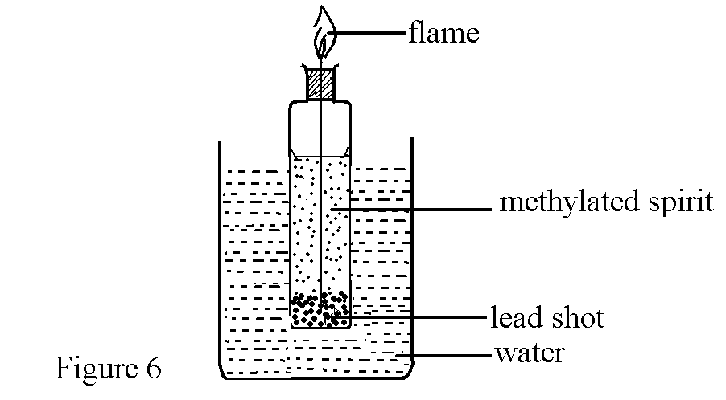
Explain what happens to the spirit burner as it continues to burn. (1 mark)

12. Explain the difference between the motion of dust particles in Brownian motion and the motion of dust particles due to convectional currents. (2 marks)

SECTION B (55 MARKS)
Answer all questions in the free spaces provided
13. a) Define the term Specific heat capacity (1mark)

b) 100g of steam at 100°C was passed into cold water at 27°C. The temperature of the mixture became 50°C. Taking specific heat capacity of water as 4200Jkg⁻¹K⁻¹ and specific latent heat of vaporization of water as 2260kJkg⁻¹ and that heat losses were negligible. Determine the,
i) Quantity of heat lost by steam (3marks)

ii) Quantity of heat gained by water. (3marks)

iii) Mass of the cold water (3marks)

14. Figure 7 shows a glass container with a square base of sides 0.05m carrying water to a height of 7mm (h₁)
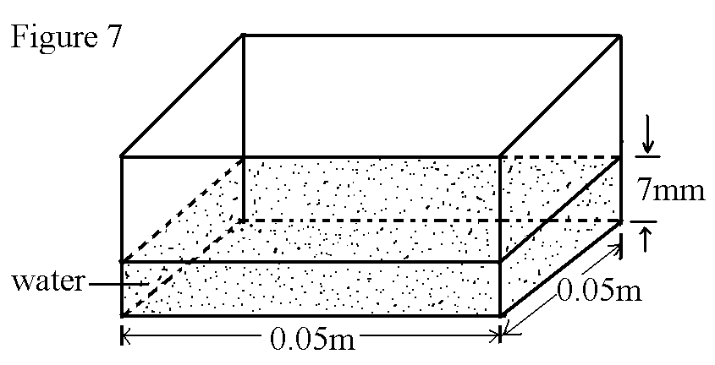

a) Calculate the volume of water container in cubic metres in standard form. (2 marks)

b) When a small ball bearing of unknown volume was immersed into the water, the level rose to 1cm (h₂). What is the volume of the ball bearing? (2 marks)

c) Calculate the pressure exerted by the water at the bottom when the ball bearing is fully immersed into the water. (2 marks)

d) Explain why a steel needle dropped on water sinks and yet if it is placed cautiously it floats. (2 marks)

e) Explain the following observations:
i) A lift pump is effective for pumping water from a well, which is about 10m deep
at the sea level. (2 marks)

ii) On a high mountain, the cliff pump lifts the water from a much lesser height. (1 mark)

15. a) An object weighs 2.04N in air, 1.64N in water and 1.72N when fully immersed in an
unknown liquid. Calculate the density of the unknown liquid. (3 marks)

b) Give a reason why a small ball-bearing made of steel sinks in water while a large ship of
the same material floats on water. (1 mark)

c) The figure 8 below is a bouy B of volume 80 litres and of mass 20Kg. It is held in
position in sea water of density 1.04x10³ Kgm⁻³ by a light string fixed to the bottom
so that 0.73 of its volume is below the surface of water.

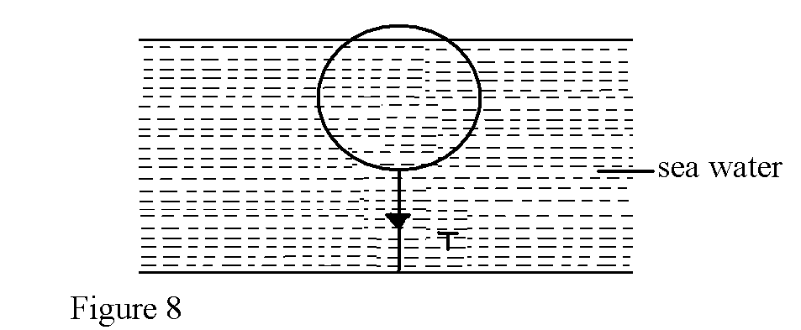

Determine the tension T in the string. (2 mark)

d) Figure 9 shows a hydrometer which is suitable for measuring densities of liquids range
between 1.0 and 1.2gcm⁻³
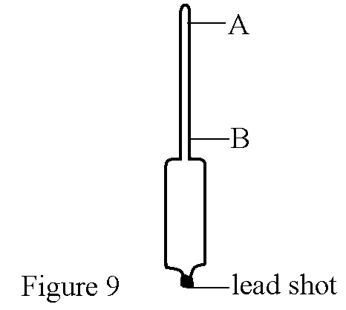
On the diagram, indicate against A and B the level corresponding to these extreme range of densities. (1 mark)

e) Figure 10 shows a wooden cube whose density is the same as that of water. The cube is held on the suface of water.
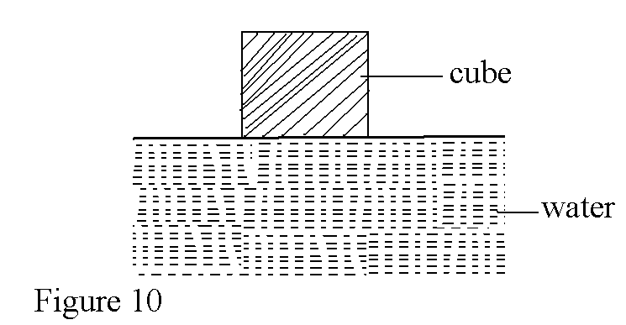
State and explain what would happen to the cube on releasing it. (2 marks)

16. a) A body of mass 20Kg hangs 4m and swings through a vertical height of 0.9m as shown in
the figure 11.
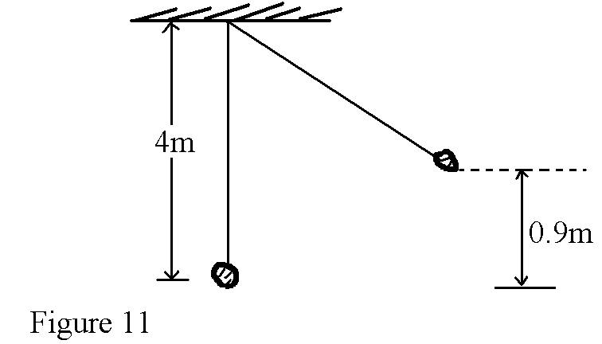
Determine;
i) the potential energy at its position. (2 marks)

ii) the speed of the body when passing through the lowest point. (3 marks)

b) A crane lifts a load of 2000Kg through a vertical distance of 3.0m in 6 seconds.
Determine the;
i) Work done by the crane. (2 marks)

ii) Power developed by the crane. (2 marks)

iii) Efficiency of the crane given that it is operated by an electric motor rated 12.5kw. (1 mk)

17. Figure 12 shows an apparatus used to investigate the variation of pressure of a fixed mass of air with temperature at constant volume.
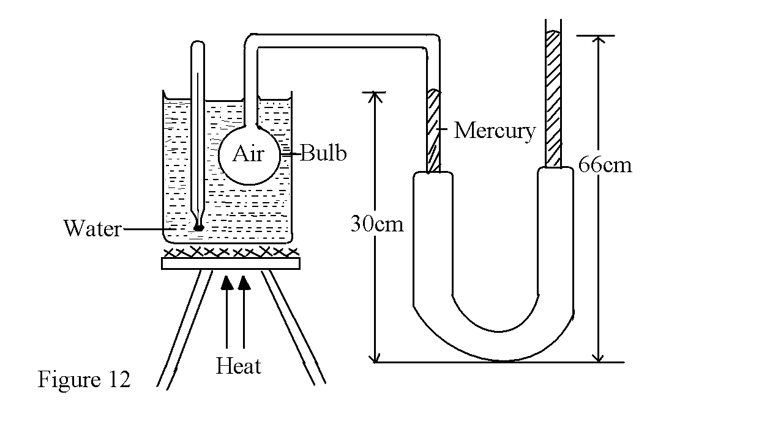
a) i) State the gas law under investigation. (2 marks)

ii) How would you ensure that all the air trapped in the bulb was at the temperature
recorded by the thermometer. (1 mark)

b) Using the values given in the diagram, calculate the total pressure of air trapped in the
bulb. (Density of mercury=13600Kgm⁻³) (3 marks)

c) On the axis shown below, sketch a graph of the results obtained from the set-up of the
apparatus. (3 marks)
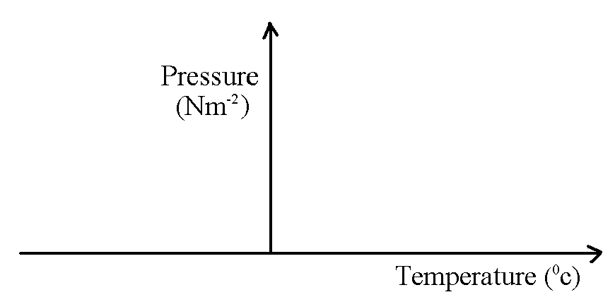

d) Explain how kinetic theories of gases account for the results in the above experiment.
(2 marks)

18. a) Figure13 shows the motion of stone moving vertically downwards as it goes with the tape
from a ticker time.
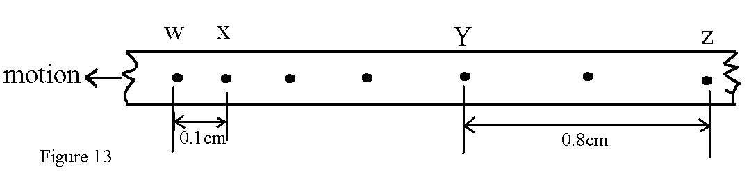
If the ticker timer has a frequency of 100Hz, calculate the values of the acceleration due to gravity ‘g’ (2 mks)

b) A 50g mass elastic ball moving on a horizontal surface at a velocity v collides with a
stationery wooden block of mass 500g. the ball bounces along the same path at a velocity
of 1.5ms⁻¹ while the block moves forward at a speed of 0.5ms⁻¹. (3 marks)

