ASUMBI GIRLS HIGH SCHOOL
TERM 2– DECEMBER 2021
FORM 4 – BIOLOGY PAPER 2

231/2
FORM 4 BIOLOGY
PAPER 2
DEC 2021

TIME: 2 HOURS

NAME ______________________________________________________________________

CLASS ______________________________ADM NO _______________________________

SIGNATURE__________________________ DATE_________________________________

INSTRUCTIONS TO CANDIDATES

- Write your name, admission number and class in the spaces provided above.

- Answer all the questions in Section A in the spaces provided.

- In section B answer question 6 Compulsory and Either Question 7 or 8

- This paper consists of 11 printed pages. Candidates should check the question paper to ensure that all the pages are printed as indicated and that no questions are missing.

FOR EXAMINERS USE ONLY

Questions | Questions | Maximum Score | Candidate Score
A | 1 | 8
 | 2 | 8
 | 3 | 8
 | 4 | 8
 | 5 | 8
B | 6 | 20
 | 7 | 20
 | 8 | 20
TOTAL |  | 80

SECTION A
1. The quantity of urine passed per day was established in five mammals A, B, C, D, and E of the
same species in the natural habitats. The results are ash shown in the following diagram;
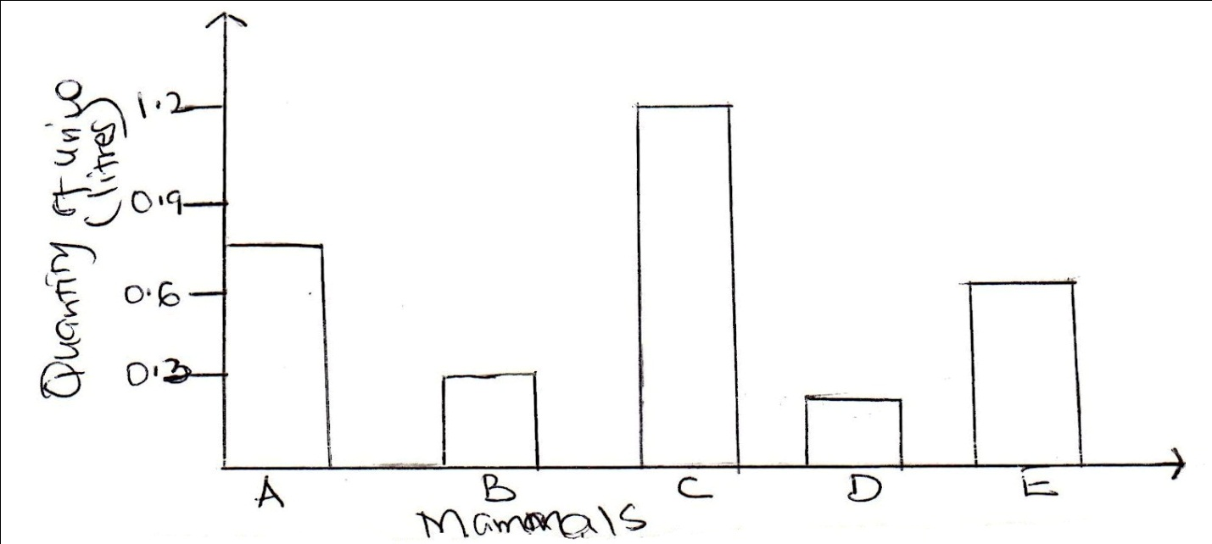

(a) Which of the above mammals is likely to be excreting urine very high in ammonia? Explain
(2mks)
........................................................................................................................................................................................................................................................................................................................
............................................................................................................................................................
(b) Which of the five mammals was likely to be living in a desert? Explain (2mks)
........................................................................................................................................................................................................................................................................................................................
............................................................................................................................................................
(c) State two structural differences expected in the nephron of mammals A and D. (2mks)
........................................................................................................................................................................................................................................................................................................................
............................................................................................................................................................
(d) Name two physiological mechanisms used in mammal D to regulate its salt and water
balance in the body. (2mks)
.......................................................................................................................................................................................................................................................................................................................
........................................................................................................................................................................................................................................................................................................................
2. (a) State the function of the following parts of mammalian ear;

- Tympanic membrane (1mk)
........................................................................................................................................................................................................................................................................................................................
- Pinna (1mk)
........................................................................................................................................................................................................................................................................................................................
- Ear ossicles (1mk)
........................................................................................................................................................................................................................................................................................................................
(b) Give two defects of mammalian eye (2mks)

........................................................................................................................................................................................................................................................................................................................
(c) The diagram below show how the iris and pupil of a human eye appear under different
Condition
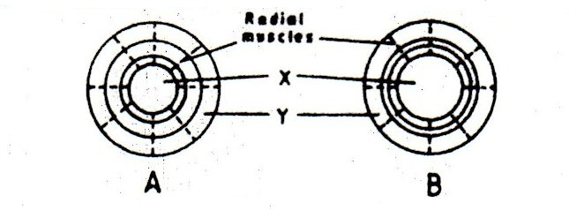

- Name the structures labeled X and Y (2mks)
X.............................................................................................................................................

Y.............................................................................................................................................
- State the condition that lead to the change in appearance shown in the diagram labeled B
...............................................................................................................................................................................................................................................................................................
3. A biologists carried out a study to investigate the growth of a certain species of herbivorous
fish and the factors influencing plant and animal life in four lakes A,B,C and D. The lakes
were located in the same geographical area.
Two of the lakes A and B were found to contain hard water due to the presence of high
content of calcium salts. The mean body length of 2 year old fish, amount of plant use and
invertebrates biomass in each lake were determined. The data was shown in the table below;

Lakes | Means of fish body length (m) | Type of water | Amount of plant life | Invertebrate biomass g/cm3
 |  |  |  | insects | snails | crabs | worms
A | 31.2 | Hard | 1050 | 11 | 300 | 10 | 180
B | 38.6 | Hard | 950 | 72 | 100 | 9 | 90
C | 18.4 | Soft | 1.2 | 79 | 0 | 2 | 20
D | 16.3 | soft | 0.5 | 99 | 0 | 1 | 10

(a) Describe the procedure that may have been used to determine the mean body length of the
fish. (4mks)
........................................................................................................................................................................................................................................................................................................................
........................................................................................................................................................................................................................................................................................................................
........................................................................................................................................................................................................................................................................................................................
(b)What are the likely reasons for the difference in mean body length of the fish living in lakes A
and D (2mks)
........................................................................................................................................................................................................................................................................................................................
(c) Explain why primary producers have a higher biomass than primary consumers. (2mks)

.......................................................................................................................................................................................................................................................................................................................
4. In an experiment to investigate a factor affecting photosynthesis a potted plant which had
been kept in the dark overnight was treated as shown in the diagram below and exposed to
light.
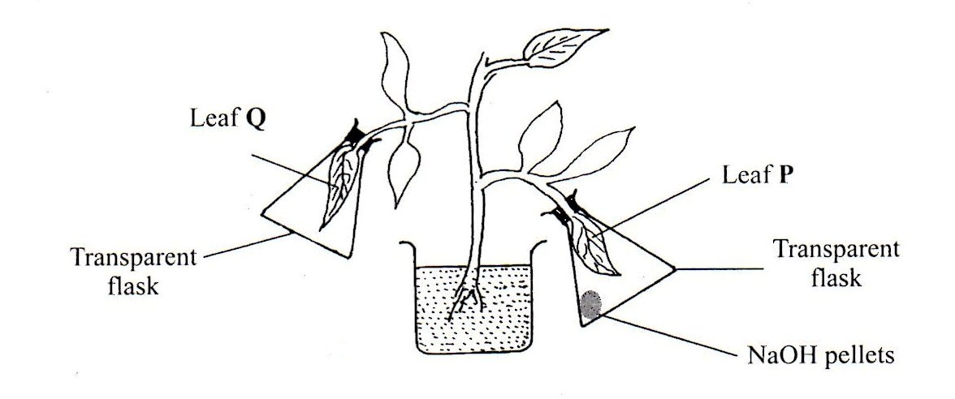

(a) why was the potted plant kept in the dark overnight? (1mk)
........................................................................................................................................................................................................................................................................................................................

(b) Which factor was being investigated in the experiment? (1mk)
........................................................................................................................................................................................................................................................................................................................

(c) (i) Which test did the students perform to confirm photosynthesis in the leaves labeled P and
Q
...................................................................................................................................................................................................................................................................................................................

(ii) State the results obtained in the leaves labeled P and Q.
P (1mk)
........................................................................................................................................................................................................................................................................................................................
Q (1mk)

........................................................................................................................................................................................................................................................................................................................
(iii) Explain the results obtained in the leaves labelled P and Q
P (1mk)
........................................................................................................................................................................................................................................................................................................................
Q (1mk)

........................................................................................................................................................................................................................................................................................................................

(iv) What was the purpose of the leaf Q in the experiment? (1mk)
........................................................................................................................................................................................................................................................................................................................
5. The diagram below shows samples of blood obtained from two different persons A and B
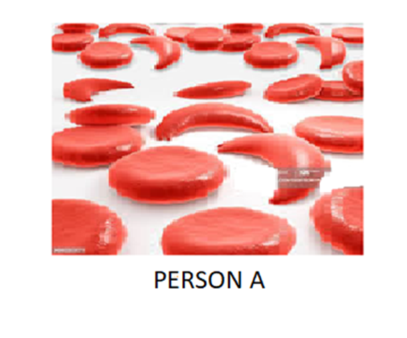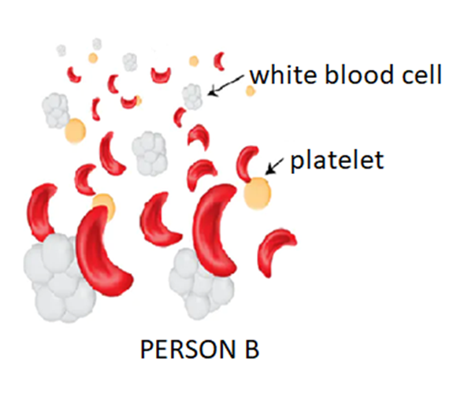

(a) What genetic disorder is person B suffering from? (1mk)

........................................................................................................................................................................................................................................................................................................................

(b) State one advantage and one disadvantage of the disorder exhibited in person A. (2mks)

........................................................................................................................................................................................................................................................................................................................
(c) Work out the genotype and phenotypes of the resulting offspring of a marriage between
person A and B. Show your working (5mks)

........................................................................................................................................................................................................................................................................................................................
........................................................................................................................................................................................................................................................................................................................
........................................................................................................................................................................................................................................................................................................................
........................................................................................................................................................................................................................................................................................................................

SECTION B
6.The data below represents levels of progesterone hormone produced in a female’s body within a period of 34 days. Study the data and use it to answer the questions that follow
NB: The days were counted from the 1st day that menstruation was noticed.

Day | Progesterone hormone concentration in arbitrary units
1 | 6
2 | 5
3 | 3
4 | 2
5 | 1
6 | 1
8 | 1
10 | 2
12 | 4
14 | 7
16 | 8
20 | 9
22 | 10
24 | 10
26 | 10
28 | 10
30 | 11
32 | 11
34 | 11

(a) Plot a graph of progesterone concentration against time using a suitable scale. (6mks)

(b) Account for the progesterone levels in the blood between
- Day 1 - day 5 (2mks)

........................................................................................................................................................................................................................................................................................................................
............................................................................................................................................................
- Day 14 – day 20 (2mks)

........................................................................................................................................................................................................................................................................................................................
............................................................................................................................................................
- Day 28 – day 35 (2mks)

........................................................................................................................................................................................................................................................................................................................
........................................................................................................................................................................................................................................................................................................................
(c) Name two structures that produce progesterone in females . (3mks)

........................................................................................................................................................................................................................................................................................................................
........................................................................................................................................................................................................................................................................................................................
(d) Suggest the process that usually takes place at day 14. (1mk)
........................................................................................................................................................................................................................................................................................................................
(e) Suggest two other hormones that were in high concentration in the body of the female
between day 10 – 15 . Give reasons for your answer. (4mks)
........................................................................................................................................................................................................................................................................................................................
........................................................................................................................................................................................................................................................................................................................
.......................................................................................................................................................................................................................................................................................................................

7. Describe how water moves from the soil to the leaves in a tree. (20mks)

8. (a) Describe the process of carbohydrates digestion in human beings. (12mks)

(b) Describe the flow of energy from the sun through the different trophic levels in an
Ecosystem (8mks)

....................................................................................................................................................................................................................................................................................................................................................................................................................................................................................................................................................................................................................................................................................................................................................................................................................................................................................................................................................................................................................................................................................................................................................................................................................................................................................................................................................................................................................................................................................................................................................................................................................................................................................................................................................................................................................................................................................................................................................................................................................................................................................................................................................................................................................................................................................................................................................................................................................................................................................................................................................................................................................................................................................................................................................................................................................................................................................................................................................................................................................................................................................
....................................................................................................................................................................................................................................................................................................................................................................................................................................................................................................................................................................................................................................................................................................................................................................................................................................................................................................................................................................................................................................................................................................................................................................................................................................................................................................................................................................................................................................................................................................................................................................................................................................................................................................................................................................................................................................................................................................................................................................................................................................................................................................................................................................................................................................................................................................................................................................................................................................................................................................................................................................................................................................................................................................................................................................................................................................................................................................................... ........................................................................................................................................................................................................................................................................................................................................................................................................................................................................................................................................................................................................................................................................................................................................................................................................................................................................................................................................................................................................................................................................................................................................................................................................................................................................................................................................................................................................................................................................................................................................................................................................................................................................................................................................................................................................................................................................................................................................................................................................................................................................................................................................................................................................................................................................................................................................................................................................................................................................................................................................................................................................................................................................................................................................................................................................................................................................................................................................................................................................................................................................................................................................................................................................................................................................................................................................................................................................................................................................................................................................................................................................................................................................................................................................................................................................................................................................................................................................................................................................................................................................................................................................................................................................................................................................................................................................................................................................................................................................................................................................................................................................................................................................................................................................................................................................................................................................
END.

